|  |  |
| --- | --- |
|  | **MINISTRY OF EDUCATION AND TRAINING** |

**FPT UNIVERSITY**

|  |  |
| --- | --- |
| Capstone Project Document | |
| **Resell Unused Transportation Ticket** | |
| **Group 2 – IS** | |
| **Group members** | Dương Anh Tuấn – SE62310 (Leader)  Lê Xuân Huy – SE62558  Nguyễn Văn Thanh – SE62560  Phạm Phú Tiến – SE61597 |
| **Supervisor** | Nguyễn Phan Quang Nhật |
| **Ext. Supervisor** | N/A |
| **Project Code** | Resell Ticket |

– **Ho Chi Minh City, 18 May 2019** –

**Table of contents**

A. Introduction 16

1. Project Information 16

2. Introduction 16

3. Current Situation 16

4. Problem Definition 17

5. Proposed Solution 17

**5.1 Feature functions** 17

**5.2** **Advantages and disadvantages** 17

6. Functional Requirements 18

7. Role & Responsibility 19

B. Software Project Management Plan 19

1. Problem Definition 19

2. Project Organization 22

3. Project Management Plan 24

4. Coding Convention 25

C. Software Requirement Specification 26

1. User Requirement Specification 26

**1.1. Guest Requirement** 26

**1.2. Customer requirement** 26

**1.3. Admin requirement** 27

2. System Requirement Specification 27

**2.1. External Interface Requirement** 27

**2.2. System Overview Use Case** 28

**2.3. List of use case** 29

3. Software System Attribute 103

**3.1. Usability** 103

**3.2. Reliability** 103

**3.3. Availability** 103

**3.4. Security** 103

**3.5. Maintainability** 103

**3.6. Portability** 103

**3.7. Performance** 103

4. Conceptual Diagram 104

D. Software Design Description 106

1. Design Overview 106

2. System Architecture Design 107

**2.1. System architecture description** 108

**2.2. Web Service architecture description** 108

**2.3. Admin website architecture description** 108

**2.4. Customer website architecture description** 108

**2.5. Customer Mobile architecture description** 108

3. Component Diagram 109

4. Detailed Description 110

**4.1. Class Diagram** 110

**4.2. Class Diagram Explanation** 112

**4.3. Interaction Diagram** 120

5. Interface 144

**5.1. Component Interface** 144

**5.2. User Interface Design** 144

6. Database Design 219

**6.1. Entity Relationship Diagram (ERD)** 219

**6.2. Data Dictionary** 221

7. Algorithms 228

**7.1. Finding the $k$ cheapest combination tickets** 228

E. System implementation & Test 235

1. Introduction 235

**1.1. Overview** 235

**1.2 Test Approach** 235

2. Data Relationship Diagram 236

**2.1. Physical Diagram** 236

**2.2. Data Dictionary** 237

3. Test Plan 245

**3.1. Features To Be Tested** 245

**3.2. Features Not To Be Tested** 246

4. System Testing Test Case 246

**4.1. Guest Testcase** 246

**4.2. Staff Testcase** 248

**4.3. Customer Testcase** 252

F. Software User’s Manual 264

1. Installation Guide 264

**1.1.** **Setting up environment at Cloud Server** 264

**1.2.** **Deployment at Server Side** 269

**1.3.** **Setting up the environment at client side.** 274

2. User Guide 275

**2.1.** **Admin Web Application** 275

**2.2.** **Customer Web Application** 278

**2.3.** **Customer Mobile Application** 294

G. Appendix 305

**List of tables**

Table 1 - Role & Responsibility 25

Table 2 - Hardware Requirements for Server 27

Table 3 - Hardware requirement for PC 27

Table 4 - Software Requirement 28

Table 5 - Roles and responsibilities 30

Table 6 - Tools and techniques 30

Table 7 - Deliverables 31

Table 8 - Usecase <Guest> Login 37

Table 9 - Usecase <Guest> Register 38

Table 10 - Usecase <Guest> Reset Password 41

Table 11 - Usecase <Guest> Search Route 43

Table 12 - Usecase <Customer> Add Customer Payment Method 47

Table 13 - Usecase <Customer> Change Payment Method 48

Table 14 - Usecase <Customer> Delete Customer Card 50

Table 15 - Usecase <Customer> Create Receivable Account 52

Table 16 - Usecase <Customer> Create Receivable Account 54

Table 17 - Usecase <Customer> Post Unused Ticket 56

Table 18 - Usecase <Customer> Edit Posted Ticket 58

Table 19 - Usecase <Customer> Delete Posted Ticket 60

Table 20 - Usecase <Customer> Delete Posted Ticket 63

Table 21 - Usecase <Customer> Get Route History 64

Table 22 - Usecase <Customer> Edit Route 66

Table 23 - Usecase <Customer> Delete Route 68

Table 24 - Usecase <Customer> Buy Ticket 70

Table 25 - Usecase <Customer> Get Notification History 72

Table 26 - Usecase <Customer> Get Transaction History 73

Table 27 - Usecase <Manager> Create User 76

Table 28 - Usecase <Manager> Edit User 77

Table 29 - Usecase <Manager> Active Customer 79

Table 30 - Usecase <Manager> Deactive Customer 80

Table 31 - Usecase <Manager> Create City 81

Table 32 – Use case <Manager> Edit City 83

Table 33 - Usecase <Manager> Create Station 84

Table 34 - Usecase <Manager> Edit Station 86

Table 35 – Use case <Manager> Create Transportation 88

Table 36 – Use case <Manager> Edit Transportation 89

Table 37 – Use case <Manager> Create Ticket Type 91

Table 38 – Use case <Manager> Edit Ticket Type 93

Table 39 - Usecase <Manager> View Statistic 94

Table 40 - Use case <Staff> Verify Ticket 96

Table 41 – Use case <Staff> Verify Renamed Ticket 98

Table 42 – Use case <Staff> Make Payout 100

Table 43 – Use case <Staff> Make Refund 102

Table 44 – Use case <Staff> Replace Ticket 104

Table 45 – Use case <Authorized user> Logout 105

Table 46 – Use case <Authorized user> Edit Profile 107

Table 47 – Use case <Authorized user> Change Password 109

Table 48 - Conceptual Diagram Data Dictionary 111

Table 49 - Component Diagram Data Dictionary 116

Table 50 - Class Diagram Data Dictionary 119

Table 51 – Class Diagram Data Dictionary - Role 119

Table 52 - Class Diagram Data Dictionary – AdminDevice 119

Table 53 - Class Diagram Data Dictionary - User 119

Table 54 - Class Diagram Data Dictionary - ResolveOptionLog 120

Table 55 - Class Diagram Data Dictionary - TicketType 120

Table 56 - Class Diagram Data Dictionary - Vehicle 120

Table 57 - Class Diagram Data Dictionary - Transportation 121

Table 58 - Class Diagram Data Dictionary - Payout 121

Table 59 - Class Diagram Data Dictionary - Route 122

Table 60 - Class Diagram Data Dictionary - Ticket 123

Table 61 - Class Diagram Data Dictionary - Station 123

Table 62 - Class Diagram Data Dictionary - City 123

Table 63 - Class Diagram Data Dictionary - OTP 123

Table 64 - Class Diagram Data Dictionary - Refund 124

Table 65 - Class Diagram Data Dictionary - Payment 124

Table 66 - Class Diagram Data Dictionary - Customer 125

Table 67 - Class Diagram Data Dictionary - Notification 125

Table 68 - Class Diagram Data Dictionary - CustomerDevice 126

Table 69 - Class Diagram Data Dictionary - CreditCard 126

Table 70 - <Field> Login Page 150

Table 71 - <Button/Hyperlinks> Login Page 151

Table 72 - <Field> Register Phone Page 151

Table 73 - <Button/Hyperlinks> Register Phone Page 151

Table 74 - <Field> Register Account Page 153

Table 75 - <Button/Hyperlinks>Register Account Page 153

Table 76 - <Button/Hyperlinks> Navigation 154

Table 77 - <Button/Hyperlinks> Route List Page 155

Table 78 - <Field> Search Route Page 156

Table 79 - <Button/Hyperlinks> Search Route Page 156

Table 80 - <Button/Hyperlinks> Search Result Page 157

Table 81 - <Button/Hyperlinks> Route Detail Page 158

Table 82 - <Field> Buyer Customer Modal 159

Table 83 - <Button/Hyperlinks> Buyer Customer Modal 159

Table 84 - <Field> Update Profile Page 162

Table 85 - <Button/Hyperlinks> Update Profile Page 162

Table 86 - <Field> Change Password Page 163

Table 87 - <Button/Hyperlinks> Change Password Page 164

Table 88 - <Button/Hyperlinks> Payment Method Page 165

Table 89 - <Field> Add Credit Card Page 166

Table 90 - <Button/Hyperlinks> Add Credit Card Page 167

Table 91 - <Button/Hyperlinks> Selling Ticket Page 167

Table 92 - <Field> Post Ticket Page 169

Table 93 - <Button/Hyperlinks> Post Ticket Page 169

Table 94 - <Button/Hyperlinks> Edit Ticket Page 170

Table 95 - <Button/Hyperlinks> Confirm Renaming Page 171

Table 96 - <Field> Login Screen 172

Table 97 - <Button/Hyperlinks> Login Screen 173

Table 98 - <Field> Register Phone Screen 173

Table 99 - <Button/Hyperlinks> Register Phone Screen 174

Table 100 - <Field> Register Account Screen 175

Table 101 - <Button/Hyperlinks> Register Account Screen 175

Table 102 - <Field> Route List Screen 176

Table 103 - <Field> Search Form Screen 178

Table 104 - <Button/Hyperlinks> Search Form Screen 178

Table 105 - <Button/Hyperlinks> Search Route Result Screen 179

Table 106 - <Button/Hyperlinks> Route Detail Screen 180

Table 107 - <Field> Passenger Information Screen 180

Table 108 - <Button/Hyperlinks> Passenger Information Screen 181

Table 109 - <Button/Hyperlinks> Notification History Screen 182

Table 110 - <Field> Update Profile Screen 184

Table 111 - <Button/Hyperlinks> Update Profile Screen 184

Table 112 - <Button/Hyperlinks> Payment Method Screen 185

Table 113 - <Field> Add Payment Method Screen 186

Table 114 - <Button/Hyperlinks> Add Payment Method Screen 187

Table 115 - <Button/Hyperlinks> Selling Ticket Screen 188

Table 116 - <Field> Post Ticket Screen 189

Table 117 - <Button/Hyperlinks> Post Ticket Screen 190

Table 118 - <Button/Hyperlinks> Edit Posted Ticket Screen 190

Table 119 - <Button/Hyperlinks> Confirm Renaming Screen 191

Table 120 <Fields> Login Page 192

Table 121 - <Button/Hyperlinks> Login Page 192

Table 122 - <Button/Hyperlinks> Main Menu 194

Table 123 - <Button/Hyperlinks> Manager Menu 194

Table 124 <Fields> Manager Profile 195

Table 125 <Buttons/Hyperlinks> Manager Profile 196

Table 126 <Fields> Change password 196

Table 127 <Buttons/Hyperlinks> Change password 196

Table 128 <Fields> Dashboard menu 197

Table 129 <Buttons/Hyperlinks> Dashboard menu 198

Table 130 <Fields> User menu 198

Table 131 <Buttons/Hyperlinks> User menu 199

Table 132 <Fields> Customer menu 199

Table 133 <Buttons/Hyperlinks> Customer menu 200

Table 134 <Fields> Cities menu 200

Table 135 <Buttons/Hyperlinks> Cities menu 201

Table 136 <Fields> Station menu 202

Table 137 <Buttons/Hyperlinks> Station menu 202

Table 138 <Fields> Transportation menu 203

Table 139 <Buttons/Hyperlinks> Transportation menu 203

Table 140 <Fields> Ticket type menu 204

Table 141 <Buttons/Hyperlinks> Ticket type menu 205

Table 142 <Buttons/Hyperlinks> Main menu 207

Table 143 <Buttons/Hyperlinks> User menu 208

Table 144 <Fields> User profile 209

Table 145 <Buttons/Hyperlinks> User profile 209

Table 146 <Fields> Change password 210

Table 147 <Buttons/Hyperlinks> Change password 210

Table 148 <Fields> New posted tickets menu 210

Table 149 <Buttons/Hyperlinks> New posted tickets menu 211

Table 150 <Fields> Valid new posted tickets menu 213

Table 151 <Buttons/Hyperlinks> Valid new posted tickets menu 213

Table 152 <Fields> Valid tickets menu 214

Table 153 <Buttons/Hyperlinks> Valid tickets menu 214

Table 154 <Fields> View ticket details 215

Table 155 <Buttons/Hyperlinks> View ticket details 215

Table 156 <Fields> Invalid tickets menu 216

Table 157 <Buttons/Hyperlinks> Invalid tickets menu 216

Table 158 <Fields>Bought tickets menu 216

Table 159 <Buttons/Hyperlinks> Bought tickets menu 217

Table 160 <Fields>Renamed tickets menu 217

Table 161 <Buttons/Hyperlinks> Renamed tickets menu 217

Table 162 <Fields>Verify renamed ticket 218

Table 163 <Buttons/Hyperlinks> Verify renamed ticket 219

Table 164 <Buttons/Hyperlinks> Confirm renamed ticket success 219

Table 165 <Buttons/Hyperlinks> Confirm renamed ticket success 220

Table 166 <Fields>Renamed tickets menu 221

Table 167 <Buttons/Hyperlinks> Renamed tickets menu 221

Table 168 - <Buttons/Hyperlinks> Bought Route Page 222

Table 169 - <Buttons/Hyperlinks> Resolve Renamed Success Ticket Page 222

Table 170 - <Buttons/Hyperlinks> Resolve Renamed Ticket Failed Page 224

Table 171 - <ERD> Data Dictionary 227

Table 172 - <ERD> Entity Dictionary 233

Table 173 - <Physical Diagram> Data Dictionary 251

Table 174 - <Test case> Register 254

Table 175 - <Test case> Resolve Route 257

Table 176 - <Test case> Manage Payment Method 260

Table 177 - <Test case> Manage Posted Ticket 263

Table 178 - <Test case> Search Route 266

Table 179 - <Test case> Buy Route 269

Table 180 - <Installation Guide> Hardware Requirements 270

Table 181 - <User Guide> Verify Pending Ticket 282

Table 182 - <User Guide> Verify Renamed Ticket 283

Table 183 - <User Guide> Transfer money to seller 284

Table 184 - <User Guide> Add Payment Method 285

Table 185 - <User Guide> Add Payment Method 285

Table 186 - <User Guide> Add Receivable Account 286

Table 187 - <User Guide> Add Receivable Account 287

Table 188 - <User Guide> Add Receivable Account 287

Table 189 - <User Guide> Add Receivable Account 288

Table 190 - <User Guide> Add Receivable Account 289

Table 191 - <User Guide> Add Receivable Account 290

Table 192 - <User Guide> Add Receivable account 291

Table 193 - <User Guide> Add Receivable Account 292

Table 194 - <User Guide> Post Ticket 293

Table 195 - <User Guide> Post ticket 295

Table 196 - <User Guide> Search Route 295

Table 197 - <User Guide> Search Route 296

Table 198 - <User Guide> Buy Route 297

Table 199 - <User Guide> Buy Route 298

Table 200 - <User Guide> Buy Route 299

Table 201 - <User Guide> Confirm Renamed Ticket 299

Table 202 - <User Guide> Add Payment Method 300

Table 203 - <User Guide> Add Receivable Account 305

Table 204 - <User Guide> Post Ticket 307

Table 205 - <User Guide> Search Route 308

Table 206 - <User Guide> Buy Route 309

Table 207 - <User Guide> Confirm Renamed Ticket 311

**List of Figures**

Figure 1 - Scrum Framework 29

Figure 2 - <Use case> System Overview 34

Figure 3 - <Use case> Guest Overview 35

Figure 4 - <Use case> Guest Login 35

Figure 5 - <Use case> Guest Register 37

Figure 6 - <Use case> Guest Reset Password 39

Figure 7 - <Use case> Guest Search Route 41

Figure 8 - <Use case> Customer Overview 44

Figure 9 - <Use case> Customer Add Payment Method 45

Figure 10 - <Use case> Customer Change Default Payment Method 47

Figure 11 - <Use case> Customer Delete Payment Method 49

Figure 12 - <Use case> Customer Create Receivable Account 50

Figure 13 - <Use case> Customer Edit Receivable Account 52

Figure 14 - <Use case> Customer Post Ticket 55

Figure 15 - <Use case> Customer Edit Posted Ticket 57

Figure 16 - <Use case> Customer Delete Posted Ticket 59

Figure 17 - <Use case> Customer Search Route 60

Figure 18 - <Use case> Customer Get Route History 63

Figure 19 - <Use case> Customer Edit Route 65

Figure 20 - <Use case> Customer Delete Route 67

Figure 21 - <Use case> Customer Buy Route 68

Figure 22 - <Use case> Customer Get Notification History 71

Figure 23 - <Use case> Customer Get Transaction History 72

Figure 24 - <Use case> Manager Overview 74

Figure 25 - <Use case> Manager Create User 75

Figure 26 - <Use case> Manager Edit User 76

Figure 27 - <Use case> Manager Active Customer 78

Figure 28 - <Use case> Manager Deactive Customer 79

Figure 29 - <Use case> Manager Create City 80

Figure 30 - <Use case> Manager Edit City 82

Figure 31 - <Use case> Manager Creates Station 83

Figure 32 - <Use case> Manager Edits Station 84

Figure 33 - <Use case> Manager Creates Transportation 86

Figure 34 - <Use case> Manager Edits Transportation 88

Figure 35 - <Use case> Manager Creates Ticket Type 90

Figure 36 - <Use case> Manager Edits Tick Type 91

Figure 37 - <Use case> Manager Deletes Ticket Type 93

Figure 38 - <Use case> Manager Views Statistic 93

Figure 39 - <Use case> Staff Overview 95

Figure 40 - <Use case> Staff Verify Ticket 95

Figure 41 - <Use case> Staff Verify Renamed Ticket 97

Figure 42 - <Use case> Staff Makes payout 98

Figure 43 - <Use case> Staff Makes Refund 100

Figure 44 - <Use case> Staff Replaces Ticket 102

Figure 45 - <Use case> Authorized User Overview 104

Figure 46 - <Use case> Authorized User Logout 104

Figure 47 - <Use case> Authorized User Edits Profile 106

Figure 48 - <Use case> Authorized User Changes Password 107

Figure 49 - Conceptual Diagram 110

Figure 50 - System Architecture Diagram 113

Figure 51 - Component Diagram 115

Figure 52 - Class Diagram 117

Figure 53 - <Sequence> Manager Creates City 127

Figure 54 Sequence Diagram - Edit City 128

Figure 55 Sequence Diagram - Delete City 129

Figure 56 Sequence Diagram – Verify new Ticket 130

Figure 57 Sequence Diagram – Verify Ticket renamed successfully 131

Figure 58 Sequence Diagram – Verify Ticket renamed failed 132

Figure 59 Sequence Diagram - Payout 133

Figure 60 Sequence Diagram – Refund a Ticket 134

Figure 61 Sequence Diagram - Refund a route 135

Figure 62 Sequence Diagram - Replace Ticket 136

Figure 63 Activity Diagram - Login Guest 137

Figure 64 Activity Diagram - Add Credit Card 138

Figure 65 Activity Diagram – Delete Credit Card 139

Figure 66 Activity Diagram – Set Default Credit Card 140

Figure 67 Activity Diagram – Update Profile 141

Figure 68 Activity Diagram – Create Receivable Account 142

Figure 69 Activity Diagram – View Receivable Account 143

Figure 70 Activity Diagram – Post unused ticket 144

Figure 71 Activity Diagram – Edit Posted Ticket 145

Figure 72 Activity Diagram – Delete Posted Ticket 146

Figure 73 Activity Diagram – Confirm renamed Ticket 147

Figure 74 Activity Diagram – Refuse Renamed Ticket 148

Figure 75 Activity Diagram – Buy route 149

Figure 76 - <Interface> Login Page 150

Figure 77 - <Interface> Register Phone Page 151

Figure 78 - <Interface> Register Account Page 152

Figure 79 - <Interface> Navigation 153

Figure 80 - <Interface> Route List Page 154

Figure 81 - <Interface> Search Route Page 155

Figure 82 - <Interface> Searched Result Page 157

Figure 83 - <Interface> Route Detail Page 158

Figure 84 - <Interface> Buyer Customer Modal 159

Figure 85 - <Interface> Transaction History Page 160

Figure 86 - <Interface> Notification List 160

Figure 87 - <Interface> Update Profile Page 161

Figure 88 - <Interface> Change Password Page 163

Figure 89 - <Interface> Stripe Account 164

Figure 90 - <Interface> Payment Method Page 165

Figure 91 - <Interface> Add Payment Method Page 166

Figure 92 - <Interface> Selling Tickets Page 167

Figure 93 - <Interface> Post Ticket Page 168

Figure 94 - <Interface> Edit Ticket Page 170

Figure 95 - <Interface> Confirm Renaming Page 171

Figure 96 - <Interface> Login Screen 172

Figure 97 - <Interface> Register Phone Screen 173

Figure 98 - <Interface> Register Account Screen 174

Figure 99 - <Interface> Route List Screen 176

Figure 100 - <Interface> Search Form Screen 177

Figure 101 - <Interface> Search Route Detail Screen 178

Figure 102 - <Interface> Route Detail Screen 179

Figure 103 - <Interface> Passenger Information Screen 180

Figure 104 - <Interface> Transaction History Screen 181

Figure 105 - <Interface> Notification History Screen 182

Figure 106 - <Interface> Update Profile Screen 183

Figure 107 - <Interface> Stripe Account Screen 184

Figure 108 - <Interface> Payment Method Screen 185

Figure 109 - <Interface> Add Payment Method Screen 186

Figure 110 - <Interface> Selling Ticket Screen 187

Figure 111 - <Interface> Post Ticket Screen 188

Figure 112 - <Interface> Edit Posted Ticket Screen 190

Figure 113 - <Interface> Confirm Renaming Screen 191

Figure 114 - <Interface> Login Page 192

Figure 115 - <Interface> Manager Main Menu 193

Figure 116 - <Interface> Manager Menu 194

Figure 117 - <Interface> Manager Profile 195

Figure 118 - <Interface> Change Password 196

Figure 119 - <Interface> Dashboard Page 197

Figure 120 - <Interface> User Management Page 198

Figure 121 - <Interface> Customer Management page 199

Figure 122 - <Interface> City management page 200

Figure 123 - <Interface> Station Management Page 201

Figure 124 - <Interface> Transportation Management Page 202

Figure 125 - <Interface> Ticket Type Management Page 204

Figure 126 - <Interface> Staff Main menu 206

Figure 127 - <Interface> Staff Menu 208

Figure 128 - <Interface> Staff Profile 208

Figure 129 - <Interface> Staff Change Password page 209

Figure 130 - <Interface> New Posted Tickets menu 210

Figure 131 - <Interface> Valid New Posted Ticket 211

Figure 132 - <Interface> Valid new Posted Ticket 212

Figure 133 - <Interface> Valid Ticket Menu 213

Figure 134 - <Interface> View Ticket Details 214

Figure 135 - <Interface> Invalid Tickets Menu 215

Figure 136 - <Interface> Bought Tickets Menu 216

Figure 137 - <Interface> Renamed Tickets Menu 217

Figure 138 - <Interface> Verify Renamed Ticket 218

Figure 139 - <Interface> Confirm Renamed Ticket Success 219

Figure 140 - <Interface> Confirm Renamed Ticket Failed 220

Figure 141 - <Interface> Completed Tickets Menu 220

Figure 142 - <Interface> Bought Routes Page 221

Figure 143 - <Interface> Resolve Renamed Success Ticket Page 222

Figure 144 - <Interface> Resolve Renamed Ticket Failed Page 223

Figure 145 - <Interface> Resolve Renamed Ticket Failed Page 223

Figure 146 - <Interface> Resolve Renamed Ticket Failed Page 223

Figure 147 - <Interface> Resolve Tickets History Page 225

Figure 148 - <Interface> Completed Routes Page 225

Figure 149 - Entity Relationship Diagram (ERD) 226

Figure 150 - <Algorithm> Available Tickets 236

Figure 151 - <Algorithm> Ticket Graph 236

Figure 152 - <Algorithm> Dijkstra Flow Chart 238

Figure 153 - <Algorithm> Flow chart - Get the shortest path from any vertex to destination vertex 239

Figure 154 - <Algorithm> Flow chart - Find sidetrack 240

Figure 155 - Physical Diagram 242

Figure 156 - <Installation Guide> Create SQL Database 271

Figure 157 - <Installation Guide> Connect to SQL Database 272

Figure 158 - <Installation Guide> Get Connection String 272

Figure 159 - <Installation Guide> Create App Service 274

Figure 160 - <Installation Guide> Create App Services Result 275

Figure 161 - <Installation Guide> Get Publish Profile 275

Figure 162 - <Installation Guide> Publish WebAPI 276

Figure 163 - <Installation Guide> Import Publish Pofile 277

Figure 164 - <Installation Guide> Modify Publish Profile 278

Figure 165 - <Installation Guide> Connect To Azure in Visual Studio Code 278

Figure 166 - <Installation Guide> Deploy to App Service in Visual Studio Code 279

Figure 167 - <Installation Guide> Deploy into App Service in Visual Studio Code 280

Figure 168 - <User Guide> Verify Pending Ticket 281

Figure 169 - <User Guide> Verify Pending Ticket 281

Figure 170 - <User Guide> Verify Pending Ticket 281

Figure 171 - <User Guide> Verify Renamed Ticket 282

Figure 172 - <User Guide> Verify Renamed Ticket 283

Figure 173 - <User Guide> Transfer money to seller 283

Figure 174 - <User Guide> Transfer Money to seller 283

Figure 175 - <User Guide> Transfer Money to seller 284

Figure 176 - <User Guide> Add Payment Method 284

Figure 177 - <User Guide> Add Payment Method 285

Figure 178 - <User Guide> Add Receivable Account 286

Figure 179 - <User Guide> Add Receivable Account 286

Figure 180 - <User Guide> Add Receivable Account 287

Figure 181 - <User Guide> Add Receivable Account 288

Figure 182 - <User Guide> Add Receivable Account 289

Figure 183 - <User Guide> Add Receivable Account 290

Figure 184 - <User Guide> Add Receivable Account 291

Figure 185 - <User Guide> Add Receivable Account 292

Figure 186 - <User Guide> Post Ticket 293

Figure 187 - <User Guide> Post Ticket 294

Figure 188 - <User Guide> Search Route 295

Figure 189 - <User Guide> Search Route 296

Figure 190 - <User Guide> Buy Route 297

Figure 191 - <User Guide> Buy Route 298

Figure 192 - <User Guide> Buy Route 298

Figure 193 - <User Guide> Confirm Renamed Ticket 299

Figure 194 - <User Guide> Add Payment Method 300

Figure 195 - <User Guide> Add Receivable Account 301

Figure 196 - <User Guide> Add Receivable Account 302

Figure 197 - <User Guide> Add Receivable Account 303

Figure 198 - <User Guide> Add Receivable Account 304

Figure 199 - <User Guide> Post ticket 306

Figure 200 - <User Guide> Search Route 307

Figure 201 - <User Guide> Buy Route 308

Figure 202 - <User Guide> Buy Route 309

Figure 203 - <User Guide> Confirm Renamed Ticket 310

Figure 204 - <User Guide> Confirm Renamed Ticket 310

# Introduction

## Project Information

* Project name:  **Resell Unused Transportation Ticket**
* Project Code: **Resell Ticket**
* Product Type: **Android Application, Website Application**
* Start Date: **May 18th, 2019**
* End Date: **--**

## Introduction

Nowadays, there are many ways that people can book a plane, a train or a bus ticket but later cannot use due to due to change in their plan. Those tickets might be non-refundable or refundable but with a high charge and it takes a long time to get money back. In these cases, people can resell or give out tickets to other people who might need to travel on the same route with some flexibility in time or other factors.

On the other hand, there are people willing to save some money in exchange for flexibility in some factors in traveling such as longer travel time, flexibility in departure time, connecting transportation through a transit point instead of direct transportation.

With an application called is Resell Unused Transportation Ticket that will suggest not only single-tickets but also combination-tickets that match the criteria of buyers which will help sellers to resell their tickets more easily.

## Current Situation

The resale of plane tickets, train tickets, and bus tickets is quite popular with most people. There are two ways to resell tickets: posting on social networks, forums or posting on ticket reselling websites (baynhe.vn, thegioivere.net), but these two ways still exist some of the following limitations:

* With posting on social networks, forums, the post of the seller is easy to drift by newer posts. It is time-consuming to regularly check the comments from that post. For buyers, they don’t have tools to search tickets with some specific criteria, so it takes time to read the post of the sellers one by one or they may have to post a search ticket like the seller instead.
* With intermediary websites, it has overcome the above problem but there are still some issues such as the posted ticket is not authentic, the buyer must directly contact the seller to negotiate the transaction.

## Problem Definition

Below are the disadvantages of the current situation:

* Time-consuming in checking comments when buying and selling through social networks or forums.
* Tickets are posted without any authentication step.
* The potential to successfully resell ticket is not much. Because the route search engines don’t have combination-ticket feature.
* Websites still show expired tickets.
* The transaction between buyers and sellers is not safe. Because they must work directly with each other to negotiate the transaction method.
* There is no mobile platform application yet.

With the above limitations, we find that the current systems of buying and reselling tickets have many shortcomings and has not really helped users effectively.

## Proposed Solution

Build a web application and a phone application to help users buying and selling tickets more efficiently and more secure. The following workflow and features should be implemented:

### **5.1 Feature functions**

* + Sellers can post their plane, train, bus tickets they would like to resell.
  + Staff can check the validation of posted tickets and mark them as ready for sale.
  + Staff can confirm the change of ticket name and notify the buyer.
  + Sellers will be notified when their tickets are authenticated and purchased.
  + Buyers who wish to travel from A to B can search for available tickets (direct or indirect) and buy from one or more sellers with some criteria.
  + Buyers and sellers will make payment through the application.

### **5.2** **Advantages and disadvantages**

The advantages and disadvantages of the proposed solution:

* **Advantages**:
* Save time for buyers and sellers.
* Buyers can only view authenticated tickets.
* Safety payment.
* Increase the potential to successfully sell tickets.
* Buyers will easily find tickets that match their criteria.
* **Disadvantages**:
* Only support web application and mobile application in English.
* Users must have a credit card.
* Sellers will need an amount fee.

## Functional Requirements

Function requirements of the system are listed below:

**6.1 Guest:**

* Guest can view available tickets.
* Guest can search route.

**6.2 Customer:**

* Customer can view available tickets.
* Customer can search route.
* Customer can add, edit and delete credit card.
* Customer can post, edit, view and cancel unused tickets.
* Customer can alert staff when the ticket is renamed.
* Customer can make payment when they buy tickets.
* Customer can view transaction history.
* Customer can view notification history.
* Customer can create, view, edit, delete their tour.
* Customer can edit profile.

**6.3 Manager:**

* Manager can create, assign permission, activate, de-activate user admin (manager or staff).
* Manager can view reports.
* Manager can view customer list and activate, de-activate customers.

**6.4 Staff:**

* Staff can view the ticket list and ticket details.
* Staff can validate new posted tickets.
* Staff can confirm ticket-rename if applicable.

## Role & Responsibility

|  |  |  |  |  |
| --- | --- | --- | --- | --- |
| **No** | **Full Name** | **Role** | **Position** | **Contact** |
| 1 | Nguyễn Phan Quang Nhật | Project Manager | Supervisor | nhatnpq3@fe.edu.vn |
| 2 | Dương Anh Tuấn | Developer | Leader | tuandase62310@fpt.edu.vn |
| 3 | Lê Xuân Huy | Developer | Member | huylxse62558@fpt.edu.vn |
| 4 | Nguyễn Văn Thanh | Developer | Member | thanhnvse62560@fpt.edu.vn |
| 5 | Phạm Phú Tiến | Developer | Member | tienppse61597@fpt.edu.vn |

Table 1 - Role & Responsibility

# Software Project Management Plan

## Problem Definition

* 1. **Name of this Capstone Project**
* Official name: Resell Unused Transportation Ticket
* Vietnamese name: Hệ thống nhượng lại vé vận tải
* Abbreviation: Resell Ticket
  1. **Problem Abstract**

Currently, the demand for people traveling by plane, bus, and train is very high. However, there are many cases passengers cannot go, but the transportation does not allow to refund tickets. At this time, passengers will want to resell tickets to get back a part of the ticket money.  
 In addition, during travel occasions such as holidays, tickets are often sold out early at carriers. Therefore, people who cannot buy tickets will find intermediary websites to buy unused tickets.  
 However, these websites are not safe, tickets that have been posted without any verification. Both buyers and sellers will feel insecure about these websites.  
 Therefore, we might provide a more reliable reselling ticket system, focus on the security of both sellers and buyers by ensuring that sellers receive the money only when tickets have been successfully transferred, and make sure the buyer will not lose money if tickets are not transferred successfully. Furthermore, we will also provide some features to increase successful reselling ticket rates such as create combination-tickets according to passenger needs.

* 1. **Project Overview**
     1. **Current Situation**

Below are the disadvantages of the current situation:

* Time-consuming in checking comments when buying and selling through social networks or forums.
* Tickets are posted without any verification step.
* The potential to successfully resell ticket is not much.
* Search engines only find single tickets, but not combination one.
* Websites still display tickets even if these tickets have expired or have been purchased.
* The transaction between buyers and sellers is not safe.
* The buyer and seller must work directly with each other to negotiate the transaction method.
* There is no mobile platform application yet.
  + 1. **The Proposed System**

Building an application on both web and mobile platforms that allow end users to buy and resell their tickets. End users include guests, customers, managers, and staffs. Guests can view the tickets but cannot buy. Customers can post their tickets on the app so that other customers can view and decide to buy. Staffs can check the status of tickets, make money transfers and notify major activities among customers. Managers can manage user permission.

Task will be assigned vertically to team members, so that if one member quits, the team will not lack of resources.

* + 1. **Boundaries of the System**

The system can:

* Allow Manager to manage user accounts.
* Allow Staff to validate new posted ticket.
* Allow Staff to confirm renamed-ticket.
* Allow Customer to manage posted tickets.
* Allow Customer to search routes, manage tours and buy tickets.

The system cannot:

* System just support Customer have credit cards.
  + 1. **Future Plans**

The current system only support for Android and staff must approve seller’s transportation ticket manually, so we recommend some features for future:

* + Mobile app will be available for IOS.
  + The system will support multiple ways for payment methods (e- wallet, credit/debit cards).
  + Apply multi-languages and multi-currencies.
  + Support rating for sellers and buyers.
    1. **Development environment**
       1. **Hardware requirements**

**For server**

|  |  |  |
| --- | --- | --- |
| **Hardware** | **Minimum Requirement** | **Recommended** |
| **Internet Connection** | Cable, Wi-Fi (8 Mbps) | Cable, Wi-Fi (50 Mbps or more) |
| **Operation System** | XP, Vista, 7, 10, Window Server 2008 | 10, Window server 2008 |
| **Computer Processor** | Intel® Xeon ® 1.4GHz | Intel® Xeon ® Quad Core (12M Cache, 2.50 GHz) |
| **Computer memory** | 4GB RAM | 16 GB RAM or more |
| **Storage space** | 1GB | 5GB or more |

Table 2 - Hardware Requirements for Server

**For PC**

|  |  |  |
| --- | --- | --- |
| **PC** | **Minimum Requirements** | **Recommended** |
| **Internet Connection** | Cable, Wi-Fi (4 Mbps) | Cable, Wi-Fi (8 Mbps) |
| **Operating System** | Window 7 | Window 7 or more. |
| **Computer Processor** | Intel® Core i3 1.4GHz | Intel® Core i5 2.50GHz |
| **Computer Memory** | 1GB RAM | 2GB RAM or more |
| **Web Browser** | Chromes (v42 or higher) | Chrome latest stable version |

Table 3 - Hardware requirement for PC

* + - 1. **Software requirement**

|  |  |  |
| --- | --- | --- |
| **Software** | **Name / Version** | **Description** |
| **Operation System** | Windows Server 2014 | Operating system and platform for development |
| **Environment** | Java EE 8.0, Node v10, npm v6 | Specification for developing web application |
| **Modeling tool** | DrawIO | Used to design diagram |
| **IDE** | Visual Studio 2019 16.1.0, Visual Studio Code 1.34.0 | Programming tools |
| **DBMS** | SQL Server Management Studio 17 | Used to create & manage the database for system |
| **Source control** | SourceTree | Used for source control |
| **Web browser** | Chrome 74 or above | Testing browser |

Table 4 - Software Requirement

## Project Organization

* 1. **Software Process Model**

This project is developed using Scrum model – part of an agile framework for Software development project. Our team choose Scrum model because of the following reasons:

* Our team only has 4 members, and tasks are assigned vertically, do all steps from design, coding, testing and implementation. Scrum is the most suitable model for small and medium project.
* After research about K-Shortest paths algorithm such as Yen’s Algorithm, Eppstein's Algorithm. The risk of changing algorithm is high because proving accuracy of those algorithms is complicated. We need to use “try and test” method.
* In the project there are many new technologies that need to be learned. With the Scrum model, the team can learn and develop in parallel to meet deadline.
* There is no leader, no hierarchy in team, so team members work cheerfully, stimulating the initiative and creativity of each member.
* Product owner can change requirement or extend scope. The team will adapt to change better.



Figure 1 - Scrum Framework

* 1. **Roles and responsibilities**

|  |  |  |  |
| --- | --- | --- | --- |
| **No** | **Full name** | **Role in Group** | **Responsibilities** |
| **1** | Nguyễn Phan Quang Nhật | Product Owner | * Specify user requirement * Control the development process * Give out technique and business analysis support |
| **2** | Dương Anh Tuấn | Scrum Master | * Managing process * Designing database * Clarifying requirements * Prepare documents * GUI Design * Create test plan * Coding * Testing * Arrange Meeting * Risk Management |
| **3** | Lê Xuân Huy | Scrum team member | * Designing database * Clarifying requirements * Prepare documents * GUI Design * Create test plan * Coding * Testing |
| **4** | Nguyễn Văn Thanh | Scrum team member | * Designing database * Clarifying requirements * Prepare documents * GUI Design * Create test plan * Coding * Testing |
| **5** | Phạm Phú Tiến | Scrum team member | * Clarifying requirements * Prepare documents * GUI Design * Create test plan * Coding * Testing |

Table 5 - Roles and responsibilities

* 1. **Tools and Techniques**

|  |  |
| --- | --- |
| Tool/Technique | Name |
| Front-end | HTML, CSS, JavaScript, ReactJS, React Native, Redux |
| Back-end | .NET Core 2.2, Entity Framework, Identity Framework |
| IDE | Visual Studio 2019 |
| DBMS | SQL Server |
| Source Control | SourceTree |
| Modelling tool | draw.io |

Table 6 - Tools and techniques

## Project Management Plan

* + 1. **Product Backlog**

Product Backlog could be found [here](https://freedcamp.com/FU_Capstone_Resell_T_gDH/Resell_Ticket_874/todos).

* + 1. **Sprint Backlog**

Sprint Backlog can be found [here](https://freedcamp.com/FU_Capstone_Resell_T_gDH/Resell_Ticket_874/todos)

* + 1. **Deliverables**

|  |  |  |
| --- | --- | --- |
| **No** | **Deliverable** | **Note** |
| 1 | Introduction, Entity Relationship Diagram, Use Case Overview | Sprint 1 |
| 2 | Study .NET Core, Entity Framework, React JS, Design User Interface for Web Application | Sprint 2 |
| … |  |  |
|  |  |  |

Table 7 - Deliverables

* + 1. **All Meeting Minutes**

All sprint meeting minutes could be found here.

## Coding Convention

**Summary**:

* **Naming Convention**:
* Variable names should be short yet meaningful. The choice of a variable name should be designed to indicate to the casual observer the intent of its use.
* Methods should be verbs, in mixed case with the first letter lowercase, with the first letter of each internal word capitalized.
* **Indentation**:
* One declaration per line is recommended since it encourages commenting.
* In absolutely no case should variables and functions be declared on the same line.
* Do not put different types on the same line.
* **Declarations Convention:**
  + One declaration per line is recommended since it encourages commenting.
  + Using C# Convention from:

<https://docs.microsoft.com/en-us/dotnet/csharp/programming-guide/inside-a-program/coding-conventions>

# Software Requirement Specification

## User Requirement Specification

### **1.1. Guest Requirement**

Guest is a person who doesn’t have access to the system. Guest can only use some functions in the system. To use all functions, guest must login. These are some functions guest can use:

* + Login
  + Register
  + Search route

### **1.2. Customer requirement**

**Customer** is an authorized user who logged in into the system. In order to provide a more understandable and clearer view, we divide customer into 2 smaller but similar and exchangeable roles: **seller** and **buyer**. A buyer is a customer who search, buy tickets. A seller is a customer who search, sell, or lease things. At a time, a customer can be both seller and buyer. A buyer can do whatever a seller can and vice versa, a seller can do whatever a buyer can. This division is only to simplify the requirement

#### 1.2.1. Seller

**Seller** is a customer who want to sell tickets. Seller can use the following functions:

* + Seller can post and manage ticket for selling.
  + Seller can receive notification from staff.
  + Seller can view their transaction history.
  + Seller can view notification history.

#### 1.2.2. Buyer

**Buyer** is a customer who want to search, buy route, or buy tour. Buyer can use the following functions:

* + Buyer can search route.
  + Buyer can manage their tour.
  + Buyer can view their transaction history.
  + Buyer can buy tickets.

### **1.3. Admin requirement**

#### 1.3.1. Staff

**Staff** is an authorized user must log in to the system. With staff role, user can perform the following functions:

* + Staff can manage their profiles.
  + Staff can confirm renaming ticket.
  + Staff can validate ticket.

#### 1.3.2. Manager requirement

**Manager** is an authorized user has permission to log in to the system. An admin has higher authority than staff and can do whatever a staff can. In addition, an admin can do the following functions:

* + Manager can manage user.
  + Manager can manage customer.

## System Requirement Specification

### **2.1. External Interface Requirement**

#### 2.1.1. User Interface

* GUI should be simple, clear, intuitive, and reminiscent.
* The interface design is an iterate process includes design, sketching, prototyping, user assessment.
* The User Interface uses language is English.

#### 2.1.2. Hardware Interface

* Desktop PC.

#### 2.1.3. Software Interface

* Web application: work with browsers Firefox (v67 or higher), Chromes (v77 or higher), Internet Explorer (v10 or above) or with any web browser that supports HTML5 & CSS3.

#### 2.1.4. Communication Protocol

Use HTTP protocol 1.1 for communication between:

Web application and web server

### **2.2. System Overview Use Case**

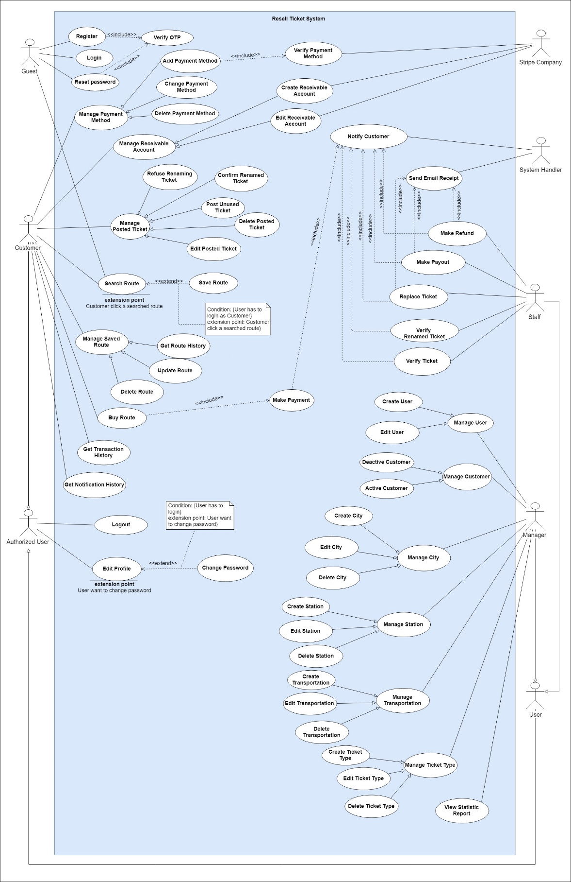

Figure 2 - <Use case> System Overview

### **2.3. List of use case**

#### 2.3.1. <Guest> Overview Use Case

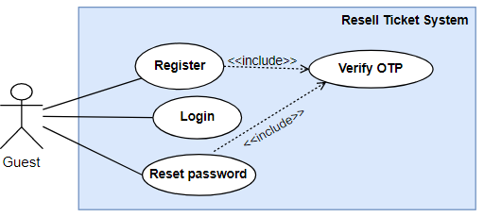

Figure 3 - <Use case> Guest Overview

**Figure: <Guest> Overview use case**

##### 2.3.1.1. <Guest> Login

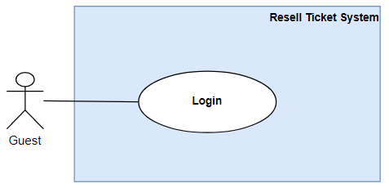

Figure 4 - <Use case> Guest Login

**Figure <Guest> Login**

|  |  |  |  |
| --- | --- | --- | --- |
| **USE CASE – RT_01** | | | |
| **Use Case No.** | **RT_01** | Use Case Version | 2.0 |
| **Use Case Name** | Login | | |
| **Author** | Nguyen Van Thanh | | |
| **Date** | 29/07/2019 | **Priority** | Normal |
| **Actor:**   * Guest   **Summary:**   * This use case allows guest to login to the system.   **Goal:**   * Guest can login to the system   **Trigger:**   * Guest send the login command.   **Precondition:**   * Guest is viewing the login screen   **Post Conditions:**   * Success: Guest login to the system successfully * Fail: Show error messages   **Main Success Scenario:**   |  |  |  | | --- | --- | --- | | Step | Actor Action | System Response | | 1 | Guest go to the login view | The system requires the following input from Guest includes:   * Username: text input, required * Password: text input, required | | 2 | Guest inputs information. |  | | 3 | Guest sends command to login | The system show message that the guest has logged in successfully  [Exception 1] |   **Exception 1:**   |  |  |  | | --- | --- | --- | | **Step** | **Cause** | **System Response** | | 1 | No internet connection | System shows message the "Please check your connection" when the internet is lost. |   **Relationship:** N/A.  **Business rule:**   * User password character is secured and hidden with special character * The system generates an access token * System can use access token to verify identity without reenter username and password again * Access token is signed with RSA256 algorithm * Access token also contain at least following information:   + Username   + User id   + Expire time   + Created time   + Signature for security | | | |

Table 8 - Usecase <Guest> Login

##### 2.3.1.2. <Guest> Register

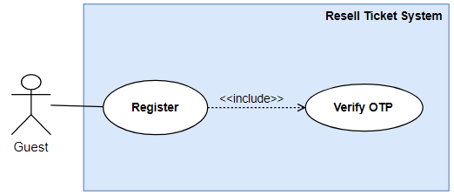

Figure 5 - <Use case> Guest Register

**Use Case Specification**

|  |  |  |  |
| --- | --- | --- | --- |
| **USE CASE - RT_02** | | | |
| **Use Case No.** | RT_02 | **Use Case Version** | 2.0 |
| **Use Case Name** | Register | | |
| **Author** | Nguyen Van Thanh | | |
| **Date** | 29/7/2019 | **Priority** | Normal |
| **Actor**:   * Guest   **Summary**:   * This use case allows guest to register to the system.   **Goal**:   * Guest can register to the system   **Trigger**:   * Guest send the register command.   **Precondition**:   * Guest is viewing the register screen   **Post Conditions:**   * Success: Guest register to the system successfully * Fail: Show error messages   **Main Success Scenario:**   |  |  |  | | --- | --- | --- | | **Step** | **Actor Action** | **System Response** | | 1 | Guest go to the guest view. | The system requires the following input from Guest includes:   * Phone: text input as number, required.   The system will send an OTP number to verify. | | 2 | Guest goes to the next view. | The system requires the following input from Guest includes:   * Username: text input, required. * Password: text input, required. * Confirm password: text input, required. * Name: text input, required. * Email: text input, required. * OTP: text input as number, required. | | 3 | Guest sends the command to register. | The system show message that the guest has registered successfully.  [Exception 1] |   Exception 1:   |  |  |  | | --- | --- | --- | | **Step** | **Cause** | **System Response** | | 1 | No internet connection | System shows message the "Please check your connection" when the internet is lost. |   **Relationship**: N/A.  **Business** **rule**:   * User password must not be saved directly plain text, and must be hashed * User input their phone number, so the system can verify that number is unique. * The system will send the OTP number to user’s phone * The system validates user input with the following constraints:   + - Username: unique.     - Phone number: number format, unique.     - Email: as an email format, unique.     - The confirm password matches the password.     - OTP: The confirm OTP matches The OTP that the system sent to user’s phone. | | | |

Table 9 - Usecase <Guest> Register

##### 2.3.1.3. <Guest> Reset Password

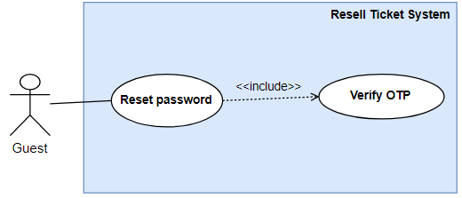

Figure 6 - <Use case> Guest Reset Password

**Figure <Guest> Reset Password**

**Use Case Specification**

|  |  |  |  |
| --- | --- | --- | --- |
| **USE CASE – RT_03** | | | |
| **Use Case No.** | **RT_03** | Use Case Version | 2.0 |
| **Use Case Name** | Reset Password | | |
| **Author** | Nguyen Van Thanh | | |
| **Date** | 29/07/2019 | **Priority** | Normal |
| **Actor:**   * Guest   **Summary:**   * This use case allows guest to reset password to the system.   **Goal:**   * Guest can reset password to the system   **Trigger:**   * Guest sends the reset-password command.   **Precondition:**   * Guest is viewing the reset password screen   **Post Conditions:**   * Success: Guest reset password to the system successfully * Fail: Show error messages   **Main Success Scenario:**   |  |  |  | | --- | --- | --- | | Step | Actor Action | System Response | | 1 | Guest go to the reset password view | The system requires the following input from User includes:   * Phone: text input, required   [Exception 1]  [Exception 2] | | 2 | Guest inputs phone number and sends command to go to next view. | The system sends OTP to inputted phone number. Then navigate to Change password screen that requires the following input from Guest includes:   * New Password: text input, required. * Confirm new password: text input, required. * OTP: text input, required. | | 3 | Guest fills the form then sends command to submit form changing password. | The system show message that the guest’s password has reset then navigate to Login Screen.  [Exception 3] |   **Exception 1:**   |  |  |  | | --- | --- | --- | | **Step** | **Cause** | **System Response** | | 1 | No internet connection | The system shows message the "Please check your connection" when the internet is lost. | | 2 | Wrong phone number | The system shows message the "Please check username or phone" when phone number is wrong. | | 3 | Wrong OTP | The system shows message the "Please check your OTP" when wrong OTP. |   **Relationship:** N/A.  **Business rule:**   * OTP field will be able to type, and the OTP will be sent to guest’s phone number after guest submit successfully phone number. * The system validates guest input with the following constraints:   + Phone number: number format.   + OTP: The confirm OTP matches The OTP that the system sent to user’s phone or email.   + Confirm new password must match New Password. | | | |

Table 10 - Usecase <Guest> Reset Password

##### 2.3.1.4. <Guest> Search Route

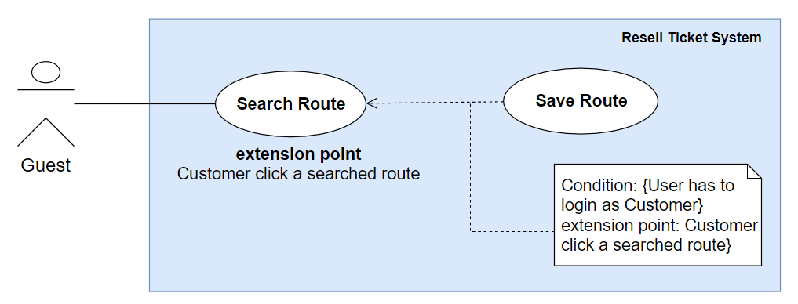

Figure 7 - <Use case> Guest Search Route

**Figure 5: <Guest> Search Route**

**Use Case Specification**

|  |  |  |  |
| --- | --- | --- | --- |
| **USE CASE - RT_04** | | | |
| **Use Case No.** | **RT_04** | **Use Case Version** | 1.1 |
| **Use Case Name** | Search Route | | |
| **Author** | Duong Anh Tuan | | |
| **Date** | 30/07/2019 | **Priority** | High |
| **Actor:**   * Guest   **Summary:**   * This use case allows guest to search the route in the system.   **Goal:**   * Guest can view the list of routes.   **Trigger:**   * Guest inputs text and sends the search command.   **Precondition:**   * Guest is viewing the searching screen.   **Post Conditions:**   * Success: List of routes will be displayed as a list in UI or displayed label “No data”. * Fail: Show error messages.   **Main Success Scenario:**   |  |  |  | | --- | --- | --- | | **Step** | **Actor Action** | **System Response** | | 1 | Guest goes to the search screen. | The system requires text input from User includes:   * Departure City: auto suggest text, required. * Arrival City: auto suggest text, required. * Departure Date: date, required, default value: current date * Arrival Date: date, default value: current date * Max tickets: select box, required, including:   + Only 1 ticket.   + Maximum 2 tickets.   + Maximum 3 tickets. * Max waiting hours between 2 tickets in a route: number, required, default value: 5. * Vehicle: multiple select, required, default value: select all. * Transportation: multiple select, required, default value: select all, * Ticket type: multiple select, required, default value: select all. | | 2 | Guest inputs searching condition. |  | | 3 | Guest sends a command to search. [Alternative 1]  [Alternative 2] | All search results will be displayed with information includes:   * Departure date. * Departure location. * Arrival date. * Arrival location. * Number of tickets in a route. * Total amount of this route. * Route status.   [Exception 1] | | 4 | Guest sends a command to view route detail. | System shows message to notify guest must login to be able to view route detail. |   **Alternative Scenario:**   |  |  |  | | --- | --- | --- | | **No** | **Actor Action** | **System Response** | | 1 | Guest sends command to cancel search route. | System redirects to Home Screen. | | 2 | Guest enters right text and requirements but there is no result. | System shows result screen “There is no result.” |   **Exception:**   |  |  |  | | --- | --- | --- | | **No** | **Cause** | **System Response** | | 1 | No internet connection. | System shows message the "Please check your connection" when the internet is lost. |   **Relationship:** N/A.  **Business rule:**   * The system will find combination-ticket that match conditions above. * A route detail contains:   + Departure date.   + Departure location.   + Arrival date.   + Arrival location.   + Number of tickets in a route.   + Total amount of this route.   + Route Status. * List routes after searched is ordered by price ascending. | | | |

Table 11 - Usecase <Guest> Search Route

#### 2.3.2. <Customer> Overview Use Case

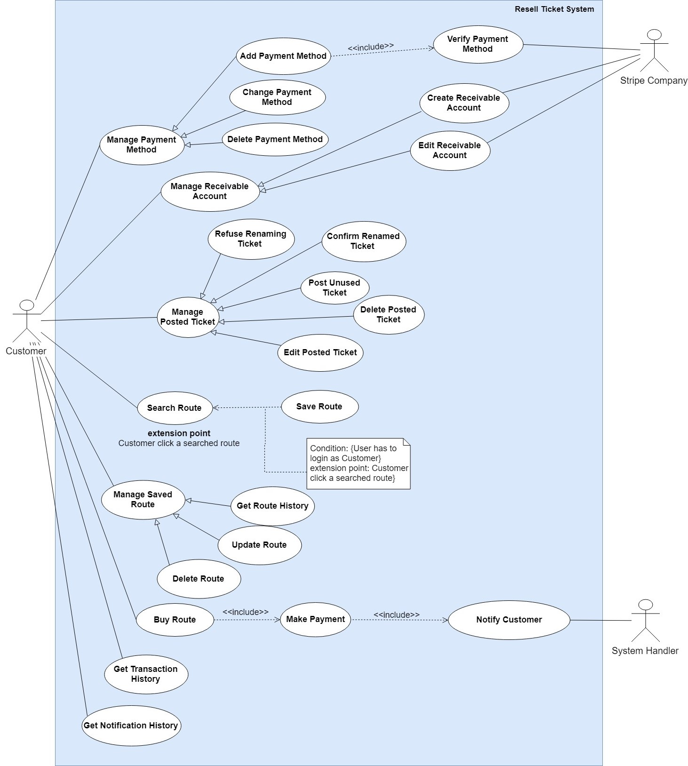

Figure 8 - <Use case> Customer Overview

##### 2.3.2.1. <Customer> Add Payment Method

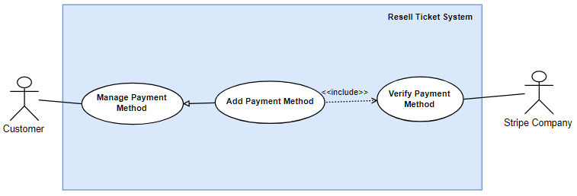

Figure 9 - <Use case> Customer Add Payment Method

|  |  |  |  |
| --- | --- | --- | --- |
| **USE CASE – RT_05** | | | |
| **Use Case No.** | **RT_05** | **Use Case Version** | 2.0 |
| **Use Case Name** | Add Customer Payment Method | | |
| **Author** | Nguyen Van Thanh | | |
| **Date** | 29/07/2019 | **Priority** | Normal |
| **Actor:**   * Customer, Stripe Company   **Summary:**   * This use case allow customer to add Customer’s credit card into system.   **Goal:**   * Customer can add a valid credit card.   **Triggers:**   * Customer sends command to add a credit card.   **Preconditions:**   * Guest must login into the system as a customer.   **Post conditions:**   * Success: Customer add a credit card successfully. * Fail: System shows error messages.   **Main Success Scenario:**   |  |  |  | | --- | --- | --- | | **Step** | **Actor Action** | **System Response** | | 1 | Customer goes to Customer Card Management Screen. | System shows list credit cards of this customer, and “Add Payment Method” Button. | | 2 | Customer clicks on “Add Customer Card” Button. | System navigate to Add Customer Card Screen which includes:   * Credit Card Number: textbox. * Expiry: textbox. * Name: textbox. * CVV/CVC: textbox. * Add Payment Method: Button. * Back: Button. | | 3 | Customer inputs information. |  | | 4 | Customer sends command to add Customer Card. [Alternative 1] | System call API of a trusted third-party system to create account, then navigates to Customer Card Management Screen. [Exception 1] |   **Alternative Scenario:**   |  |  |  | | --- | --- | --- | | **No** | **Actor Action** | **System Response** | | 1 | Customer sends command to cancel adding credit card. | System navigates to Customer Card Management Screen. |   **Exceptions:**   |  |  |  | | --- | --- | --- | | **No** | **Actor Action** | **System Response** | | 1 | Customer credit card is invalid. | System shows error messages to notify customer the fail reason of trusted third-party system. |   **Relationships:** N/A  **Business Rules:**   * Customer credit card information is stored and verified in trusted third-party system with inputted information. * Resell Ticket System only store some encrypted customer credit card information for displaying purpose. This customer credit card information includes:   + Card brand Can be “American Express”, “Diners Club”, “Discover”, “JCB”, “MasterCard”, “UnionPay”, “Visa”, or “Unknown”.   + Last four digits of the card.   + Two-digit number representing the card’s expiration month.   + Four-digit number representing the card’s expiration year. * Credit Card information is encrypted before sending to server. * Credit Card information is encrypted before sending to trusted third-party system. * Created customer card is set as Default payment method of this customer. | | | |

Table 12 - Usecase <Customer> Add Customer Payment Method

##### 2.3.2.2. <Customer> Change default Payment Method

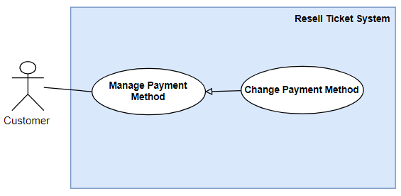

Figure 10 - <Use case> Customer Change Default Payment Method

|  |  |  |  |
| --- | --- | --- | --- |
| **USE CASE – RT_06** | | | |
| **Use Case No.** | RT_06 | **Use Case Version** | 2.0 |
| **Use Case Name** | Change Default Payment Method | | |
| **Author** | Nguyen Van Thanh | | |
| **Date** | 29/07/2019 | **Priority** | Normal |
| **Actor:**   * Customer   **Summary:**   * This use case allow customer to change Customer default payment method in Resell Ticket System.   **Goal:**   * Customer can change default payment method.   **Triggers:**   * Customer sends command to change default payment method.   **Preconditions:**   * Guest must login into the system as a customer.   **Post conditions:**   * Success: Customer edit payment method successfully. * Fail: System shows error messages.   **Main Success Scenario:**   |  |  |  | | --- | --- | --- | | **Step** | **Actor Action** | **System Response** | | 1 | Customer goes to Customer Card Management Screen. | System shows list credit cards of this customer. Each of listed credit card include “Edit” Button. | | 2 | Customer clicks on “Edit” Button. | System navigate to Edit Customer Card Screen which includes some non-editable customer credit card information and “Is default payment method” check box. | | 3 | Customer chooses whether this card is default payment method or not. |  | | 4 | Customer sends command to edit Customer Card | System navigates to Customer Card Management Screen. |   **Alternative Scenario: N/A**  **Exceptions:** N/A  **Relationships:** N/A  **Business Rules:**   * Customer might have many credit cards. But only one credit card can be default payment method. If customer set a credit card as default payment method, the system will also update the previous default payment method into non default payment method. | | | |

Table 13 - Usecase <Customer> Change Payment Method

##### 2.3.2.3. <Customer> Delete Payment Method

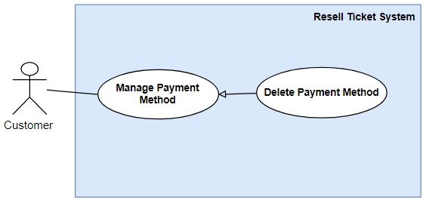

Figure 11 - <Use case> Customer Delete Payment Method

Figure 4<Customer> Delete Customer Card

|  |  |  |  |
| --- | --- | --- | --- |
| **USE CASE – RT_07** | | | |
| **Use Case No.** | RT_07 | **Use Case Version** | 2.0 |
| **Use Case Name** | Delete Payment Method | | |
| **Author** | Dương Anh Tuấn | | |
| **Date** | 29/07/2019 | **Priority** | Normal |
| **Actor:**   * Customer   **Summary:**   * This use case allow customer to Delete Customer credit card from Resell Ticket System.   **Goal:**   * Customer can delete existed card.   **Triggers:**   * Customer sends command to delete a credit card.   **Preconditions:**   * Guest must login into the system as a customer.   **Post conditions:**   * Success: Customer delete credit card successfully. * Fail: System shows error messages.   **Main Success Scenario:**   |  |  |  | | --- | --- | --- | | **Step** | **Actor Action** | **System Response** | | 1 | Customer goes to Customer Card Management Screen. | System shows list credit cards of this customer. Each of listed credit card include “Delete” Button. | | 2 | Customer clicks on “Delete” Button. | System shows pop up for customer confirm before delete card. | | 3 | Customer sends command to delete customer card. [Alternative 1] | System closes pop up confirm before delete card. |   **Alternative Scenario:**   |  |  |  | | --- | --- | --- | | **No** | **Actor Action** | **System Response** | | 1 | Customer sends command to cancel deleting credit card. | System closes pop up confirm before delete card. |   **Exceptions:** N/A  **Relationships:** N/A  **Business Rules:**   * If customer delete default payment method credit card, the system will set latest inserted credit card as default payment method. | | | |

Table 14 - Usecase <Customer> Delete Customer Card

##### 2.3.2.4. <Customer> Create Receivable Account

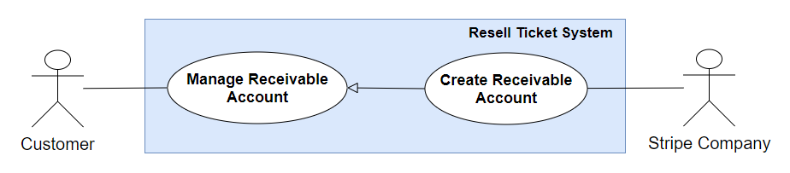

Figure 12 - <Use case> Customer Create Receivable Account

|  |  |  |  |
| --- | --- | --- | --- |
| **USE CASE – RT_08** | | | |
| **Use Case No.** | RT_08 | **Use Case Version** | 2.0 |
| **Use Case Name** | Create Receivable Account | | |
| **Author** | Dương Anh Tuấn | | |
| **Date** | 01/06/2019 | **Priority** | Normal |
| **Actor:**   * Customer, Stripe Company   **Summary:**   * This use case allows a customer to create a receivable account for receiving the payout after sold ticket successfully.   **Goal:**   * Customer can create a receivable account in Stripe that links to Resell Ticket System.   **Triggers:**   * Customer sends command to create a receivable account.   **Preconditions:**   * Guest must login into the system as a customer.   **Post conditions:**   * Success: Customer create a receivable successfully. * Fail: System shows error messages.   **Main Success Scenario:**   |  |  |  | | --- | --- | --- | | **Step** | **Actor Action** | **System Response** | | 1 | Customer goes to Home Screen. | System shows a button “Stripe Account” in navigation area. | | 2 | Customer clicks “Stripe Account” Button | System redirects to Create Customer account Screen of Stripe Company. This screen shows a form for filling his information. [Exception 1] | | 3 | Customer fills his information following instruction of Stripe, then clicks “Save” button. [Alternative 1] | Stripe Company redirects to Resell Ticket System with a one-time token.  Resell Ticket System calls Stripe API with this one-time token to verify creating Stripe customer process then navigates to Home screen. [Exception 2] |   **Alternative Scenario:**   |  |  |  | | --- | --- | --- | | **No** | **Actor Action** | **System Response** | | 1 | Customer sends command to cancel creating Receivable account. | System navigates to Home Screen. |   **Exceptions:**   |  |  |  | | --- | --- | --- | | **No** | **Actor Action** | **System Response** | | 1 | If Stripe website is maintaining. | System redirect to 404 page. | | 2 | If Stripe does not accept this one-time token. | Show message to notify customer that cannot create Customer Stripe Account. |   **Relationships:** N/A  **Business Rules:**   * Customer only can create one receivable account. * The process of create customer receivable account is followed by The Payment Card Industry Data Security Standard (PCI DSS). * Customer information including credit card number, bank account number is stored and verified by Stripe. * After creating Stripe account, Resell Ticket System only stores Stripe Customer Identity, and uses this identity to make payout for this customer. | | | |

Table 15 - Usecase <Customer> Create Receivable Account

##### 2.3.2.5. <Customer> Edit Receivable Account

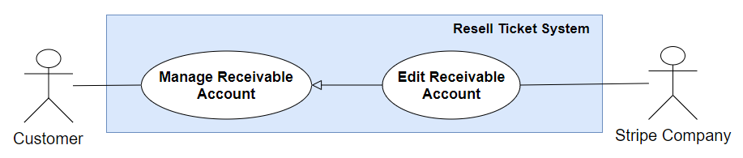

Figure 13 - <Use case> Customer Edit Receivable Account

|  |  |  |  |
| --- | --- | --- | --- |
| **USE CASE – RT_09** | | | |
| **Use Case No.** | RT_09 | **Use Case Version** | 2.0 |
| **Use Case Name** | Edit Receivable Account | | |
| **Author** | Dương Anh Tuấn | | |
| **Date** | 01/06/2019 | **Priority** | Normal |
| **Actor:**   * Customer, Stripe Company   **Summary:**   * This use case allows a customer to edit a receivable account information including bank number or debit card for receiving the payout after sold ticket successfully.   **Goal:**   * Customer can edit a receivable account in Stripe that links to Resell Ticket System.   **Triggers:**   * Customer sends command to edit a receivable account.   **Preconditions:**   * Guest must login into the system as a customer.   **Post conditions:**   * Success: Customer edit a receivable successfully. * Fail: System shows error messages.   **Main Success Scenario:**   |  |  |  | | --- | --- | --- | | **Step** | **Actor Action** | **System Response** | | 1 | Customer goes to Home Screen. | System shows a button “Stripe Account” in navigation area. | | 2 | Customer clicks “Stripe Account” Button | System call Stripe API to get a single-use login link to Stripe Customer Account Screen. [Exception 1]  System redirects to login link. This screen shows Stripe Customer Account information including receivable amount, edit receivable account form. | | 3 | Customer fills his new information following instruction of Stripe, then clicks “Save” button. [Alternative 1] | Stripe verify and save new receivable account information.  Stripe show message to notify saving successfully. [Exception 2] |   **Alternative Scenario:**   |  |  |  | | --- | --- | --- | | **No** | **Actor Action** | **System Response** | | 1 | Customer sends command to cancel editing Receivable account. | System navigates to Home Screen. |   **Exceptions:**   |  |  |  | | --- | --- | --- | | **No** | **Actor Action** | **System Response** | | 1 | If this customer has not created a Stripe Account. | System redirects to Create Stripe Customer Account Screen. | | 2 | If Stripe cannot verify new receivable account information. | Show message to notify customer that new information is invalid. |   **Relationships:** N/A  **Business Rules:**   * Customer can only edit Receivable account after he created one. * Resell Ticket System calls Stripe API with Stripe Customer Identity to get login link for customers. Therefore, customers do not need to remember username or password of Stripe Account. * The process of editing customer receivable account is followed by The Payment Card Industry Data Security Standard (PCI DSS). * Customer information including credit card number, bank account number is stored and verified by Stripe. | | | |

Table 16 - Usecase <Customer> Create Receivable Account

##### 2.3.2.6. <Customer> Post Ticket

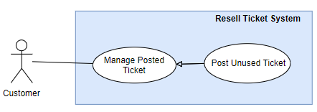

Figure 14 - <Use case> Customer Post Ticket

|  |  |  |  |
| --- | --- | --- | --- |
| **USE CASE – RT_10** | | | |
| **Use Case No.** | RT_10 | **Use Case Version** | 2.0 |
| **Use Case Name** | Post Unused Ticket | | |
| **Author** | Le Xuan Huy | | |
| **Date** | 27/7/2019 | **Priority** | High |
| **Actor:**   * Customer   **Summary:**   * This use case allows customer to post their unused tickets.   **Goal:**   * Customer will see their tickets display on screen with “Pending” status.   **Triggers:**   * Customer send post unused ticket command.   **Preconditions:**   * Guest must login into the system with role Customer. * Customer must input all required ticket’s information.   **Post conditions:**   * Success: The ticket will be saved and displayed on the screen. * Fail: Display error messages.   **Main Success Scenario:**   |  |  |  | | --- | --- | --- | | **Step** | **Actor Action** | **System Response** | | 1 | Customer go to new posted ticket screen. | System requires ticket’s information from customer:  - *Ticket code: text input*  *- Full name: text input*  *-  Vehicle: combobox*  *- Ticket type: text input*  *- Transportation: text input*  *- Departure city: text input*  *- Departure station : text input*  *- Departure date: datetime picker*  *- Arrival city:  text input*  *- Arrival station:  text input*  *- Arrival date: datetime picker*  *- Selling price: number input*  *- Passenger name:  text input*  *- Email Booking: text input* | | 2 | Customer inputs their ticket’s information |  | | 3 | Customer send command to post their ticket | System validate information and display the ticket that includes all ticket’s information  [Exception 1] |   **Alternative Scenario:**  **Exceptions:**   |  |  |  | | --- | --- | --- | | **No** | **Actor Action** | **System Response** | | 1 | Customer send command to post their ticket | System show error to ask user input missing required fields. | |  |  |  |   **Relationships:**  **Business Rules:**   * Authorized user must log in to the system with role Customer. * Customer must connect with Stripe account to receive money before post new ticket. * The posted ticket will be saved in the system with inputted information with “Pending” status. * Ticket’s code can be duplicated. * Staff will see the new posted ticket on the screen, they will verify the ticket’s information and set the ticket’s status is “valid” or “invalid”. * Customer will receive a notification or email after staff verify their ticket. | | | |

Table 17 - Usecase <Customer> Post Unused Ticket

##### 2.3.2.7. <Customer> Edit Posted Ticket

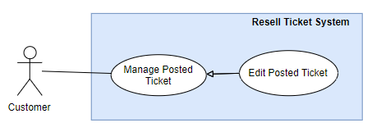

Figure 15 - <Use case> Customer Edit Posted Ticket

|  |  |  |  |
| --- | --- | --- | --- |
| **USE CASE – RT_11** | | | |
| **Use Case No.** | RT_11 | **Use Case Version** | 2.0 |
| **Use Case Name** | Edit Posted Ticket | | |
| **Author** | Le Xuan Huy | | |
| **Date** | 28/7/2019 | **Priority** | High |
| **Actor:**   * Customer   **Summary:**   * This use case allows customer to edit their posted tickets.   **Goal:**   * Customer will see their ticket’s information has been updated on the screen            with “Pending” status.  **Triggers:**   * Customer send edit posted ticket command.   **Preconditions:**   * Guest must login into the system with role Customer. * Customer must post at least 1 ticket and ticket’s status still be “Pending”.   **Post conditions:**   * Success: Ticket’s information will be updated and display on the screen. * Fail: Display error messages.   **Main Success Scenario:**   |  |  |  | | --- | --- | --- | | **Step** | **Actor Action** | **System Response** | | 1 | Customer go to edit posted ticket screen. | System display ticket’s information that has been saved.  - *Ticket code: text input*  *- Full name: text input*  *-  Vehicle: combo box*  *- Ticket type: text input*  *- Transportation: text input*  *- Departure city: text input*  *- Departure station: text input*  *- Departure date: datetime picker*  *- Arrival city:  text input*  *- Arrival station:  text input*  *- Arrival date: datetime picker*  *- Selling price: number input*  *- Passenger name:  text input*  *- Email Booking: text input* | | 2 | Customer edit their ticket’s information |  | | 3 | Customer send command to edit their ticket | System validate information and display the ticket that ticket’s information has been updated.  [Exception 1, 2] |   **Alternative Scenario:**  **Exceptions:**   |  |  |  | | --- | --- | --- | | **No** | **Actor Action** | **System Response** | | 1 | Customer send command to edit their ticket | System show error to ask user input missing required fields. | | 2 | Customer send command to edit their ticket | Show the message “Check Internet Connection” |   **Relationships:** WCS_UC_1, WCS_UC_4, WCS_UC_22, WCS_UC_23, WCS_UC_28.  **Business Rules:**   * Authorized user must log in to the system with role Customer. * Customer can only edit the tickets that their status still be “Pending” * The ticket’s information will be updated in the system with “Pending” status. * Staff will see the new posted ticket on the screen, they will verify the ticket’s information and set the ticket’s status is “valid” or “invalid”. * Customer will receive a notification or email after staff verify their ticket. | | | |
|  | | | |

Table 18 - Usecase <Customer> Edit Posted Ticket

##### 2.3.2.8. <Customer> Delete Posted Ticket

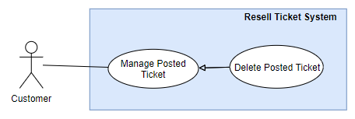

Figure 16 - <Use case> Customer Delete Posted Ticket

|  |  |  |  |
| --- | --- | --- | --- |
| **USE CASE – RT_12** | | | |
| **Use Case No.** | RT_12 | **Use Case Version** | 2.0 |
| **Use Case Name** | Delete Posted Ticket | | |
| **Author** | Le Xuan Huy | | |
| **Date** | 28/7/2019 | **Priority** | High |
| **Actor:**   * Customer   **Summary:**   * This use case allows customer to delete their posted tickets.   **Goal:**   * Customer won’t see their posted ticket that is deleted on the screen.   **Triggers:**   * Customer send delete posted ticket command.   **Preconditions:**   * Guest must login into the system with role Customer. * Customer must post at least 1 ticket.   **Post conditions:**   * Success: The ticket still be saved in the system with “Deleted” status and don’t display on the screen. * Fail: System shows error message.   **Main Success Scenario:**   |  |  |  | | --- | --- | --- | | **Step** | **Actor Action** | **System Response** | | 1 | Customer go to manage posted ticket screen. | System render the manage posted ticket screen and posted ticket list. | | 2 | Customer send command to delete their ticket | System show dialog box to make sure customer want to delete the ticket | | 3 | Customer send command to confirm delete their ticket | System message deleted successful.  [Exception 1] |   **Alternative Scenario:**  **Exceptions:**   |  |  |  | | --- | --- | --- | | **No** | **Actor Action** | **System Response** | | 1 | Customer send command to confirm delete their ticket | Show the message “Check Internet Connection” |   **Relationships:** WCS_UC_1, WCS_UC_4, WCS_UC_22, WCS_UC_23, WCS_UC_28.  **Business Rules:**   * Authorized user must log in to the system with role Customer. * Customer can delete the posted tickets that have status Pending, Invalid, and Completed. * After sending delete command, the ticket won’t display on the screen and will be saved in the system with “Deleted” status. | | | |
|  | | | |

Table 19 - Usecase <Customer> Delete Posted Ticket

##### 2.3.2.9. <Customer> Search Route

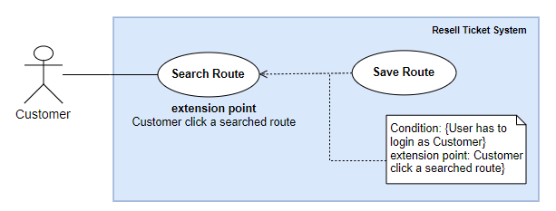

Figure 17 - <Use case> Customer Search Route

|  |  |  |  |
| --- | --- | --- | --- |
| **USE CASE - RT_13** | | | |
| **Use Case No.** | **RT_13** | **Use Case Version** | 1.1 |
| **Use Case Name** | Search Route | | |
| **Author** | Duong Anh Tuan | | |
| **Date** | 31/05/2019 | **Priority** | High |
| **Actor:**   * Customer   **Summary:**   * This use case allows customer to search the route in the system.   **Goal:**   * Customer can view the list of routes.   **Trigger:**   * Customer inputs text and send the search command.   **Precondition:**   * Customer is viewing the searching screen.   **Post Conditions:**   * Success: List of routes will be displayed as a list in UI or displayed label “No data”. * Fail: Show error messages.   **Main Success Scenario:**   |  |  |  | | --- | --- | --- | | **Step** | **Actor Action** | **System Response** | | 1 | Customer goes to the search screen | The system requires text input from User includes:   * Departure City: auto suggest text, required. * Arrival City: auto suggest text, required. * Departure Date: date, required, default value: current date * Arrival Date: date, default value: current date * Max tickets: select box, required, including:   + Only 1 ticket.   + Maximum 2 tickets.   + Maximum 3 tickets. * Max waiting hours between 2 tickets in a route: number, required, default value: 5. * Vehicle: multiple select, required, default value: select all. * Transportation: multiple select, required, default value: select all, * Ticket type: multiple select, required, default value: select all. | | 2 | Customer inputs searching condition. |  | | 3 | Customer sends a command to search [Alternative 1] | All search results will be displayed with information includes:   * Departure date. * Departure location. * Arrival date. * Arrival location. * Number of tickets in a route. * Total amount of this route. * Route status.   [Exception 1] | | 4 | Customer sends a command to view route detail. | The system will redirect to Route detail screen that contain ticket’s information of this route and save this route in history for this customer. |   **Alternative Scenario:**   |  |  |  | | --- | --- | --- | | **No** | **Actor Action** | **System Response** | | 1 | Guest sends command to cancel search route | System redirects to Home Screen. |   **Exception:**   |  |  |  | | --- | --- | --- | | **No** | **Cause** | **System Response** | | 1 | No internet connection | System shows message the "Please check your connection" when the internet is lost. |   **Relationship:** N/A.  **Business rule:**   * Customer will get the search results list. * Customer can get an equipment detail which contains:   + Departure date.   + Departure location.   + Arrival date.   + Arrival location.   + Number of tickets in a route.   + Total amount of this route.   + Route Status. * List routes after searched is ordered by price. * When customer view a route detail, Resell Ticket System also saves this route into Customer Route History. | | | |

Table 20 - Usecase <Customer> Delete Posted Ticket

##### 2.3.2.10. <Customer> Get Route History

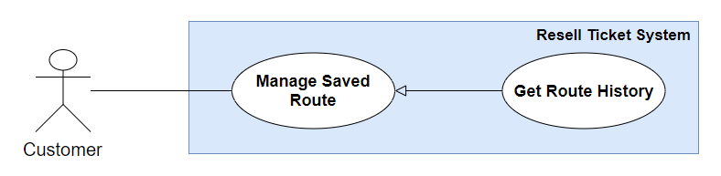

Figure 18 - <Use case> Customer Get Route History

|  |  |  |  |
| --- | --- | --- | --- |
| **USE CASE – RT_14** | | | |
| **Use Case No.** | RT_14 | **Use Case Version** | 2.0 |
| **Use Case Name** | Get Route History | | |
| **Author** | Dương Anh Tuấn | | |
| **Date** | 02/06/2019 | **Priority** | Normal |
| **Actor:**   * Customer.   **Summary:**   * This use case allow customer to get route history.   **Goal:**   * Customer can get route history.   **Triggers:**   * Customer sends command to get route history.   **Preconditions:**   * Guest must login into the system as a customer.   **Post conditions:**   * Success: Customer get route history. * Fail: System shows error messages.   **Main Success Scenario:**   |  |  |  | | --- | --- | --- | | **Step** | **Actor Action** | **System Response** | | 1 | Customer sends command to get route history. | System navigates to Route Management Screen which includes Route list and filters.  Each item in list includes a status to indicate which Route is Available or Not Available. [Exception 1] | | 2 | Customer adjusts Route list filters | System search route and display result for customer. [Exception 1] |   **Alternative Scenario:** N/A  **Exceptions:**   |  |  |  | | --- | --- | --- | | **No** | **Cause** | **System Response** | | 1 | No internet connection | System shows message the "Please check your connection" when the internet is lost. |   **Relationships:** N/A  **Business Rules:**   * A Route in system has 3 status: “New”, “Bought” and “Completed”. * Filters in Route Management Screen includes:   + History. It indicates routes viewed by this customer but have not bought yet.   + Processing. It indicates bought routes did not finish changed tickets information yet.   + Completed. It indicates bought routes finish changed tickets information. | | | |

Table 21 - Usecase <Customer> Get Route History

##### 2.3.2.11. <Customer> Edit Route

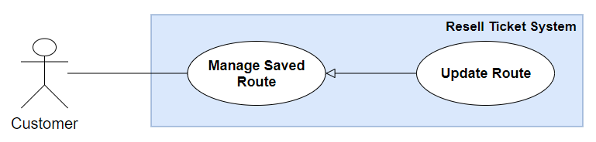

Figure 19 - <Use case> Customer Edit Route

|  |  |  |  |
| --- | --- | --- | --- |
| **USE CASE – RT_15** | | | |
| **Use Case No.** | RT_15 | **Use Case Version** | 2.0 |
| **Use Case Name** | Edit Route | | |
| **Author** | Dương Anh Tuấn | | |
| **Date** | 02/06/2019 | **Priority** | Normal |
| **Actor:**   * Customer.   **Summary:**   * This use case allow customer to edit route.   **Goal:**   * Customer can edit route by choosing ticket himself.   **Triggers:**   * Customer sends command to edit Route.   **Preconditions:**   * Guest must login into the system as a customer.   **Post conditions:**   * Success: Customer edit route successfully. * Fail: System shows error messages.   **Main Success Scenario:**   |  |  |  | | --- | --- | --- | | **Step** | **Actor Action** | **System Response** | | 1 | Customer goes to Route Detail screen. | System navigates to Route Detail Screen which includes:   * Route Code. * List of tickets in this route. | | 2 | Customer clicks a ticket listed in screen. [Alternative 1] | System navigates to Update Route Ticket Detail screen which includes:   * Departure City: text input. * Departure Station: text input. * Arrival City: text input. * Arrival Station: text input. * Departure date: text input. * List of tickets that match above filters. * Save: button. * Back: button. | | 3 | Customer clicks on a ticket in ticket list then clicks “Save” button. [Alternative 2] | System navigates to Route Detail screen and display pop up with message “Save Route successfully”. [Exception 1] |   **Alternative Scenario:**   |  |  |  | | --- | --- | --- | | **No** | **Actor Action** | **System Response** | | 1 | Customer sends command to cancel updating Route Detail. | System navigate to Route Management Screen. | | 2 | Customer clicks on Back button. | System navigates to Tour Detail screen. |   **Exceptions:**   |  |  |  | | --- | --- | --- | | **No** | **Actor Action** | **System Response** | | 1 | Customer clicks “Back” button. | System navigates to Route Detail Screen. |   **Relationships:** N/A  **Business Rules:**   * When customer clicks “Save” button in Update Route Ticket screen, Resell Ticket system save ticket for that route. | | | |

Table 22 - Usecase <Customer> Edit Route

##### 2.3.2.12. <Customer> Delete Route

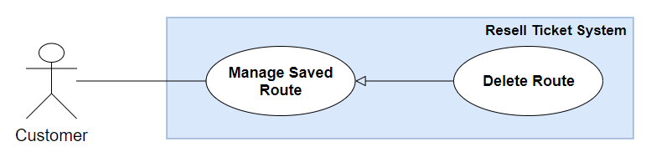

Figure 20 - <Use case> Customer Delete Route

|  |  |  |  |
| --- | --- | --- | --- |
| **USE CASE – RT_16** | | | |
| **Use Case No.** | RT_16 | **Use Case Version** | 2.0 |
| **Use Case Name** | Delete Route | | |
| **Author** | Dương Anh Tuấn | | |
| **Date** | 02/06/2019 | **Priority** | Normal |
| **Actor:**   * Customer.   **Summary:**   * This use case allow customer to delete route.   **Goal:**   * Customer can delete route.   **Triggers:**   * Customer sends command to delete route.   **Preconditions:**   * Guest must login into the system as a customer.   **Post conditions:**   * Success: Customer delete tour successfully. * Fail: System shows error messages.   **Main Success Scenario:**   |  |  |  | | --- | --- | --- | | **Step** | **Actor Action** | **System Response** | | 1 | Customer goes to Route Detail screen. | System navigates to Route Detail Screen which includes:   * Route Code. * List of tickets in this route. | | 2 | Customer sends command to delete a route. | System show pop up to confirm before delete route which has “Yes” button and “No” button. | | 3 | Customer clicks “Yes”. [Alternative 1] | System delete route and close pop up. |   **Alternative Scenario:**   |  |  |  | | --- | --- | --- | | **No** | **Actor Action** | **System Response** | | 1 | Customer sends command to cancel deleting route. | System closes pop up confirm delete route. |   **Exceptions:** N/A  **Relationships:** N/A  **Business Rules:**   * Only display “Delete” button in Route Detail Screen when route’s status is “New”. * When customer confirm to delete Route, system delete Route in database. | | | |

Table 23 - Usecase <Customer> Delete Route

##### 2.3.2.13. <Customer> Buy Route

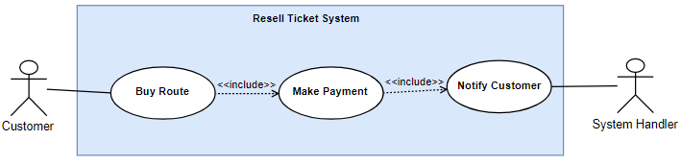

Figure 21 - <Use case> Customer Buy Route

|  |  |  |  |
| --- | --- | --- | --- |
| **USE CASE – RT_17** | | | |
| **Use Case No.** | **RT_17** | **Use Case Version** | 2.0 |
| **Use Case Name** | Buy Route | | |
| **Author** | Pham Phu Tien, Nguyen Van Thanh | | |
| **Date** | 29/07/2019 | **Priority** | High |
| **Actor:**   * Customer   **Summary:**   * This use case allows Customer to buy route.   **Goal:**   * Customer successfully buy the route.   **Triggers:**   * Customer send buy route command to the system.   **Preconditions:**   * User must login to the system with role Customer.   **Post conditions:**   * Success: A list of routes successfully send to customer. * Fail: List of routes cannot be display.   **Main Success Scenario:**   |  |  |  | | --- | --- | --- | | **Step** | **Actor Action** | **System Response** | | 1 | Customer goes to history route screen. | Display a table show list of routes.  [Alternative 1] | | 2 | Customer select a specific route in route list | Display route detail | | 3 | Customer send buy route command | [Alternative 2]  Display form customer detail to require customer input fields:   * *New Passenger Name: text, required* * *New Passenger Email: text, required* * *New Passenger Phone: text, required* * *New Passenger Identify: text, required* | | 4 | Customer inputted form and select confirm | Confirm box display with a text and 2 options:   * Confirm * Cancel | | 5 | Customer finished buy route command | System display buy route successfully and redirect to main page.  Then, system will send notification to sellers who posted tickets of the route. |   **Alternative Scenario 1:**   |  |  |  | | --- | --- | --- | | **No** | **Cause** | **System Response** | | 1 | Customer goes to history route screen. | Route list is displayed as empty list. |   **Alternative Scenario 2:**   |  |  |  | | --- | --- | --- | | **No** | **Cause** | **System Response** | | 1 | Customer hasn’t added credit card yet | Redirect to Create credit card page |   **Exceptions:**   |  |  |  | | --- | --- | --- | | **No** | **Cause** | **System Response** | | 1 | When the connection to the server is lost | System shows message "Please check your connection" when the internet is lost. |   **Relationships:** N/A  **Business Rules:**   * The amount captured from user is transferred to Resell Ticket trusted third-party account. * Sold tickets change status from “Valid” to “Bought”. * All the response of transaction from trusted third-party is stored in database. * Only make payment when all selected tickets’ status is “Valid”. * Resell Ticket system does not send any information of customer credit card to make payment except customer credit card Id which is stored when customer added a credit card. | | | |

Table 24 - Usecase <Customer> Buy Ticket

##### 2.3.2.14. <Customer> Get notification history

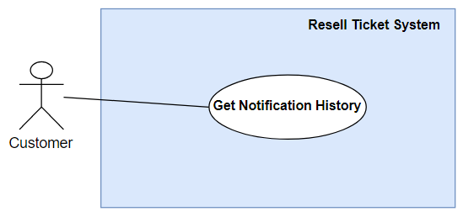

Figure 22 - <Use case> Customer Get Notification History

**Use Case Specification**

|  |  |  |  |
| --- | --- | --- | --- |
| **USE CASE – RT_18** | | | |
| **Use Case No.** | **RT_18** | **Use Case Version** | 2.0 |
| **Use Case Name** | Get notification history | | |
| **Author** | Duong Anh Tuan | | |
| **Date** | 30/07/2019 | **Priority** | Normal |
| **Actor:**   * Customer   **Summary:**   * This use case allows Customer to get notification history.   **Goal:**   * Customer successfully get notification history.   **Triggers:**   * Customer send get notification history command to the system.   **Preconditions:**   * User must login to the system with role Customer.   **Post conditions:**   * Success: A list of notification successfully display to customer. * Fail: list of notification history cannot be display.   **Main Success Scenario:**   |  |  |  | | --- | --- | --- | | **Step** | **Actor Action** | **System Response** | | 1 | Customer sends get notification history command. | System render a box show list of customer’s notification history.  [Alternative 1]  [Exception 1] |   **Alternative Scenario 1:**   |  |  |  | | --- | --- | --- | | **No** | **Cause** | **System Response** | | 1 | Customer sends get notification history command. | Notification history is displayed as “Empty box”. |   **Exceptions:**   |  |  |  | | --- | --- | --- | | **No** | **Cause** | **System Response** | | 1 | When the connection to the server is lost. | System shows an empty box when the internet is lost. |   **Relationships:** N/A  **Business Rules:**   * In case of success scenarios, user will get notification history list. | | | |

Table 25 - Usecase <Customer> Get Notification History

##### 2.3.2.15. <Customer> Get Transaction History

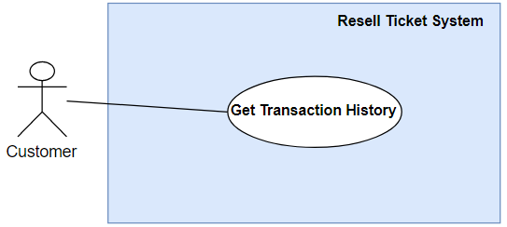

Figure 23 - <Use case> Customer Get Transaction History

**Use Case Specification**

|  |  |  |  |
| --- | --- | --- | --- |
| **USE CASE – RT_19** | | | |
| **Use Case No.** | **RT_19** | **Use Case Version** | 2.0 |
| **Use Case Name** | Get transaction history | | |
| **Author** | Pham Phu Tien | | |
| **Date** | 30/07/2019 | **Priority** | Normal |
| **Actor:**   * Customer   **Summary:**   * This use case allows Customer to get transaction history.   **Goal:**   * Customer successfully get transaction history.   **Triggers:**   * Customer send get transaction history command to the system.   **Preconditions:**   * User must login to the system with role Customer.   **Post conditions:**   * Success: A list of transaction successfully send to customer. * Fail: List of transaction history cannot be display.   **Main Success Scenario:**   |  |  |  | | --- | --- | --- | | **Step** | **Actor Action** | **System Response** | | 1 | Customer goes to transaction history screen. | Display a table show list of customer’s transaction history.  [Alternative 1]  [Exception 1] |   **Alternative Scenario 1:**   |  |  |  | | --- | --- | --- | | **No** | **Cause** | **System Response** | | 1 | Customer sends get transaction history command | Transaction history list is displayed empty |   **Exceptions:**   |  |  |  | | --- | --- | --- | | **No** | **Cause** | **System Response** | | 1 | When the connection to the server is lost | System shows message "Please check your connection" when the internet is lost. |   **Relationships:** N/A  **Business Rules:**   * User will get customer transaction history list. * Transaction history list can be sorted by date. | | | |

Table 26 - Usecase <Customer> Get Transaction History

#### 2.3.3. <Manager> Overview Use Case

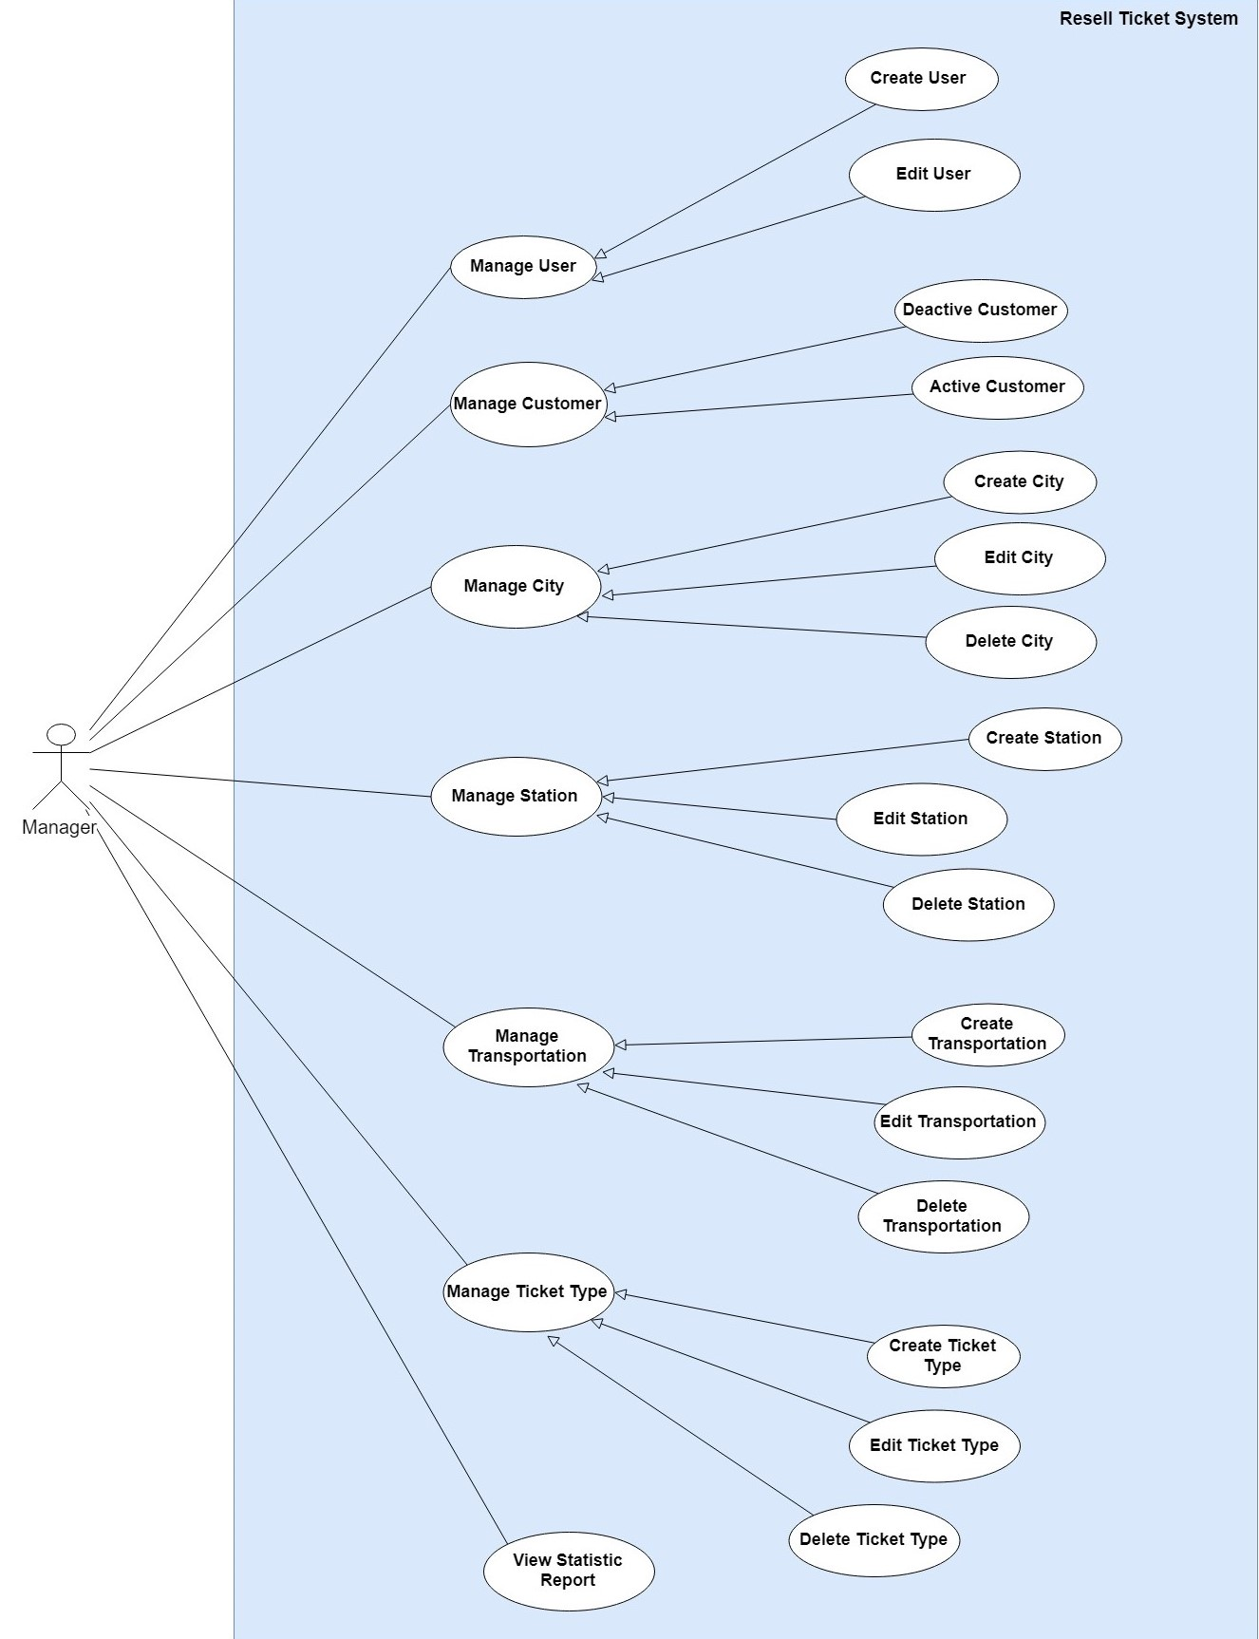

Figure 24 - <Use case> Manager Overview

##### 2.3.3.1. <Manager> Create User

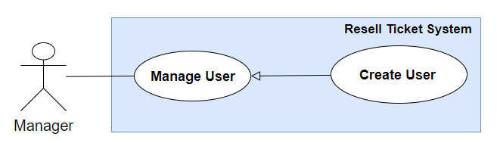

Figure 25 - <Use case> Manager Create User

**Use Case Specification**

|  |  |  |  |
| --- | --- | --- | --- |
| **USE CASE - RT_20** | | | |
| **Use Case No.** | **RT_20** | **Use Case Version** | 1.0 |
| **Use Case Name** | Create user | | |
| **Author** | Dương Anh Tuấn | | |
| **Date** | 01/06/2019 | **Priority** | Normal |
| **Actor:**   * Manager   **Summary:**   * This use case allows manager to create a user.   **Goal:**   * Manager successfully create a user.   **Triggers:**   * Manager send create user command to the system.   **Preconditions:**   * User must login into the system with role Manager.   **Post conditions:**   * Success: New user successful created. * Fail: Show error message   **Main Success Scenario:**   |  |  |  | | --- | --- | --- | | **Step** | **Actor Action** | **System Response** | | 1 | Manager sends command to create new Use. | The system requires input from user includes:   * Username: text input, required. * Full name: text input, required. * Email: text input, required. * Phone number: text input, required. * Status: select box, required. * Role: select box, required. * Save: button. | | 2 | Manager inputs information. |  | | 3 | Manager clicks “Save” button. | Create new user in the system.  System shows message user has been created successfully then redirect to User Management Screen. [Exception 1] [Exception 2] |   **Alternative Scenario: N/A**  **Exception:**   |  |  |  | | --- | --- | --- | | **No** | **Actor Action** | **System Response** | | 1 | Create new fail. (Input contain special characters) | The system shows an error message “Input may not contain special characters”. | | 2 | When the connection to the server is lost | System shows message the "Please check your connection" when the internet is lost. |   **Relationships:** N/A.  **Business Rules:**   * User is required for Username, full name, email, phone number, status, Role. * Status options include:   + Active.   + Inactive. * Role options include:   + Manager.   + Staff. | | | |

Table 27 - Usecase <Manager> Create User

##### 2.3.3.2. <Manager> Edit user

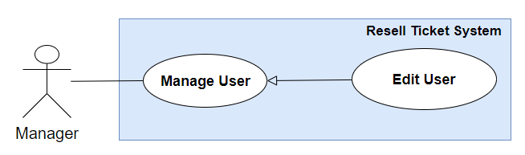

Figure 26 - <Use case> Manager Edit User

**Use Case Specification**

|  |  |  |  |
| --- | --- | --- | --- |
| **USE CASE - RT_21** | | | |
| **Use Case No.** | **RT_21** | **Use Case Version** | 1.0 |
| **Use Case Name** | Edit user permission | | |
| **Author** | Pham Phu Tien | | |
| **Date** | 02/06/2019 | **Priority** | Normal |
| **Actor:**   * Manager   **Summary:**   * This use case allows manager to edit user.   **Goal:**   * Manager successfully edit user.   **Triggers:**   * Manager send edit user command to the system.   **Preconditions:**   * User must login into the system with role manager.   **Post conditions:**   * Success: The user successful edited. * Fail: Show error message   **Main Success Scenario:**   |  |  |  | | --- | --- | --- | | **Step** | **Actor Action** | **System Response** | | 1 | Manager goes to user screen. | System shows list of users. | | 2 | Manager goes to edit User Detail Screen. | System shows user profile. | | 3 | User send edit profile command. | System shows message profile has been edited successfully. [Exception 1] |   **Exception:**   |  |  |  | | --- | --- | --- | | **Step** | **Cause** | **System Response** | | 1 | When the connection to the server is lost | System shows message the "Please check your connection" when the internet is lost. |   **Relationships:** N/A.  **Business Rules:**   * Manager only edit Status and Role of this User. | | | |

Table 28 - Usecase <Manager> Edit User

##### 2.3.3.3. <Manager> Active Customer

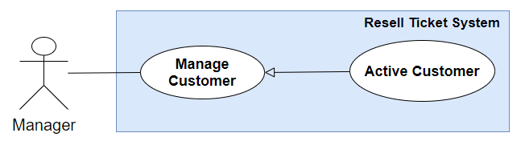

Figure 27 - <Use case> Manager Active Customer

**Use Case Specification**

|  |  |  |  |
| --- | --- | --- | --- |
| **USE CASE – RT_22** | | | |
| **Use Case No.** | **RT_22** | **Use Case Version** | 2.0 |
| **Use Case Name** | Active customer | | |
| **Author** | Pham Phu Tien | | |
| **Date** | 30/7/2019 | **Priority** | Normal |
| **Actor:**   * Manager   **Summary:**   * This use case allows Manager to active customer.   **Goal:**   * Manager successfully active customer in the system.   **Triggers:**   * Manager send active command to the system.   **Preconditions:**   * Manager must login into the system with role Manager.   **Post conditions:**   * Success: Customer is active by Manager. * Fail: Show error message.   **Main Success Scenario:**   |  |  |  | | --- | --- | --- | | **Step** | **Actor Action** | **System Response** | | 1 | Manager goes to manage customer screen. | Display a table show list of customers. | | 2 | Manager send active customer command. | System start active customer.  [Exception 1]  [Exception 2]  System show message active successful |   **Exception:**   |  |  |  | | --- | --- | --- | | **No** | **Cause** | **System Response** | | 1 | Active fail. | Show message to notify Manager that active failed. | | 2 | When the connection to the server is lost | System shows message "Please check  your connection" when the internet  is lost. |   **Relationships:** Active customer generalized from Manage customer  **Business Rules:**   * In case of success scenarios, customer will be active in the system. | | | |

Table 29 - Usecase <Manager> Active Customer

##### 2.3.3.4. <Manager> Deactive Customer

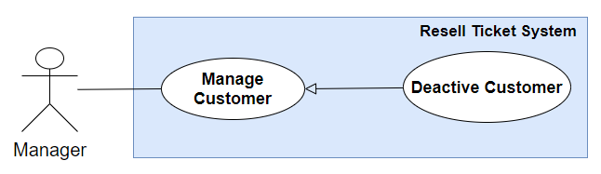

Figure 28 - <Use case> Manager Deactive Customer

**Use Case Specification**

|  |  |  |  |
| --- | --- | --- | --- |
| **USE CASE – RT_23** | | | |
| **Use Case No.** | **RT_23** | **Use Case Version** | 2.0 |
| **Use Case Name** | Deactive customer | | |
| **Author** | Pham Phu Tien | | |
| **Date** | 30/07/2019 | **Priority** | Normal |
| **Actor:**   * Manager   **Summary:**   * This use case allows Manager to deactive customer.   **Goal:**   * Manager successfully deactive customer.   **Triggers:**   * Manager send deactive customer command to the system.   **Preconditions:**   * Manager must login into the system with role Manager.   **Post conditions:**   * Success: Customer successful deactive in database. * Fail: Customer cannot be deactive.   **Main Success Scenario:**   |  |  |  | | --- | --- | --- | | **Step** | **Actor Action** | **System Response** | | 1 | Manager goes to manage customer screen. | Display a table show list of customers. | | 2 | Manager send deactive customer command. | Deactive customer in the system.  [Exception 1] [Exception 2]  System show message deactive customer successful. |   **Exceptions:**   |  |  |  | | --- | --- | --- | | **No** | **Cause** | **System Response** | | 1 | Deactive customer fail. | Show message to notify Manager that deactive customer failed. | | 2 | When the connection to the server is lost | System shows message "Please check your connection" when the internet is lost. |   **Relationships:** N/A  **Business Rules:**   * Manager soft delete customer by updating customer status to “Deactive” in the system. | | | |

Table 30 - Usecase <Manager> Deactive Customer

##### 2.3.3.5. <Manager> Create City

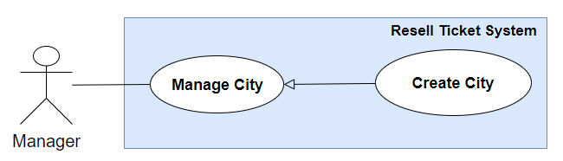

Figure 29 - <Use case> Manager Create City

**Use Case Specification**

|  |  |  |  |
| --- | --- | --- | --- |
| **USE CASE - RT_24** | | | |
| **Use Case No.** | **RT_24** | **Use Case Version** | 1.0 |
| **Use Case Name** | Create City | | |
| **Author** | Dương Anh Tuấn | | |
| **Date** | 01/06/2019 | **Priority** | Normal |
| **Actor:**   * Manager   **Summary:**   * This use case allows manager to create a city.   **Goal:**   * Manager successfully create a city.   **Triggers:**   * Manager send create city command to the system.   **Preconditions:**   * User must login into the system with role Manager.   **Post conditions:**   * Success: New city successful created. * Fail: Show error message   **Main Success Scenario:**   |  |  |  | | --- | --- | --- | | **Step** | **Actor Action** | **System Response** | | 1 | Manager sends command to create new City. | The system requires input from user includes:   * City name: Text input, require. * Time zone: select box, required. * Save: button. | | 2 | Manager inputs information. |  | | 3 | Manager clicks “Save” button. | Create new city in the system.  System shows message city has been created successfully then redirect to City Management Screen. [Exception 1] [Exception 2] |   **Alternative Scenario: N/A.**  **Exception:**   |  |  |  | | --- | --- | --- | | **No** | **Actor Action** | **System Response** | | 1 | Create new fail. (Input contain special characters) | The system shows an error message “Input may not contain special characters”. | | 2 | When the connection to the server is lost | System shows message the "Please check your connection" when the internet is lost. |   **Relationships:** N/A.  **Business Rules:**   * City Name is unique. * Time zone is required. | | | |

Table 31 - Usecase <Manager> Create City

##### 2.3.3.6. <Manager> Edit City

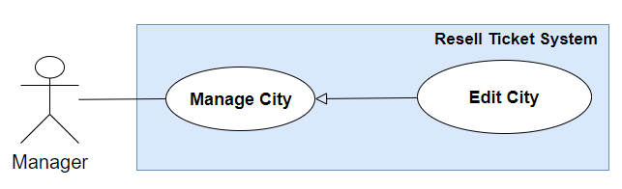

Figure 30 - <Use case> Manager Edit City

**Use Case Specification**

|  |  |  |  |
| --- | --- | --- | --- |
| **USE CASE - RT_25** | | | |
| **Use Case No.** | **RT_25** | **Use Case Version** | 1.0 |
| **Use Case Name** | Edit City | | |
| **Author** | Dương Anh Tuấn | | |
| **Date** | 02/06/2019 | **Priority** | Normal |
| **Actor:**   * Manager   **Summary:**   * This use case allows manager to edit city.   **Goal:**   * Manager successfully edit city.   **Triggers:**   * Manager send edit city command to the system.   **Preconditions:**   * User must login into the system with role manager.   **Post conditions:**   * Success: The city successful edited. * Fail: Show error message   **Main Success Scenario:**   |  |  |  | | --- | --- | --- | | **Step** | **Actor Action** | **System Response** | | 1 | Manager goes to city management screen. | System shows list of cities. | | 2 | Manager goes to City Detail Screen. | System shows City detail. | | 3 | Manager send edit City command. | System shows message city has been edited successfully. [Exception 1] |   **Exception:**   |  |  |  | | --- | --- | --- | | **Step** | **Cause** | **System Response** | | 1 | When the connection to the server is lost | System shows message the "Please check your connection" when the internet is lost. |   **Relationships:** N/A.  **Business Rules:**   * City name is unique. | | | |

Table 32 – Use case <Manager> Edit City

##### 2.3.3.7. <Manager> Delete City

##### 2.3.3.8. <Manager> Create Station

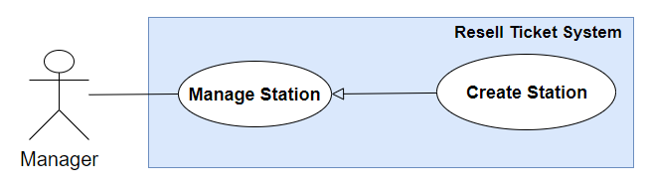

Figure 31 - <Use case> Manager Creates Station

|  |  |  |  |
| --- | --- | --- | --- |
| **USE CASE – RT_27** | | | |
| **Use Case No.** | **RT_27** | **Use Case Version** | 2.0 |
| **Use Case Name** | Create Station | | |
| **Author** | Pham Phu Tien | | |
| **Date** | 31/5/2019 | **Priority** | Normal |
| **Actor:**   * Manager   **Summary:**   * This use case allows Manager to create station.   **Goal:**   * Manager successfully create a station.   **Triggers:**   * Manager send create station command to the system.   **Preconditions:**   * Manager must login into the system with role Manager.   **Post conditions:**   * Success: Manager successful create a station in database. * Fail: Station cannot be created.   **Main Success Scenario:**   |  |  |  | | --- | --- | --- | | **Step** | **Actor Action** | **System Response** | | 1 | Manager goes to create new station view. | The system requires input from user includes:   * *Station name: text, required* * *City name: choose from city list* | | 2 | Manager inputs information. |  | | 3 | Manager send create station command. | Create a station in the system.  [Exception 1]  [Exception 2]  System show message station has been created successfully. |   **Exceptions:**   |  |  |  | | --- | --- | --- | | **No** | **Actor Action** | **System Response** | | 1 | Manager send create station command. | Show message to notify Manager that create station failed. |   **Exception 2:**   |  |  |  | | --- | --- | --- | | **No** | **Actor Action** | **System Response** | | 1 | Manager send create station command. | System shows message "Please check your connection" when the internet is lost. |   **Relationships:** Create station generalized from Manage Station  **Business Rules:**   * Station can be understood as a requirement for the system to find matched route in the future * A station contains the following information: Station Name, City Name | | | |

Table 33 - Usecase <Manager> Create Station

##### 2.3.3.9. <Manager> Edit Station

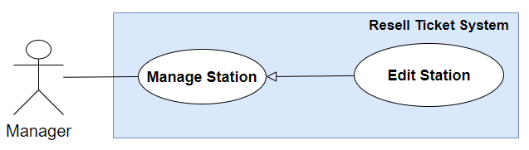

Figure 32 - <Use case> Manager Edits Station

|  |  |  |  |
| --- | --- | --- | --- |
| **USE CASE – RT_28** | | | |
| **Use Case No.** | **RT_28** | **Use Case Version** | 2.0 |
| **Use Case Name** | Edit Station | | |
| **Author** | Pham Phu Tien | | |
| **Date** | 31/5/2019 | **Priority** | Normal |
| **Actor:**   * Manager   **Summary:**   * This use case allows Manager to Edit station.   **Goal:**   * Manager successfully edit a station.   **Triggers:**   * Manager send edit station command to the system.   **Preconditions:**   * Manager must login into the system with role Manager.   **Post conditions:**   * Success: New information of station will be updated * Fail: Show error messages   **Main Success Scenario:**   |  |  |  | | --- | --- | --- | | **Step** | **Actor Action** | **System Response** | | 1 | Manager goes to station screen. | Display a table show list of stations with information:   * *Station name: text, required* * *City name: choose from city list*   [Alternative 1] | | 2 | Manager choose specific station and send edit station command. |  | | 3 | User goes to edit station screen. | Edit station screen is shown with following labels and fields:   * *Station name: text, required* * *City name: choose from city list* | | 4 | Manager send edit station command. | Update new information of station in the system.  [Exception 1]  [Exception 2]  System shows message station has been updated successfully. |   **Alternative Scenario 1:**     |  |  |  | | --- | --- | --- | | **Step** | **Actor Action** | **System Response** | | **1** | Manager sends get list of station command | Station list is displayed as empty list. |   **Exception 1:**   |  |  |  | | --- | --- | --- | | **No** | **Actor Action** | **System Response** | | 1 | Manager send edit station command. | Show message to notify Manager that create station failed. |   **Exception 2:**   |  |  |  | | --- | --- | --- | | **No** | **Actor Action** | **System Response** | | 1 | When the connection to the server is lost | System shows message "Please check your connection" when the internet is lost. |   **Relationships:** Edit station generalized from Manage Station  **Business Rules:**   * In case of success scenarios, new information of station is updated to the system. * Station can be understood as a requirement for the system to find matched route in the future | | | |

Table 34 - Usecase <Manager> Edit Station

##### 2.3.3.10. <Manager> Delete Station

##### 2.3.3.11. <Manager> Create Transportation

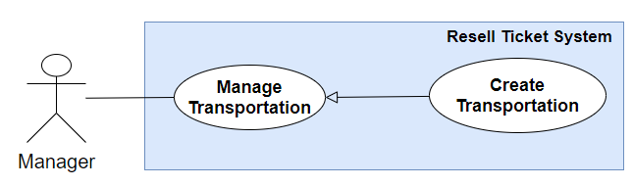

Figure 33 - <Use case> Manager Creates Transportation

**Use Case Specification**

|  |  |  |  |
| --- | --- | --- | --- |
| **USE CASE - RT_30** | | | |
| **Use Case No.** | **RT_30** | **Use Case Version** | 1.0 |
| **Use Case Name** | Create Transportation | | |
| **Author** | Dương Anh Tuấn | | |
| **Date** | 01/06/2019 | **Priority** | Normal |
| **Actor:**   * Manager   **Summary:**   * This use case allows manager to create a transportation.   **Goal:**   * Manager successfully create a transportation.   **Triggers:**   * Manager send create transportation command to the system.   **Preconditions:**   * User must login into the system with role Manager.   **Post conditions:**   * Success: New transportation successful created. * Fail: Show error message   **Main Success Scenario:**   |  |  |  | | --- | --- | --- | | **Step** | **Actor Action** | **System Response** | | 1 | Manager sends command to create new transportation. | The system requires input from user includes:   * Name: Text input, require. * Email: Text input, require, email format. * Phone number: Number input, require. * Vehicle: Select box, required. * Expire hours before departure date: number input, require. * Save: button. | | 2 | Manager inputs information. |  | | 3 | Manager clicks “Save” button. | Create new transportation in the system.  System shows message transportation has been created successfully then redirect to Transportation Management Screen. [Exception 1] [Exception 2] |   **Alternative Scenario:**  **Exception:**   |  |  |  | | --- | --- | --- | | **No** | **Actor Action** | **System Response** | | 1 | Create new fail. (Input contain special characters) | The system shows an error message “Input may not contain special characters”. | | 2 | When the connection to the server is lost | System shows message the "Please check your connection" when the internet is lost. |   **Relationships:** N/A.  **Business Rules:**   * Vehicle select options include:   + Plane.   + Bus.   + Train. * Expire before departure date: use for suggesting fill the input for staff, when staff verify ticket is valid. | | | |

Table 35 – Use case <Manager> Create Transportation

##### 2.3.3.12. <Manager> Edit Transportation

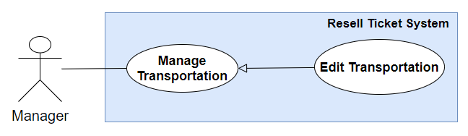

Figure 34 - <Use case> Manager Edits Transportation

**Use Case Specification**

|  |  |  |  |
| --- | --- | --- | --- |
| **USE CASE - RT_31** | | | |
| **Use Case No.** | **RT_31** | **Use Case Version** | 1.0 |
| **Use Case Name** | Edit Transportation | | |
| **Author** | Dương Anh Tuấn | | |
| **Date** | 02/06/2019 | **Priority** | Normal |
| **Actor:**   * Manager   **Summary:**   * This use case allows manager to edit transportation.   **Goal:**   * Manager successfully edit transportation.   **Triggers:**   * Manager send edit transportation command to the system.   **Preconditions:**   * User must login into the system with role manager.   **Post conditions:**   * Success: The transportation successful edited. * Fail: Show error message   **Main Success Scenario:**   |  |  |  | | --- | --- | --- | | **Step** | **Actor Action** | **System Response** | | 1 | Manager goes to transportation management screen. | System shows list of transportations. | | 2 | Manager goes to Transportation Detail Screen. | System shows City detail. | | 3 | Manager send edit Transportation command. | System shows message transportation has been edited successfully. [Exception 1] |   **Exception:**   |  |  |  | | --- | --- | --- | | **Step** | **Cause** | **System Response** | | 1 | When the connection to the server is lost | System shows message the "Please check your connection" when the internet is lost. |   **Relationships:** N/A.  **Business Rules:**   * Vehicle select options include:   + Plane.   + Bus.   + Train. * Expire before departure date: use for suggesting fill the input for staff, when staff verify ticket is valid. | | | |

Table 36 – Use case <Manager> Edit Transportation

##### 2.3.3.13. <Manager> Delete Transportation

##### 2.3.3.14. <Manager> Create Ticket Type

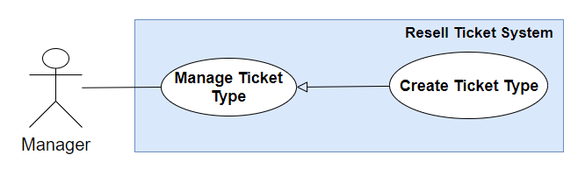

Figure 35 - <Use case> Manager Creates Ticket Type

|  |  |  |  |
| --- | --- | --- | --- |
| **USE CASE – RT_33** | | | |
| **Use Case No.** | **RT_33** | **Use Case Version** | 2.0 |
| **Use Case Name** | Create Ticket Type | | |
| **Author** | Pham Phu Tien | | |
| **Date** | 31/5/2019 | **Priority** | Normal |
| **Actor:**   * Manager   **Summary:**   * This use case allows Manager to create ticket type.   **Goal:**   * Manager successfully create ticket type.   **Triggers:**   * Manager send create ticket type command to the system.   **Preconditions:**   * Manager must login into the system with role Manager.   **Post conditions:**   * Success: Manager successful create ticket type in database. * Fail: Ticket type cannot be created.   **Main Success Scenario:**   |  |  |  | | --- | --- | --- | | **Step** | **Actor Action** | **System Response** | | 1 | Manager goes to create new ticket type view. | The system requires input from user includes:   * *Name: text, required* * *Vehicle: choose from vehicle list* | | 2 | Manager inputs information. |  | | 3 | Manager send create ticket type command. | Create a ticket type in the system.  [Exception 1]  [Exception 2]  System show message ticket type has been created successfully. |   **Exceptions:**   |  |  |  | | --- | --- | --- | | **No** | **Actor Action** | **System Response** | | 1 | Create ticket type fail. | Show message to notify Manager that create ticket type failed. |   **Exception 2:**   |  |  |  | | --- | --- | --- | | **No** | **Actor Action** | **System Response** | | 1 | When the connection to the server is lost | System shows message "Please check your connection" when the internet is lost. |   **Relationships:** Create ticket type generalized from Manage Ticket Type  **Business Rules:**   * Ticket type can be understood as a requirement for the system to find matched route in the future * A ticket type contains the following information: Name, Vehicle | | | |

Table 37 – Use case <Manager> Create Ticket Type

##### 2.3.3.15 <Manager> Edit Ticket Type

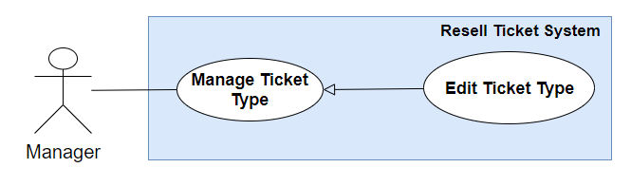

Figure 36 - <Use case> Manager Edits Tick Type

**Use Case Specification**

|  |  |  |  |
| --- | --- | --- | --- |
| **USE CASE – RT_34** | | | |
| **Use Case No.** | **RT_34** | **Use Case Version** | 1.0 |
| **Use Case Name** | Edit Ticket Type | | |
| **Author** | Pham Phu Tien | | |
| **Date** | 31/5/2019 | **Priority** | Normal |
| **Actor:**   * Manager   **Summary:**   * This use case allows Manager to Edit ticket type.   **Goal:**   * Manager successfully edit a ticket type.   **Triggers:**   * Manager send edit ticket type command to the system.   **Preconditions:**   * Manager must login into the system with role Manager.   **Post conditions:**   * Success: New information of ticket type will be updated * Fail: Show error messages   **Main Success Scenario:**   |  |  |  | | --- | --- | --- | | **Step** | **Actor Action** | **System Response** | | 1 | Manager goes to ticket type screen. | Display a table show list of ticket type with information:   * *Name: text, required* * *Vehicle name: choose from vehicle list*   [Alternative 1] | | 2 | Manager choose specific ticket type and send edit ticket type command. |  | | 3 | User goes to edit ticket type screen. | Edit station screen is shown with following labels and fields:   * *Station name: text, required* * *City name: choose from city list* | | 4 | Manager send edit ticket type command. | Update new information of ticket type in the system.  [Exception 1]  [Exception 2]  System shows message ticket type has been updated successfully. |   **Alternative Scenario 1:**     |  |  |  | | --- | --- | --- | | **Step** | **Actor Action** | **System Response** | | **1** | Manager sends get list of ticket type command | Ticket type list is displayed as empty list. |   **Exception 1:**   |  |  |  | | --- | --- | --- | | **No** | **Actor Action** | **System Response** | | 1 | Manager sends get list of ticket type command | Show message to notify Manager that create ticket type failed. |   **Exception 2:**   |  |  |  | | --- | --- | --- | | **No** | **Actor Action** | **System Response** | | 1 | Manager sends get list of ticket type command | System shows message "Please check your connection" when the internet is lost. |   **Relationships:** Edit ticket type generalized from Manage Ticket Type  **Business Rules:**   * In case of success scenarios, new information of ticket type is updated to the system. * Ticket type can be understood as a requirement for the system to find matched route in the future | | | |

Table 38 – Use case <Manager> Edit Ticket Type

##### 2.3.3.16 <Manager> Delete Ticket Type

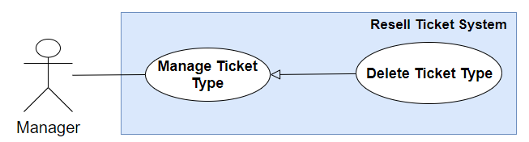

Figure 37 - <Use case> Manager Deletes Ticket Type

##### 2.3.3.17 <Manager> View Statistic Report

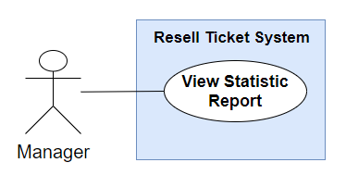

Figure 38 - <Use case> Manager Views Statistic

**Use Case Specification**

|  |  |  |  |
| --- | --- | --- | --- |
| **USE CASE - RT_36** | | | |
| **Use Case No.** | **RT_36** | **Use Case Version** | 1.0 |
| **Use Case Name** | View Statistic | | |
| **Author** | Dương Anh Tuấn | | |
| **Date** | 02/06/2019 | **Priority** | Normal |
| **Actor:**   * Manager   **Summary:**   * This use case allows manager to view statistic.   **Goal:**   * Manager can view statistic report.   **Triggers:**   * Manager send view statistic command to the system.   **Preconditions:**   * User must login into the system with role manager.   **Post conditions:**   * Success: View statistic report is successfully displayed. * Fail: Show error message   **Main Success Scenario:**   |  |  |  | | --- | --- | --- | | **Step** | **Actor Action** | **System Response** | | 1 | Manager sends command to view statistic. | System navigates to View statistic Screen includes:   * Number of available tickets. * Number of completed tickets. * Number of completed routes. * Profit amount. * List of completed routes.   [Exception 1] |   **Exception:**   |  |  |  | | --- | --- | --- | | **Step** | **Cause** | **System Response** | | 1 | When the connection to the server is lost | System shows message the "Please check your connection" when the internet is lost. |   **Relationships:** N/A.  **Business Rules:**   * The statistic number displayed in screen is calculated from data for a year. | | | |

Table 39 - Usecase <Manager> View Statistic

#### 2.3.4. <Staff> Overview Use Case

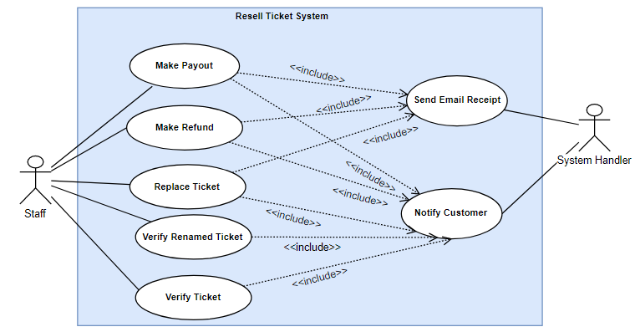

Figure 39 - <Use case> Staff Overview

##### 2.3.4.1. <Staff> Verify Ticket

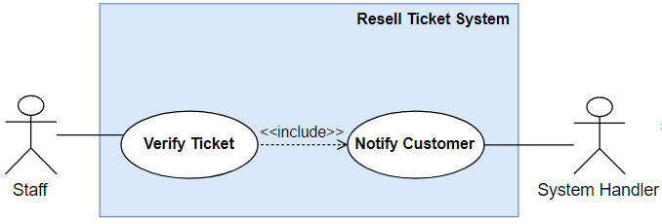

Figure 40 - <Use case> Staff Verify Ticket

**Use Case Specification**

|  |  |  |  |
| --- | --- | --- | --- |
| **USE CASE – RT_37** | | | |
| **Use Case No.** | RT_37 | **Use Case Version** | 2.0 |
| **Use Case Name** | Validate Ticket | | |
| **Author** | Le Xuan Huy | | |
| **Date** | 31/05/2019 | **Priority** | Normal |
| Actor:   * Staff   **Summary:**   * This use case allows staff to verify new posted ticket.   **Goal:**   * Staff change ticket status from “Pending” to “Valid” or from “Pending” to “Invalid”.   **Triggers:**   * Staff send verify ticket command to the system.   **Preconditions:**   * User must login to the system with role Staff   **Post conditions:**   * **Success**: A ticket status successful update in database. * **Fail**: A ticket status cannot be updated.   **Main Success Scenario:**   |  |  |  | | --- | --- | --- | | Step | Actor Action | System Response | | 1 | Staff goes to new posted tickets page | System render a list of new posted tickets. | | 2 | Staff click Valid button of each ticket | System render details of new posted ticket such as: ticket code, vehicle, departure date, arrival date,…. | | 3 | Staff check valid all details of the ticket and then send command to verify the ticket | System will verify the ticket and update in the system. Then system will notify selling customer that their ticket is valid or not.  [Exception 1] |   **Alternative Scenario:**   |  |  |  | | --- | --- | --- | | No | Actor Action | System Response |   **Exceptions:**   |  |  |  | | --- | --- | --- | | No | Actor Action | System Response | | 1 | Staff check valid all details of the ticket and then send command to verify the ticket | Show message to notify staff that update failed. |   **Relationships:** N/A  **Business Rules:**   * Seller must post their ticket with verification information before staff check. * Validation information includes: Code, vehicle, departure, arrival, transportation,   ticket type, station.   * Staff can only validate ticket on ticket detail screen. * Customer cannot search tickets that are not verified yet and tickets are verified but not valid. | | | |

Table 40 - Use case <Staff> Verify Ticket

##### 2.3.4.2. <Staff> Verify Renamed Ticket

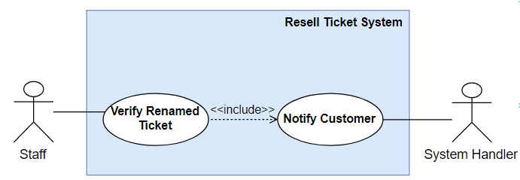

Figure 41 - <Use case> Staff Verify Renamed Ticket

**Use Case Specification**

|  |  |  |  |
| --- | --- | --- | --- |
| **USE CASE – RT_38** | | | |
| **Use Case No.** | **RT_38** | **Use Case Version** | 2.0 |
| **Use Case Name** | Verify renamed ticket | | |
| **Author** | Le Xuan Huy | | |
| **Date** | 29/07/2019 | **Priority** | Normal |
| **Actor:**   * Staff   **Summary:**   * This use case allows staff to verify the ticket after seller renaming.   **Goal:**   * Staff can verify the ticket that is renamed success or renamed fail.   **Triggers:**   * Staff send verify renamed ticket command to the system.   **Preconditions:**   * User must login to the system with role Staff   **Post conditions:**   * Success: A ticket status is updated successfully in database with “RenamedSuccess” or “RenamedFail” status. * Fail: The ticket status is updated fail.   **Main Success Scenario:**   |  |  |  | | --- | --- | --- | | **Step** | **Actor Action** | **System Response** | | 1 | Staff goes to renamed tickets page | * System render a list of renamed tickets | | 2 | Staff goes to detail of each ticket page | System render details of the ticket such as: code, vehicle, departure, arrival,… and also buyer’s information, seller’s phone number | | 3 | Staff verify renamed ticket and send command to confirm ticket is renamed successfully  [Alternative 1] | System will update ticket status and then notify to both buyer and seller that ticket is renamed successfully.  [Exception 1] |   **Alternative Scenario:**   |  |  |  | | --- | --- | --- | | **No** | **Actor Action** | **System Response** | | 1 | Staff verify renamed ticket and send command to confirm ticket is renamed fail | System will update ticket status and then notify to both buyer and seller that ticket is renamed fail. |   **Exceptions:**   |  |  |  | | --- | --- | --- | | **No** | **Actor Action** | **System Response** | | 1 | Staff verify renamed ticket and send command to confirm | Show message to notify staff that update ticket status failed. |   **Relationships:** N/A  **Business Rules:**   * Unauthorized user must login in the system with role Staff. * Buyer must rename the ticket before staff confirm that ticket. * Buyer and Seller will receive a notification when staff confirm verify the ticket is renamed success or fail. | | | |

Table 41 – Use case <Staff> Verify Renamed Ticket

##### 2.3.4.3. <Staff> Make Payout

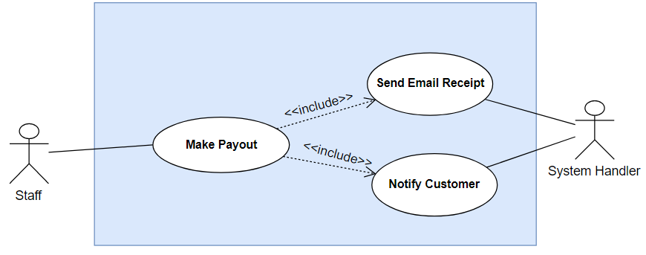

Figure 42 - <Use case> Staff Makes payout

**Figure: <Staff> Make Payout**

|  |  |  |  |
| --- | --- | --- | --- |
| **USE CASE – RT_39** | | | |
| **Use Case No.** | **RT_39** | **Use Case Version** | 1.1 |
| **Use Case Name** | Make Payout | | |
| **Author** | Le Xuan Huy | | |
| **Date** | 27/07/2019 | **Priority** | High |
| **Actor:**   * Staff   **Summary:**   * This use case allows staff to make payout money that is ticket’s selling price of seller to seller.   **Goal:**   * Staff can make payout money to seller and update ticket status.   **Triggers:**   * Staff send make payout command to the system.   **Preconditions:**   * User must login to the system with role Staff   **Post conditions:**   * Success: A ticket status is updated successfully in database and payout money to seller successfully * Fail: The ticket status is updated fail or payout money to seller fail.   **Main Success Scenario:**   |  |  |  | | --- | --- | --- | | **Step** | **Actor Action** | **System Response** | | 1 | Staff goes to bought routes page | * - System render a list of bought routes and there are some routes need to be resolved | | 2 | Staff goes to detail of each resolve needed route page | - System render details of the route such as: code, buyer phone and route’s total price and tickets of the route and one or more tickets need to be payout. | | 3 | Staff send command to make payout the ticket. | - System will make payout the money to seller and update ticket status.  - Then system will send an email that is payout receipt to seller and send a notification to notify seller.  - Finally, system will save a report that what time the ticket is payout, who make payout the ticket.  - If all tickets of this route are payout, the system will update this route with Completed status  [Exception 1] |   **Alternative Scenario:**   |  |  |  | | --- | --- | --- | | **No** | **Actor Action** | **System Response** |   **Exceptions:**   |  |  |  | | --- | --- | --- | | **No** | **Actor Action** | **System Response** | | 1 | Staff send command to make payout the ticket. | Show message to notify staff that make payout to seller fail. |   **Relationships:** N/A  **Business Rules:**   * Unauthorized user must login in the system with role Staff. * The ticket must be renamed success status. * Seller will receive a email that is payout receipt after staff make payout. | | | |

Table 42 – Use case <Staff> Make Payout

##### 2.3.4.4. <Staff> Make Refund

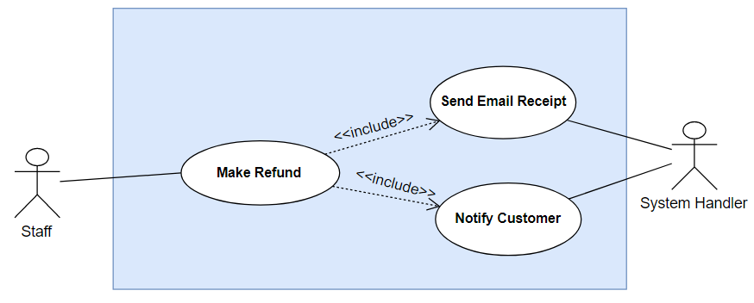

Figure 43 - <Use case> Staff Makes Refund

|  |  |  |  |
| --- | --- | --- | --- |
| **USE CASE – RT_40** | | | |
| **Use Case No.** | **RT_40** | **Use Case Version** | 1.1 |
| **Use Case Name** | Make Refund | | |
| **Author** | Le Xuan Huy | | |
| **Date** | 27/07/2019 | **Priority** | High |
| **Actor:**   * Staff   **Summary:**   * This use case allows staff to make refund money that is ticket’s selling price or route’s total price to buyer when one or more tickets are renamed fail.   **Goal:**   * Staff can make refund money of one or more renamed fail tickets or total price of route to buyer.   **Triggers:**   * Staff send make payout command to the system.   **Preconditions:**   * User must login to the system with role Staff   **Post conditions:**   * Success: A ticket, route status is updated successfully and refund money to buyer successfully * Fail: The ticket, route status is updated fail or payout money to seller fail.   **Main Success Scenario:**   |  |  |  | | --- | --- | --- | | **Step** | **Actor Action** | **System Response** | | 1 | Staff goes to bought routes page | * System render a list of bought routes and there are some routes need to be resolved | | 2 | Staff goes to detail of each resolve needed route page | System render details of the route such as: code, buyer phone and route’s total price and tickets of the route and one or more tickets are renamed fail. | | 3 | Staff calls the buyer, gives two solutions:  1. staff will refund money of the renamed fail tickets  2. Staff will refund total price of route |  | | 4 | Staff send command to refund the renamed ticket fail if buyer choose option 1  [Alternative 1] | - System will make refund the money to buyer and update ticket status.  - Then system will send an email that is refund receipt to buyer and send a notification to notify buyer  - Finally, system will save a report that what time the ticket is refund, who make refund the ticket.  - If all tickets of this route are refund, the system will update this route with Completed status  [Exception 1] |   **Alternative Scenario:**   |  |  |  | | --- | --- | --- | | **No** | **Actor Action** | **System Response** | | 1 | Staff send command to refund the total price of the route if buyer choose option 2 | - System will make refund the total money of the route to buyer and update route status become Completed.  - Then system will send an email that is refund total price receipt to buyer and send a notification to notify buyer  - Finally, system will save a report that what time the all tickets of the route are refunded, who make refund total price of the route.  [Exception 2] |   **Exceptions:**   |  |  |  | | --- | --- | --- | | **No** | **Actor Action** | **System Response** | | 1 | Staff send command to refund the renamed ticket fail if buyer choose option 1 | Show message to notify staff that make refund the renamed fail ticket to buyer fail. | | 2 | Staff send command to refund the renamed ticket fail if buyer choose option 2 | Show message to notify staff that make refund total price of the route to buyer fail. |   **Relationships:** N/A  **Business Rules:**   * Unauthorized user must login in the system with role Staff. * The route must has at least one ticket is renamed fail status. * If there are one or more tickets is renamed success, staff must make payout first. * Staff must call the buyer to ask their option before make refund. * Buyer will receive a email that is refund receipt after staff make refund. | | | |

Table 43 – Use case <Staff> Make Refund

##### 2.3.4.5. <Staff> Replace Ticket

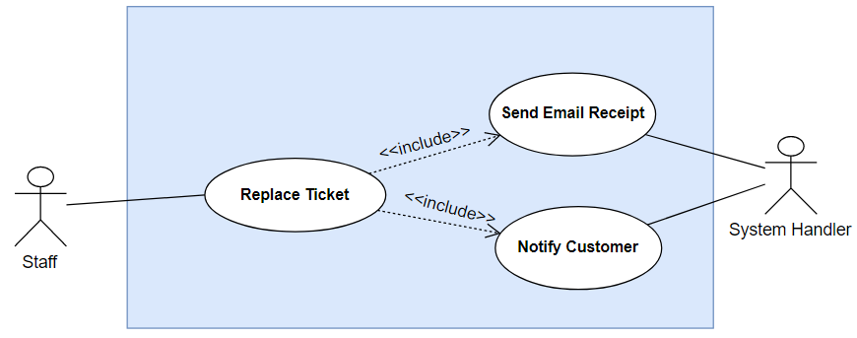

Figure 44 - <Use case> Staff Replaces Ticket

|  |  |  |  |
| --- | --- | --- | --- |
| **USE CASE – RT_41** | | | |
| **Use Case No.** | **RT_41** | **Use Case Version** | 1.1 |
| **Use Case Name** | Replace Ticket | | |
| **Author** | Le Xuan Huy | | |
| **Date** | 27/07/2019 | **Priority** | High |
| **Actor:**   * Staff   **Summary:**   * This use case allows staff to replace lower price ticket for buyer if there are one or more tickets are renamed fail.   **Goal:**   * Staff can make replace ticket for buyer if there are one or more tickets are renamed fail for buyer.   **Triggers:**   * Staff send replace ticket command to the system.   **Preconditions:**   * User must login to the system with role Staff   **Post conditions:**   * Success: A renamed fail ticket is replaced successfully and refund difference amount to buyer successfully * Fail: The ticket, route status is updated fail or payout money to seller fail.   **Main Success Scenario:**   |  |  |  | | --- | --- | --- | | **Step** | **Actor Action** | **System Response** | | 1 | Staff goes to bought routes page | * System render a list of bought routes and there are some routes need to be resolved | | 2 | Staff goes to detail of each resolve needed route page | System render details of the route such as: code, buyer phone and route’s total price and tickets of the route and one or more tickets are renamed fail. | | 3 | Staff calls the buyer, gives them a solution that staff will replace the renamed fail ticket to another lower price ticket | System render a list of available tickets that their price are lower the fail tickets | | 4 | Staff select an available ticket and send command to replace the fail ticket if buyer agree with this solution  [Alternative 1] | - System will replace the rename fail ticket to the ticket that is selected by staff and then refund difference amount to buyer.  - Then system will send an email that is difference amount receipt to buyer and send a notification to notify buyer.  - Finally, system will save a report that what time the ticket is replaced, who replaced the ticket.  - The selected ticket will be updated with Bought status in the system, then system will send notification to the seller of the ticket.  [Exception 1] |   **Alternative Scenario:**   |  |  |  | | --- | --- | --- | | **No** | **Actor Action** | **System Response** | | 1 | Buyer disagree with this solution; staff has to perform “Make Refund” use case |  |   **Exceptions:**   |  |  |  | | --- | --- | --- | | **No** | **Actor Action** | **System Response** | | 1 | Staff select an available ticket and send command to replace the fail ticket if buyer agree with this solution | Show message to notify staff that replaced the renamed fail ticket fail. |   **Relationships:** N/A  **Business Rules:**   * Unauthorized user must login in the system with role Staff. * The route must have at least one ticket is renamed fail status. * Staff must call the buyer to ask their option before replacing. * Buyer will receive an email that is difference amount receipt after staff replace. * Replaced ticket’s seller will receive a notification that the ticket is bought after staff replace. | | | |

Table 44 – Use case <Staff> Replace Ticket

#### 2.3.5. <Authorized User> Overview Use Case

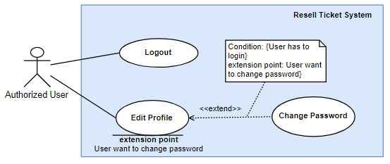

Figure 45 - <Use case> Authorized User Overview

##### 2.3.3.1. Logout

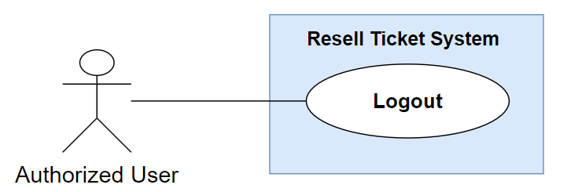

Figure 46 - <Use case> Authorized User Logout

|  |  |  |  |
| --- | --- | --- | --- |
| **USE CASE – RT_42** | | | |
| **Use Case No.** | RT_42 | **Use Case Version** | 2.0 |
| **Use Case Name** | Logout | | |
| **Author** | Nguyen Van Thanh | | |
| **Date** | 29/07/2019 | **Priority** | Normal |
| **Actor:**   * Authorized User   **Summary:**   * This use case allows authorized user can logout of the system.   **Goal:**   * Authorized user will go back to home page with guest role.   **Triggers:**   * Authorized user sends logout command.   **Preconditions:**   * Guest must login into the system to become an authorized user.   **Post conditions:**   * Success: Go back to home page. * Fail: System shows error message.   **Main Success Scenario:**   |  |  |  | | --- | --- | --- | | **Step** | **Actor Action** | **System Response** | | 1 | Authorized user send command to logout of the system. | System will go back to Home page.  [Exception 1] |   **Alternative Scenario:**  **Exceptions:**   |  |  |  | | --- | --- | --- | | **No** | **Actor Action** | **System Response** | | 1 | Authorized user send command to logout of the system. | Show the message “Check Internet Connection” |   **Relationships:**  **Business Rules:**   * After sending logout command, authorized user will become guest and system go back to Home page. | | | |
|  | | | |

Table 45 – Use case <Authorized user> Logout

##### 2.3.3.2. Edit Profile

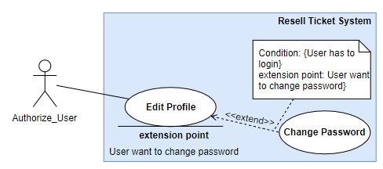

Figure 47 - <Use case> Authorized User Edits Profile

|  |  |  |  |
| --- | --- | --- | --- |
| **USE CASE – RT_43** | | | |
| **Use Case No.** | RT_43 | **Use Case Version** | 2.0 |
| **Use Case Name** | Edit Profile | | |
| **Author** | Nguyen Van Thanh | | |
| **Date** | 29/07/2019 | **Priority** | Normal |
| **Actor:**   * Authorized User   **Summary:**   * This use case allows authorized user can change their profile.   **Goal:**   * Authorized user’s profile can be updated successfully.   **Triggers:**   * Authorized user sends edit profile command.   **Preconditions:**   * Guest must login into the system to become an authorized user.   **Post conditions:**   * Success: Authorized user’s profile will be updated. * Fail: System shows error message.   **Main Success Scenario:**   |  |  |  | | --- | --- | --- | | **Step** | **Actor Action** | **System Response** | | 1 | Authorized user go to their profile screen. | System render the page with user’s profile | | 2 | Authorized user edits their profile |  | | 3 | Authorized user send command to edit profile | System will validate user’s profile and update in the system.  [Exception 1, 2] |   **Alternative Scenario:**  **Exceptions:**   |  |  |  | | --- | --- | --- | | **No** | **Actor Action** | **System Response** | | 1 | Authorized user send command to edit profile | System show error message that profile’s information is not correct | | 2 | Authorized user send command to edit profile | System show error message ask user inputs all required fields |   **Relationships:** WCS_UC_1, WCS_UC_4, WCS_UC_22, WCS_UC_23, WCS_UC_28.  **Business Rules:**   * After sending edit command, user’s new profile will be updated in the system and on the screen. | | | |
|  | | | |

Table 46 – Use case <Authorized user> Edit Profile

##### 2.3.3.3. Change Password



Figure 48 - <Use case> Authorized User Changes Password

|  |  |  |  |
| --- | --- | --- | --- |
| **USE CASE – RT_44** | | | |
| **Use Case No.** | RT_44 | **Use Case Version** | 2.0 |
| **Use Case Name** | Change password | | |
| **Author** | Nguyen Van Thanh | | |
| **Date** | 29/07/2019 | **Priority** | Medium |
| **Actor:**   * Authorized User   **Summary:**   * This use case allows authorized user can change their password.   **Goal:**   * Authorized user’s password can be updated successfully.   **Triggers:**   * Authorized user sends change password command.   **Preconditions:**   * Guest must login into the system to become an authorized user.   **Post conditions:**   * Success: Authorized user’s password will be updated. * Fail: System shows error message.   **Main Success Scenario:**   |  |  |  | | --- | --- | --- | | **Step** | **Actor Action** | **System Response** | | 1 | Authorized user goes to their change password screen | System render the page with three required input fields:   * *Current password: text input* * *New password: text input* * *Confirm password: text input* | | 2 | Authorized user input all three fields |  | | 3 | Authorized user send command to change password | System will validate three input fields and update new password in the system  [Exception 1, 2] |   **Alternative Scenario:**  **Exceptions:**   |  |  |  | | --- | --- | --- | | **No** | **Actor Action** | **System Response** | | 1 | Authorized user send command to edit profile | System show error message that current password is not correct | | 2 | Authorized user send command to edit profile | System show error message notify user new password must match with confirm password |   **Relationships:**  **Business Rules:**   * After sending change password command, user’s new password will be updated in the system and user use this password to login in the system next time. | | | |
|  | | | |

Table 47 – Use case <Authorized user> Change Password

## Software System Attribute

### **3.1. Usability**

Website’s UI is fit for each browser on each device

* Font style: Arial, Sans-serif
* Font size: 12px -26px
* Color: green, black, red, white, blue, Light Slate Grey, Fuego, Honeysuckle…
* Background: White, Catalina Blue, Whisper…

### **3.2. Reliability**

* The information storing on the database is permanent.

### **3.3. Availability**

* The system must be available at any time 24/7.

### **3.4. Security**

* Only Manager has fully access to the system.
* Input data is validated before saving to database.

### **3.5. Maintainability**

* The system is divided into separated modules for easy maintain.

### **3.6. Portability**

* Web application can be run on Chrome browser version 42 or later.

### **3.7. Performance**

* System has successfully test with basic standard.

## Conceptual Diagram

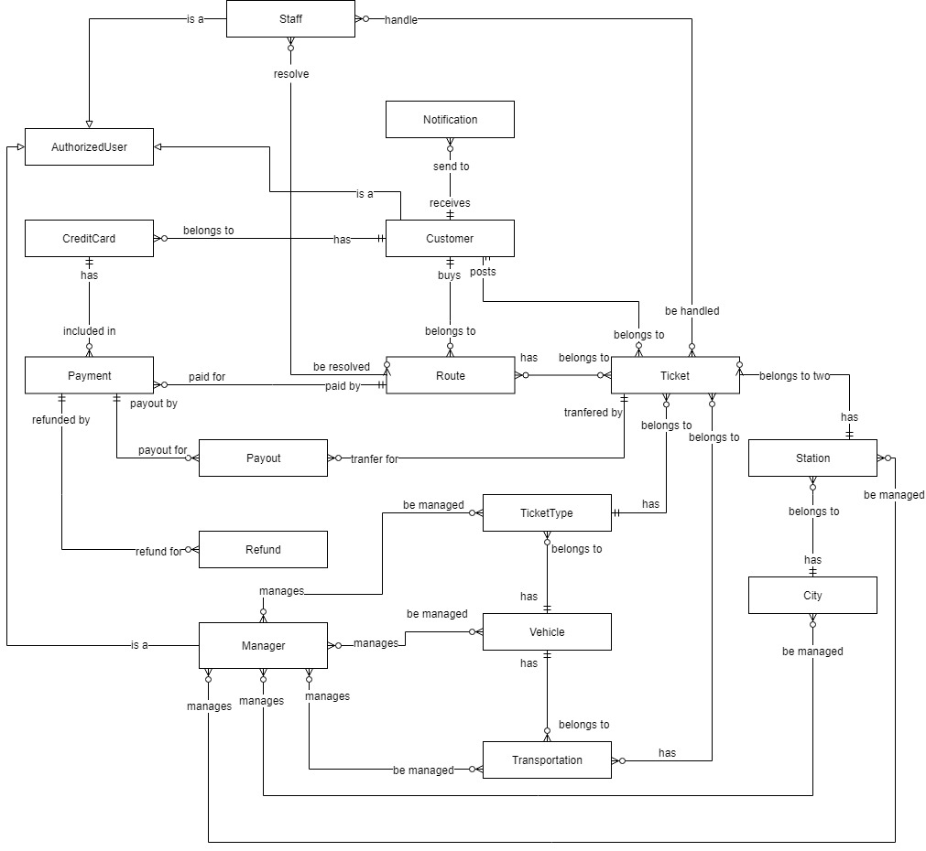

Figure 49 - Conceptual Diagram

**Data Dictionary**

|  |  |
| --- | --- |
| **ENTITY DATA DICTIONARY: DESCRIBE ALL CONTENT OF ALL ENTITIES** | |
| **Entity Name** | **Description** |
| Staff | Contain the Staff information. |
| AuthorizedUser | Abstract Entity Describe an Authorized User in system. |
| Notification | Contain the Notification information. |
| CreditCard | Contain the Credit Card information of a customer. |
| Customer | Contain the Customer information. |
| Payment | Contain the Payment of a route. |
| Route | Contain the Route Information. |
| Ticket | Contain the Ticket information. |
| Payout | Contain the Payout information. |
| Refund | Contain the Refund information. |
| TicketType | Contain the Ticket Type information. |
| Station | Contain the Station information. |
| City | Contain the City information. |
| Manager | Contain the Manager information. |
| Vehicle | Contain the Vehicle information. |
| Transportation | Contain the Transportation information. |

Table 48 - Conceptual Diagram Data Dictionary

# Software Design Description

## Design Overview

This document describes the technical and user interface design of CCP system. It includes the architectural design, the detailed design of common functions and business functions and the design of database model.

The architectural design describes the overall architecture of the system and the architecture of each main component and subsystem.

The detailed design describes static and dynamic structure for each component and functions. It includes class diagrams, class explanations and sequence diagrams for each use cases.

The database design describes the relationships between entities and details of each entity.

Document overview:

* Section 2: gives an overall description of the system architecture design.
* Section 3: gives component diagrams that describe the connection and integration of the system.
* Section 4: gives the detail design description which includes class diagram, class explanation, and sequence diagram to details the application functions.
* Section 5: describe screens design.
* Section 6: describe a fully attributed ERD.
* Section 7: describe algorithms.

## System Architecture Design

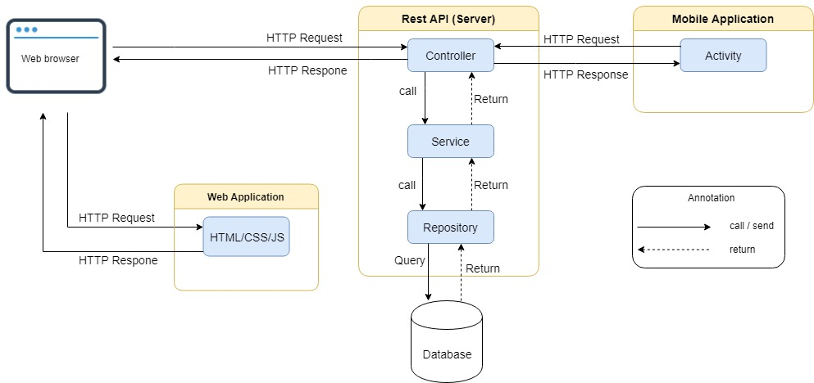

Figure 50 - System Architecture Diagram

### **2.1. System architecture description**

This system follows MVC architecture style with following components:

* Model is a part of the application that represents shape of the data and business logic. It includes Service in Admin Rest API, Repository in Admin Rest API, Service in Customer Rest API, Repository in Customer Rest API, Database.
* Controller is a part of the application that handles the user request. It includes Controller in Customer Rest API, Controller in Admin Rest API.
* View is a user interface. It includes Admin Web Application, Customer Web Application, Customer Mobile.

### **2.2. Web Service architecture description**

The back end of this system is developed under Web Service architecture. We choose this architecture because Mobile application and Web application are separated, therefore, we can use web service to handle business logic without repeating code.

### **2.3. Admin website architecture description**

In Admin Web Application, the system is developed in Single-Page Application (SPA) approach. We choose this approach because the following advantages:

* Performance improvement, Single Page Application can improve performance in many ways, Single time file load each of HTML, CSS, JS.
* No extra queries to the server to download pages.
* ReactJS is easy to master.

### **2.4. Customer website architecture description**

In Customer Web Application, we choose to develop the system in Multi-Page Application (MPA) because of the following advantages:

* SEO is better on MPA than SPA since the architecture is native to search engine crawlers.
* Unlimited scalability.

### **2.5. Customer Mobile architecture description**

In Customer Mobile Application, we developed by React Native because of the following advantages:

* Mobile app can be built with the help of Web technology which enables any web developer to easily enhance his/her skills and create React apps.
* Save time and cost to build mobile apps on multiple platforms.
* A React Native app ensures speed and agility for the mobile apps with responsiveness and a great native app-based user experience.

## Component Diagram

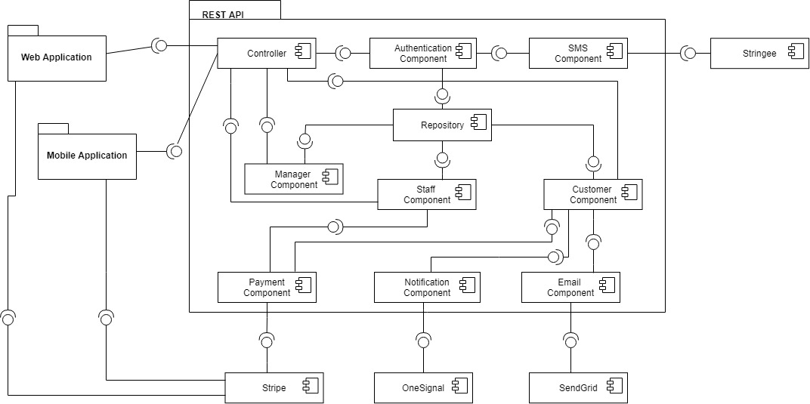

Figure 51 - Component Diagram

|  |  |  |
| --- | --- | --- |
| **Component dictionary** | | |
| **Component name** | **Description** |
| Authentication Component | Component to handle authentication and authorization of the system. |
| Guest Component | Component to handle guest activities in the system. |
| SMS Component | Component to handle sending SMS process. |
| Stringee | An external service responsible for sending SMS. |
| Controller | All Controller of the system. |
| Manager Component | Component to handle Manager activities in the system. |
| Repository | Component to manage data. |
| Staff Component | Component to handle Staff activities in the system. |
| Customer Component | Component to handle Customer activities in the system. |
| Payment Component | Component to handle Payment process. |
| Notification Component | Component to handle Pushing Notification process. |
| Email Component | Component to handle Sending Email process. |
| Stripe | An external service responsible for payment process. |
| OneSignal | An external service responsible for sending push notification. |
| SendGrid | An external service responsible for sending email. |
| Web Application | Admin web application and Customer web application. |
| Mobile Application | Customer Mobile application. |

Table 49 - Component Diagram Data Dictionary

## Detailed Description

### **4.1. Class Diagram**

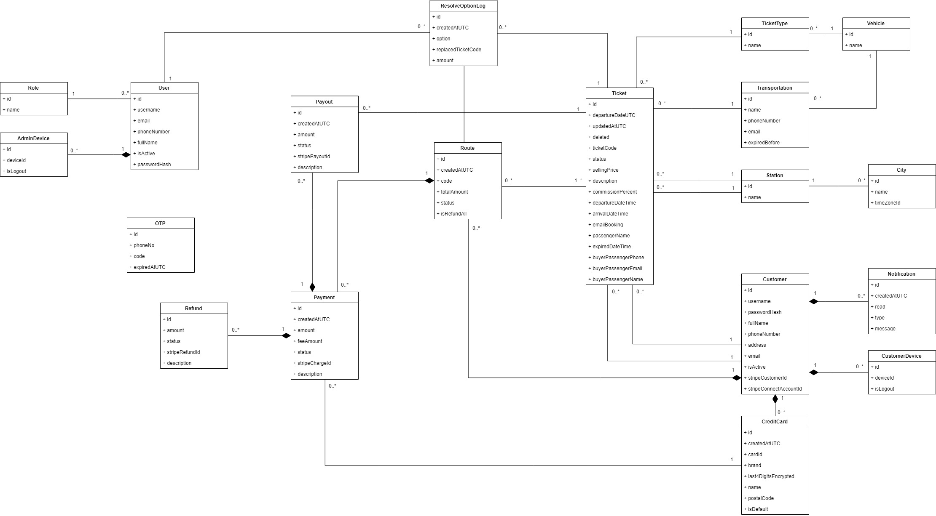

Figure 52 - Class Diagram

### **4.2. Class Diagram Explanation**

|  |  |  |
| --- | --- | --- |
| **CLASS DICTIONARY: DESCRIBE CLASS** | | |
| **Class Name** | **Mapping column with Conceptual diagram** | **Description** |
| Role | N/A | Not existed in Conceptual diagram but needed in class diagram to contain role information. |
| AdminDevice | AdminDevice | Contain Admin Device information. |
| User | Staff, Manager | Contain Staff and manager information. |
| ResolveOptionLog | N/A | Not existed in Conceptual diagram but needed in class diagram to contain log when handle resolve route. |
| TicketType | TicketType | Contain ticket types information. |
| Vehicle | Vehicle | Contain vehicle information. |
| Payout | Payout | Contain Payout information. |
| Route | Route | Contain Route information. |
| Ticket | Ticket | Contain Ticket information. |
| Transportation | Transportation | Contain Transportation information. |
| Station | Station | Contain Station information. |
| City | City | Contain City information. |
| OTP | OTP | Contain OTP information. |
| Refund | Refund | Contain Refund information. |
| Payment | Payment | Contain Payment information. |
| Customer | Customer | Contain Customer information. |
| Notification | Notification | Contain Notification information. |
| CustomerDevice | CustomerDevice | Contain Customer Device information. |
| CreditCard | CreditCard | Contain Credit Card information. |

Table 50 - Class Diagram Data Dictionary

#### 4.2.1. Role

|  |  |  |  |
| --- | --- | --- | --- |
| **Attribute** | **Type** | **Visibility** | **Description** |
| Id | String | Private | Unique identifier of role. |
| Name | String | Private | Role Name. |

Table 51 – Class Diagram Data Dictionary - Role

#### 4.2.2. AdminDevice

|  |  |  |  |
| --- | --- | --- | --- |
| **Attribute** | **Type** | **Visibility** | **Description** |
| Id | Int | Private | Unique identifier of AdminDevice. |
| DeviceId | String | Private | Id of device in OneSignal. |
| IsLogedOut | Bool | Private | Indicate this device is logout or not. |
| UserId | Int | Private | Contain information of the mentioned attribute |

Table 52 - Class Diagram Data Dictionary – AdminDevice

#### 4.2.3. User

|  |  |  |  |
| --- | --- | --- | --- |
| **Attribute** | **Type** | **Visibility** | **Description** |
| Id | Int | Private | Unique identifier of User. |
| Username | String | Private | Username for login. |
| Email | String | Private | Email of this user. |
| PhoneNumber | String | Private | Phone Number of this user. |
| FullName | String | Private | Full Name of this user. |
| IsActive | String | Private | Indicate this user is active or not. |
| PasswordHash | String | Private | Password hashed of this user. |
| RoleId | Int | Private | Contain information of the mentioned attribute. |

Table 53 - Class Diagram Data Dictionary - User

#### 4.2.4. ResolveOptionLog

|  |  |  |  |
| --- | --- | --- | --- |
| **Attribute** | **Type** | **Visibility** | **Description** |
| Id | String | Private | Unique identifier of ResolveOptionLog. |
| CreatedAtUTC | DateTime | Private | Created at UTC Time. |
| Option | Int | Private | Option that staff chose. |
| ReplaceTicketCode | String | Private | Indicate the ticket code that Staff choose to replace. |
| Amount | Decimal | Private | Amount effected when staff choose this resolve option. Use for display statistic purpose. |
| UserId | Int | Private | Contain information of the mentioned attribute |
| RouteId | Int | Private | Contain information of the mentioned attribute |
| TicketId | Int | Private | Contain information of the mentioned attribute |

Table 54 - Class Diagram Data Dictionary - ResolveOptionLog

#### 4.2.5. TicketType

|  |  |  |  |
| --- | --- | --- | --- |
| **Attribute** | **Type** | **Visibility** | **Description** |
| Id | String | Private | Unique identifier of Ticket Type |
| Name | String | Private | Role Ticket Type Name |
| VehicleId | Int | Private | Contain information of the mentioned attribute |

Table 55 - Class Diagram Data Dictionary - TicketType

#### 4.2.6. Vehicle

|  |  |  |  |
| --- | --- | --- | --- |
| **Attribute** | **Type** | **Visibility** | **Description** |
| Id | Int | Private | Unique identifier of Vehicle |
| Name | String | Private | Vehicle Name |

Table 56 - Class Diagram Data Dictionary - Vehicle

#### 4.2.7. Transportation

|  |  |  |  |
| --- | --- | --- | --- |
| **Attribute** | **Type** | **Visibility** | **Description** |
| Id | Int | Private | Unique identifier of Transportation |
| Name | String | Private | Role Transportation Name |
| VehicleId | String | Private | Contain information of the mentioned attribute |

Table 57 - Class Diagram Data Dictionary - Transportation

#### 4.2.8. Payout

|  |  |  |  |
| --- | --- | --- | --- |
| **Attribute** | **Type** | **Visibility** | **Description** |
| Id | Int | Private | Unique identifier of Payout |
| CreatedAtUTC | DateTime | Private | Created At UTC Time |
| Amount | Decimal | Private | Payout Amount |
| Status | Int | Private | Payout Status |
| StripePayoutId | String | Private | Id of payout transaction in Stripe |
| Description | String | Private | For displaying transaction history |
| PaymentId | Int | Private | Contain information of the mentioned attribute |
| TicketId | Int | Private | Contain information of the mentioned attribute |

Table 58 - Class Diagram Data Dictionary - Payout

#### 4.2.9. Route

|  |  |  |  |
| --- | --- | --- | --- |
| **Attribute** | **Type** | **Visibility** | **Description** |
| Id | Int | Private | Unique identifier of Route |
| CreatedAtUTC | DateTime | Private | Created At UTC Time |
| Code | String | Private | Route code |
| TotalAmount | Decimal | Private | Total Amount of this route. |
| Status | Int | Private | Route Status |
| IsRefundAll | Bool | Private | Indicate this route is refunded all or not |
| CustomerId | Int | Private | Contain information of the mentioned attribute |

Table 59 - Class Diagram Data Dictionary - Route

#### 4.2.10. Ticket

|  |  |  |  |
| --- | --- | --- | --- |
| **Attribute** | **Type** | **Visibility** | **Description** |
| Id | Int | Private | Unique identifier of Ticket |
| DepartureDateUTC | DateTime | Private | Departure Date in UTC Time |
| UpdatedAtUTC | DateTime | Private | Updated Date in UTC Time. |
| Deleted | Bool | Private | Indicate this ticket is deleted or not. |
| TicketCode | String | Private | Ticket Code. |
| Status | Int | Private | Ticket Status. |
| SellingPrice | Decimal | Private | Ticket Selling Price |
| Description | String | Private | Ticket Description |
| CommissionPercent | Decimal | Private | Commission Percent of Resell Ticket in this ticket. |
| DepartureDateTime | DateTime | Private | Departure Date in ticket. |
| ArrivalDateTime | DateTime | Private | Arrival Date in ticket. |
| EmailBooking | String | Private | Ticket Email booking. |
| PassengerName | String | Private | Ticket Passenger Name |
| ExpiredDateTime | DateTime | Private | Ticket Expired Date |
| BuyerPassengerPhone | String | Private | New Passenger Phone to change information |
| BuyerPassengerEmail | String | Private | New Passenger Email to change information. |
| BuyerPassengerName | DateTime | Private | New Passenger Name to change information. |
| DepartureStationId | Int | Private | Contain information of the mentioned attribute |
| ArrivalStatitonId | Int | Private | Contain information of the mentioned attribute |
| TransportationId | Int | Private | Contain information of the mentioned attribute |
| SellerId | Int | Private | Contain information of the mentioned attribute |
| BuyerId | Int | Private | Contain information of the mentioned attribute |
| TicketTypeId | Int | Private | Contain information of the mentioned attribute |

Table 60 - Class Diagram Data Dictionary - Ticket

#### 4.2.11. Station

|  |  |  |  |
| --- | --- | --- | --- |
| **Attribute** | **Type** | **Visibility** | **Description** |
| Id | Int | Private | Unique identifier of station |
| Name | String | Private | Station Name |
| CityId | Int | Private | Contain information of the mentioned attribute |

Table 61 - Class Diagram Data Dictionary - Station

#### 4.2.12. City

|  |  |  |  |
| --- | --- | --- | --- |
| **Attribute** | **Type** | **Visibility** | **Description** |
| Id | Int | Private | Unique identifier of city |
| Name | String | Private | City Name |
| TimeZoneId | String | Private | Time zone of this city |

Table 62 - Class Diagram Data Dictionary - City

#### 4.2.13. OTP

|  |  |  |  |
| --- | --- | --- | --- |
| **Attribute** | **Type** | **Visibility** | **Description** |
| Id | Int | Private | Unique identifier of OTP |
| PhoneNo | String | Private | Phone number |
| Code | String | Private | Code |
| ExpireAtUTC | DateTime | Private | Expired date in UTC time. |

Table 63 - Class Diagram Data Dictionary - OTP

#### 4.2.14. Refund

|  |  |  |  |
| --- | --- | --- | --- |
| **Attribute** | **Type** | **Visibility** | **Description** |
| Id | Int | Private | Unique identifier of refund |
| Amount | Decimal | Private | Refund Amount |
| Status | Int | Private | Refund Status |
| StripeRefundId | String | Private | Identity of this transaction in Stripe. |
| Description | String | Private | Refund Description |
| PaymentId | Int | Private | Contain information of the mentioned attribute |

Table 64 - Class Diagram Data Dictionary - Refund

#### 4.2.15. Payment

|  |  |  |  |
| --- | --- | --- | --- |
| **Attribute** | **Type** | **Visibility** | **Description** |
| Id | Int | Private | Unique identifier of payment |
| CreatedAtUTC | DateTime | Private | Created Date in UTC Time |
| Amount | Decimal | Private | Payment Amount |
| FeeAmount | Decimal | Private | Stripe Fee Amount |
| Status | Int | Private | Payment Status |
| StripeChargeId | String | Private | Identity of this transaction in Stripe. |
| RouteId | Int | Private | Contain information of the mentioned attribute |
| CreditCardId | Int | Private | Contain information of the mentioned attribute |

Table 65 - Class Diagram Data Dictionary - Payment

#### 4.2.16. Customer

|  |  |  |  |
| --- | --- | --- | --- |
| **Attribute** | **Type** | **Visibility** | **Description** |
| Id | Int | Private | Unique identifier of customer |
| Username | String | Private | Username |
| PasswordHash | String | Private | Password Hash of this Customer |
| FullName | String | Private | Customer Full Name |
| PhoneNumber | String | Private | Customer Phone Number |
| Address | String | Private | Customer Address |
| Email | String | Private | Customer Email |
| IsActive | Bool | Private | Indicate is this customer active or not |
| StripeCustomerId | String | Private | Id of this customer in Stripe |
| StripeConnectAccountId | String | Private | Id of Customer Receivable Account in Stripe |

Table 66 - Class Diagram Data Dictionary - Customer

#### 4.2.17. Notification

|  |  |  |  |
| --- | --- | --- | --- |
| **Attribute** | **Type** | **Visibility** | **Description** |
| Id | Int | Private | Unique identifier of Notification |
| CreatedAtUTC | DateTime | Private | Created At UTC Time |
| Read | Bool | Private | Indicate this notification is read or not. |
| Type | Int | Private | Notification Type. |
| Message | String | Private | Notification Message |
| CustomerId | Int | Private | Contain information of the mentioned attribute |

Table 67 - Class Diagram Data Dictionary - Notification

#### 4.2.18. CustomerDevice

|  |  |  |  |
| --- | --- | --- | --- |
| **Attribute** | **Type** | **Visibility** | **Description** |
| Id | Int | Private | Unique identifier of CustomerDevice |
| DeviceId | String | Private | Customer Device Id |
| IsLogout | Bool | Private | Indicate customer is logout or not. |
| CustomerId | Int | Private | Contain information of the mentioned attribute |

Table 68 - Class Diagram Data Dictionary - CustomerDevice

#### 4.2.19. CreditCard

|  |  |  |  |
| --- | --- | --- | --- |
| **Attribute** | **Type** | **Visibility** | **Description** |
| Id | Int | Private | Unique identifier of creditCard |
| CreatedAtUTC | DateTime | Private | Created At UTC Time |
| CardId | String | Private | Credit Card Id in Stripe |
| Brand | String | Private | Credit Card Brand |
| Last4DigitsEncryped | String | Private | Last 4 digits in credit card of this customer. |
| Name | String | Private | Credit Card Name. |
| PostalCode | String | Private | Credit Card Postal Code |
| IsDefault | Bool | Private | Indicate this credit card is default payment method or not. |
| CustomerId | Int | Private | Contain information of the mentioned attribute |

Table 69 - Class Diagram Data Dictionary - CreditCard

### **4.3. Interaction Diagram**

#### 4.3.1. Web Application

##### 4.3.1.1. <Manager> Create City

Summary:

* This diagram shows process of Manager creates City.
* Described in use case RT_24

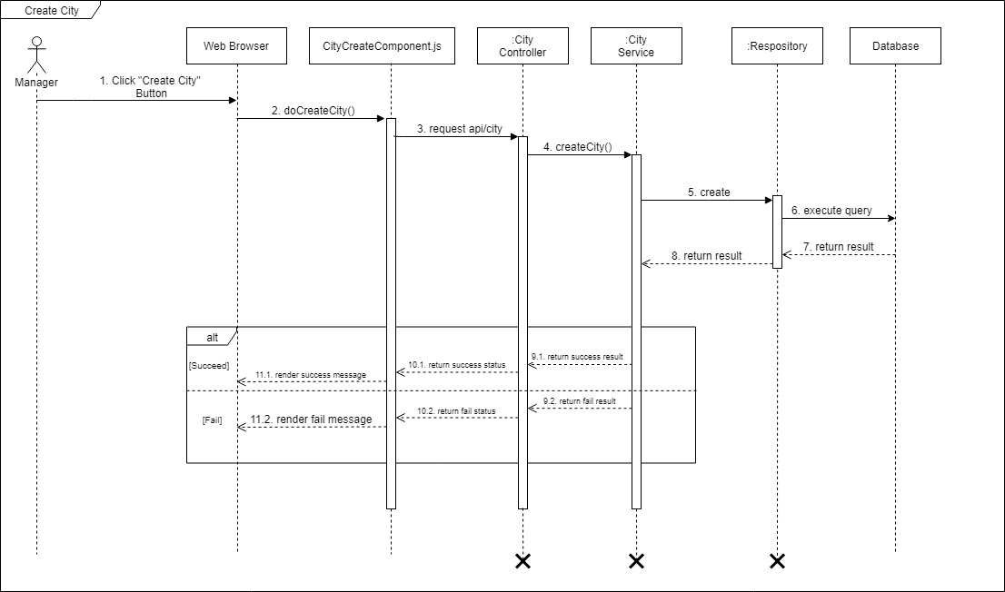

Figure 53 - <Sequence> Manager Creates City

##### 4.3.1.2. <Manager> Edit City

Summary:

* This diagram shows process of Manager edits City.
* Described in use case RT_25.

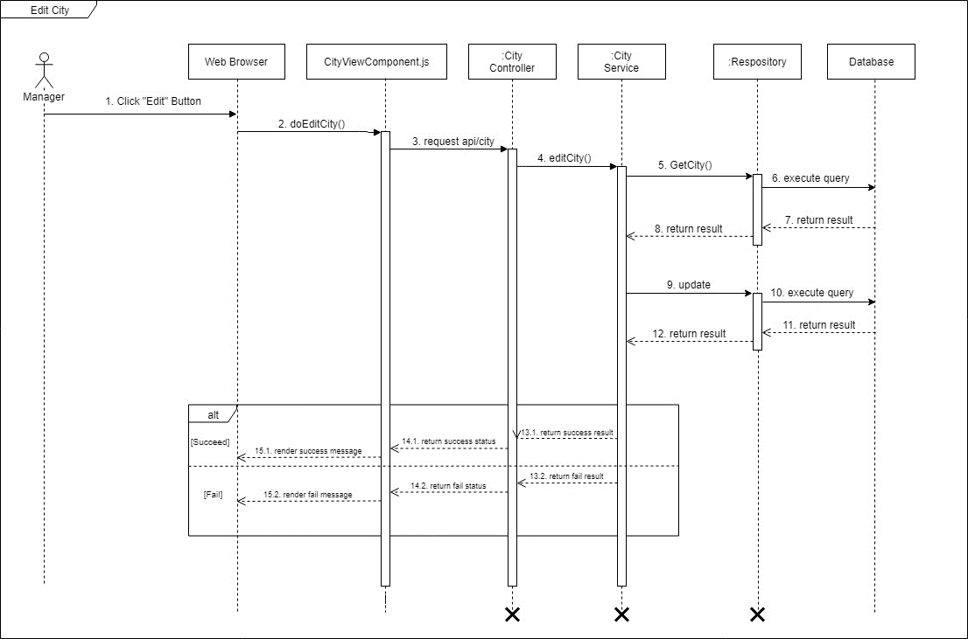

Figure 54 Sequence Diagram - Edit City

##### 4.3.1.3. <Manager> Delete City

Summary:

* This diagram shows process of Manager deletes City.
* Described in use case RT_27.

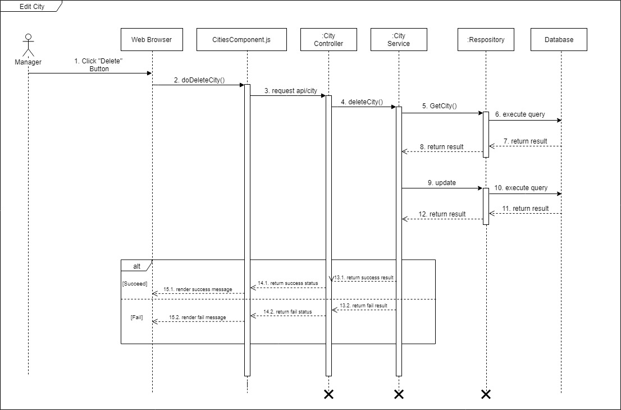

Figure 55 Sequence Diagram - Delete City

##### 4.3.1.4. <Staff> Verify new Ticket

Summary:

* This diagram shows process of Staff verifies a new Ticket.
* Described in use case RT_37.

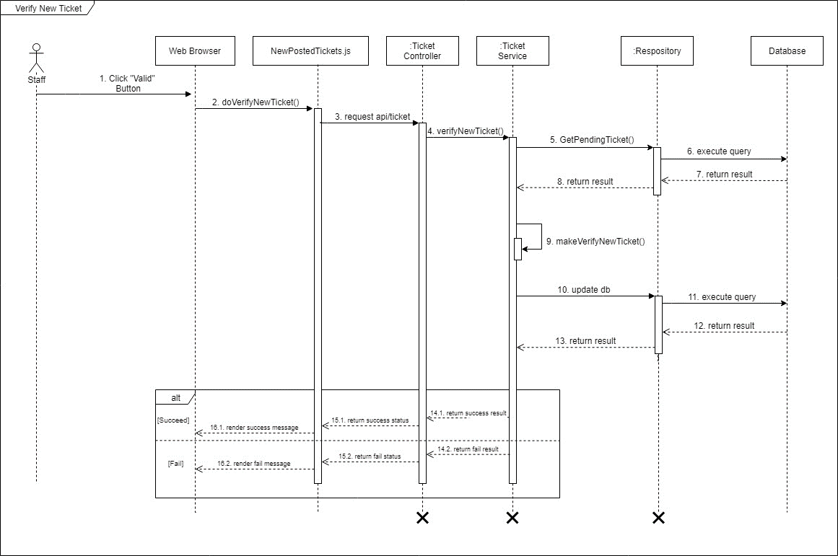

Figure 56 Sequence Diagram – Verify new Ticket

##### 4.3.1.5. <Staff> Verify Ticket Renamed Successfully

Summary:

* This diagram shows process of Staff verifies Ticket is renamed successfully.
* Described in use case RT_38.

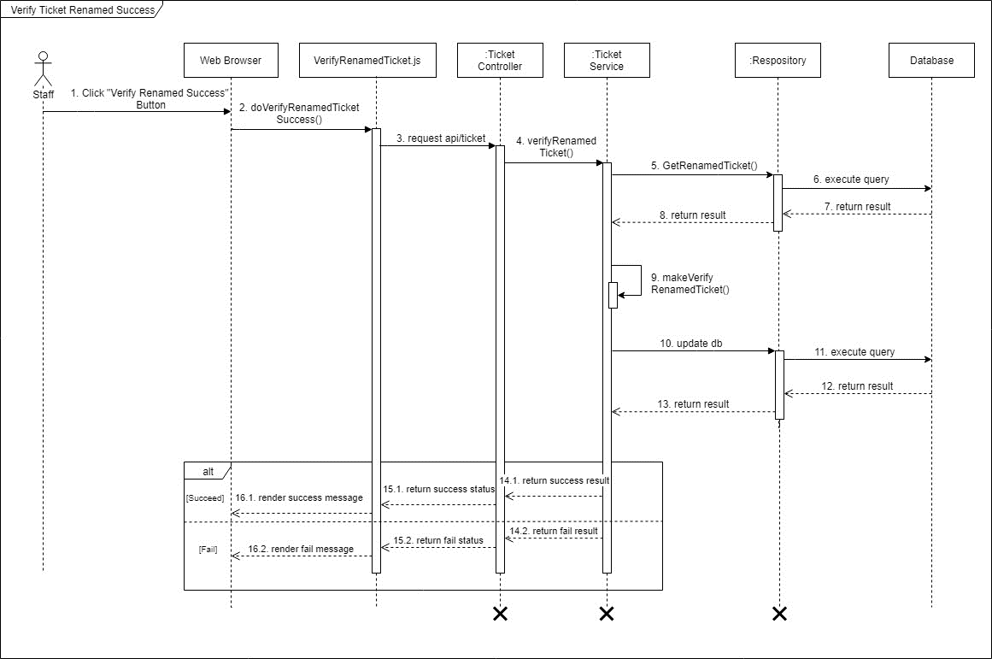

Figure 57 Sequence Diagram – Verify Ticket renamed successfully

##### 4.3.1.6. <Staff> Verify Ticket Renamed Failed

Summary:

* This diagram shows process of Staff verifies Ticket is renamed Failed.
* Described in use case RT_38.

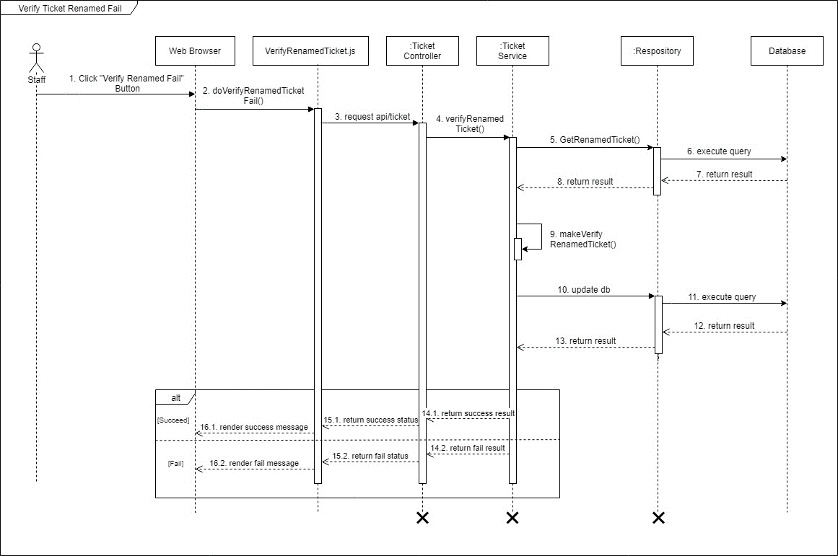

Figure 58 Sequence Diagram – Verify Ticket renamed failed

##### 4.3.1.7. <Staff> Payout

Summary:

* This diagram shows process of Staff transfer money to seller customer.
* Described in use case RT_39.

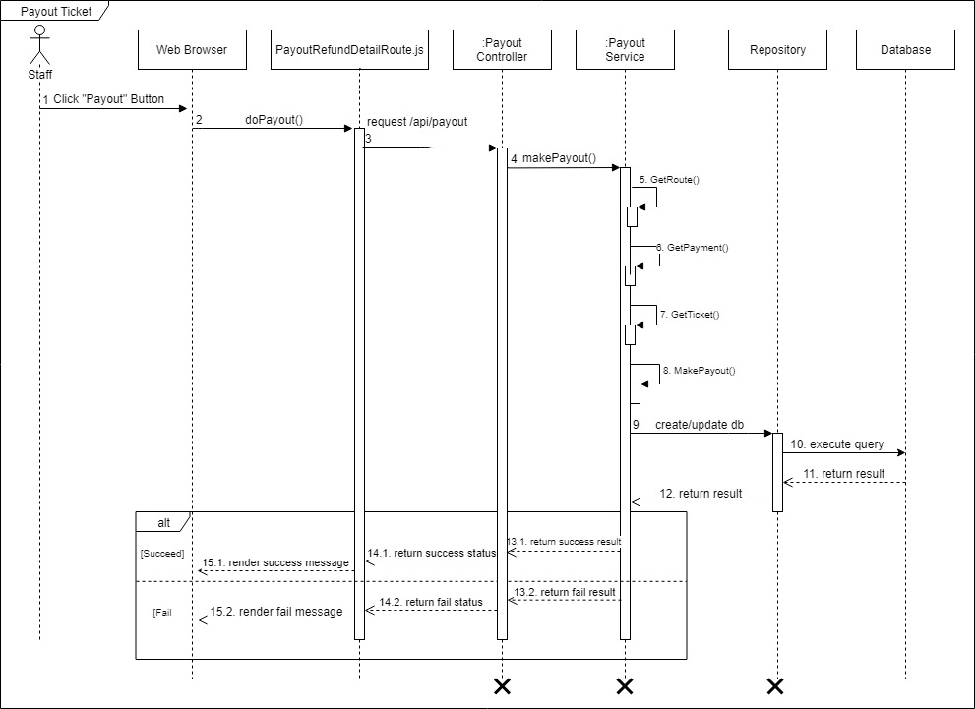

Figure 59 Sequence Diagram - Payout

##### 4.3.1.8. <Staff> Refund a ticket

Summary:

* This diagram shows process of Staff refund buyer a single ticket in his route.
* Described in use case RT_40.

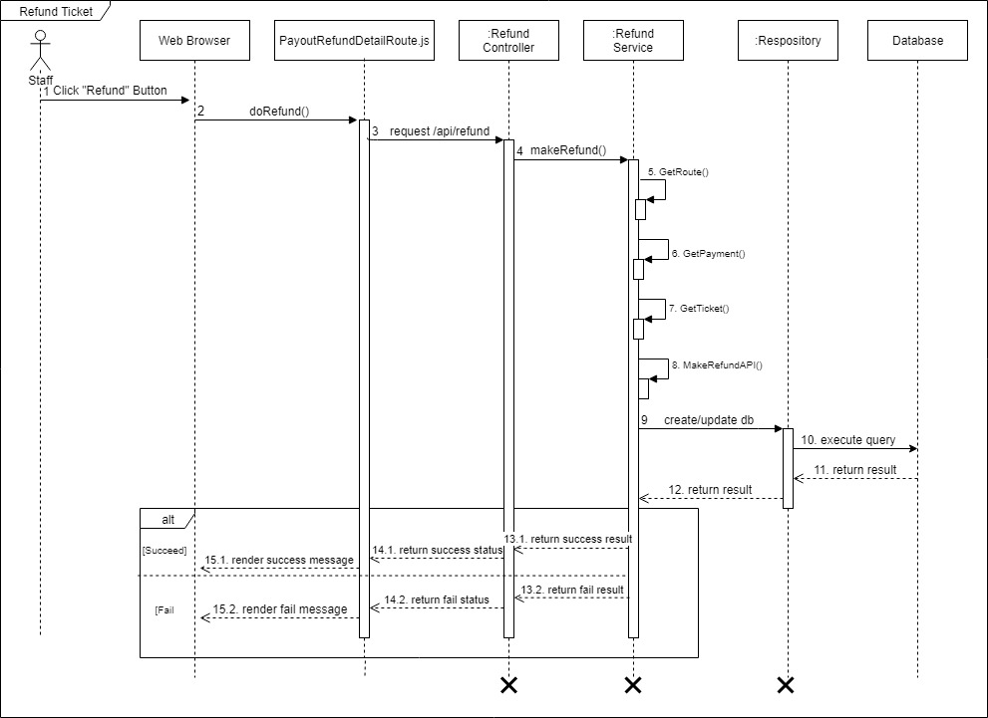

Figure 60 Sequence Diagram – Refund a Ticket

##### 4.3.1.9. <Staff> Refund a route

Summary:

* This diagram shows process of Staff refunds a route for buyer customer.
* Described in use case RT_40.

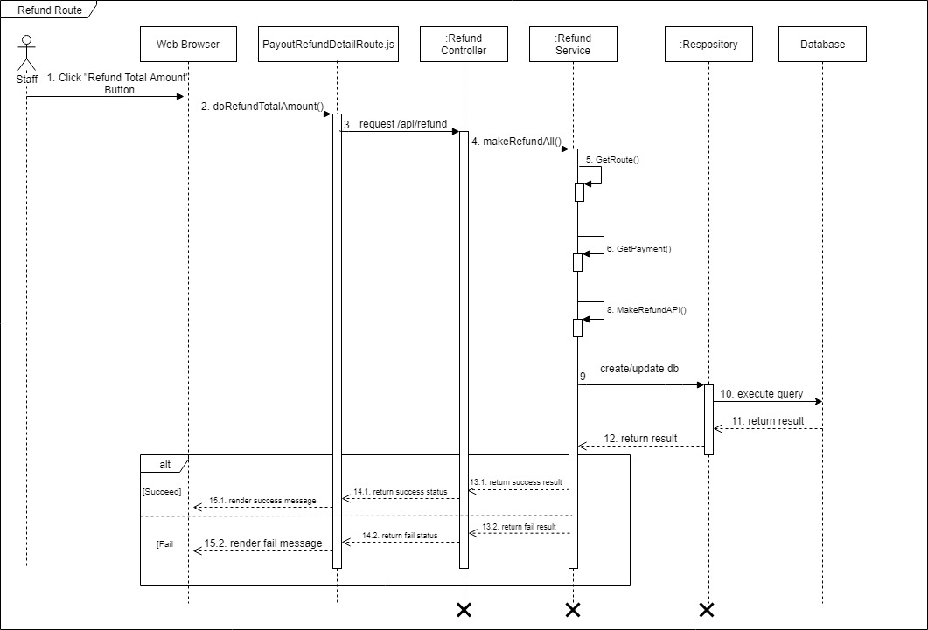

Figure 61 Sequence Diagram - Refund a route

##### 4.3.1.10. <Staff> Replace Ticket

Summary:

* This diagram shows process of Staff replaces a failed ticket for buyer customer.
* Described in use case RT_41.

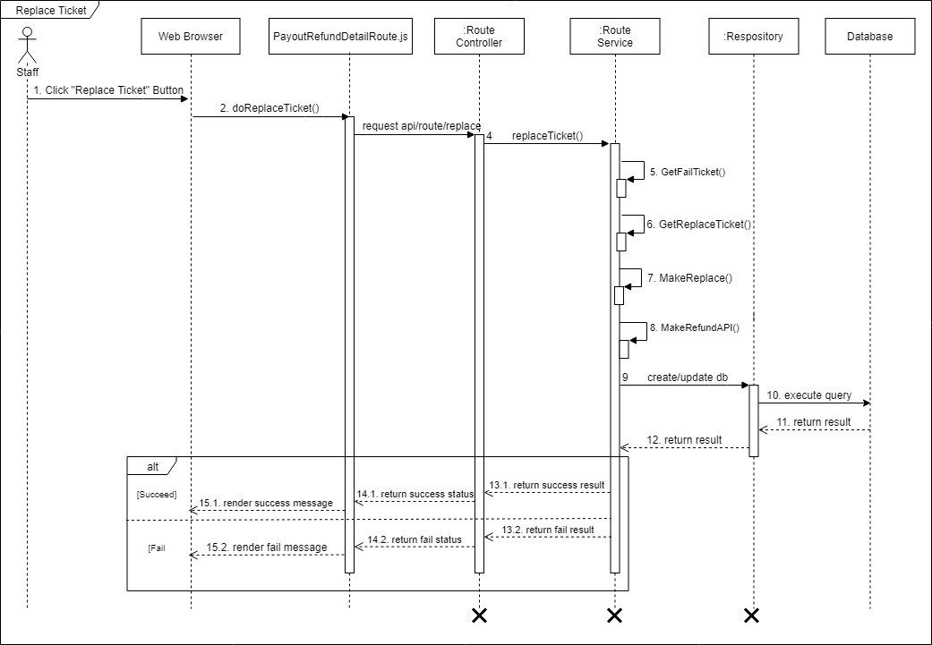

Figure 62 Sequence Diagram - Replace Ticket

#### 4.3.2. Mobile Application

##### 4.3.2.1. <Guest> Login Guest

Summary:

* This diagram shows process of Guest login into system.
* Described in use case RT_01.

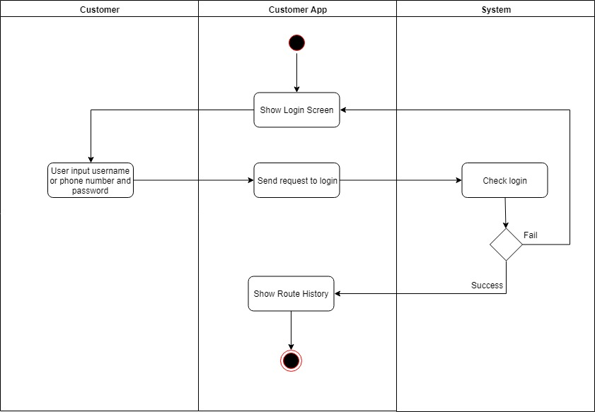

Figure 63 Activity Diagram - Login Guest

##### 4.3.2.2. <Customer> Add Credit Card

Summary:

* This diagram shows process of Customer add credit card.
* Described in use case RT_01.

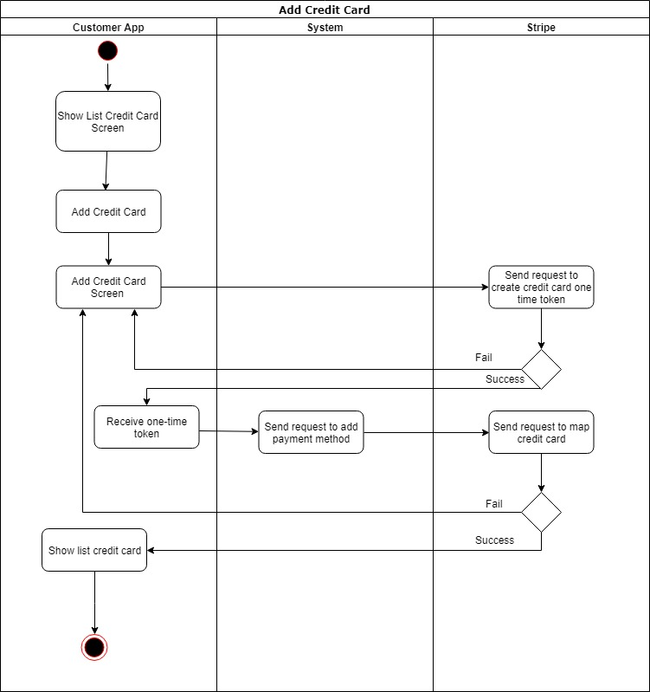

Figure 64 Activity Diagram - Add Credit Card

##### 4.3.2.3. <Customer> Delete Credit Card

Summary:

* This diagram shows process of Customer delete credit card.
* Described in use case RT_01.

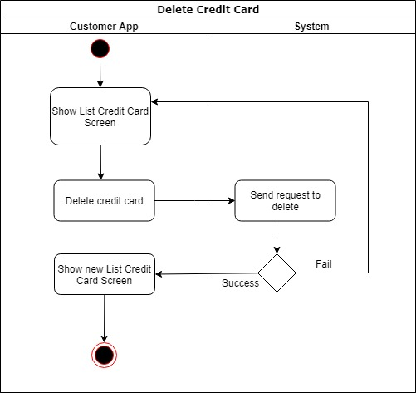

Figure 65 Activity Diagram – Delete Credit Card

##### 4.3.2.4. <Customer> Set Default Credit Card

Summary:

* This diagram shows process of Customer set default credit card.
* Described in use case RT_01.

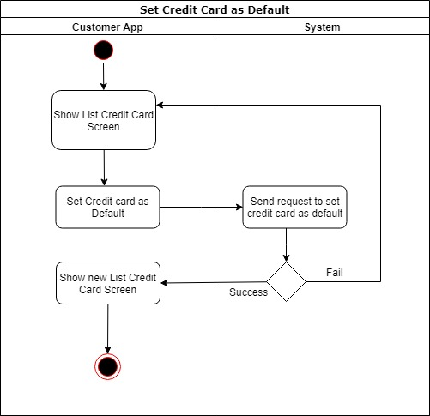

Figure 66 Activity Diagram – Set Default Credit Card

##### 4.3.2.5. <Customer> Update Profile

Summary:

* This diagram shows process of customer updates profile.
* Described in use case RT_01.

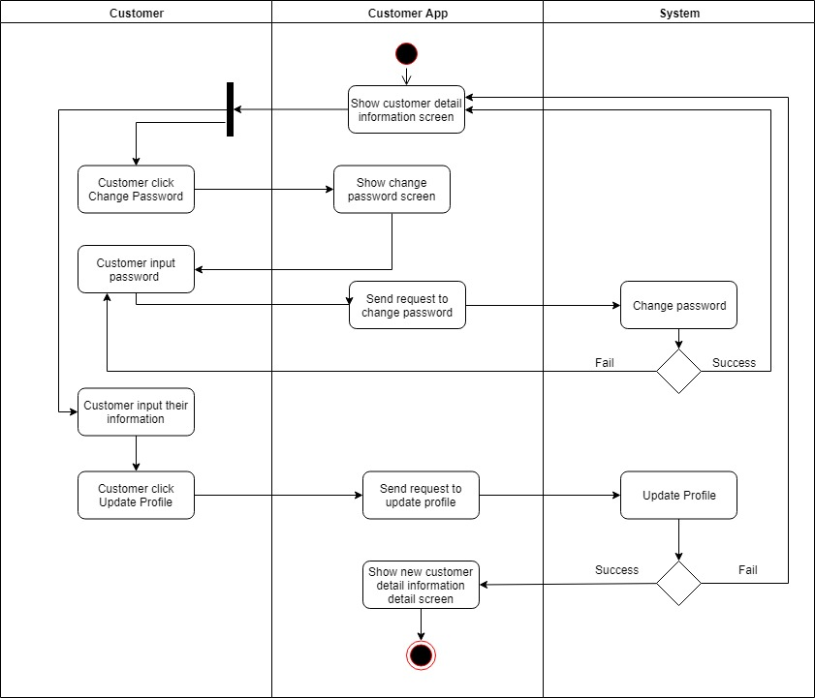

Figure 67 Activity Diagram – Update Profile

##### 4.3.2.6. <Customer> Create Receivable Account

Summary:

* This diagram shows process of Customer create Receivable account.
* Described in use case RT_01.

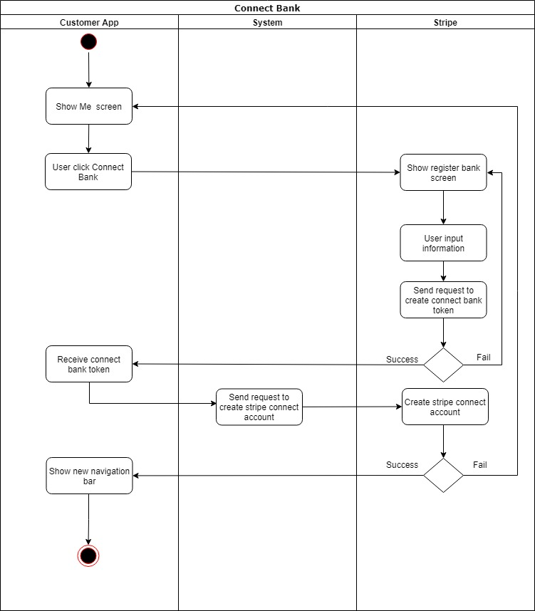

Figure 68 Activity Diagram – Create Receivable Account

##### 4.3.2.7. <Customer> View Receivable Account

Summary:

* This diagram shows process of Customer view receivable account.
* Described in use case RT_01.

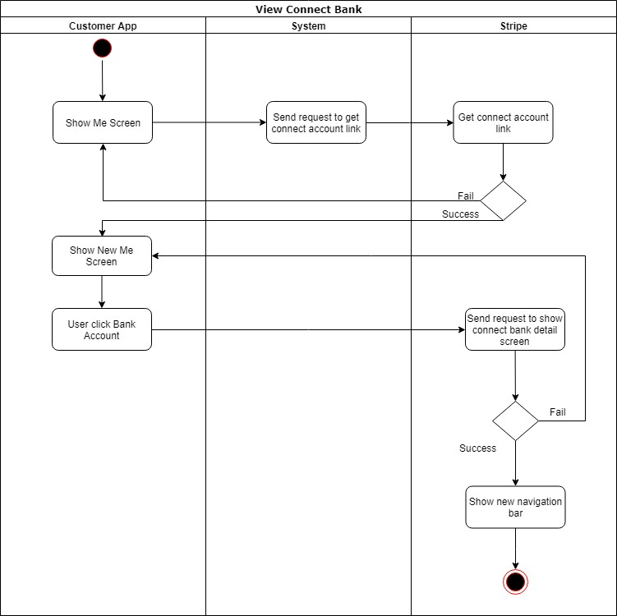

Figure 69 Activity Diagram – View Receivable Account

##### 4.3.2.8. <Customer> Post Unused Ticket

Summary:

* This diagram shows process of Customer posts unused Ticket into system.
* Described in use case RT_01.

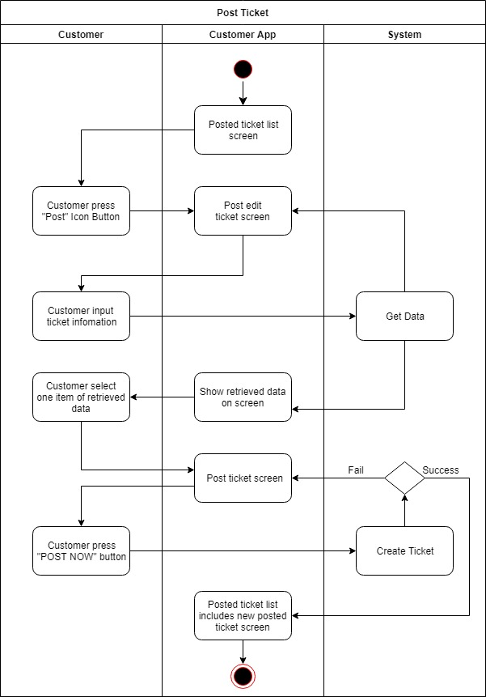

Figure 70 Activity Diagram – Post unused ticket

##### 4.3.2.9. <Customer> Edit Posted Ticket

Summary:

* This diagram shows process of Customer Edit Posted Ticket.
* Described in use case RT_01.

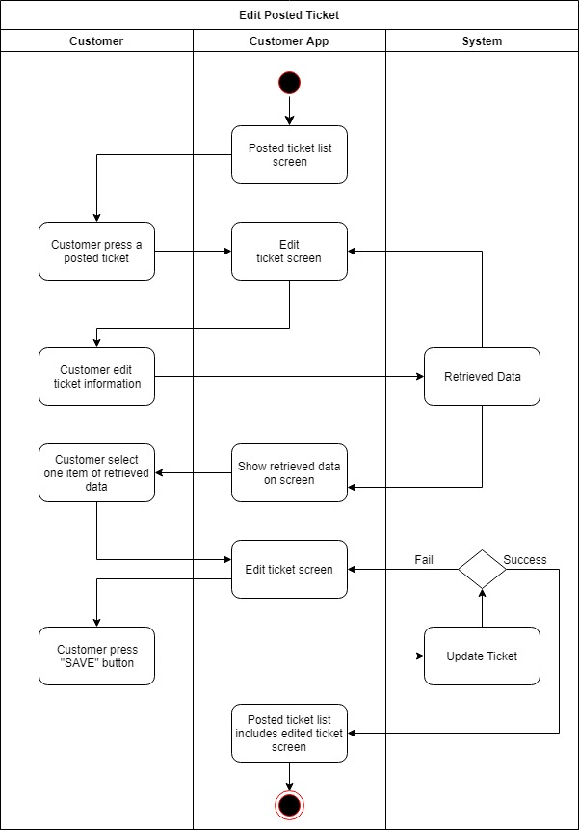

Figure 71 Activity Diagram – Edit Posted Ticket

##### 4.3.2.10. <Customer> Delete Posted Ticket

Summary:

* This diagram shows process of Customer deletes posted Ticket.
* Described in use case RT_01.

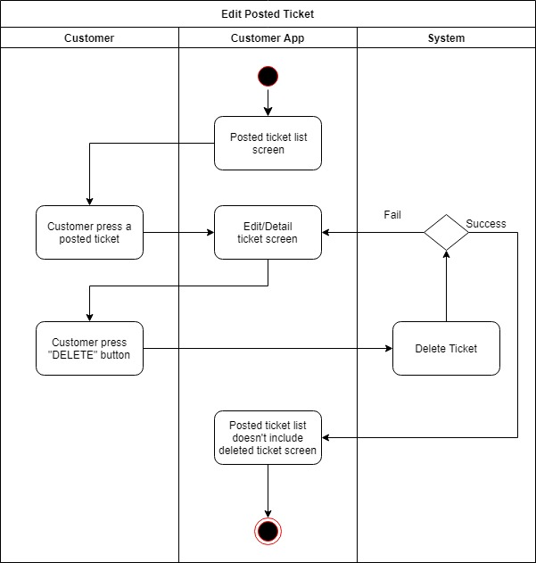

Figure 72 Activity Diagram – Delete Posted Ticket

##### 4.3.2.11. <Customer> Confirm renamed Ticket

Summary:

* This diagram shows process of Seller customer confirm renamed ticket.
* Described in use case RT_01.

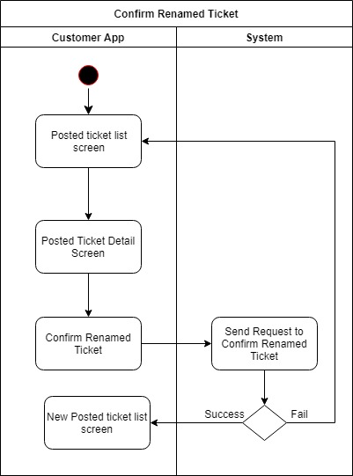

Figure 73 Activity Diagram – Confirm renamed Ticket

##### 4.3.2.12 <Customer> Refuse renamed Ticket

Summary:

* This diagram shows process of Customer refuses renamed Ticket.
* Described in use case RT_01.

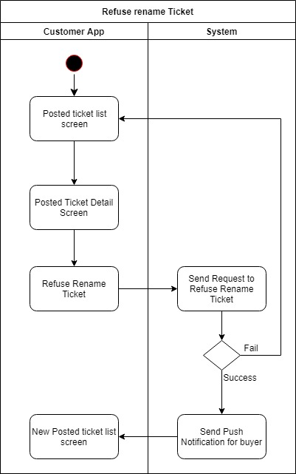

Figure 74 Activity Diagram – Refuse Renamed Ticket

##### 4.3.2.14. <Customer> Buy Route

Summary:

* This diagram shows process of Customer buys Route.
* Described in use case RT_01.

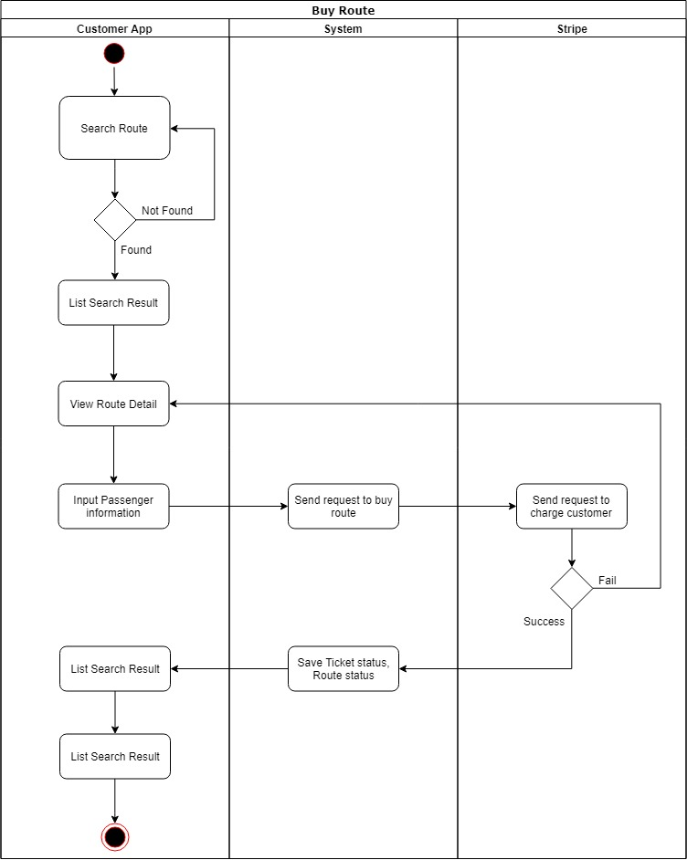

Figure 75 Activity Diagram – Buy route

## Interface

### **5.1. Component Interface**

### **5.2. User Interface Design**

#### 5.2.1. Web Customer Interface

##### 5.2.1.1. Login Page

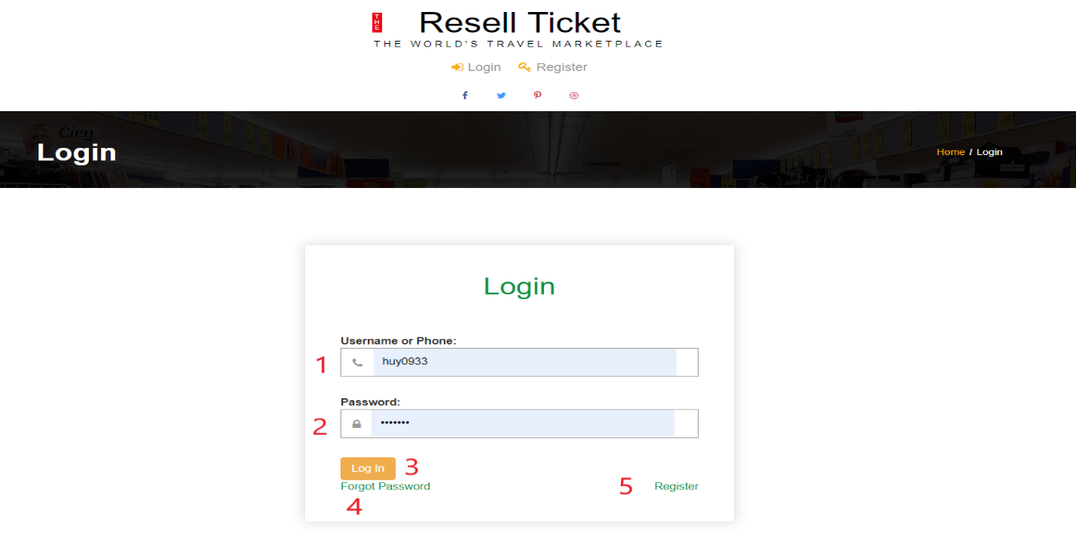

Figure 76 - <Interface> Login Page

**Fields**

|  |  |  |  |  |  |  |
| --- | --- | --- | --- | --- | --- | --- |
| **No** | **Field Name** | **Description** | **Read only** | **Mandatory** | **Control Type** | **Data Type** |
| 1 | Username or Phone | Username or Phone to login | No | Yes | TextBox | String |
| 2 | Password | Password to login | No | Yes | TexBox | String |

Table 70 - <Field> Login Page

**Buttons/Hyperlinks:**

|  |  |  |  |  |
| --- | --- | --- | --- | --- |
| **No** | **Function** | **Description** | **Validation** | **Outcome** |
| 3 | Login | Login into the system | Required | Redirect to home page |
| 4 | Forgot Password | Reset a new password |  | Redirect to forgot password page |
| 5 | Register | Sign up a new account |  | Redirect to register page |

Table 71 - <Button/Hyperlinks> Login Page

##### 5.2.1.2. Register Phone Page

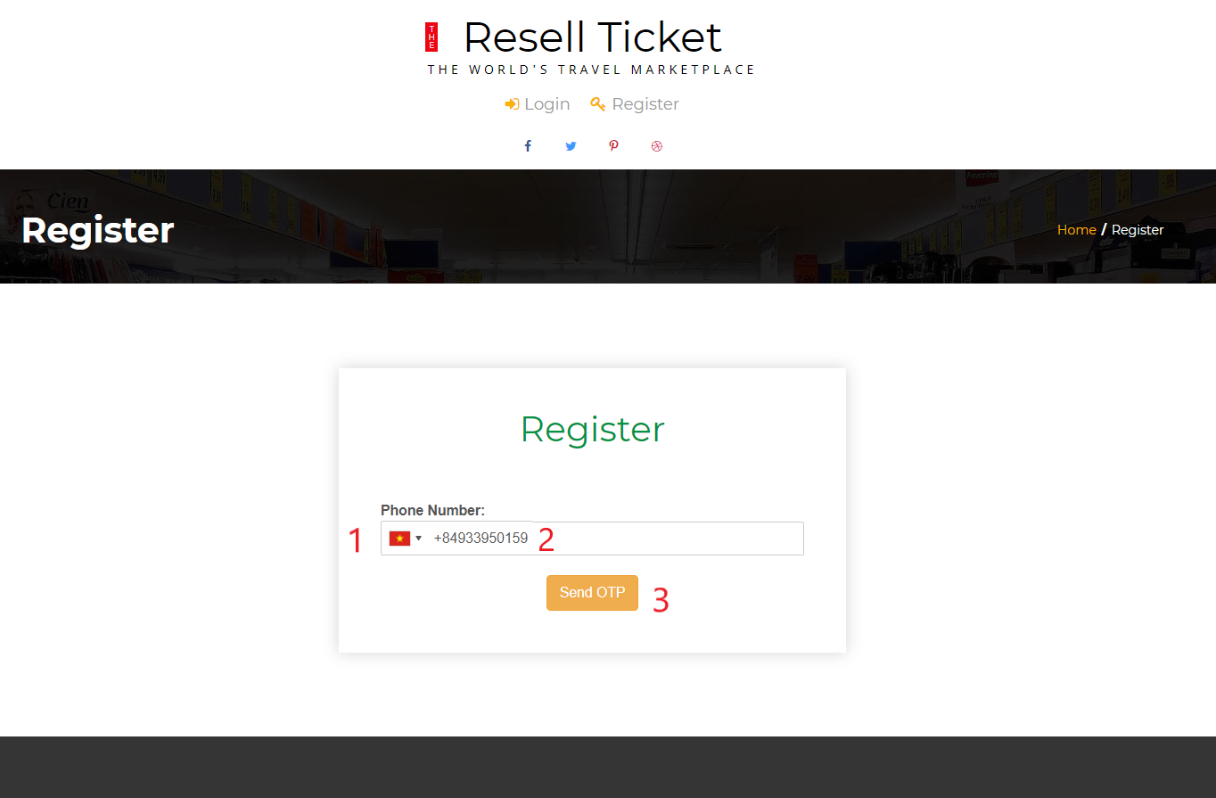

Figure 77 - <Interface> Register Phone Page

**Fields**

|  |  |  |  |  |  |  |
| --- | --- | --- | --- | --- | --- | --- |
| **No** | **Field Name** | **Description** | **Read only** | **Mandatory** | **Control Type** | **Data Type** |
| 1 | Country Code | Country code to register phone | No | Yes | combobox | String |
| 2 | Phone number | Phone number to send OTP | No | Yes | TexBox | String |

Table 72 - <Field> Register Phone Page

**Buttons/Hyperlinks:**

|  |  |  |  |  |
| --- | --- | --- | --- | --- |
| **No** | **Function** | **Description** | **Validation** | **Outcome** |
| 3 | Send OTP | Send OTP code to phone | Required | Redirect to register account page |

Table 73 - <Button/Hyperlinks> Register Phone Page

##### 5.2.1.3. Register Account Page

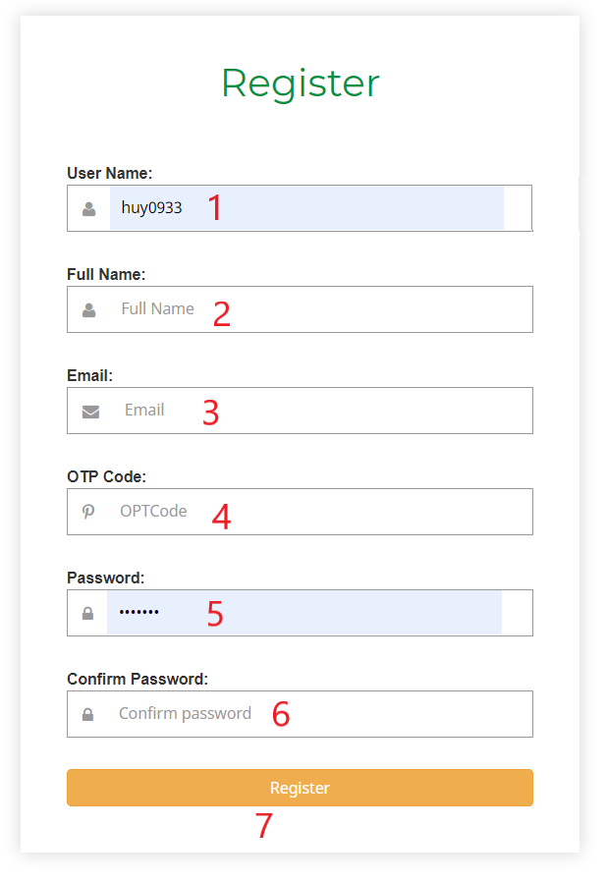

Figure 78 - <Interface> Register Account Page

**Fields**

|  |  |  |  |  |  |  |
| --- | --- | --- | --- | --- | --- | --- |
| **No** | **Field Name** | **Description** | **Read only** | **Mandatory** | **Control Type** | **Data Type** |
| 1 | Username | Username to login | No | Yes | Textbox | string |
| 2 | Fullname | Fullname | No | Yes | Texbox | string |
| 3 | Email | Email to receive email | No | Yes | Textbox | string |
| 4 | OTPCode | OTPCode to verify | No | Yes | Textbox | string |
| 5 | Password | Password to login | No | Yes | Textbox | string |
| 6 | Confirm password | Confirm password | No | Yes | Textbox | string |

Table 74 - <Field> Register Account Page

**Buttons/Hyperlinks:**

|  |  |  |  |  |
| --- | --- | --- | --- | --- |
| **No** | **Function** | **Description** | **Validation** | **Outcome** |
| 3 | Register | Register a new account | Required | Redirect to login page |

Table 75 - <Button/Hyperlinks>Register Account Page

##### 5.2.1.4. Navigation

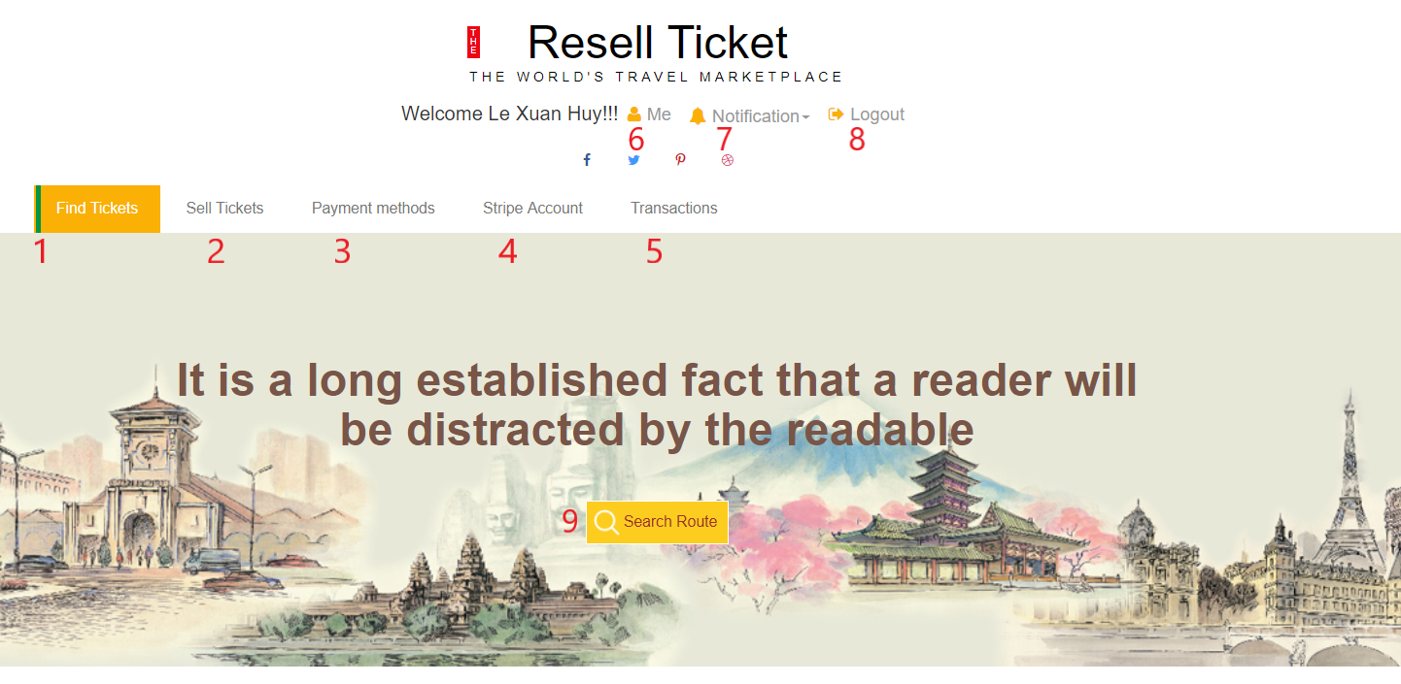

Figure 79 - <Interface> Navigation

**Buttons/Hyperlinks:**

|  |  |  |  |  |
| --- | --- | --- | --- | --- |
| **No** | **Function** | **Description** | **Validation** | **Outcome** |
| 1 | Find Tickets | Redirect to routes page | N/A | Redirect to routes page |
| 2 | Sell Tickets | Redirect to selling tickets page | N/A | Redirect to selling tickets page |
| 3 | Payment methods | Redirect to payment methods page | N/A | Redirect to payment methods page |
| 4 | Stripe Account | Redirect to Stripe account page | N/A | Redirect to Stripe account page |
| 5 | Transactions | Redirect to transaction history page | N/A | Redirect to transaction history page |
| 6 | Me | Account’s profile | N/A | Redirect to account’s profile |
| 7 | Notification | Notification history list | N/A | Render a notification history box |
| 8 | Logout | Logout | N/A | Redirect to home page |
| 9 | Search Route | Search route | N/A | Redirect to search route page |

Table 76 - <Button/Hyperlinks> Navigation

##### 5.2.1.5. Route list page

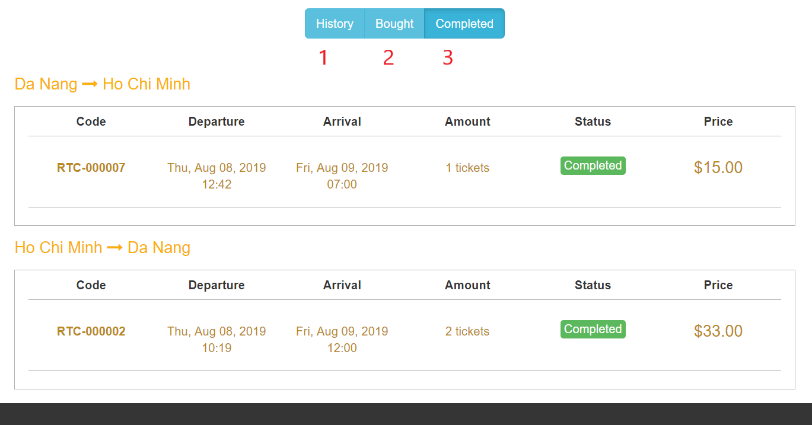

Figure 80 - <Interface> Route List Page

**Buttons/Hyperlinks:**

|  |  |  |  |  |
| --- | --- | --- | --- | --- |
| **No** | **Function** | **Description** | **Validation** | **Outcome** |
| 1 | History | Saved route list | N/A | Render saved route list |
| 2 | Bought | Bought route list | N/A | Render bought route list |
| 3 | Completed | Completed route list | N/A | Render completed route list |

Table 77 - <Button/Hyperlinks> Route List Page

##### 5.2.1.6. Search Route Page

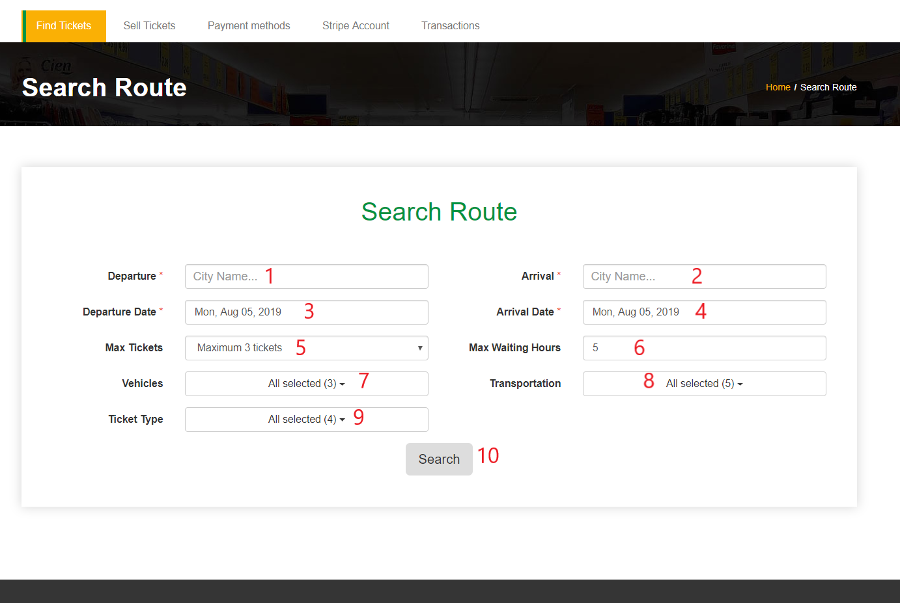

Figure 81 - <Interface> Search Route Page

**Fields**

|  |  |  |  |  |  |  |
| --- | --- | --- | --- | --- | --- | --- |
| **No** | **Field Name** | **Description** | **Read only** | **Mandatory** | **Control Type** | **Data Type** |
| 1 | Departure | Departure City | No | Yes | Textbox | string |
| 2 | Arrival | Arrival city | No | Yes | Texbox | string |
| 3 | Departure Date | Departure date | No | Yes | Textbox | string |
| 4 | Arrival Date | Arrival date | No | Yes | Textbox | string |
| 5 | Max tickets | Max tickets in route | No | Yes | Combobox | String |
| 6 | Max Waiting Hours | Max waiting between 2 tickets | No | Yes | Textbox | number |
| 7 | Vehicles | Vehicles | No | Yes | Multi select box | String |
| 8 | Transportation | Transportation | No | Yes | Multi select box | String |
| 9 | Ticket type | Ticket type | No | Yes | Multi select box | string |

Table 78 - <Field> Search Route Page

**Buttons/Hyperlinks:**

|  |  |  |  |  |
| --- | --- | --- | --- | --- |
| **No** | **Function** | **Description** | **Validation** | **Outcome** |
| 1 | Search | Search route | Required | Redirect to searched result page |

Table 79 - <Button/Hyperlinks> Search Route Page

##### 5.2.1.7. Searched Result Page

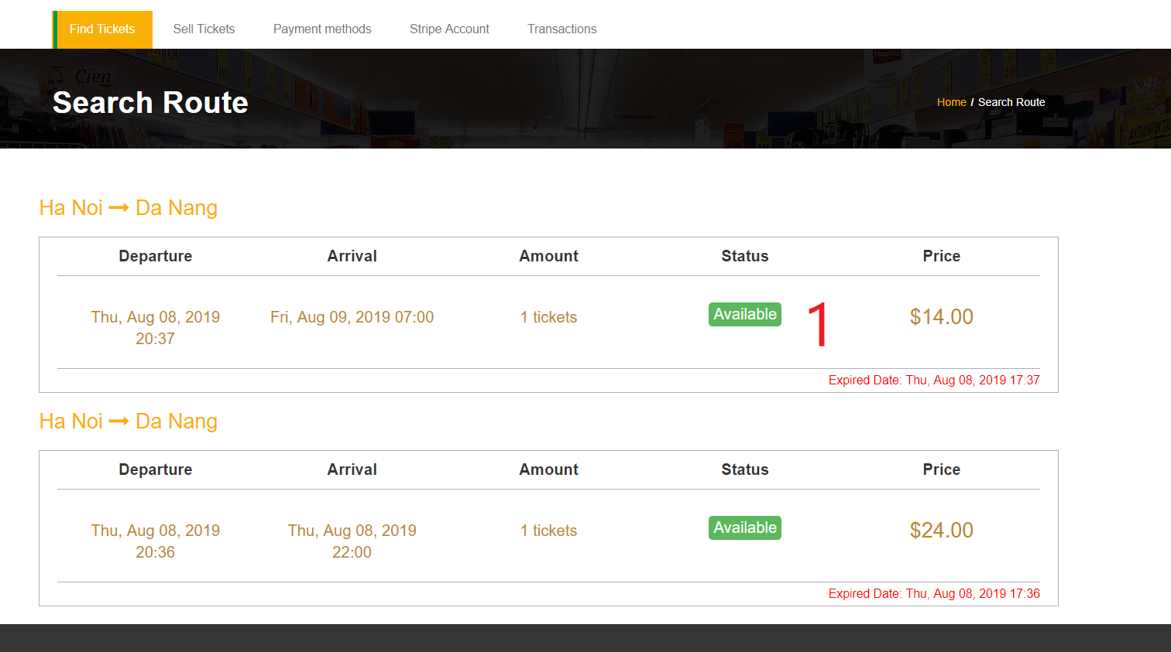

Figure 82 - <Interface> Searched Result Page

**Buttons/Hyperlinks:**

|  |  |  |  |  |
| --- | --- | --- | --- | --- |
| **No** | **Function** | **Description** | **Validation** | **Outcome** |
| 1 | Route | Route |  | Redirect to route detail page |

Table 80 - <Button/Hyperlinks> Search Result Page

##### 5.2.1.8. Route Detail Page

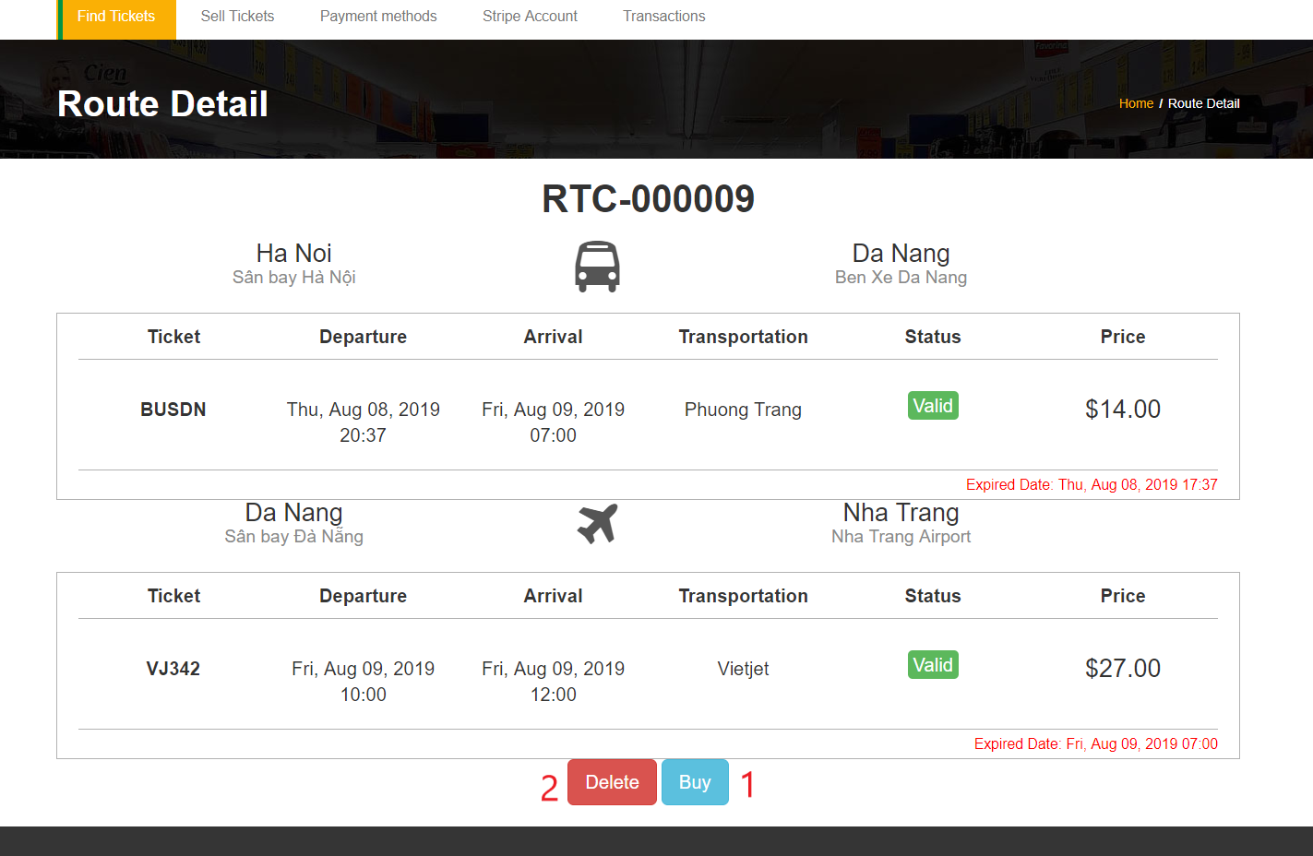

Figure 83 - <Interface> Route Detail Page

**Buttons/Hyperlinks:**

|  |  |  |  |  |
| --- | --- | --- | --- | --- |
| **No** | **Function** | **Description** | **Validation** | **Outcome** |
| 1 | Buy | Buy route | N/A | Render modal to input buyer’s information |
| 2 | Delete | Delete saved route | N/A | Redirect route list page |

Table 81 - <Button/Hyperlinks> Route Detail Page

##### 5.2.1.9. Buyer Customer Modal

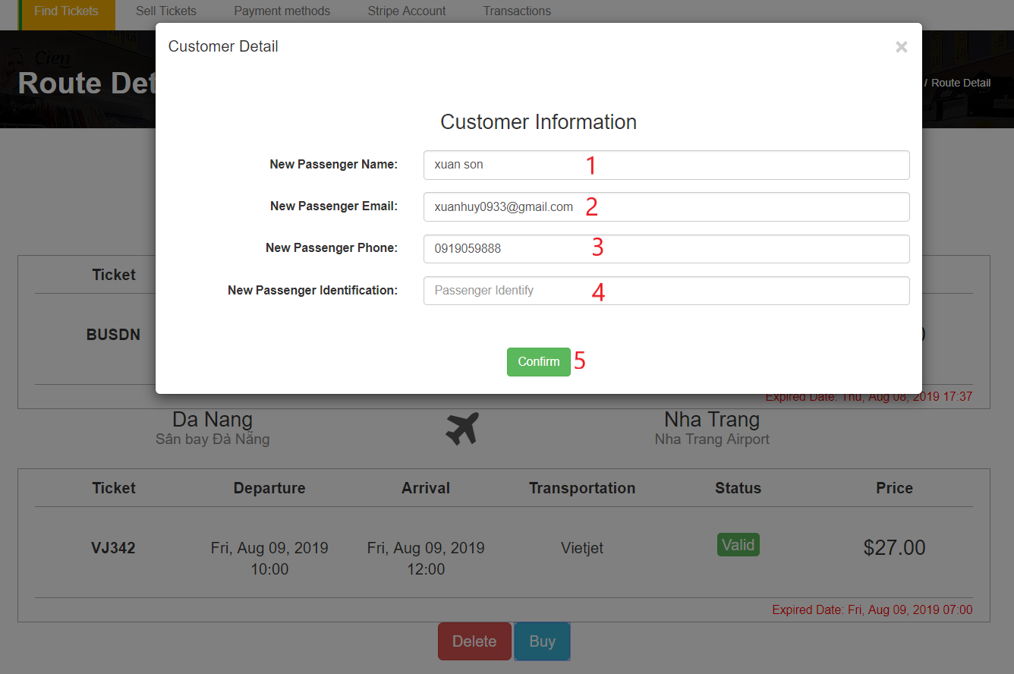

Figure 84 - <Interface> Buyer Customer Modal

**Fields**

|  |  |  |  |  |  |  |
| --- | --- | --- | --- | --- | --- | --- |
| **No** | **Field Name** | **Description** | **Read only** | **Mandatory** | **Control Type** | **Data Type** |
| 1 | New Passenger Name | New passenger name | No | Yes | Textbox | string |
| 2 | New Passenger Email | New passenger email | No | Yes | Texbox | string |
| 3 | New Passenger Phone | New passenger phone | No | Yes | Textbox | string |
| 4 | New Passenger Identification | New passenger identification | No | Yes | Textbox | string |

Table 82 - <Field> Buyer Customer Modal

**Buttons/Hyperlinks:**

|  |  |  |  |  |
| --- | --- | --- | --- | --- |
| **No** | **Function** | **Description** | **Validation** | **Outcome** |
| 1 | Confirm | Confirm buy route | N/A | Redirect to route list page |

Table 83 - <Button/Hyperlinks> Buyer Customer Modal

##### 5.2.1.10. Transaction History Page

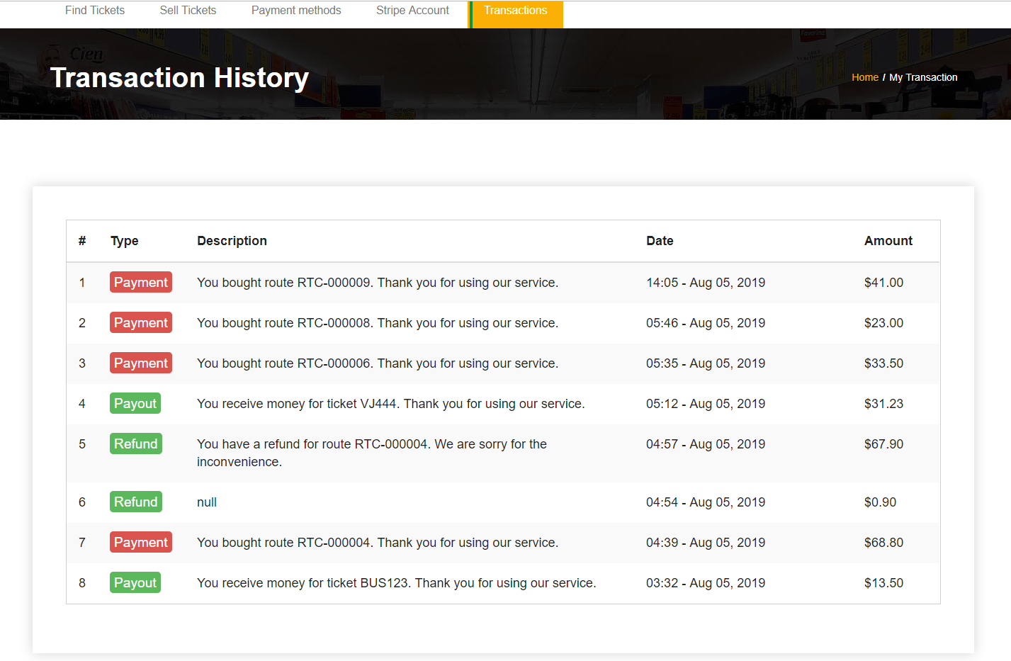

Figure 85 - <Interface> Transaction History Page

##### 5.2.1.11. Notification List

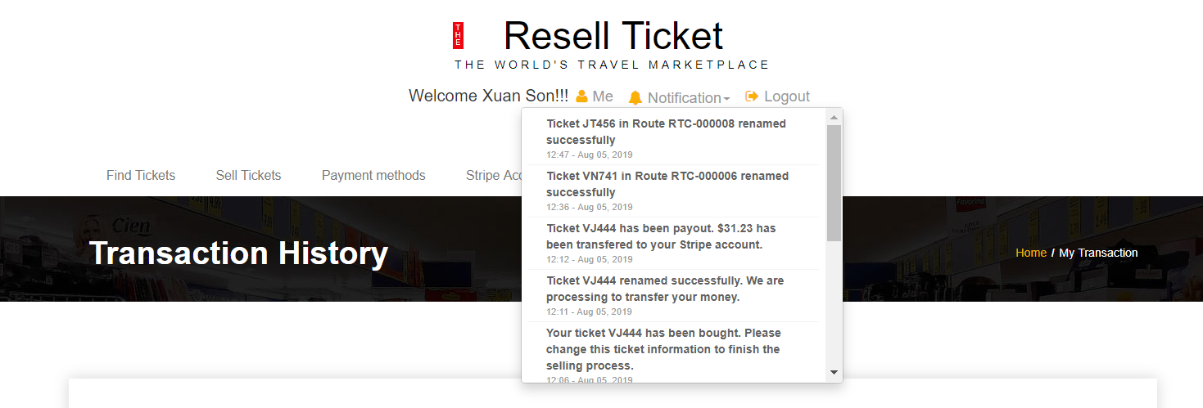

Figure 86 - <Interface> Notification List

##### 5.2.1.12. Update Profile Page

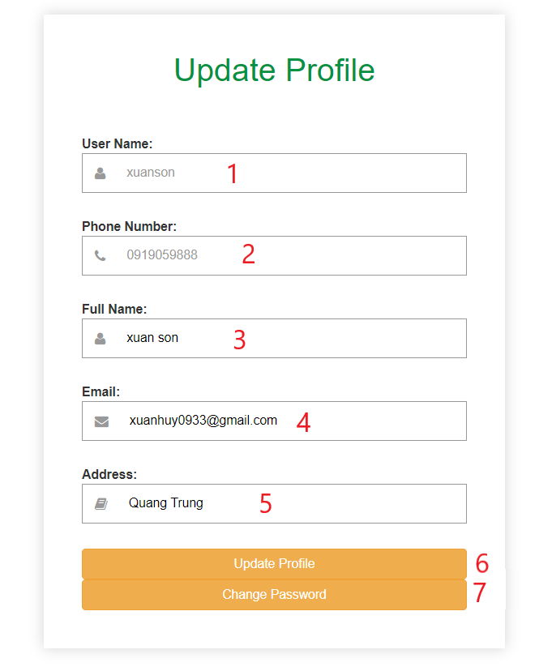

Figure 87 - <Interface> Update Profile Page

**Fields**

|  |  |  |  |  |  |  |
| --- | --- | --- | --- | --- | --- | --- |
| **No** | **Field Name** | **Description** | **Read only** | **Mandatory** | **Control Type** | **Data Type** |
| 1 | Username | Customer’s username | Yes | Yes | Textbox | string |
| 2 | Phone Number | Customer’s phone number | Yes | Yes | Texbox | string |
| 3 | Full name | Customer ‘s full name | No | yes | Textbox | string |
| 5 | Email | Customer’s email | No | Yes | Textbox | string |
| 6 | Address | Customer’s address | No | No | Textbox | String |

Table 84 - <Field> Update Profile Page

**Buttons/Hyperlinks:**

|  |  |  |  |  |
| --- | --- | --- | --- | --- |
| **No** | **Function** | **Description** | **Validation** | **Outcome** |
| 1 | Update Profile | Update new customer’s profile | N/A | Render update successfully |
| 2 | Change Password | Change customer account password | N/A | Redirect to change password page |

Table 85 - <Button/Hyperlinks> Update Profile Page

##### 5.2.1.13. Change Password Page

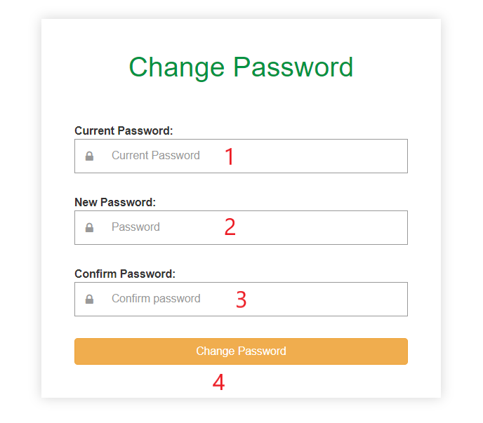

Figure 88 - <Interface> Change Password Page

**Fields**

|  |  |  |  |  |  |  |
| --- | --- | --- | --- | --- | --- | --- |
| **No** | **Field Name** | **Description** | **Read only** | **Mandatory** | **Control Type** | **Data Type** |
| 1 | Current password | Customer’s current password | No | Yes | Textbox | string |
| 2 | New password | New password | No | Yes | Texbox | string |
| 3 | Confirm password | Confirm password | No | yes | Textbox | string |

Table 86 - <Field> Change Password Page

**Buttons/Hyperlinks:**

|  |  |  |  |  |
| --- | --- | --- | --- | --- |
| **No** | **Function** | **Description** | **Validation** | **Outcome** |
| 1 | Change Password | Change current password to new password | N/A | Render change password successfully |

Table 87 - <Button/Hyperlinks> Change Password Page

##### 5.2.1.14. Stripe Account

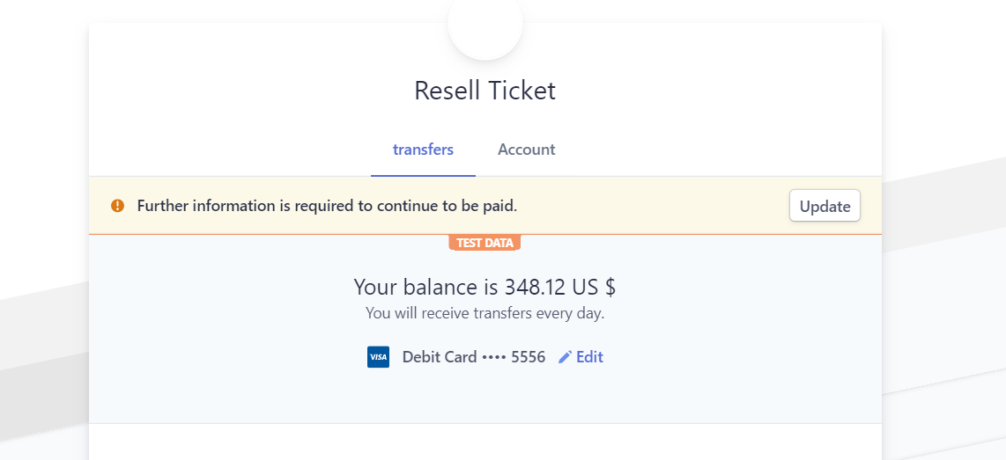

Figure 89 - <Interface> Stripe Account

##### 5.2.1.15. Payment Method Page

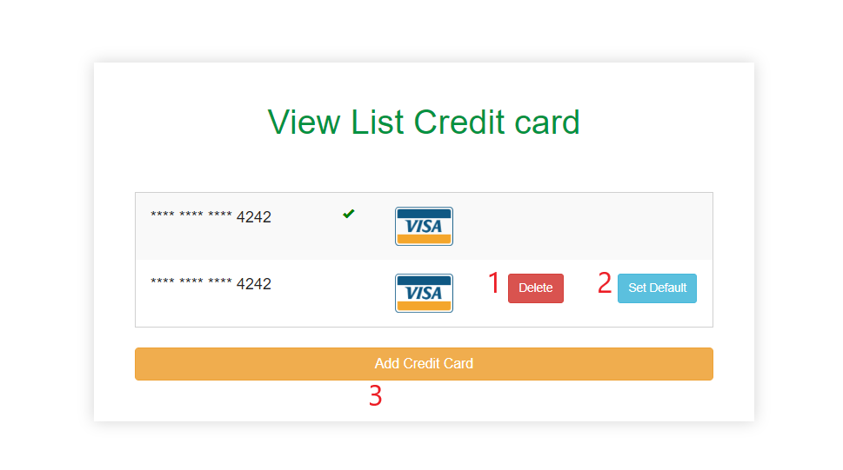

Figure 90 - <Interface> Payment Method Page

**Buttons/Hyperlinks:**

|  |  |  |  |  |
| --- | --- | --- | --- | --- |
| **No** | **Function** | **Description** | **Validation** | **Outcome** |
| 1 | Delete | Delete payment method | N/A | Render delete successfully |
| 2 | Set Default | Set default payment method | N/A | Render set default successfully |
| 3 | Add Credit Card | Add new payment method | N/A | Redirect add payment method page |

Table 88 - <Button/Hyperlinks> Payment Method Page

##### 5.2.1.16. Add Payment Method Page

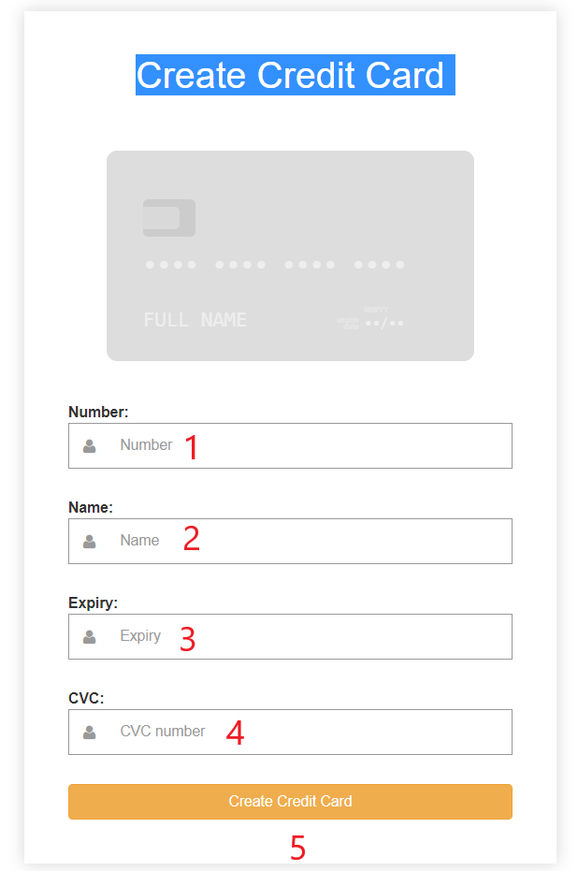

Figure 91 - <Interface> Add Payment Method Page

**Fields**

|  |  |  |  |  |  |  |
| --- | --- | --- | --- | --- | --- | --- |
| **No** | **Field Name** | **Description** | **Read only** | **Mandatory** | **Control Type** | **Data Type** |
| 1 | Number | Credit card number account | No | Yes | Textbox | string |
| 2 | Name | Credit card name | No | Yes | Texbox | string |
| 3 | Expiry | Month/year expiry | No | yes | Textbox | string |
| 4 | CVC | Card signature | No | Yes | Text | string |

Table 89 - <Field> Add Credit Card Page

**Buttons/Hyperlinks:**

|  |  |  |  |  |
| --- | --- | --- | --- | --- |
| **No** | **Function** | **Description** | **Validation** | **Outcome** |
| 1 | Create Credit Card | Create a new payment method | N/A | Redirect to payment method list |

Table 90 - <Button/Hyperlinks> Add Credit Card Page

##### 5.2.1.17. Selling Tickets Page

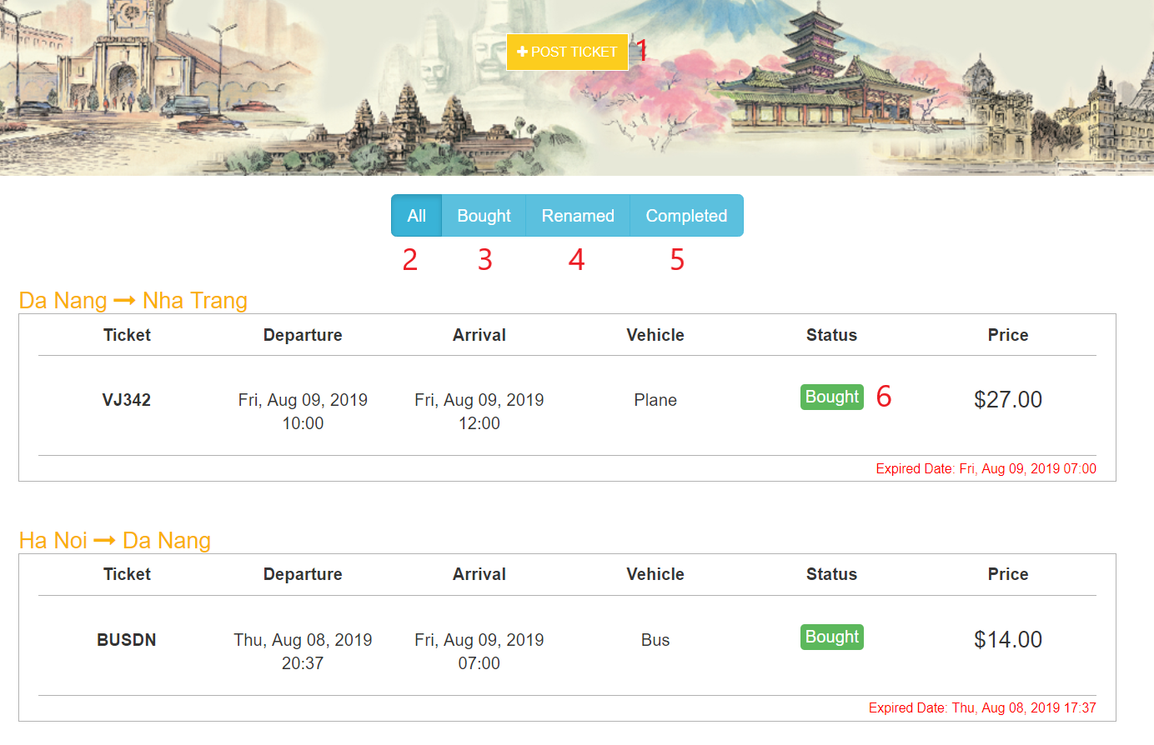

Figure 92 - <Interface> Selling Tickets Page

**Buttons/Hyperlinks:**

|  |  |  |  |  |
| --- | --- | --- | --- | --- |
| **No** | **Function** | **Description** | **Validation** | **Outcome** |
| 1 | Post ticket | Post a new unused ticket | N/A | Redirect to post ticket page |
| 2 | All | All posted tickets | N/A | Render all posted tickets |
| 3 | Bought | Tickets are bought | N/A | Render tickets are bought |
| 4 | Renamed | Ticket are renamed | N/A | Render tickets are renamed |
| 5 | Completed | Tickets are completed | N/A | Render tickets are completed |

Table 91 - <Button/Hyperlinks> Selling Ticket Page

##### 5.2.1.18. Post Ticket Page

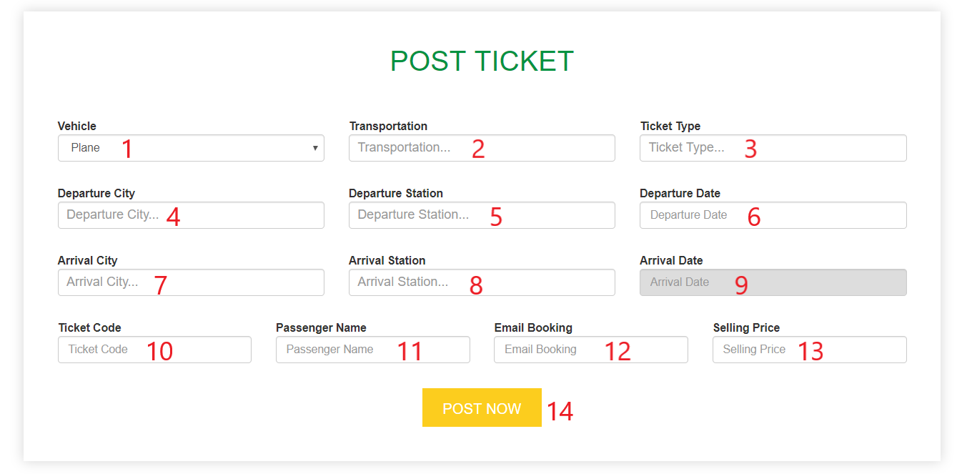

Figure 93 - <Interface> Post Ticket Page

**Fields**

|  |  |  |  |  |  |  |
| --- | --- | --- | --- | --- | --- | --- |
| **No** | **Field Name** | **Description** | **Read only** | **Mandatory** | **Control Type** | **Data Type** |
| 1 | Vehicle | The ticket’s vehicle | No | Yes | Combobox | string |
| 2 | Transportation | Ticket’s transportation | No | Yes | Texbox | string |
| 3 | Ticket Type | Ticket’s ticket type | No | yes | Textbox | string |
| 4 | Departure city | Ticket departure city | No | Yes | Textbox | string |
| 5 | Departure station | Ticket departure station | No | Yes | Textbox | String |
| 6 | Departure date | Ticket departure date | No | Yes | Textbox | String |
| 7 | Arrival city | Ticket arrival city | No | Yes | Textbox | String |
| 8 | Arrival station | Ticket arrival station | No | Yes | Textbox | String |
| 9 | Arrival date | Ticket arrival date | No | Yes | Textbox | String |
| 10 | Ticket code | Ticket code | No | Yes | Textbox | String |
| 11 | Passenger name | Ticket passenger name | No | Yes | Textbox | String |
| 12 | Email booking | Ticket email booking | No | Yes | Textbox | String |
| 13 | Selling price | Ticket resell price | No | Yes | Textbox | string |

Table 92 - <Field> Post Ticket Page

**Buttons/Hyperlinks:**

|  |  |  |  |  |
| --- | --- | --- | --- | --- |
| **No** | **Function** | **Description** | **Validation** | **Outcome** |
| 1 | Post now | Post a new ticket | N/A | Redirect to selling tickets page |

Table 93 - <Button/Hyperlinks> Post Ticket Page

##### 5.2.1.19. Edit Ticket Page

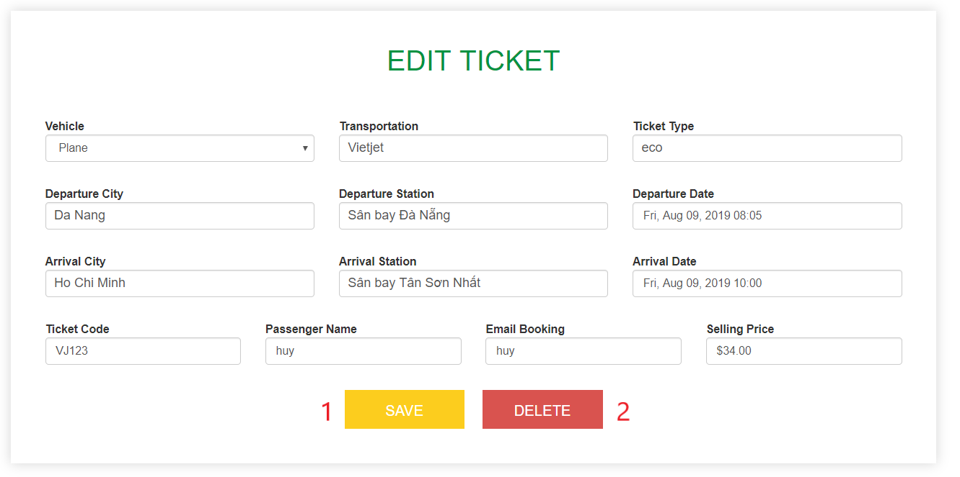

Figure 94 - <Interface> Edit Ticket Page

**Buttons/Hyperlinks:**

|  |  |  |  |  |
| --- | --- | --- | --- | --- |
| **No** | **Function** | **Description** | **Validation** | **Outcome** |
| 1 | Save | Save an edited ticket | N/A | Redirect to selling tickets page |
| 2 | Delete | Delete a posted ticket | N/A | Redirect to selling tickets page |

Table 94 - <Button/Hyperlinks> Edit Ticket Page

##### 5.2.1.20. Confirm Renaming Page

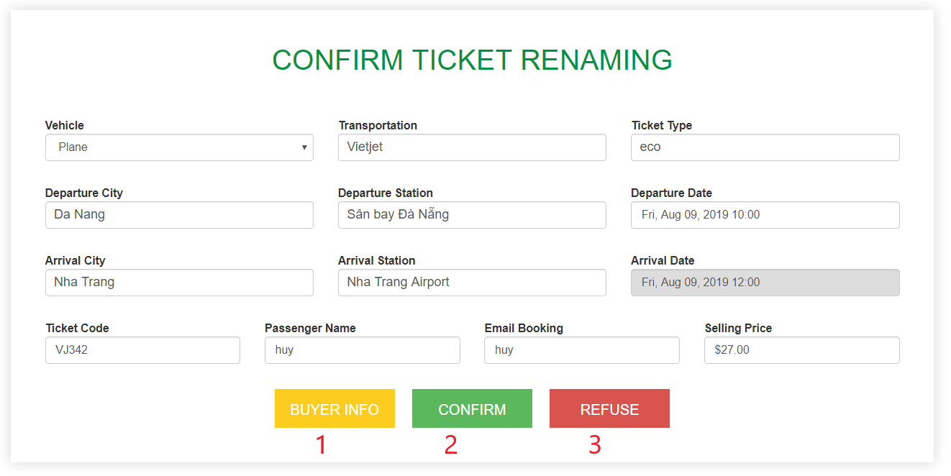

Figure 95 - <Interface> Confirm Renaming Page

**Buttons/Hyperlinks:**

|  |  |  |  |  |
| --- | --- | --- | --- | --- |
| **No** | **Function** | **Description** | **Validation** | **Outcome** |
| 1 | Buyer Info | Buyer info to rename the ticket | N/A | Render a modal includes buyer’s information |
| 2 | Confirm | Confirm after renaming | N/A | Redirect to selling tickets page |
| 3 | Refuse | Refuse rename ticket | N/A | Redirect to selling tickets page |

Table 95 - <Button/Hyperlinks> Confirm Renaming Page

#### 5.2.2. Customer Mobile Interface

##### 5.2.2.1. Login Screen

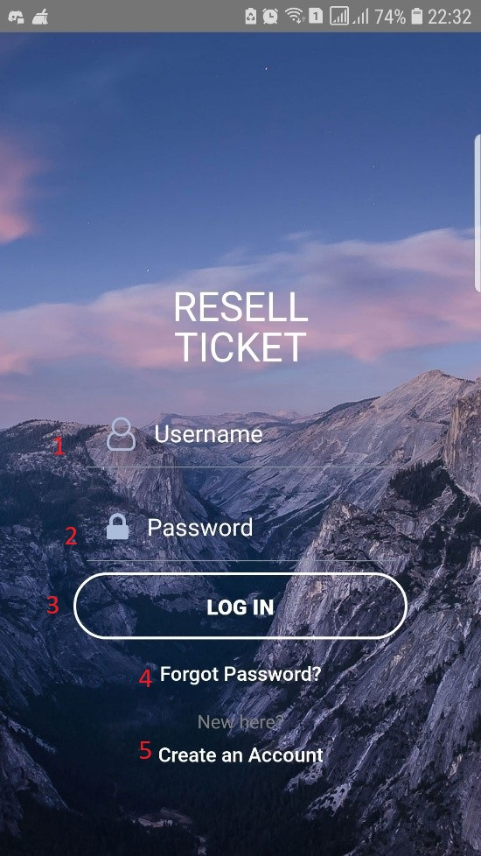

Figure 96 - <Interface> Login Screen

**Fields**

|  |  |  |  |  |  |  |
| --- | --- | --- | --- | --- | --- | --- |
| **No** | **Field Name** | **Description** | **Read only** | **Mandatory** | **Control Type** | **Data Type** |
| 1 | Username or Phone | Username or Phone to login | No | Yes | TextBox | String |
| 2 | Password | Password to login | No | Yes | TexBox | String |

Table 96 - <Field> Login Screen

**Buttons/Hyperlinks:**

|  |  |  |  |  |
| --- | --- | --- | --- | --- |
| **No** | **Function** | **Description** | **Validation** | **Outcome** |
| 3 | Login | Login into the system | Required | Redirect to home page |
| 4 | Forgot Password | Reset a new password |  | Redirect to forgot password page |
| 5 | Register | Sign up a new account |  | Redirect to register page |

Table 97 - <Button/Hyperlinks> Login Screen

##### 5.2.2.2. Register Phone Screen

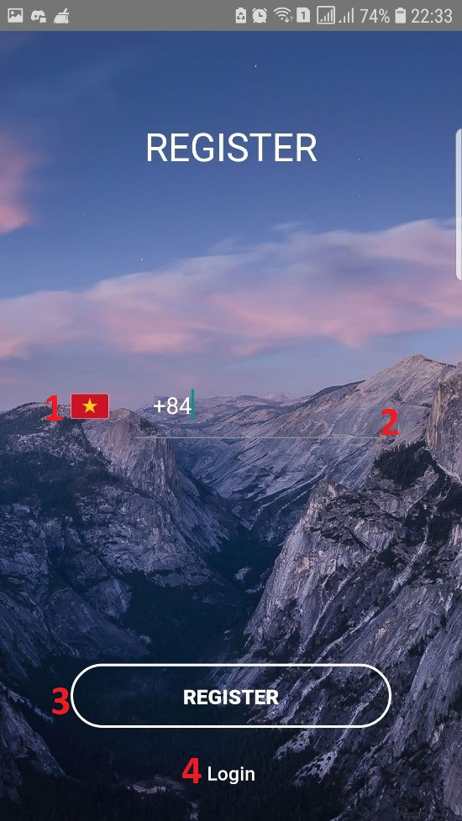

Figure 97 - <Interface> Register Phone Screen

**Fields**

|  |  |  |  |  |  |  |
| --- | --- | --- | --- | --- | --- | --- |
| **No** | **Field Name** | **Description** | **Read only** | **Mandatory** | **Control Type** | **Data Type** |
| 1 | Country Code | Country code to register phone | No | Yes | combobox | String |
| 2 | Phone number | Phone number to send OTP | No | Yes | TexBox | String |

Table 98 - <Field> Register Phone Screen

**Buttons/Hyperlinks:**

|  |  |  |  |  |
| --- | --- | --- | --- | --- |
| **No** | **Function** | **Description** | **Validation** | **Outcome** |
| 3 | Send OTP | Send OTP code to phone | Required | Redirect to register account page |
| 4 | Login | Login Page |  | Redirec to Login Page |

Table 99 - <Button/Hyperlinks> Register Phone Screen

##### 5.2.2.3. Register Account Screen

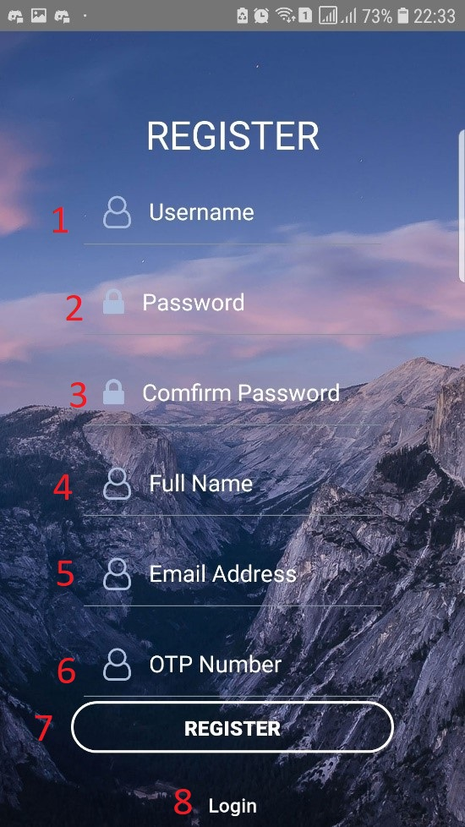

Figure 98 - <Interface> Register Account Screen

**Fields**

|  |  |  |  |  |  |  |
| --- | --- | --- | --- | --- | --- | --- |
| **No** | **Field Name** | **Description** | **Read only** | **Mandatory** | **Control Type** | **Data Type** |
| 1 | Username | Username to login | No | Yes | Textbox | string |
| 2 | Password | Password to login | No | Yes | Textbox | string |
| 3 | Confirm password | Confirm password | No | Yes | Textbox | string |
| 4 | Fullname | Fullname | No | Yes | Texbox | string |
| 5 | Email | Email to receive email | No | Yes | Textbox | string |
| 6 | OTPCode | OTPCode to verify | No | Yes | Textbox | string |

Table 100 - <Field> Register Account Screen

**Buttons/Hyperlinks:**

|  |  |  |  |  |
| --- | --- | --- | --- | --- |
| **No** | **Function** | **Description** | **Validation** | **Outcome** |
| 7 | Register | Register a new account | Required | Redirect to login page |
| 8 | Login | Login page |  | Redirect to login page |

Table 101 - <Button/Hyperlinks> Register Account Screen

##### 5.2.2.4. Route List Screen

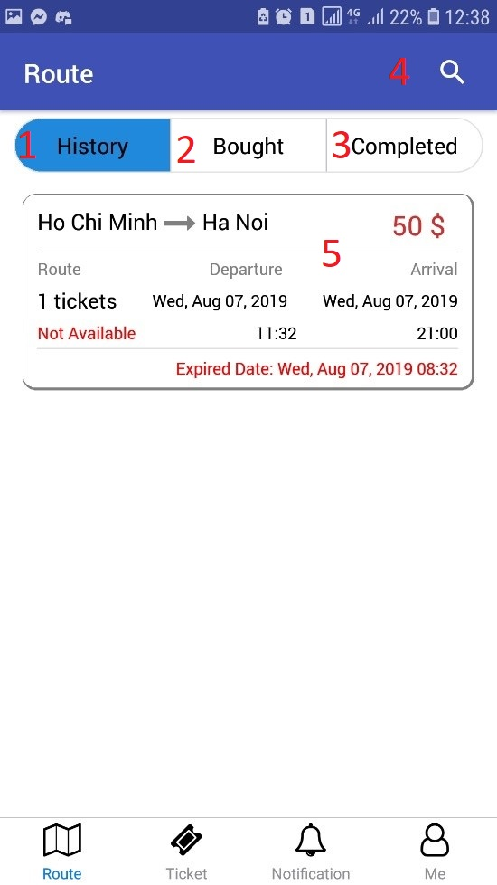

Figure 99 - <Interface> Route List Screen

**Buttons/Hyperlinks:**

|  |  |  |  |  |
| --- | --- | --- | --- | --- |
| **No** | **Function** | **Description** | **Validation** | **Outcome** |
| 1 | History | Saved route list | N/A | Render saved route list |
| 2 | Bought | Bought route list | N/A | Render bought route list |
| 3 | Completed | Completed route list | N/A | Render completed route list |
| 4 | Search | Search Form | N/A | Redirect to search form |
| 5 | Route detail | Route detail | N/A | Redirect to route detail screen |

Table 102 - <Field> Route List Screen

##### 5.2.2.5. Search Form Screen

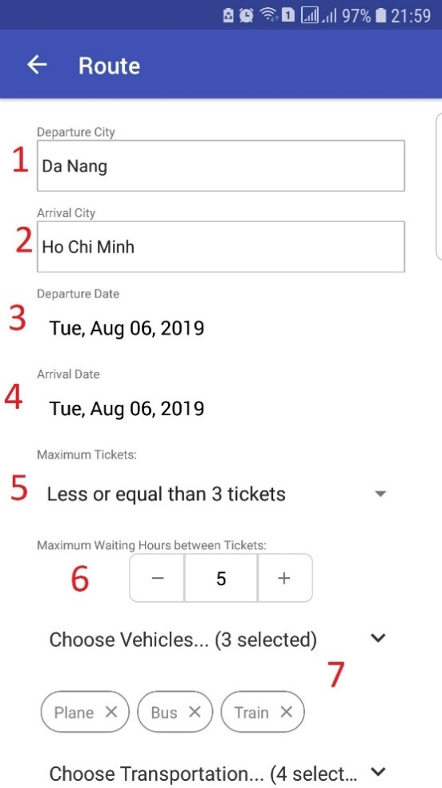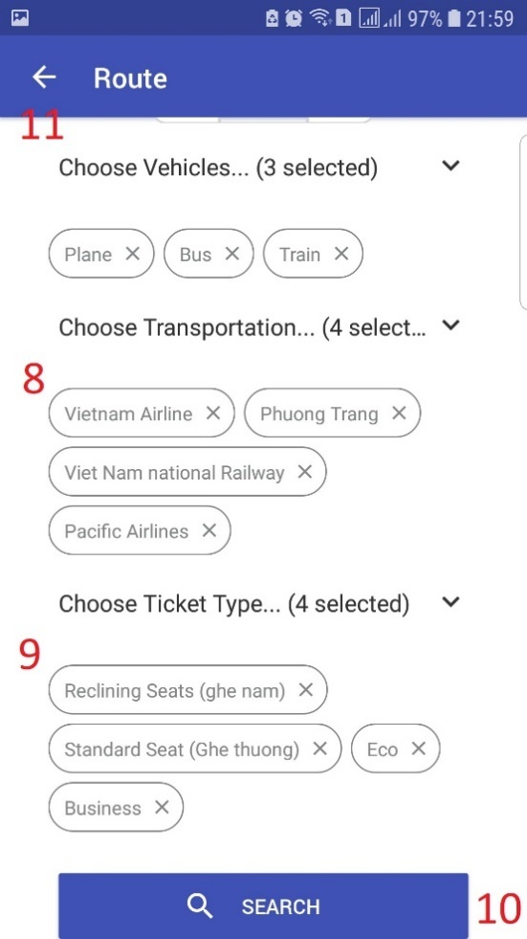

Figure 100 - <Interface> Search Form Screen

**Fields**

|  |  |  |  |  |  |  |
| --- | --- | --- | --- | --- | --- | --- |
| **No** | **Field Name** | **Description** | **Read only** | **Mandatory** | **Control Type** | **Data Type** |
| 1 | Departure | Departure City | No | Yes | Textbox | string |
| 2 | Arrival | Arrival city | No | Yes | Texbox | string |
| 3 | Departure Date | Departure date | No | Yes | Textbox | string |
| 4 | Arrival Date | Arrival date | No | Yes | Textbox | string |
| 5 | Max tickets | Max tickets in route | No | Yes | Combobox | String |
| 6 | Max Waiting Hours | Max waiting between 2 tickets | No | Yes | Textbox | number |
| 7 | Vehicles | Vehicles | No | Yes | Multi select box | String |
| 8 | Transportation | Transportation | No | Yes | Multi select box | String |
| 9 | Ticket type | Ticket type | No | Yes | Multi select box | string |

Table 103 - <Field> Search Form Screen

**Buttons/Hyperlinks:**

|  |  |  |  |  |
| --- | --- | --- | --- | --- |
| **No** | **Function** | **Description** | **Validation** | **Outcome** |
| 10 | Search | Search route | Required | Redirect to searched result page |
| 11 | Back | Go back to route sceen |  |  |

Table 104 - <Button/Hyperlinks> Search Form Screen

##### 5.2.2.6. Search Route Result Screen

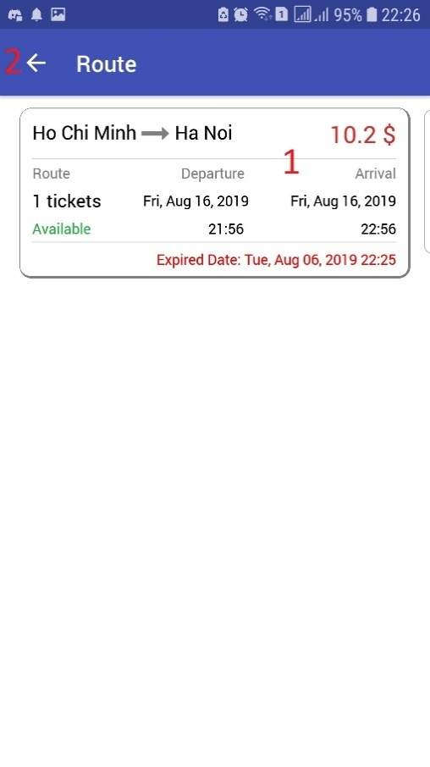

Figure 101 - <Interface> Search Route Detail Screen

**Buttons/Hyperlinks:**

|  |  |  |  |  |
| --- | --- | --- | --- | --- |
| **No** | **Function** | **Description** | **Validation** | **Outcome** |
| 1 | Route | Route detail |  | Redirect to route detail page |
| 2 | Back | Go back |  | Redirect to search form |

Table 105 - <Button/Hyperlinks> Search Route Result Screen

##### 5.2.2.7. Route Detail Screen

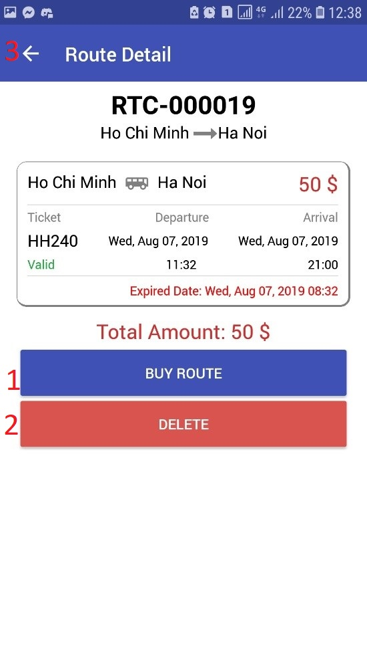

Figure 102 - <Interface> Route Detail Screen

**Buttons/Hyperlinks:**

|  |  |  |  |  |
| --- | --- | --- | --- | --- |
| **No** | **Function** | **Description** | **Validation** | **Outcome** |
| 1 | Buy | Buy route | N/A | Render modal to input buyer’s information |
| 2 | Delete | Delete saved route | N/A | Redirect route list page |
| 3 | Back | Back to perious page | N/A | Redirect route list page |

Table 106 - <Button/Hyperlinks> Route Detail Screen

##### 5.2.2.8. Passenger Information Screen

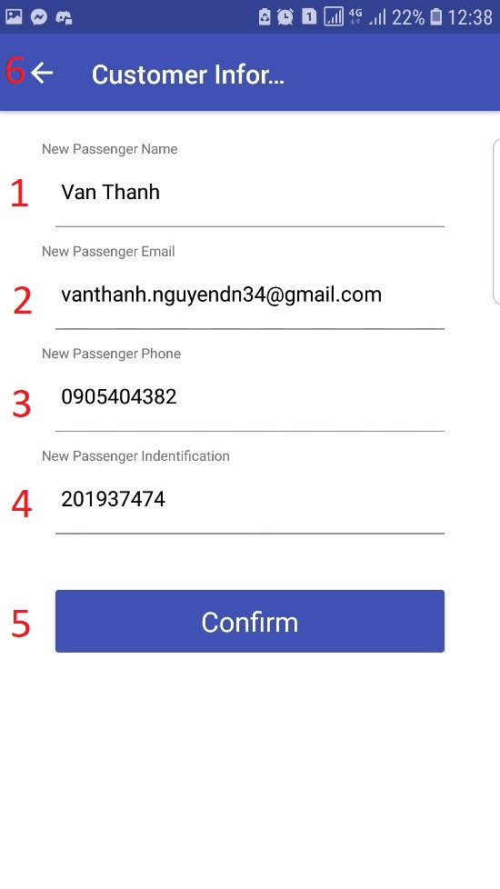

Figure 103 - <Interface> Passenger Information Screen

**Fields**

|  |  |  |  |  |  |  |
| --- | --- | --- | --- | --- | --- | --- |
| **No** | **Field Name** | **Description** | **Read only** | **Mandatory** | **Control Type** | **Data Type** |
| 1 | New Passenger Name | New passenger name | No | Yes | Textbox | string |
| 2 | New Passenger Email | New passenger email | No | Yes | Texbox | string |
| 3 | New Passenger Phone | New passenger phone | No | Yes | Textbox | string |
| 4 | New Passenger Identification | New passenger identification | No | Yes | Textbox | string |

Table 107 - <Field> Passenger Information Screen

**Buttons/Hyperlinks:**

|  |  |  |  |  |
| --- | --- | --- | --- | --- |
| **No** | **Function** | **Description** | **Validation** | **Outcome** |
| 5 | Confirm | Confirm buy route | N/A | Redirect to route list page |
| 6 | Back | Back to previous page | N/A | Redirect route list page |

Table 108 - <Button/Hyperlinks> Passenger Information Screen

##### 5.2.2.9. Transaction History Screen

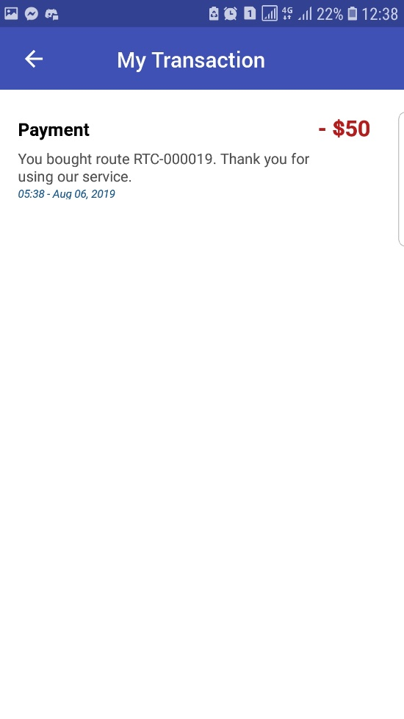

Figure 104 - <Interface> Transaction History Screen

##### 5.2.2.10. Notification History Screen

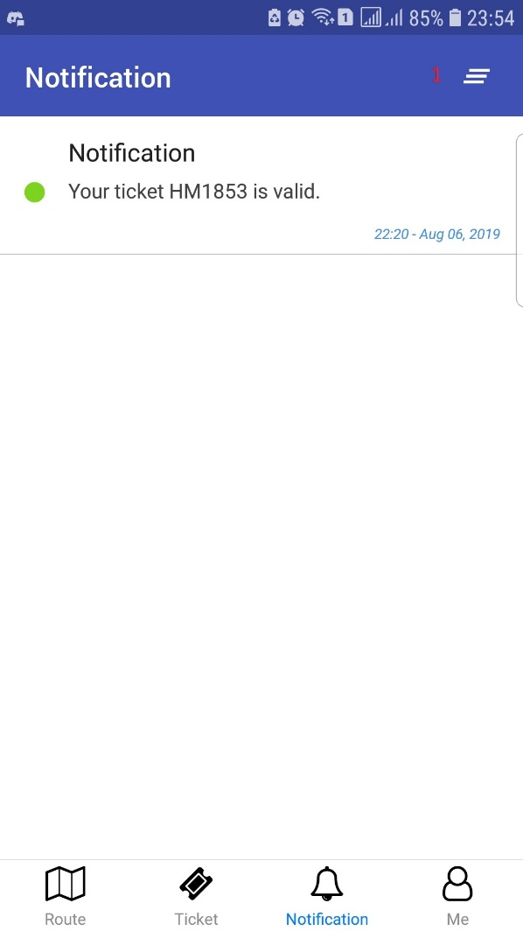

Figure 105 - <Interface> Notification History Screen

**Buttons/Hyperlinks:**

|  |  |  |  |  |
| --- | --- | --- | --- | --- |
| **No** | **Function** | **Description** | **Validation** | **Outcome** |
| 1 | Read | Read all notification | N/A | Mark all notifications as read |

Table 109 - <Button/Hyperlinks> Notification History Screen

##### 5.2.2.11. Update Profile Screen

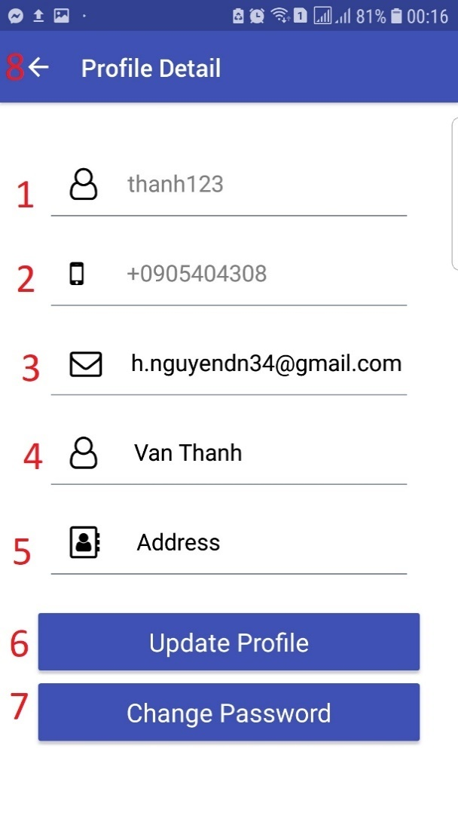

Figure 106 - <Interface> Update Profile Screen

**Fields**

|  |  |  |  |  |  |  |
| --- | --- | --- | --- | --- | --- | --- |
| **No** | **Field Name** | **Description** | **Read only** | **Mandatory** | **Control Type** | **Data Type** |
| 1 | Username | Customer’s username | Yes | Yes | Textbox | string |
| 2 | Phone Number | Customer’s phone number | Yes | Yes | Texbox | string |
| 3 | Full name | Customer ‘s full name | No | yes | Textbox | string |
| 5 | Email | Customer’s email | No | Yes | Textbox | string |
| 6 | Address | Customer’s address | No | No | Textbox | String |

Table 110 - <Field> Update Profile Screen

**Buttons/Hyperlinks:**

|  |  |  |  |  |
| --- | --- | --- | --- | --- |
| **No** | **Function** | **Description** | **Validation** | **Outcome** |
| 1 | Update Profile | Update new customer’s profile | N/A | Render update successfully |
| 2 | Change Password | Change customer account password | N/A | Redirect to change password page |
| 3 | Back | Back to previous page | N/A | Redirect route list page |

Table 111 - <Button/Hyperlinks> Update Profile Screen

##### 5.2.2.12. Stripe Account Screen

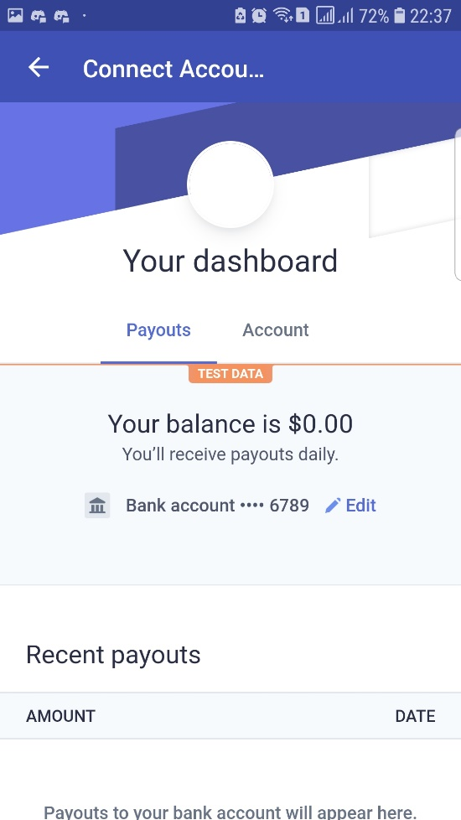

Figure 107 - <Interface> Stripe Account Screen

##### 5.2.2.13. Payment Method Screen

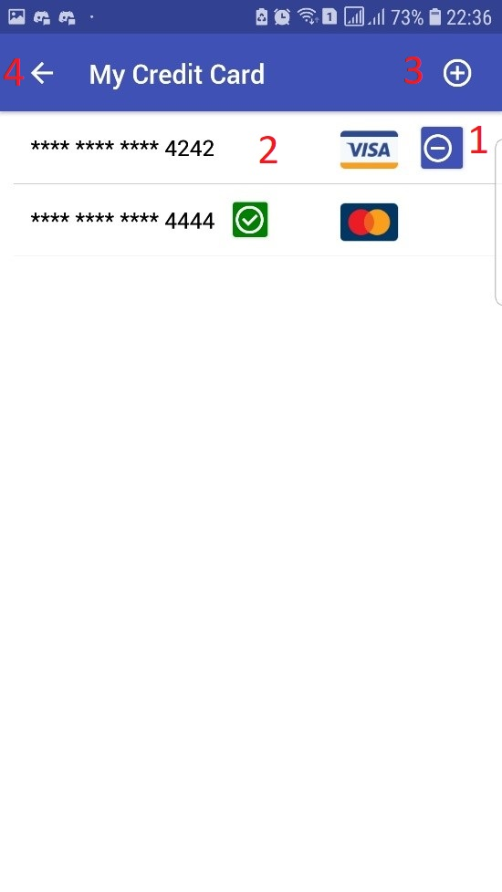

Figure 108 - <Interface> Payment Method Screen

**Buttons/Hyperlinks:**

|  |  |  |  |  |
| --- | --- | --- | --- | --- |
| **No** | **Function** | **Description** | **Validation** | **Outcome** |
| 1 | Delete | Delete payment method | N/A | Render delete successfully |
| 2 | Set Default | Set default payment method | N/A | Render set default successfully |
| 3 | Add Credit Card | Add new payment method | N/A | Redirect add payment method page |
| 4 | Back | Back to perious page | N/A | Redirect me page |

Table 112 - <Button/Hyperlinks> Payment Method Screen

##### 5.2.2.14. Add Payment Method Screen

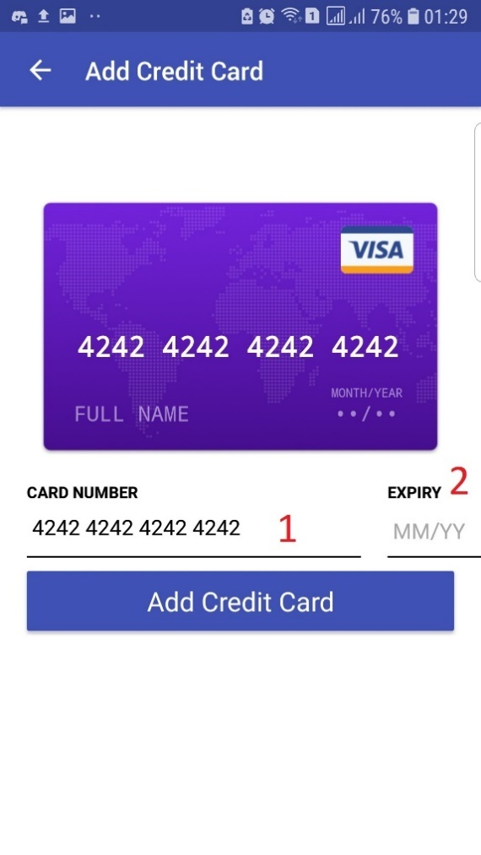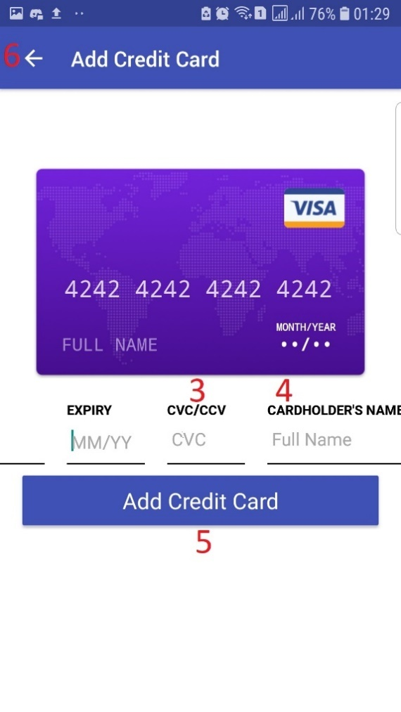

Figure 109 - <Interface> Add Payment Method Screen

**Fields**

|  |  |  |  |  |  |  |
| --- | --- | --- | --- | --- | --- | --- |
| **No** | **Field Name** | **Description** | **Read only** | **Mandatory** | **Control Type** | **Data Type** |
| 1 | Number | Credit card number account | No | Yes | Textbox | string |
| 2 | Expiry | Month/year expiry | No | yes | Textbox | string |
| 4 | CVC | Card signature | No | Yes | Text | string |
| 5 | Name | Credit card name | No | Yes | Texbox | string |

Table 113 - <Field> Add Payment Method Screen

**Buttons/Hyperlinks:**

|  |  |  |  |  |
| --- | --- | --- | --- | --- |
| **No** | **Function** | **Description** | **Validation** | **Outcome** |
| 5 | Add Credit Card | Create a new payment method | N/A | Redirect to payment method list |
| 6 | Back | Back to previous page | N/A | Redirect list credit card page |

Table 114 - <Button/Hyperlinks> Add Payment Method Screen

##### 5.2.2.15. Selling Ticket Screen

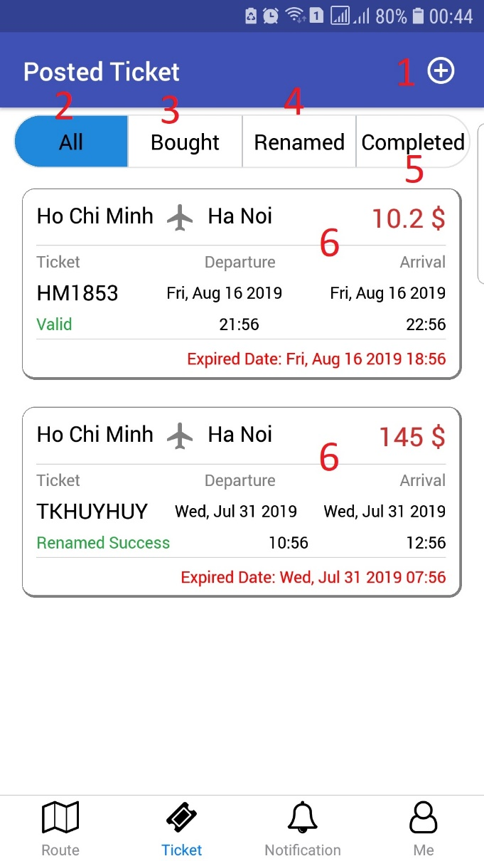

Figure 110 - <Interface> Selling Ticket Screen

**Buttons/Hyperlinks:**

|  |  |  |  |  |
| --- | --- | --- | --- | --- |
| **No** | **Function** | **Description** | **Validation** | **Outcome** |
| 1 | Post ticket | Post a new unused ticket | N/A | Redirect to post ticket page |
| 2 | All | All posted tickets | N/A | Render all posted tickets |
| 3 | Bought | Tickets are bought | N/A | Render tickets are bought |
| 4 | Renamed | Ticket are renamed | N/A | Render tickets are renamed |
| 5 | Completed | Tickets are completed | N/A | Render tickets are completed |
| 6 | Ticket Detail | Ticket detail | N/A | Redirect ticket detail |

Table 115 - <Button/Hyperlinks> Selling Ticket Screen

##### 5.2.2.16. Post Ticket Screen

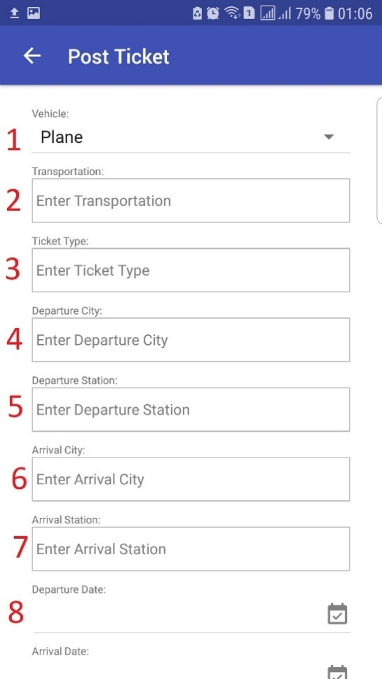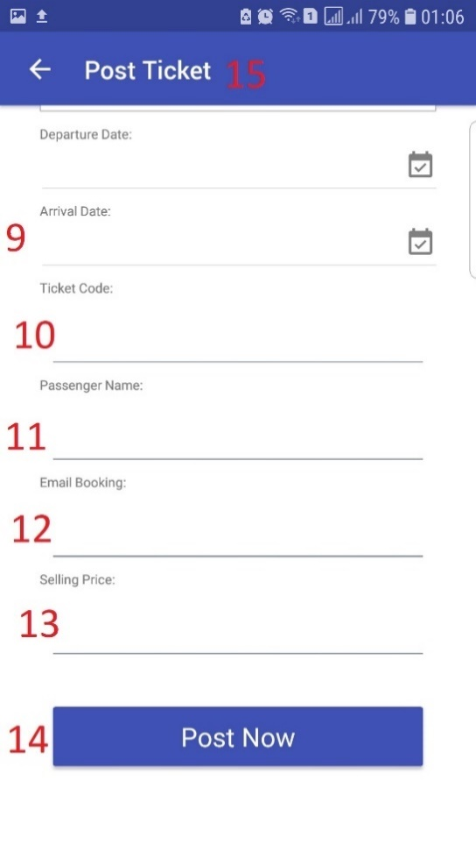

Figure 111 - <Interface> Post Ticket Screen

**Fields**

|  |  |  |  |  |  |  |
| --- | --- | --- | --- | --- | --- | --- |
| **No** | **Field Name** | **Description** | **Read only** | **Mandatory** | **Control Type** | **Data Type** |
| 1 | Vehicle | The ticket’s vehicle | No | Yes | Combobox | string |
| 2 | Transportation | Ticket’s transportation | No | Yes | Texbox | string |
| 3 | Ticket Type | Ticket’s ticket type | No | yes | Textbox | string |
| 4 | Departure city | Ticket departure city | No | Yes | Textbox | string |
| 5 | Departure station | Ticket departure station | No | Yes | Textbox | String |
| 6 | Arrival city | Ticket arrival city | No | Yes | Textbox | String |
| 7 | Arrival station | Ticket arrival station | No | Yes | Textbox | String |
| 8 | Departure date | Ticket departure date | No | Yes | Textbox | String |
| 9 | Arrival date | Ticket arrival date | No | Yes | Textbox | String |
| 10 | Ticket code | Ticket code | No | Yes | Textbox | String |
| 11 | Passenger name | Ticket passenger name | No | Yes | Textbox | String |
| 12 | Email booking | Ticket email booking | No | Yes | Textbox | String |
| 13 | Selling price | Ticket resell price | No | Yes | Textbox | string |

Table 116 - <Field> Post Ticket Screen

**Buttons/Hyperlinks:**

|  |  |  |  |  |
| --- | --- | --- | --- | --- |
| **No** | **Function** | **Description** | **Validation** | **Outcome** |
| 14 | Post now | Post a new ticket | N/A | Redirect to selling tickets page |
| 15 | Back | Back to previous page | N/A | Redirect list ticket page |

Table 117 - <Button/Hyperlinks> Post Ticket Screen

##### 5.2.2.17. Edit Posted Ticket Screen

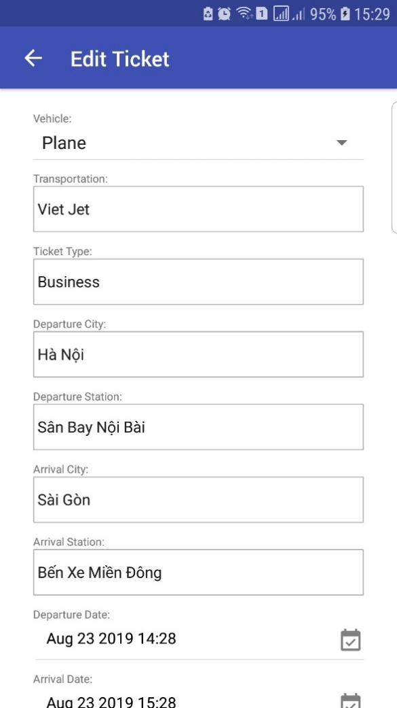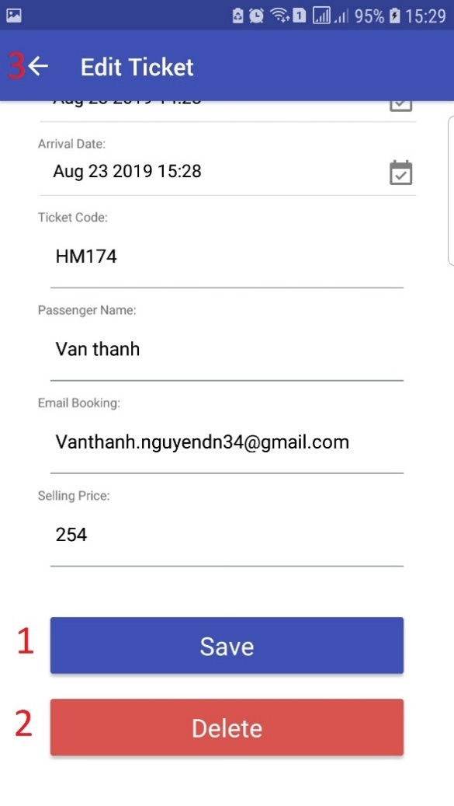

Figure 112 - <Interface> Edit Posted Ticket Screen

**Buttons/Hyperlinks:**

|  |  |  |  |  |
| --- | --- | --- | --- | --- |
| **No** | **Function** | **Description** | **Validation** | **Outcome** |
| 1 | Save | Save an edited ticket | N/A | Redirect to selling tickets page |
| 2 | Delete | Delete a posted ticket | N/A | Redirect to selling tickets page |
| 3 | Back | Back to perious page | N/A | Redirect list ticket page |

Table 118 - <Button/Hyperlinks> Edit Posted Ticket Screen

##### 5.2.2.18. Confirm Renaming Screen

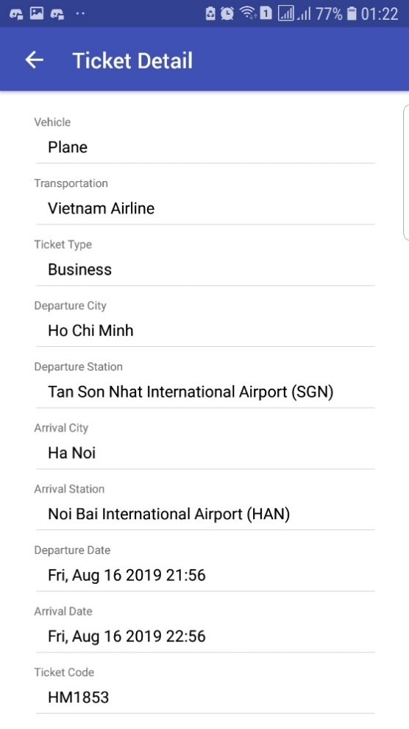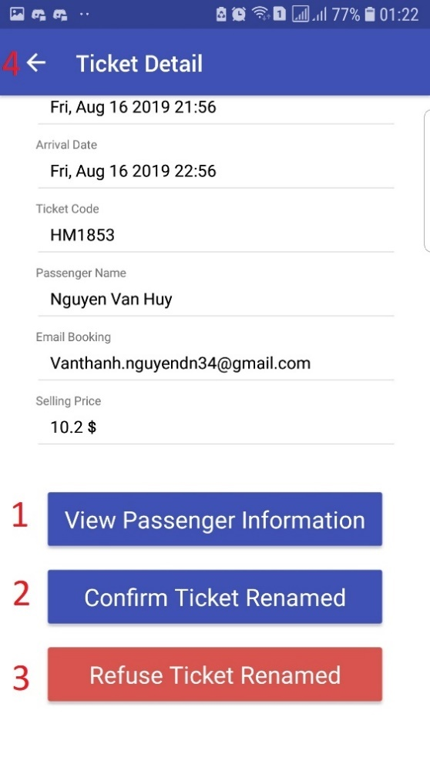

Figure 113 - <Interface> Confirm Renaming Screen

**Buttons/Hyperlinks:**

|  |  |  |  |  |
| --- | --- | --- | --- | --- |
| **No** | **Function** | **Description** | **Validation** | **Outcome** |
| 1 | Buyer Info | Buyer info to rename the ticket | N/A | Render a modal includes buyer’s information |
| 2 | Confirm | Confirm after renaming | N/A | Redirect to selling tickets page |
| 3 | Refuse | Refuse rename ticket | N/A | Redirect to selling tickets page |
| 4 | Back | Back to perious page | N/A | Redirect list ticket page |

Table 119 - <Button/Hyperlinks> Confirm Renaming Screen

#### Manager web application

##### Login

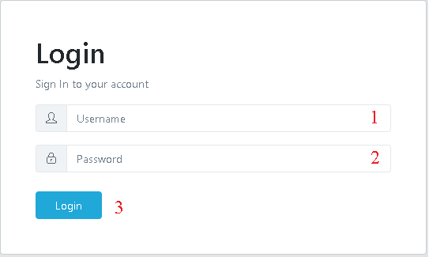

Figure 114 - <Interface> Login Page

**Fields**

|  |  |  |  |  |  |  |
| --- | --- | --- | --- | --- | --- | --- |
| **No** | **Field Name** | **Description** | **Read only** | **Mandatory** | **Control Type** | **Data Type** |
| 1 | Username | Username to login | No | Yes | Textbox | String |
| 2 | Password | Password to login | No | Yes | Texbox | String |

Table 120 <Fields> Login Page

**Buttons/Hyperlinks:**

|  |  |  |  |  |
| --- | --- | --- | --- | --- |
| **No** | **Function** | **Description** | **Validation** | **Outcome** |
| 3 | Login | Login into the system | Required | User logged in into the system |

Table 121 - <Button/Hyperlinks> Login Page

##### Main menu

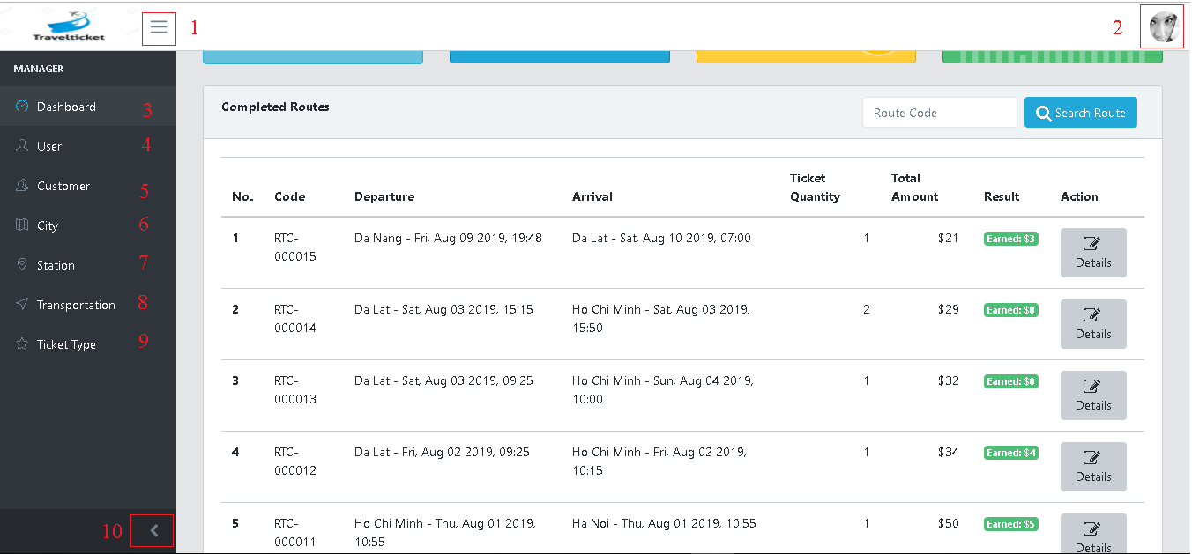

Figure 115 - <Interface> Manager Main Menu

**Buttons/Hyperlinks:**

|  |  |  |  |  |
| --- | --- | --- | --- | --- |
| **No** | **Function** | **Description** | **Validation** | **Outcome** |
| 1 | Hide sidebar menu | Hide sidebar menu | User must had been authorized | Hide sidebar menu |
| 2 | User menu | User menu | User must had been authorized | Show user menu |
| 3 | Dashboard | Dashboard page | User must had been authorized | Redirect to dashboard page |
| 4 | User | User page | User must had been authorized | Redirect to user page |
| 5 | Customer | Customer page | User must had been authorized | Redirect to customer page |
| 6 | City | City page | User must had been authorized | Redirect to city page |
| 7 | Station | Station page | User must had been authorized | Redirect to station page |
| 8 | Transportation | Transportation page | User must had been authorized | Redirect to transportation page |
| 9 | Ticket type | Ticket type page | User must had been authorized | Redirect to ticket type page |
| 10 | Hide sidebar menu | Hide sidebar menu | User must had been authorized | Hide sidebar menu |

Table 122 - <Button/Hyperlinks> Main Menu

##### Manager menu

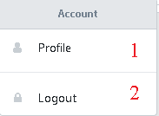

Figure 116 - <Interface> Manager Menu

**Buttons/Hyperlinks:**

|  |  |  |  |  |
| --- | --- | --- | --- | --- |
| **No** | **Function** | **Description** | **Validation** | **Outcome** |
| 1 | Profile | Profile | User must had been authorized | Redirect to view current manager profile page |
| 2 | Logout | Logout | User must had been authorized | Logout of the system |

Table 123 - <Button/Hyperlinks> Manager Menu

##### Manager profile

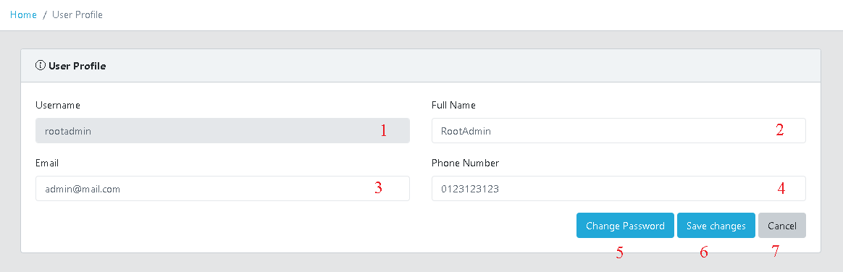

Figure 117 - <Interface> Manager Profile

**Fields**

|  |  |  |  |  |  |  |
| --- | --- | --- | --- | --- | --- | --- |
| **No** | **Field Name** | **Description** | **Read only** | **Mandatory** | **Control Type** | **Data Type** |
| 1 | Username | Username | No | Yes | Textbox | String |
| 2 | Full name | Full name | No | Yes | Textbox | String |
| 3 | Email | Email | No | Yes | Textbox | String |
| 4 | Phone number | Phone number | No | Yes | Textbox | String |

Table 124 <Fields> Manager Profile

**Buttons/Hyperlinks:**

|  |  |  |  |  |
| --- | --- | --- | --- | --- |
| **No** | **Function** | **Description** | **Validation** | **Outcome** |
| 5 | Change password | Change manager password | User must had been authorized | Show change password form |
| 6 | Save changes | Save changes of manager information | User must had been authorized | Update manager profile |
| 7 | Cancel | Redirect to main menu | User must had been authorized | Redirect to main menu |

Table 125 <Buttons/Hyperlinks> Manager Profile

##### Change password

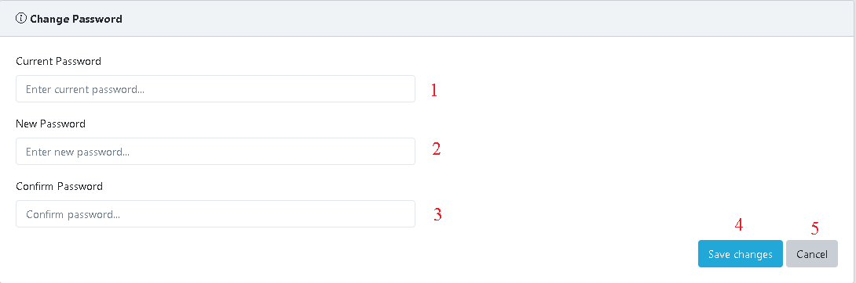

Figure 118 - <Interface> Change Password

**Fields**

|  |  |  |  |  |  |  |
| --- | --- | --- | --- | --- | --- | --- |
| **No** | **Field Name** | **Description** | **Read only** | **Mandatory** | **Control Type** | **Data Type** |
| 1 | Current password | Current manager password | No | Yes | Textbox | String |
| 2 | New password | New password | No | Yes | Textbox | String |
| 3 | Confirm password | Confirm new password | No | Yes | Textbox | String |

Table 126 <Fields> Change password

**Buttons/Hyperlinks:**

|  |  |  |  |  |
| --- | --- | --- | --- | --- |
| **No** | **Function** | **Description** | **Validation** | **Outcome** |
| 4 | Save changes | Save change of manager information | User must had been authorized | Update manager password,  Redirect to login page |
| 5 | Cancel | Redirect to main menu | User must had been authorized | Close change password form |

Table 127 <Buttons/Hyperlinks> Change password

##### Dashboard menu

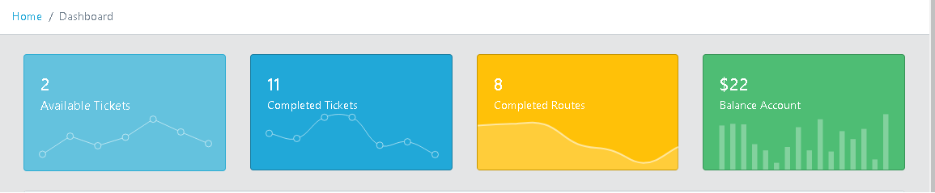

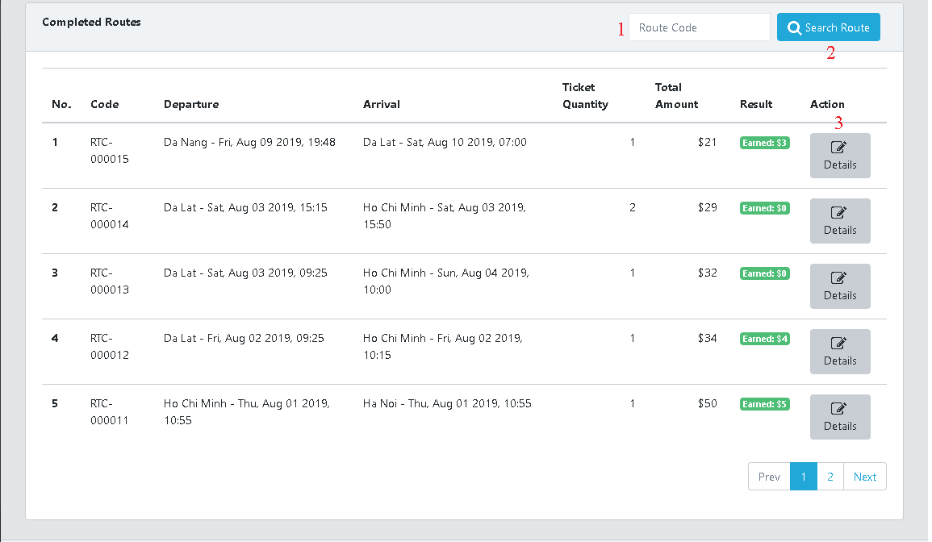

Figure 119 - <Interface> Dashboard Page

**Fields**

|  |  |  |  |  |  |  |
| --- | --- | --- | --- | --- | --- | --- |
| **No** | **Field Name** | **Description** | **Read only** | **Mandatory** | **Control Type** | **Data Type** |
| 1 | Route code | Route code to search | No | Yes | Textbox | String |

Table 128 <Fields> Dashboard menu

**Buttons/Hyperlinks:**

|  |  |  |  |  |
| --- | --- | --- | --- | --- |
| **No** | **Function** | **Description** | **Validation** | **Outcome** |
| 2 | Search route | Search route | User must had been authorized | Show searched route |
| 2 | Details | Route details page | User must had been authorized | Redirect to route details page |

Table 129 <Buttons/Hyperlinks> Dashboard menu

##### User management page

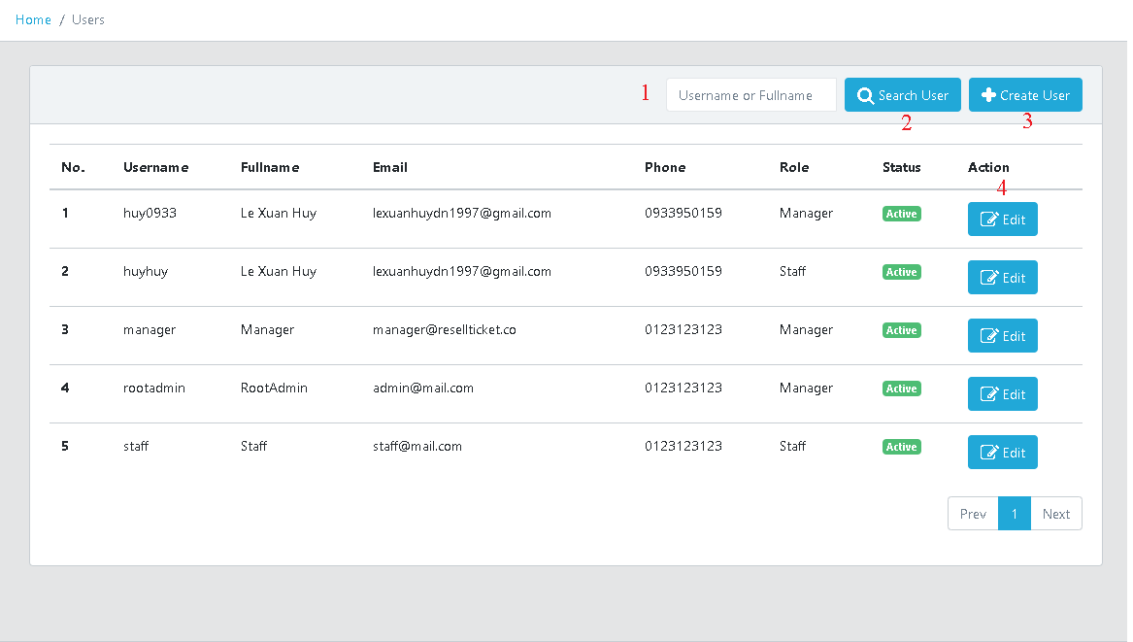

Figure 120 - <Interface> User Management Page

**Fields**

|  |  |  |  |  |  |  |
| --- | --- | --- | --- | --- | --- | --- |
| **No** | **Field Name** | **Description** | **Read only** | **Mandatory** | **Control Type** | **Data Type** |
| 1 | Route code | Route code to search | No | Yes | Textbox | String |

Table 130 <Fields> User menu

**Buttons/Hyperlinks:**

|  |  |  |  |  |
| --- | --- | --- | --- | --- |
| **No** | **Function** | **Description** | **Validation** | **Outcome** |
| 2 | Search route | Search route | User must had been authorized | Show searched route |
| 3 | Create route | Create route | User must had been authorized | New user added to list, redirect to user page |
| 4 | Edit | Edit user details | User must had been authorized | Redirect to user details page and manager can edit user details |

Table 131 <Buttons/Hyperlinks> User menu

##### Customer management page

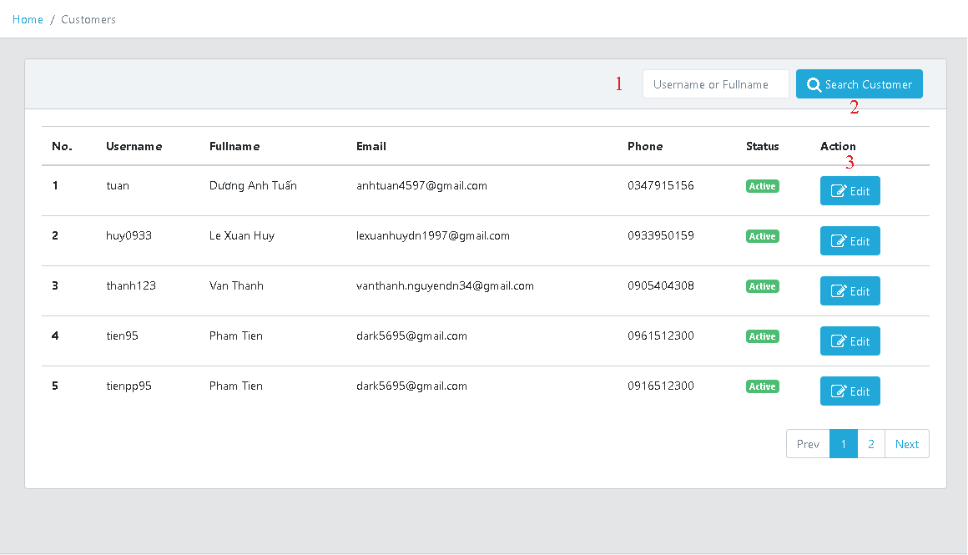

Figure 121 - <Interface> Customer Management page

**Fields**

|  |  |  |  |  |  |  |
| --- | --- | --- | --- | --- | --- | --- |
| **No** | **Field Name** | **Description** | **Read only** | **Mandatory** | **Control Type** | **Data Type** |
| 1 | Username or full name | Username or full name to search | No | Yes | Textbox | String |

Table 132 <Fields> Customer menu

**Buttons/Hyperlinks:**

|  |  |  |  |  |
| --- | --- | --- | --- | --- |
| **No** | **Function** | **Description** | **Validation** | **Outcome** |
| 2 | Search customer | Search customer | User must had been authorized | Show searched customer |
| 3 | Edit | Edit customer details | User must had been authorized | Redirect to customer details page and manager can edit customer details |

Table 133 <Buttons/Hyperlinks> Customer menu

##### City management page

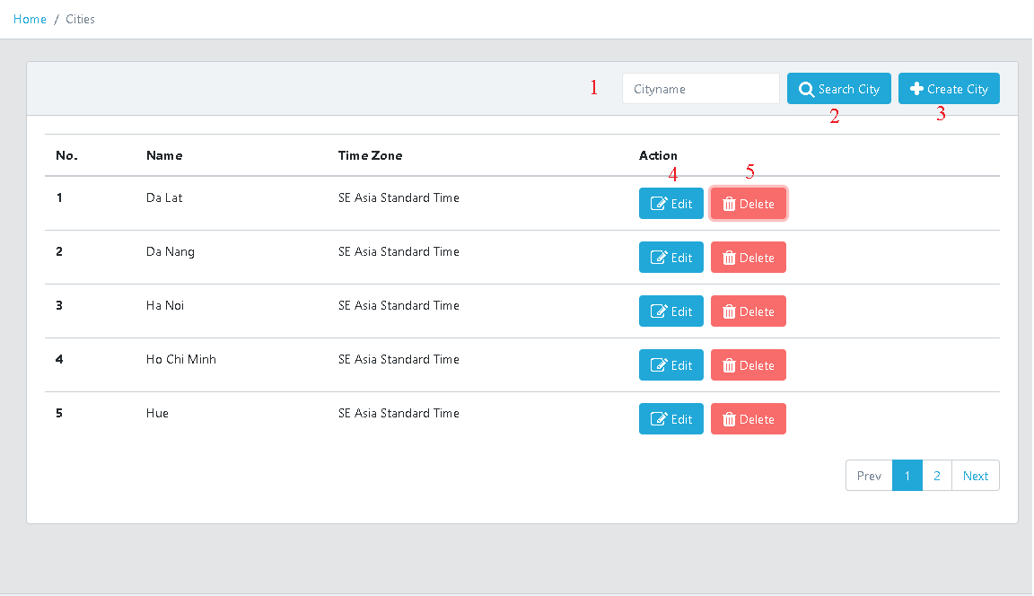

Figure 122 - <Interface> City management page

**Fields**

|  |  |  |  |  |  |  |
| --- | --- | --- | --- | --- | --- | --- |
| **No** | **Field Name** | **Description** | **Read only** | **Mandatory** | **Control Type** | **Data Type** |
| 1 | City name | City name to search | No | Yes | Textbox | String |

Table 134 <Fields> Cities menu

**Buttons/Hyperlinks:**

|  |  |  |  |  |
| --- | --- | --- | --- | --- |
| **No** | **Function** | **Description** | **Validation** | **Outcome** |
| 2 | Search city | Search city | User must had been authorized | Show searched city |
| 3 | Create city | Create new city | User must had been authorized | Redirect to city details page and new city can be added to list, redirect to city page |
| 4 | Edit | Edit city details | User must had been authorized | Redirect to city details, manager can edit city details |
| 5 | Delete | Delete city | User must had been authorized | Selected city was edit |

Table 135 <Buttons/Hyperlinks> Cities menu

##### Station management page

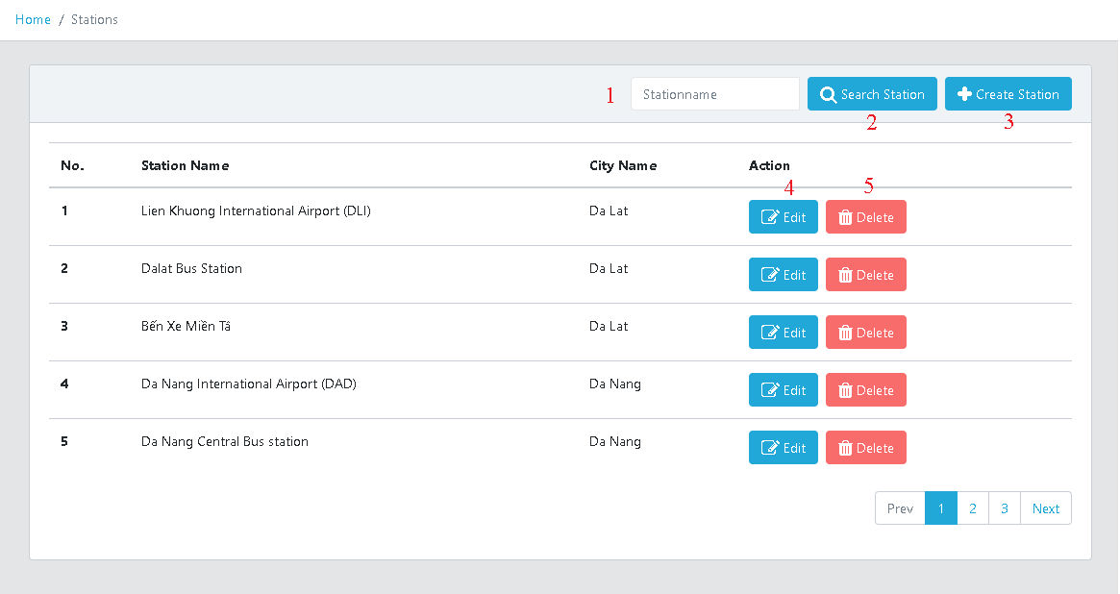

Figure 123 - <Interface> Station Management Page

**Fields**

|  |  |  |  |  |  |  |
| --- | --- | --- | --- | --- | --- | --- |
| **No** | **Field Name** | **Description** | **Read only** | **Mandatory** | **Control Type** | **Data Type** |
| 1 | Station name | Station name to search | No | Yes | Textbox | String |

Table 136 <Fields> Station menu

**Buttons/Hyperlinks:**

|  |  |  |  |  |
| --- | --- | --- | --- | --- |
| **No** | **Function** | **Description** | **Validation** | **Outcome** |
| 2 | Search station | Search station | User must had been authorized | Show searched station |
| 3 | Create station | Create new station | User must had been authorized | Redirect to station details page and new station can be added to list, redirect to city page |
| 4 | Edit | Edit station details | User must had been authorized | Redirect to station details, manager can edit station details |
| 5 | Delete | Delete station | User must had been authorized | Selected station was edit |

Table 137 <Buttons/Hyperlinks> Station menu

##### Transportation management page

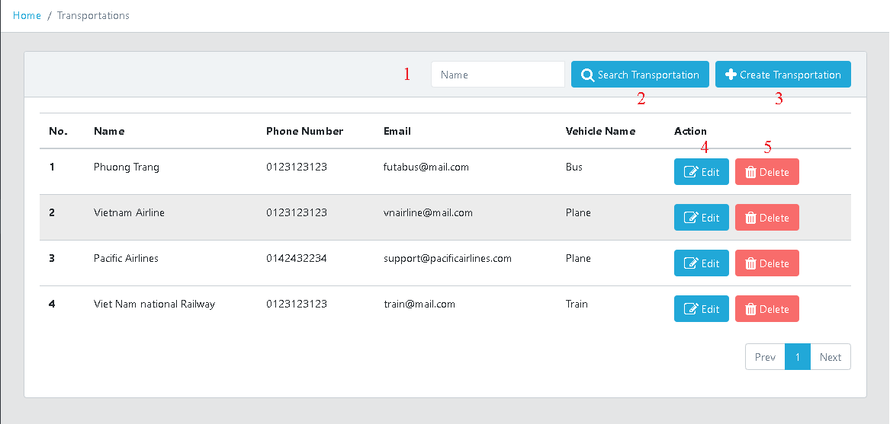

Figure 124 - <Interface> Transportation Management Page

**Fields**

|  |  |  |  |  |  |  |
| --- | --- | --- | --- | --- | --- | --- |
| **No** | **Field Name** | **Description** | **Read only** | **Mandatory** | **Control Type** | **Data Type** |
| 1 | Name | Transportation name to search | No | Yes | Textbox | String |

Table 138 <Fields> Transportation menu

**Buttons/Hyperlinks:**

|  |  |  |  |  |
| --- | --- | --- | --- | --- |
| **No** | **Function** | **Description** | **Validation** | **Outcome** |
| 2 | Search transportation | Search transportation | User must had been authorized | Show searched transportation |
| 3 | Create transportation | Create new transportation | User must had been authorized | Redirect to transportation details page and new transportation can be added to list, redirect to transportation page |
| 4 | Edit | Edit transportation details | User must had been authorized | Redirect to transportation details, manager can edit transportation details |
| 5 | Delete | Delete transportation | User must had been authorized | Selected transportation was edit |

Table 139 <Buttons/Hyperlinks> Transportation menu

##### Ticket type management page

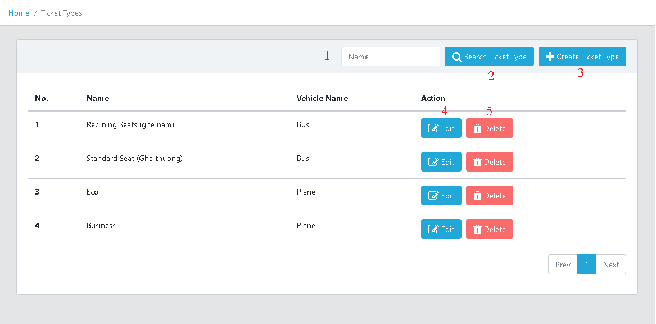

Figure 125 - <Interface> Ticket Type Management Page

**Fields**

|  |  |  |  |  |  |  |
| --- | --- | --- | --- | --- | --- | --- |
| **No** | **Field Name** | **Description** | **Read only** | **Mandatory** | **Control Type** | **Data Type** |
| 1 | Name | Ticket type name to search | No | Yes | Textbox | String |

Table 140 <Fields> Ticket type menu

**Buttons/Hyperlinks:**

|  |  |  |  |  |
| --- | --- | --- | --- | --- |
| **No** | **Function** | **Description** | **Validation** | **Outcome** |
| 2 | Search ticket type | Search ticket type | User must had been authorized | Show searched ticket type |
| 3 | Create ticket type | Create new ticket type | User must had been authorized | Redirect to ticket type details page and new ticket type can be added to list, redirect to ticket type page |
| 4 | Edit | Edit ticket type details | User must had been authorized | Redirect to ticket type details, manager can edit ticket type details |
| 5 | Delete | Delete ticket type | User must had been authorized | Selected ticket type was edit |

Table 141 <Buttons/Hyperlinks> Ticket type menu

#### Staff web application

##### Main menu

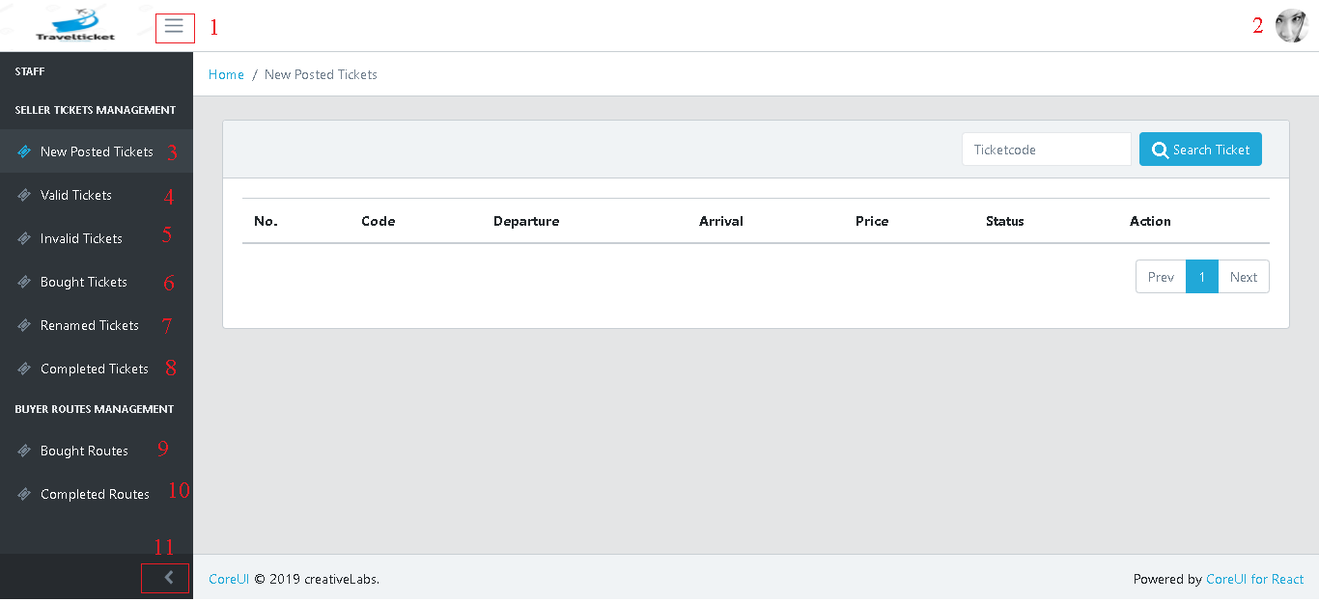

Figure 126 - <Interface> Staff Main menu

**Buttons/Hyperlinks:**

|  |  |  |  |  |
| --- | --- | --- | --- | --- |
| **No** | **Function** | **Description** | **Validation** | **Outcome** |
| 1 | Hide sidebar menu | Hide sidebar menu | User must had been authorized | Hide sidebar menu |
| 2 | User menu | User menu | User must had been authorized | Show user menu |
| 3 | New posted tickets | New posted tickets page | User must had been authorized | Redirect to new posted tickets page |
| 4 | Valid tickets | Valid tickets page | User must had been authorized | Redirect to valid ticket page |
| 5 | Invalid tickets | Invalid tickets page | User must had been authorized | Redirect to invalid tickets page |
| 6 | Bought tickets | Bought tickets page | User must had been authorized | Redirect to bought tickets page |
| 7 | Renamed tickets | Renamed tickets page | User must had been authorized | Redirect to renamed tickets page |
| 8 | Completed Ticket | Completed ticket page | User must had been authorized | Redirect to completed tickets page |
| 9 | Bought routes | Bought routes page | User must had been authorized | Redirect to bought routes page |
| 10 | Completed routes | Completed routes page | User must had been authorized | Redirect to completed routes page |
| 11 | Hide sidebar menu | Hide sidebar menu | User must had been authorized | Hide sidebar menu |

Table 142 <Buttons/Hyperlinks> Main menu

##### Staff menu



Figure 127 - <Interface> Staff Menu

**Buttons/Hyperlinks:**

|  |  |  |  |  |
| --- | --- | --- | --- | --- |
| **No** | **Function** | **Description** | **Validation** | **Outcome** |
| 1 | Profile | Profile | User must had been authorized | Redirect to view current staff profile page |
| 2 | Logout | Logout | User must had been authorized | Logout of the system |

Table 143 <Buttons/Hyperlinks> User menu

##### User profile

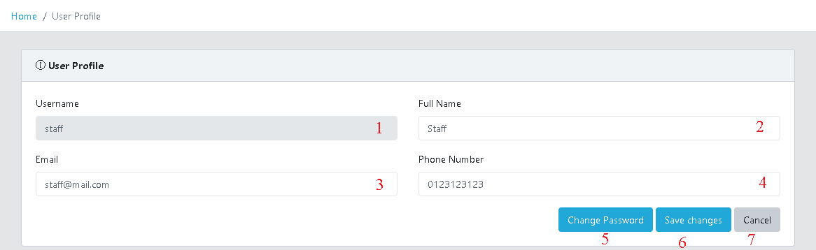

Figure 128 - <Interface> Staff Profile

**Fields**

|  |  |  |  |  |  |  |
| --- | --- | --- | --- | --- | --- | --- |
| **No** | **Field Name** | **Description** | **Read only** | **Mandatory** | **Control Type** | **Data Type** |
| 1 | Username | Username | No | Yes | Textbox | String |
| 2 | Full name | Full name | No | Yes | Textbox | String |
| 3 | Email | Email | No | Yes | Textbox | String |
| 4 | Phone number | Phone number | No | Yes | Textbox | String |

Table 144 <Fields> User profile

**Buttons/Hyperlinks:**

|  |  |  |  |  |
| --- | --- | --- | --- | --- |
| **No** | **Function** | **Description** | **Validation** | **Outcome** |
| 5 | Change password | Change staff password | User must had been authorized | Show change password form |
| 6 | Save changes | Save changes of staff information | User must had been authorized | Update staff profile |
| 7 | Cancel | Redirect to main menu | User must had been authorized | Redirect to main menu |

Table 145 <Buttons/Hyperlinks> User profile

##### Change password



Figure 129 - <Interface> Staff Change Password page

**Fields**

|  |  |  |  |  |  |  |
| --- | --- | --- | --- | --- | --- | --- |
| **No** | **Field Name** | **Description** | **Read only** | **Mandatory** | **Control Type** | **Data Type** |
| 1 | Current password | Current staff password | No | Yes | Textbox | String |
| 2 | New password | New password | No | Yes | Textbox | String |
| 3 | Confirm password | Confirm new password | No | Yes | Textbox | String |

Table 146 <Fields> Change password

**Buttons/Hyperlinks:**

|  |  |  |  |  |
| --- | --- | --- | --- | --- |
| **No** | **Function** | **Description** | **Validation** | **Outcome** |
| 4 | Save changes | Save change of staff information | User must had been authorized | Update staff password,  Redirect to login page |
| 5 | Cancel | Redirect to main menu | User must had been authorized | Close change password form |

Table 147 <Buttons/Hyperlinks> Change password

##### New posted tickets menu

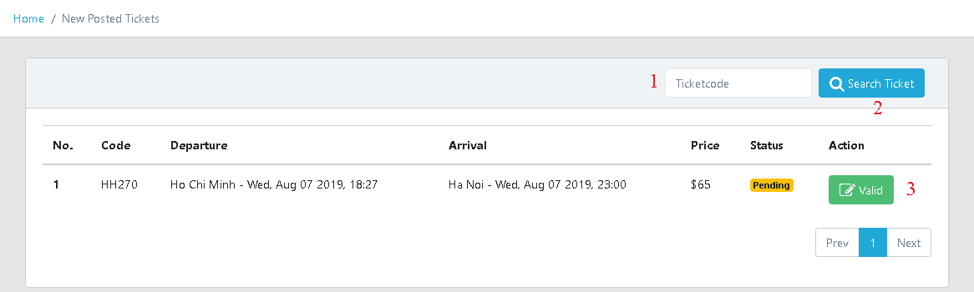

Figure 130 - <Interface> New Posted Tickets menu

**Fields**

|  |  |  |  |  |  |  |
| --- | --- | --- | --- | --- | --- | --- |
| **No** | **Field Name** | **Description** | **Read only** | **Mandatory** | **Control Type** | **Data Type** |
| 1 | Ticket code | Ticket code to search | No | Yes | Textbox | String |

Table 148 <Fields> New posted tickets menu

**Buttons/Hyperlinks:**

|  |  |  |  |  |
| --- | --- | --- | --- | --- |
| **No** | **Function** | **Description** | **Validation** | **Outcome** |
| 1 | Search ticket | Search new posted ticket | User must had been authorized | Show searched ticket |
| 2 | Valid | Valid new posted ticket page | User must had been authorized | Redirect to valid ticket detail page |

Table 149 <Buttons/Hyperlinks> New posted tickets menu

##### Valid new posted ticket

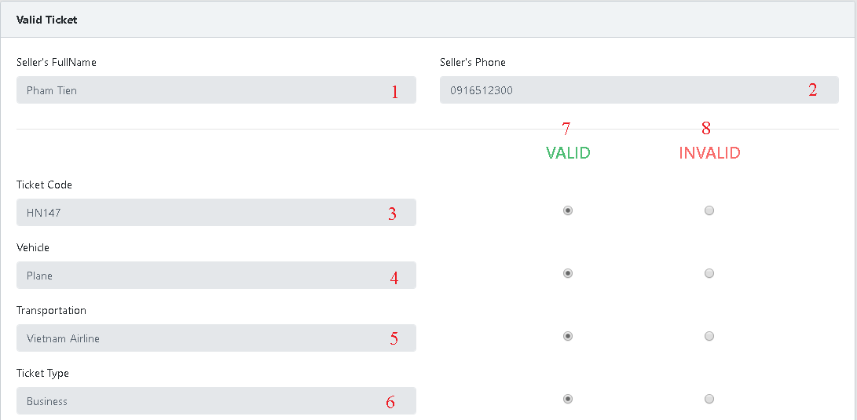

Figure 131 - <Interface> Valid New Posted Ticket

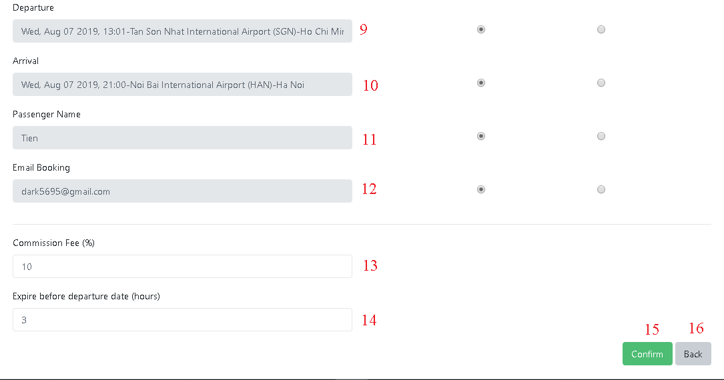

Figure 132 - <Interface> Valid new Posted Ticket

**Fields**

|  |  |  |  |  |  |  |
| --- | --- | --- | --- | --- | --- | --- |
| **No** | **Field Name** | **Description** | **Read only** | **Mandatory** | **Control Type** | **Data Type** |
| 1 | Seller’s full name | Full name of seller | No | Yes | Textbox | String | |
| 2 | Seller’s phone | Phone of seller | No | Yes | Textbox | String | |
| 3 | Ticket code | Code of ticket | No | Yes | Textbox | String | |
| 4 | Vehicle | Vehicle of ticket | No | Yes | Textbox | String | |
| 5 | Transportation | Transportation of ticket | No | Yes | Textbox | String | |
| 6 | Ticket type | Ticket type of ticket | No | Yes | Textbox | String | |
| 9 | Departure | Departure city of ticket | No | Yes | Textbox | String | |
| 10 | Arrival | Arrival city of ticket | No | Yes | Textbox | String | |
| 11 | Passenger Name | Passenger name of ticket | No | Yes | Textbox | String | |
| 12 | Email booking | Email booking of ticket | No | Yes | Textbox | String | |
| 13 | Commission fee | Commission fee (%) | No | Yes | Textbox | Decimal | |
| 14 | Expire before departure date | Expire before departure date(hours) | No | Yes | Textbox | Datetime | |

Table 150 <Fields> Valid new posted tickets menu

**Buttons/Hyperlinks:**

|  |  |  |  |  |
| --- | --- | --- | --- | --- |
| **No** | **Function** | **Description** | **Validation** | **Outcome** |
| 7 | Valid | Valid information of new posted ticket | User must had been authorized | Information of new posted ticket was checked valid |
| 8 | Invalid | Invalid information of new posted ticket | User must had been authorized | Information of new posted ticket was checked invalid |
| 15 | Confirm | Confirm new posted ticket | User must had been authorized | New posted ticket was valid/invalid, redirect to new posted tickets page |
| 16 | Back | Back to previous page | User must had been authorized | Redirect to new posted tickets page |

Table 151 <Buttons/Hyperlinks> Valid new posted tickets menu

##### Valid tickets menu

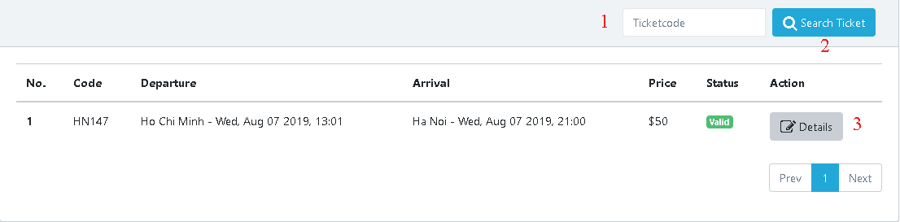

Figure 133 - <Interface> Valid Ticket Menu

**Fields**

|  |  |  |  |  |  |  |
| --- | --- | --- | --- | --- | --- | --- |
| **No** | **Field Name** | **Description** | **Read only** | **Mandatory** | **Control Type** | **Data Type** |
| 1 | Ticket code | Ticket code to search | No | Yes | Textbox | String |

Table 152 <Fields> Valid tickets menu

**Buttons/Hyperlinks:**

|  |  |  |  |  |
| --- | --- | --- | --- | --- |
| **No** | **Function** | **Description** | **Validation** | **Outcome** |
| 1 | Search ticket | Search new posted ticket | User must had been authorized | Show searched ticket |
| 2 | Details | Ticket details page | User must had been authorized | Redirect to ticket details page |

Table 153 <Buttons/Hyperlinks> Valid tickets menu

##### View ticket details

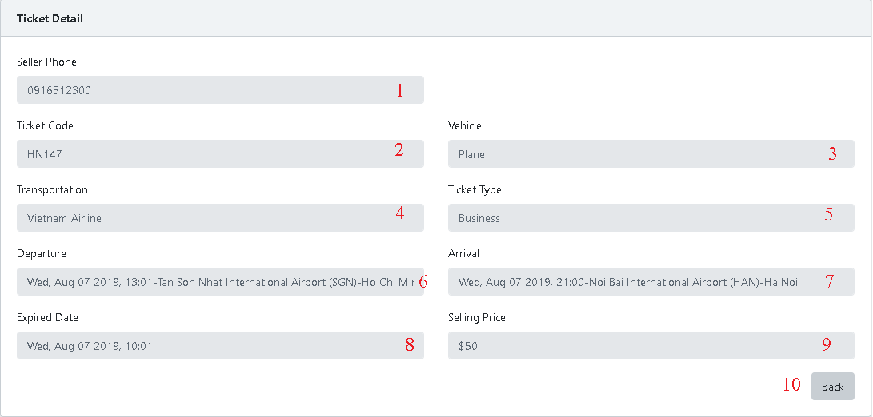

Figure 134 - <Interface> View Ticket Details

**Fields**

|  |  |  |  |  |  |  |
| --- | --- | --- | --- | --- | --- | --- |
| **No** | **Field Name** | **Description** | **Read only** | **Mandatory** | **Control Type** | **Data Type** |
| 1 | Seller phone | Seller phone | No | Yes | Textbox | String |
| 2 | Ticket code | Code of ticket | No | Yes | Textbox | String |
| 3 | Vehicle | Vehicle of ticket | No | Yes | Textbox | String |
| 4 | Transportation | Transportation of ticket | No | Yes | Textbox | String |
| 5 | Ticket type | Type of ticket | No | Yes | Textbox | String |
| 6 | Departure | Departure city of ticket | No | Yes | Textbox | String |
| 7 | Arrival | Arrival city of ticket | No | Yes | Textbox | String |
| 8 | Expired date | Expired date of ticket | No | Yes | Textbox | Datetime |
| 9 | Selling price | Selling price | No | Yes | Textbox | Decimal |

Table 154 <Fields> View ticket details

**Buttons/Hyperlinks:**

|  |  |  |  |  |
| --- | --- | --- | --- | --- |
| **No** | **Function** | **Description** | **Validation** | **Outcome** |
| 10 | Back | Back to previous page | User must had been authorized | Redirect to previous page |

Table 155 <Buttons/Hyperlinks> View ticket details

##### Invalid tickets menu

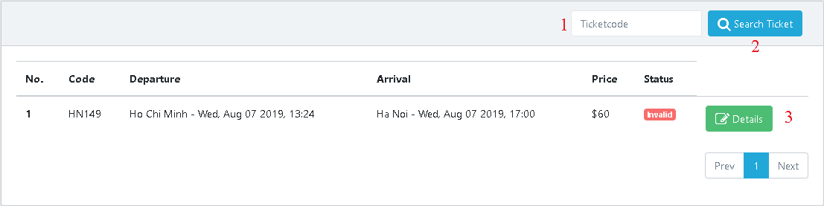

Figure 135 - <Interface> Invalid Tickets Menu

**Fields**

|  |  |  |  |  |  |  |
| --- | --- | --- | --- | --- | --- | --- |
| **No** | **Field Name** | **Description** | **Read only** | **Mandatory** | **Control Type** | **Data Type** |
| 1 | Ticket code | Ticket code to search | No | Yes | Textbox | String |

Table 156 <Fields> Invalid tickets menu

**Buttons/Hyperlinks:**

|  |  |  |  |  |
| --- | --- | --- | --- | --- |
| **No** | **Function** | **Description** | **Validation** | **Outcome** |
| 1 | Search ticket | Search new posted ticket | User must had been authorized | Show searched ticket |
| 2 | Details | Ticket details page | User must had been authorized | Redirect to ticket details page |

Table 157 <Buttons/Hyperlinks> Invalid tickets menu

##### Bought tickets menu

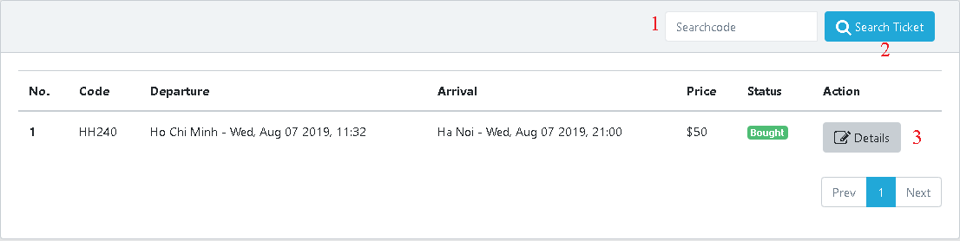

Figure 136 - <Interface> Bought Tickets Menu

**Fields**

|  |  |  |  |  |  |  |
| --- | --- | --- | --- | --- | --- | --- |
| **No** | **Field Name** | **Description** | **Read only** | **Mandatory** | **Control Type** | **Data Type** |
| 1 | Ticket code | Ticket code to search | No | Yes | Textbox | String |

Table 158 <Fields>Bought tickets menu

**Buttons/Hyperlinks:**

|  |  |  |  |  |
| --- | --- | --- | --- | --- |
| **No** | **Function** | **Description** | **Validation** | **Outcome** |
| 1 | Search ticket | Search new posted ticket | User must had been authorized | Show searched ticket |
| 2 | Details | Ticket details page | User must had been authorized | Redirect to ticket details page |

Table 159 <Buttons/Hyperlinks> Bought tickets menu

##### Renamed tickets menu



Figure 137 - <Interface> Renamed Tickets Menu

**Fields**

|  |  |  |  |  |  |  |
| --- | --- | --- | --- | --- | --- | --- |
| **No** | **Field Name** | **Description** | **Read only** | **Mandatory** | **Control Type** | **Data Type** |
| 1 | Ticket code | Ticket code to search | No | Yes | Textbox | String |

Table 160 <Fields>Renamed tickets menu

**Buttons/Hyperlinks:**

|  |  |  |  |  |
| --- | --- | --- | --- | --- |
| **No** | **Function** | **Description** | **Validation** | **Outcome** |
| 1 | Search ticket | Search new posted ticket | User must had been authorized | Show searched ticket |
| 2 | Details | Verify renamed ticket page | User must had been authorized | Redirect to verify renamed ticket page |

Table 161 <Buttons/Hyperlinks> Renamed tickets menu

##### Verify renamed ticket

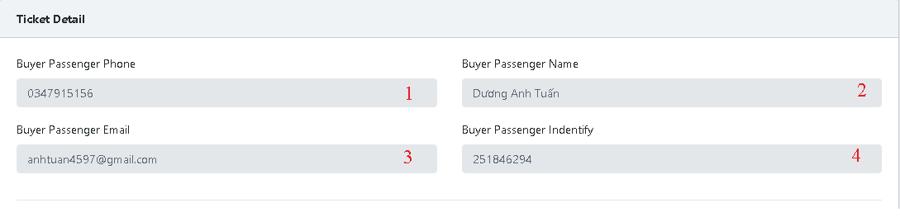

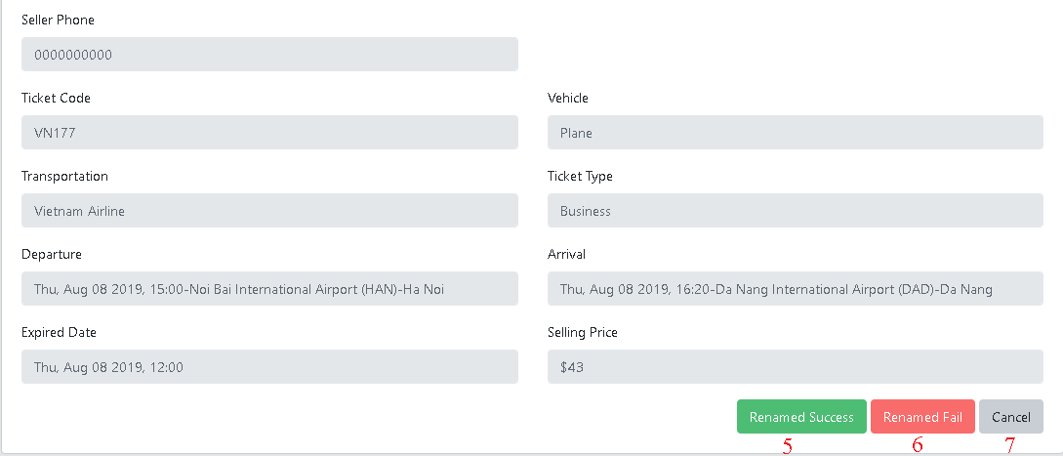

Figure 138 - <Interface> Verify Renamed Ticket

**Fields**

|  |  |  |  |  |  |  |
| --- | --- | --- | --- | --- | --- | --- |
| **No** | **Field Name** | **Description** | **Read only** | **Mandatory** | **Control Type** | **Data Type** |
| 1 | Buyer passenger phone | Buyer passenger phone | No | Yes | Textbox | String |
| 2 | Buyer passenger name | Buyer passenger name | No | Yes | Textbox | String |
| 3 | Buyer passenger email | Buyer passenger email | No | Yes | Textbox | String |
| 4 | Buyer passenger identify | Buyer passenger identify | No | Yes | Textbox | String |

Table 162 <Fields>Verify renamed ticket

**Buttons/Hyperlinks:**

|  |  |  |  |  |
| --- | --- | --- | --- | --- |
| **No** | **Function** | **Description** | **Validation** | **Outcome** |
| 5 | Rename success | Rename success | User must had been authorized | Show confirm renamed ticket success dialog |
| 6 | Rename fail | Rename fail | User must had been authorized | Show confirm renamed ticket fail dialog |
| 7 | Cancel | Redirect to previous page | User must had been authorized | Redirect to renamed tickets page |

Table 163 <Buttons/Hyperlinks> Verify renamed ticket

##### Confirm renamed ticket success

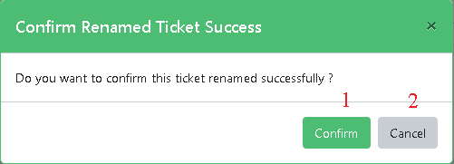

Figure 139 - <Interface> Confirm Renamed Ticket Success

**Buttons/Hyperlinks:**

|  |  |  |  |  |
| --- | --- | --- | --- | --- |
| **No** | **Function** | **Description** | **Validation** | **Outcome** |
| 1 | Confirm | Confirm | User must had been authorized | Renamed ticket successfully, redirect to renamed tickets page |
| 2 | Cancel | Redirect to previous page | User must had been authorized | Redirect to renamed tickets page |

Table 164 <Buttons/Hyperlinks> Confirm renamed ticket success

##### Confirm renamed ticket fail

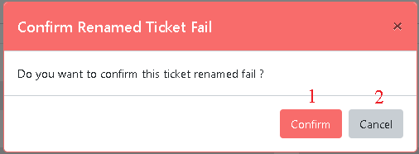

Figure 140 - <Interface> Confirm Renamed Ticket Failed

**Buttons/Hyperlinks:**

|  |  |  |  |  |
| --- | --- | --- | --- | --- |
| **No** | **Function** | **Description** | **Validation** | **Outcome** |
| 1 | Confirm | Confirm | User must had been authorized | Renamed ticket fail, redirect to renamed tickets page |
| 2 | Cancel | Redirect to previous page | User must had been authorized | Redirect to renamed tickets page |

Table 165 <Buttons/Hyperlinks> Confirm renamed ticket success

##### Completed tickets menu

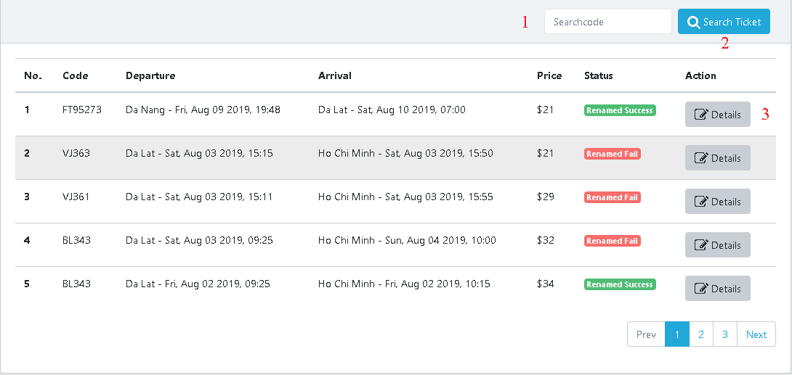

Figure 141 - <Interface> Completed Tickets Menu

**Fields**

|  |  |  |  |  |  |  |
| --- | --- | --- | --- | --- | --- | --- |
| **No** | **Field Name** | **Description** | **Read only** | **Mandatory** | **Control Type** | **Data Type** |
| 1 | Ticket code | Ticket code to search | No | Yes | Textbox | String |

Table 166 <Fields>Renamed tickets menu

**Buttons/Hyperlinks:**

|  |  |  |  |  |
| --- | --- | --- | --- | --- |
| **No** | **Function** | **Description** | **Validation** | **Outcome** |
| 1 | Search ticket | Search new posted ticket | User must had been authorized | Show searched ticket |
| 2 | Details | Verify renamed ticket page | User must had been authorized | Redirect to verify renamed ticket page |

Table 167 <Buttons/Hyperlinks> Renamed tickets menu

##### Bought Routes Page

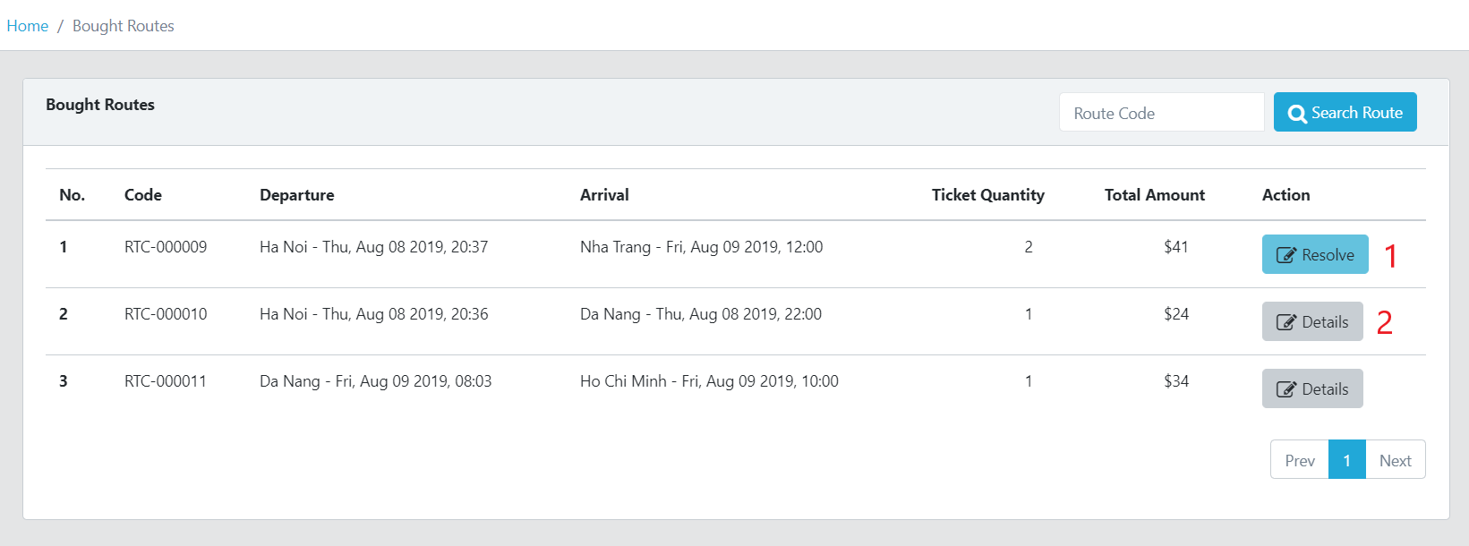

Figure 142 - <Interface> Bought Routes Page

**Buttons/Hyperlinks:**

|  |  |  |  |  |
| --- | --- | --- | --- | --- |
| **No** | **Function** | **Description** | **Validation** | **Outcome** |
| 1 | Resolve | Resolve route that has one or more tickets are renamed success or fail | N/A | Redirect to resolve route page |
| 2 | Details | Details of this route | N/A | Redirect to details of route |

Table 168 - <Buttons/Hyperlinks> Bought Route Page

##### Resolve Renamed Success Ticket Page

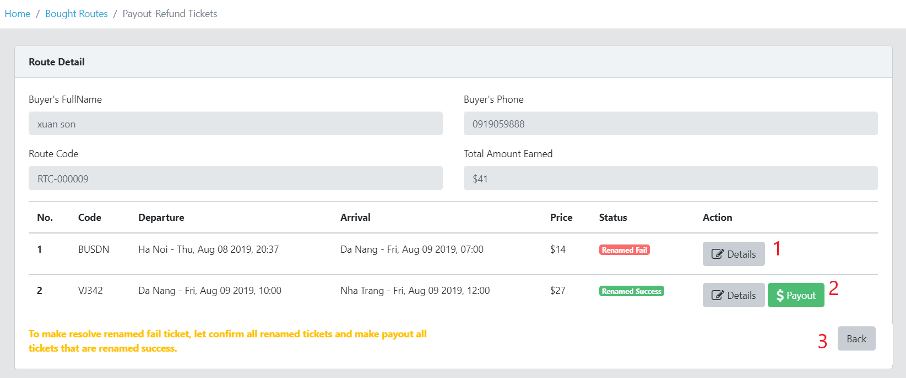

Figure 143 - <Interface> Resolve Renamed Success Ticket Page

**Buttons/Hyperlinks:**

|  |  |  |  |  |
| --- | --- | --- | --- | --- |
| **No** | **Function** | **Description** | **Validation** | **Outcome** |
| 1 | Details | Details of ticket | N/A | Redirect to details of ticket |
| 2 | Payout | Payout money for seller | N/A | Render payout successfully |
| 3 | Back | Go back | N/A | Redirect to bought routes page |

Table 169 - <Buttons/Hyperlinks> Resolve Renamed Success Ticket Page

##### Resolve Renamed Fail Ticket Page

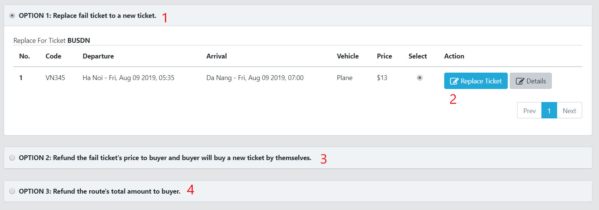

Figure 144 - <Interface> Resolve Renamed Ticket Failed Page

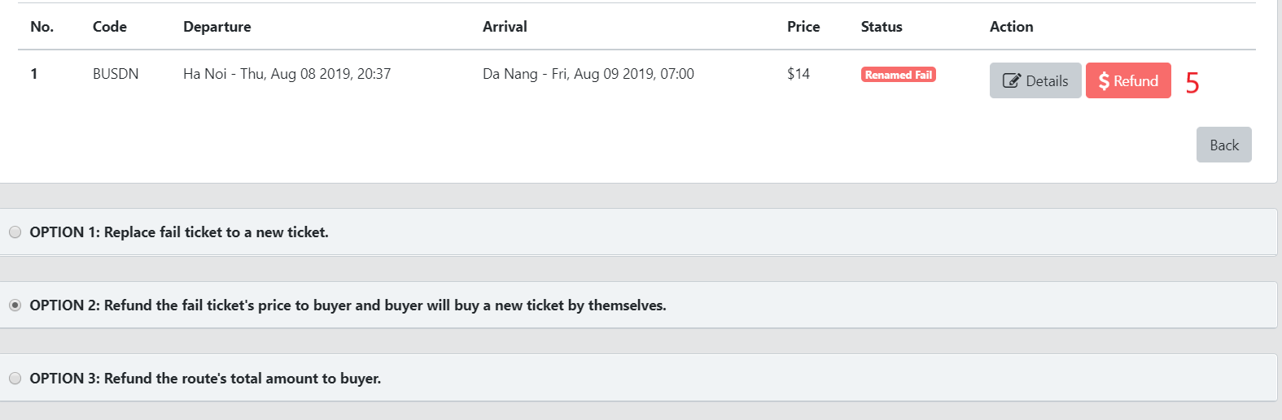

Figure 145 - <Interface> Resolve Renamed Ticket Failed Page

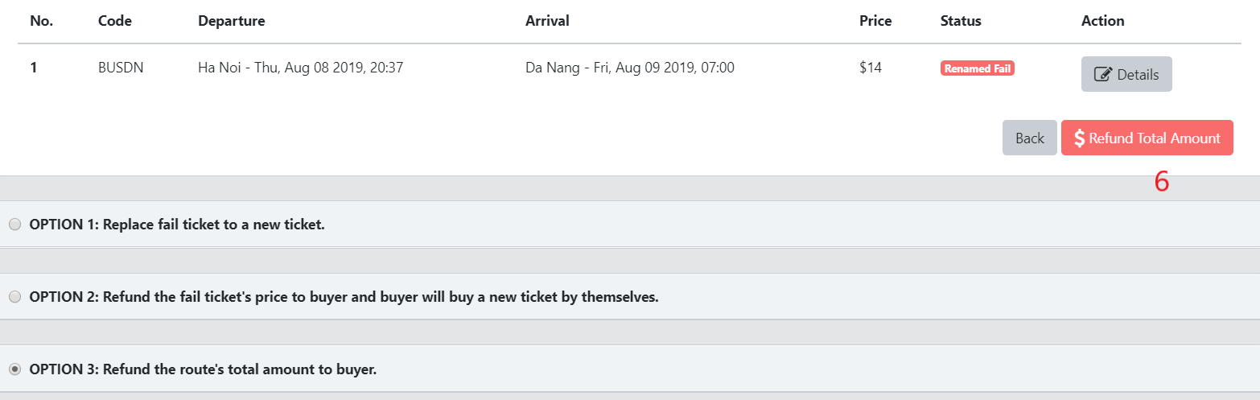

Figure 146 - <Interface> Resolve Renamed Ticket Failed Page

**Buttons/Hyperlinks:**

|  |  |  |  |  |
| --- | --- | --- | --- | --- |
| **No** | **Function** | **Description** | **Validation** | **Outcome** |
| 1 | Option 1 | Option 1 to resolve renamed fail ticket | N/A | Render available tickets to replace fail ticket |
| 2 | Replace Ticket | Replace renamed fail ticket | N/A | Render replace successfully |
| 3 | Option 2 | Option 2 to resolve renamed fail ticket | N/A | Render Refund button |
| 4 | Option 3 | Option to resolve fail route | N/A | Render Refund Total Amount button |
| 5 | Refund | Refund ticket’s price to buyer | N/A | Render refund successfully |
| 6 | Refund Total Amount | Refund total amount of route to buyer | N/A | Render refund successfully |

Table 170 - <Buttons/Hyperlinks> Resolve Renamed Ticket Failed Page

##### Resolve Tickets History Page

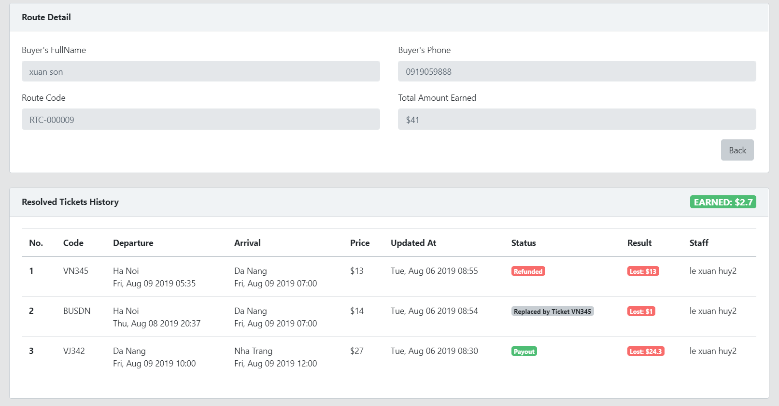

Figure 147 - <Interface> Resolve Tickets History Page

##### Completed Routes Page

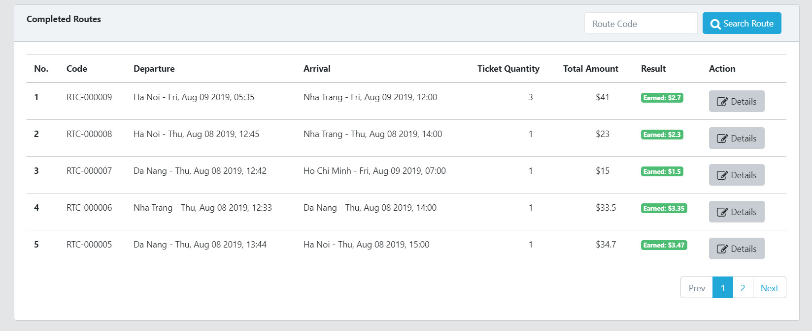

Figure 148 - <Interface> Completed Routes Page

## Database Design

### **6.1. Entity Relationship Diagram (ERD)**

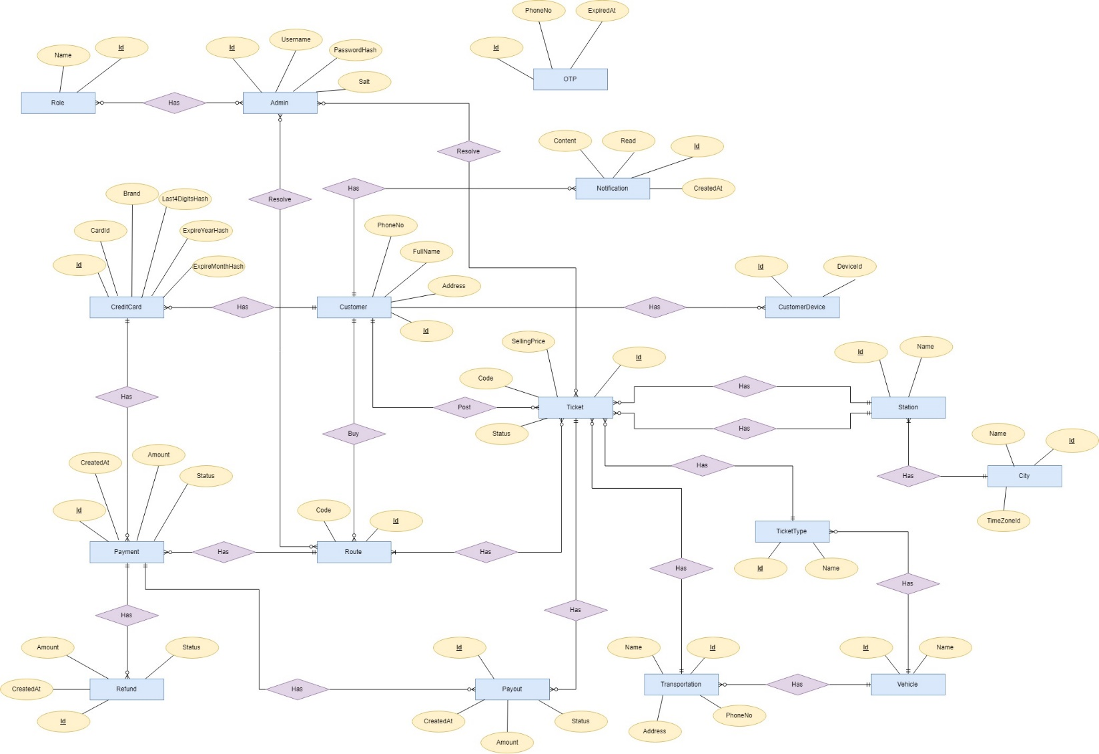

Figure 149 - Entity Relationship Diagram (ERD)

### **6.2. Data Dictionary**

|  |  |
| --- | --- |
| **Entity Data Dictionary: describe content of all entities** | |
| **Entity name** | **Description** |
| Admin | Contains the admin’s information. |
| Role | Contains the role’s information. |
| OTP | Contains the OTP’s information. |
| Customer | Contains the customer’s information |
| Route | Contains the route’s information |
| CreditCard | Contains the creditcard’s information |
| Ticket | Contains the ticket’s information |
| Station | Contains the station’s information |
| City | Contains the city’s information |
| Transportation | Contains the transportation’s information |
| Ticket Type | Contains the ticket type’s information |
| Vehicle | Contains the vehicle information |
| Notification | Contains the notification’s information |
| Payment | Contains the payment’s information |
| Payout | Contains the payout’s information |
| Refund | Contains the refund’s information |
| CustomerDevice | Contains the customer device’s information |

Table 171 - <ERD> Data Dictionary

|  |  |  |  |  |
| --- | --- | --- | --- | --- |
| Entity Name | Attributes | Description | Domain | Null |
| User | id | Id of user | NVARCHAR(450) | NO |
| Username | Username of user | NVARCHAR(256) | NO |
| Address | Address of user | NVARCHAR(256) | NO |
| Fullname | Fullname of user | NVARCHAR(MAX) | NO |
| Email | Email of user | NVARCHAR(256) | NO |
| PhoneNumber | PhoneNumber of user | NVARCHAR(MAX) | NO |
| Role | Id | Role Id of user | NVARCHAR(450) | NO |
| Name | Role name of user | NVARCHAR(256) | NO |
| OTP | Id | Id of otp code | Int | NO |
| CreatedAtUTC | The moment OTP is created | Datetime2(7) | NO |
| PhoneNo | Phone number to send otp code | NVARCHAR(MAX) | NO |
| Code | OTP code | NVARCHAR(MAX) | NO |
| ExpiredAt | The moment OTP is expired | Datetime2(7) | NO |
| Customer | Id | Id of customer | Int | NO |
| CreatedAtUTC | The moment customer is created | Datetime2(7) | NO |
| UpdatedAtUTC | The moment customer is updated | Datetime2(7) | NO |
| Username | Customer’ username | NVARCHAR(MAX) | NO |
| PasswordHash | Customer’s password | NVARCHAR(MAX) | NO |
| Email | Customer’s email | NVARCHAR(MAX) | NO |
| PhoneNumber | Customer’s phone number | NVARCHAR(MAX) | NO |
| Address | Customer ‘s address | NVARCHAR(MAX) | NO |
| FullName | Customer’s fullname | NVARCHAR(MAX) | NO |
| CreditCard | Id | Id of credit card | BIGINT(20) | NO |
| CardId | Stripe Card Id | NVARCHAR(MAX) | NO |
| Brand | Brand of card | NVARCHAR(MAX) | NO |
| Last4DigitsHash | 4 last digits of card number | NVARCHAR(MAX) | NO |
| ExpiredYearHash | The year the card is expired | NVARCHAR(MAX) | YES |
| ExpiredMonthHash | The month the card is expired | NVARCHAR(MAX) | YES |
| CreatedAtUTC | Created time | DATETIME | NO |
| UpdatedAtUTC | Updated time | DATETIME | YES |
| Ticket | id | Id of ticket | BIGINT(20) | NO |
| Code | Code of ticket | NVARCHAR(MAX) | NO |
| Status | Status of ticket | Int | NO |
| SellingPrice | Price of ticket | Decimal(18,2) | NO |
| DepartureDateTime | Departure time of ticket | Datetime2(7) | NO |
| ArrivalDateTime | Arrival time of ticket | Dateime2(7) | NO |
| ExpiredDateTime | Expired time of ticket | Datetime2(7) | NO |
| PassengerName | Name of the seller | NVARCHAR(MAX) | NO |
| EmailBooking | Email of the seller | NVARCHAR(MAX) | NO |
| BuyerPassenger  Name | Name of the buyer | NVARCHAR(MAX) | NO |
| BuyerPassenger  Email | Emal of buyer | NVARCHAR(MAX) | NO |
| BuyerPassenger  Phone | Phone of buyer | NVARCHAR(MAX) | NO |
| BuyerPassenger  Identification | Identification of buyer | NVARCHAR(MAX) | NO |
| CreatedAtUTC | Created time | DATETIME | NO |
| UpdatedAtUTC | Updated time | DATETIME | YES |
| Route | id | Id of route | Int | NO |
| Code | Code of route | NVARCHAR(MAX) | NO |
| CreatedAtUTC | Created time | DATETIME | NO |
| UpdatedAtUTC | Updated time | DATETIME | YES |
| Status | Status of route | Int | NO |
| TotalAmount | Total price of route | Decimal(18,2) | NO |
| Station | id | Id of station | Int | NO |
| Name | Name of staion | NVARCHAR(MAX) | NO |
| CreatedAtUTC | Created time | DATETIME | NO |
| UpdatedAtUTC | Updated time | DATETIME | YES |
| City | id | Id of city | Int | NO |
| Name | Name of city | NVARCHAR(MAX) | NO |
| CreatedAtUTC | Created time | DATETIME | NO |
| UpdatedAtUTC | Updated time | DATETIME | YES |
| TimeZoneId | Time zone id of city | NVARCHAR(MAX) | NO |
| Transportation | Id | Id of transportation | Int | NO |
| Name | Name of transportation | NVARCHAR(MAX) | NO |
| PhoneNumber | Phone number of transportation | NVARCHAR(MAX) | NO |
| CreatedAtUTC | Created time | DATETIME | NO |
| UpdatedAtUTC | Updated time | DATETIME | YES |
| Email | Email of transportation | NVARCHAR(MAX) | NO |
| TicketType | Id | Id of ticket type | Int | NO |
| Name | Name of ticket type | VARCHAR(255) | NO |
| CreatedAtUTC | Created time | DATETIME | NO |
| UpdatedAtUTC | Updated time | DATETIME | YES |
| Vehicle | Id | Id of vehicle | Int | NO |
| CreatedAtUTC | Created time | DATETIME | NO |
| UpdatedAtUTC | Updated time | DATETIME | YES |
| Name | Name of vehicle | NVARCHAR(MAX) | NO |
| Payment | Id | Id of payment | Int | NO |
| Amount | The money amount of payment | Decimal(18,2) | NO |
| FeeAmount | Fee amount the Stripe take | Decimal(18,2) | NO |
| Status | Status of payment | Int | NO |
| CreatedAtUTC | Created time | DATETIME | NO |
| UpdatedAtUTC | Updated time | DATETIME | YES |
| Description | Description of the payment | NVARCHAR(MAX) | NO |
| Payout | Id | Id of payout | Int | NO |
| Status | Status of payout | Int | NO |
| Amount | The money amount to transfer to seller | Decimal(18,2) | NO |
| Fee Amount | Commission fee amount | Decimal(18,2) | NO |
| CreatedAtUTC | Created time | DATETIME | NO |
| UpdatedAtUTC | Updated time | DATETIME | YES |
| Description | Description of payout | NVARCHAR(MAX) | NO |
| Refund | id | Id of refuint | Int | NO |
| Status | Status of refund | Int | NO |
| Amount | Money amount to refund to buyer | Decimal(18,2) | NO |
| CreatedAtUTC | Created time | DATETIME | NO |
| UpdatedAtUTC | Updated time | DATETIME | YES |
| Description | Description of refund | NVARCHAR(MAX) | NO |
| Notification | Id | Id of notification | Int | NO |
| Data | Data of notification | NVARCHAR(MAX) | NO |
| Type | Type of notification | Int | NO |
| Message | Message of notification | NVARCHAR(MAX) | NO |
| Read | Notification whether read or not | Bit | NO |
| CreatedAtUTC | Created time | DATETIME | NO |
| UpdatedAtUTC | Updated time | DATETIME | YES |
| CustomerDevice | Id | Id of customer device | Int | NO |
| DeviceId | customer device Id | NVARCHAR(MAX) | NO |
| IsLogout | The device is login or logout | Bit | NO |
| CreatedAtUTC | Created time | DATETIME | NO |
| UpdatedAtUTC | Updated time | DATETIME | YES |

Table 172 - <ERD> Entity Dictionary

## Algorithms

### **7.1. Finding the $k$ cheapest combination tickets**

#### 7.1.1. Definition

* A Combination ticket is a route.
* A Ticket has information:
  + Departure City.
  + Departure Date.
  + Arrival City.
  + Arrival Date.
  + Price.
  + Vehicle.
  + Ticket Type.
  + Transportation.

#### 7.1.2. Define Problem

When customer search for tickets available from a city to another city, the system will not only find single ticket match that criterial, but it will find combination tickets match that criterial. In additional, we want to enhance user’s experience by ordering ascending those combination tickets by total price. Therefore, we use an algorithm to find $k$ cheapest combination tickets based on some input constraints.

* Input constraints:
  + Departure City.
  + Departure Date.
  + Arrival City.
  + Arrival Date.
  + Max Ticket quantity in a route.
  + Max Waiting time.
  + List of accepted vehicles.
  + List of accepted ticket types.
  + List of accepted transportations.
* A valid route result must valid those conditions:
  + The $i^{th}$ Ticket’s Arrival date must be earlier than the $({i+1)}^{th}$ Ticket’s Departure date.
  + The $i^{th}$ Ticket’s Arrival city must be the same the ${(i+1)}^{th}$ Ticket’s Departure City.
  + The $i^{th}$ Ticket’s Departure city must be the same the ${(i-1)}^{th}$ Ticket’s Arrival City.
  + Total number of tickets in a route must not greater than “Max Ticket quantity in a route”.
  + The waiting time in a route is the difference between the $i^{th}$ Ticket’s Arrival date and the ${(i+1)}^{th}$ Ticket’s Departure date.
  + Each ticket in a route must valid accepted vehicles, accepted ticket types, accepted transportation.

#### 7.1.3. Solution

To solve this problem, we use Eppstein’s Finding the $k$ Shortest paths algorithm. While implement Eppstein Algorithm, we also use Dijkstra's Shortest Path First algorithm to find the shortest path between nodes in a graph and Heap data structure as a priority queue. The main steps of algorithm are:

* Search available tickets that satisfy condition:
  + Ticket’s vehicle existed in accepted vehicles.
  + Ticket’s ticket type existed in accepted Ticket Types.
  + Ticket’s transportation existed in accepted ticket Transportation.
  + Ticket’s status is Valid.
  + Ticket’s departure date is not before Departure date input.
  + Ticket’s arrival date is not after Arrival date input.
* Build a graph from set available tickets.
* Finding the $k$ Shortest paths.
* Convert the $k$ Shortest paths into a combination ticket.

##### 7.1.3.1. Building the graph.

We will convert tickets into a direction graph, in order to apply generic finding the $k$ Shortest paths.

The direction graph contains vertices and edges. Each vertex is a combination of City and Date. Two vertices are equaled only when their City are equaled, and their Date are equaled. A vertex represents that the passenger just entered the City at the time Date. Each edge has a tail vertex and head vertex and a distance. An edge represents that the passenger can travel from tail vertex to head vertex with a distance. In an edge, if the tail vertex’s city is different from the head vertex’s city, that edge is a ticket, that edge’s distance is ticket Price. And if the tail vertex’s city is the same as the head vertex’s city, that edge shows the passenger is waiting at this city.

The graph is built by following steps:

* With every ticket, we create 2 vertices represent departure and destination (if not existed) and create an edge.
  + Departure vertex includes Departure City, and Departure Date.
  + Arrival vertex includes Arrival City, and Arrival Date.
  + Edge’s tail is departure vertex.
  + Edge’s head is arrival vertex.
  + Edge’s distance is ticket price.
* Create waiting edge for vertices in the same city:
  + In a group the vertex the same city, order vertices ascending by Date.
  + In that ordered vertices, if $i^{th}$ vertex’s city equal ${(i+1)}^{th}$ vertex’s city and $i^{th}$ vertex’s Date is before ${(i+1)}^{th}$ vertex’s Date, create an edge that tail is $i^{th}$ vertex and head is ${(i+1)}^{th}$ vertex with distance equal zero.

After the graph is built, we also specify the departure vertex and the destination vertex in the graph:

* The Departure vertex is the lowest Date vertex among vertices that has City is the same as Input Departure City.
* The Destination vertex is the highest Date vertex among vertices that has City is the same as Input Arrival City.

Example:

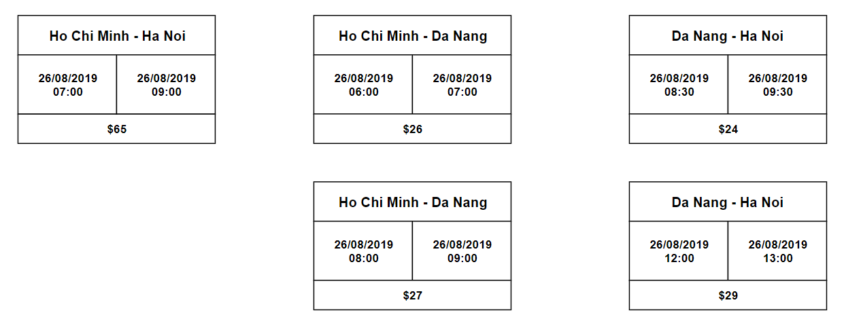

Figure 150 - <Algorithm> Available Tickets

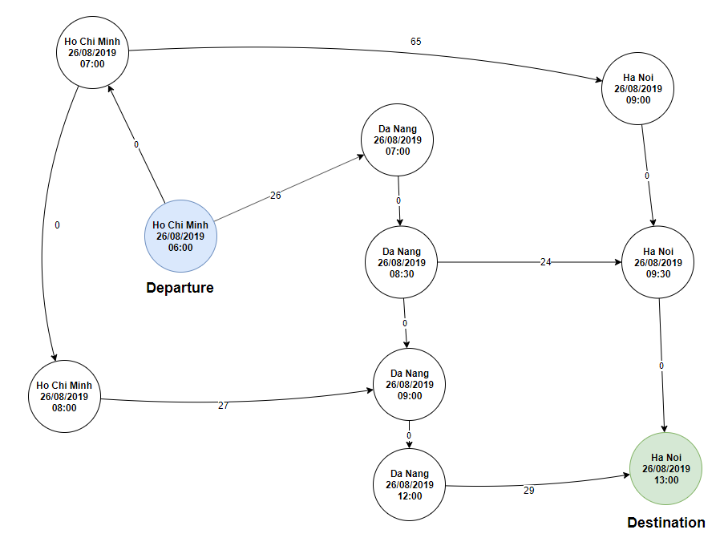

Figure 151 - <Algorithm> Ticket Graph

Now, our problem is changed from finding the k shortest paths from Departure vertex to Destination vertex.

##### 7.1.3.2. Finding the $k$ Shortest paths.

Let $d_{i}$ is the distance of the shortest path from $i^{th}$ vertex to Destination vertex.

Let $e_{i}$ is the next vertex of the shortest path from $i^{th}$ vertex to Destination vertex.

Let $v_{i}$ is the parameter to dedicate $i^{th}$ vertex is visited or not.

Let $q$ is the priority queue to store sidetrack base on the distance of sidetrack. That means the smaller distance sidetrack is more priority than the higher sidetrack.

We follow these steps:

* Use Dijkstra Algorithm to find the shortest path from any vertex to destination vertex.
  + Reverse the direction of the graph.
  + Run Dijkstra algorithm with source vertex is destination vertex, until cannot optimize any vertex. After ran Dijkstra algorithm, we filled the $d_{i}, e_{i}, v_{i}$.

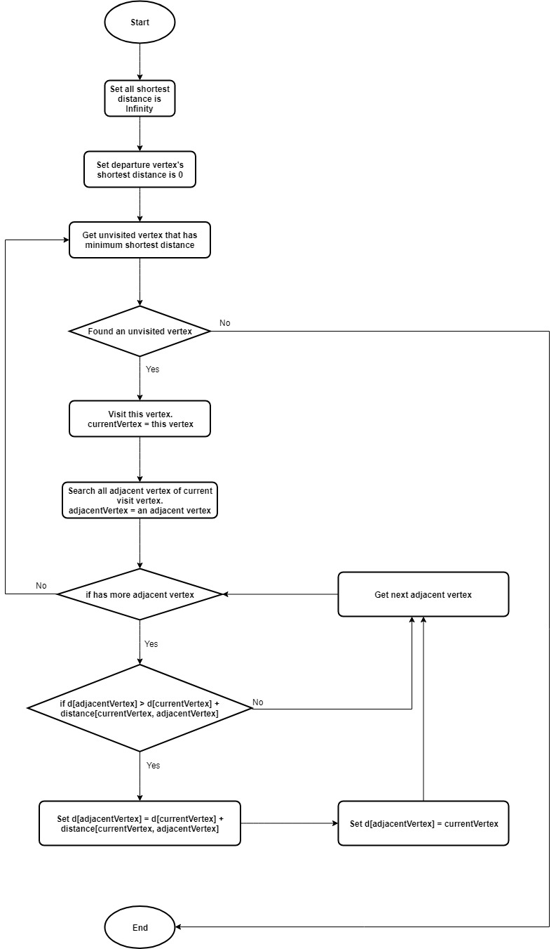

Figure 152 - <Algorithm> Dijkstra Flow Chart

* Get the shortest path from departure vertex to destination vertex. Apply flow chart below with currentVertex is departure vertex.

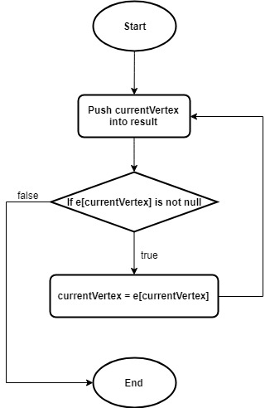

Figure 153 - <Algorithm> Flow chart - Get the shortest path from any vertex to destination vertex

* Try to go to sidetrack to get k shortest paths.

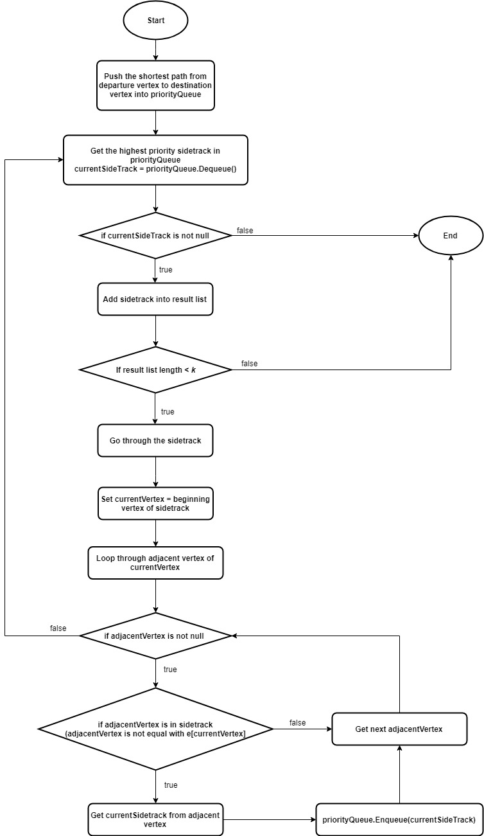

Figure 154 - <Algorithm> Flow chart - Find sidetrack

* The k shortest paths are produced after run finding sidetrack.
* Now, we will convert the result set from graph into a combination ticket by getting all travelling edges a path, remove waiting edges.

#### 7.1.4. Complexity

* Complexity of the building graph is $O(n\log_{n})$ with n is number of tickets.
* After built graph, number of vertices in graph is $2*n$, maximum number of edges in graph is $4*n$.
* Complexity of Dijkstra using heap to implement priority queue: $O\left(4*n+\left(2*n\right)\log_{2*n}\right)=O(n+n\log_{n})$
* Complexity of searching sidetrack:
  + Total dequeue: $k$
  + Total enqueue: $k*\left(2*n\right)$
  + Cost of total enqueue: $O\left(\left(k*2*n\right)\log_{k*2*n}\right)=O(nk*\log_{nk})$
  + Cost of total dequeue: $O(k\log_{k})$
  + Total complexity of searching sidetrack: $O\left(nk\log_{nk}+k\log_{k}\right)$
* Total complexity of this algorithm: $$O\left(n\log_{n}+n+n\log_{n}+nk\log_{nk}+k\log_{k}\right) \\ =O(n\log_{n}+n+ nk\log_{nk}+k\log_{k})$$  
  with n is the number of tickets, k is the number of the cheapest combination ticket we need to find.

# System implementation & Test

## 1. Introduction

### **1.1. Overview**

### **1.2 Test Approach**

## 2. Data Relationship Diagram

### **2.1. Physical Diagram**

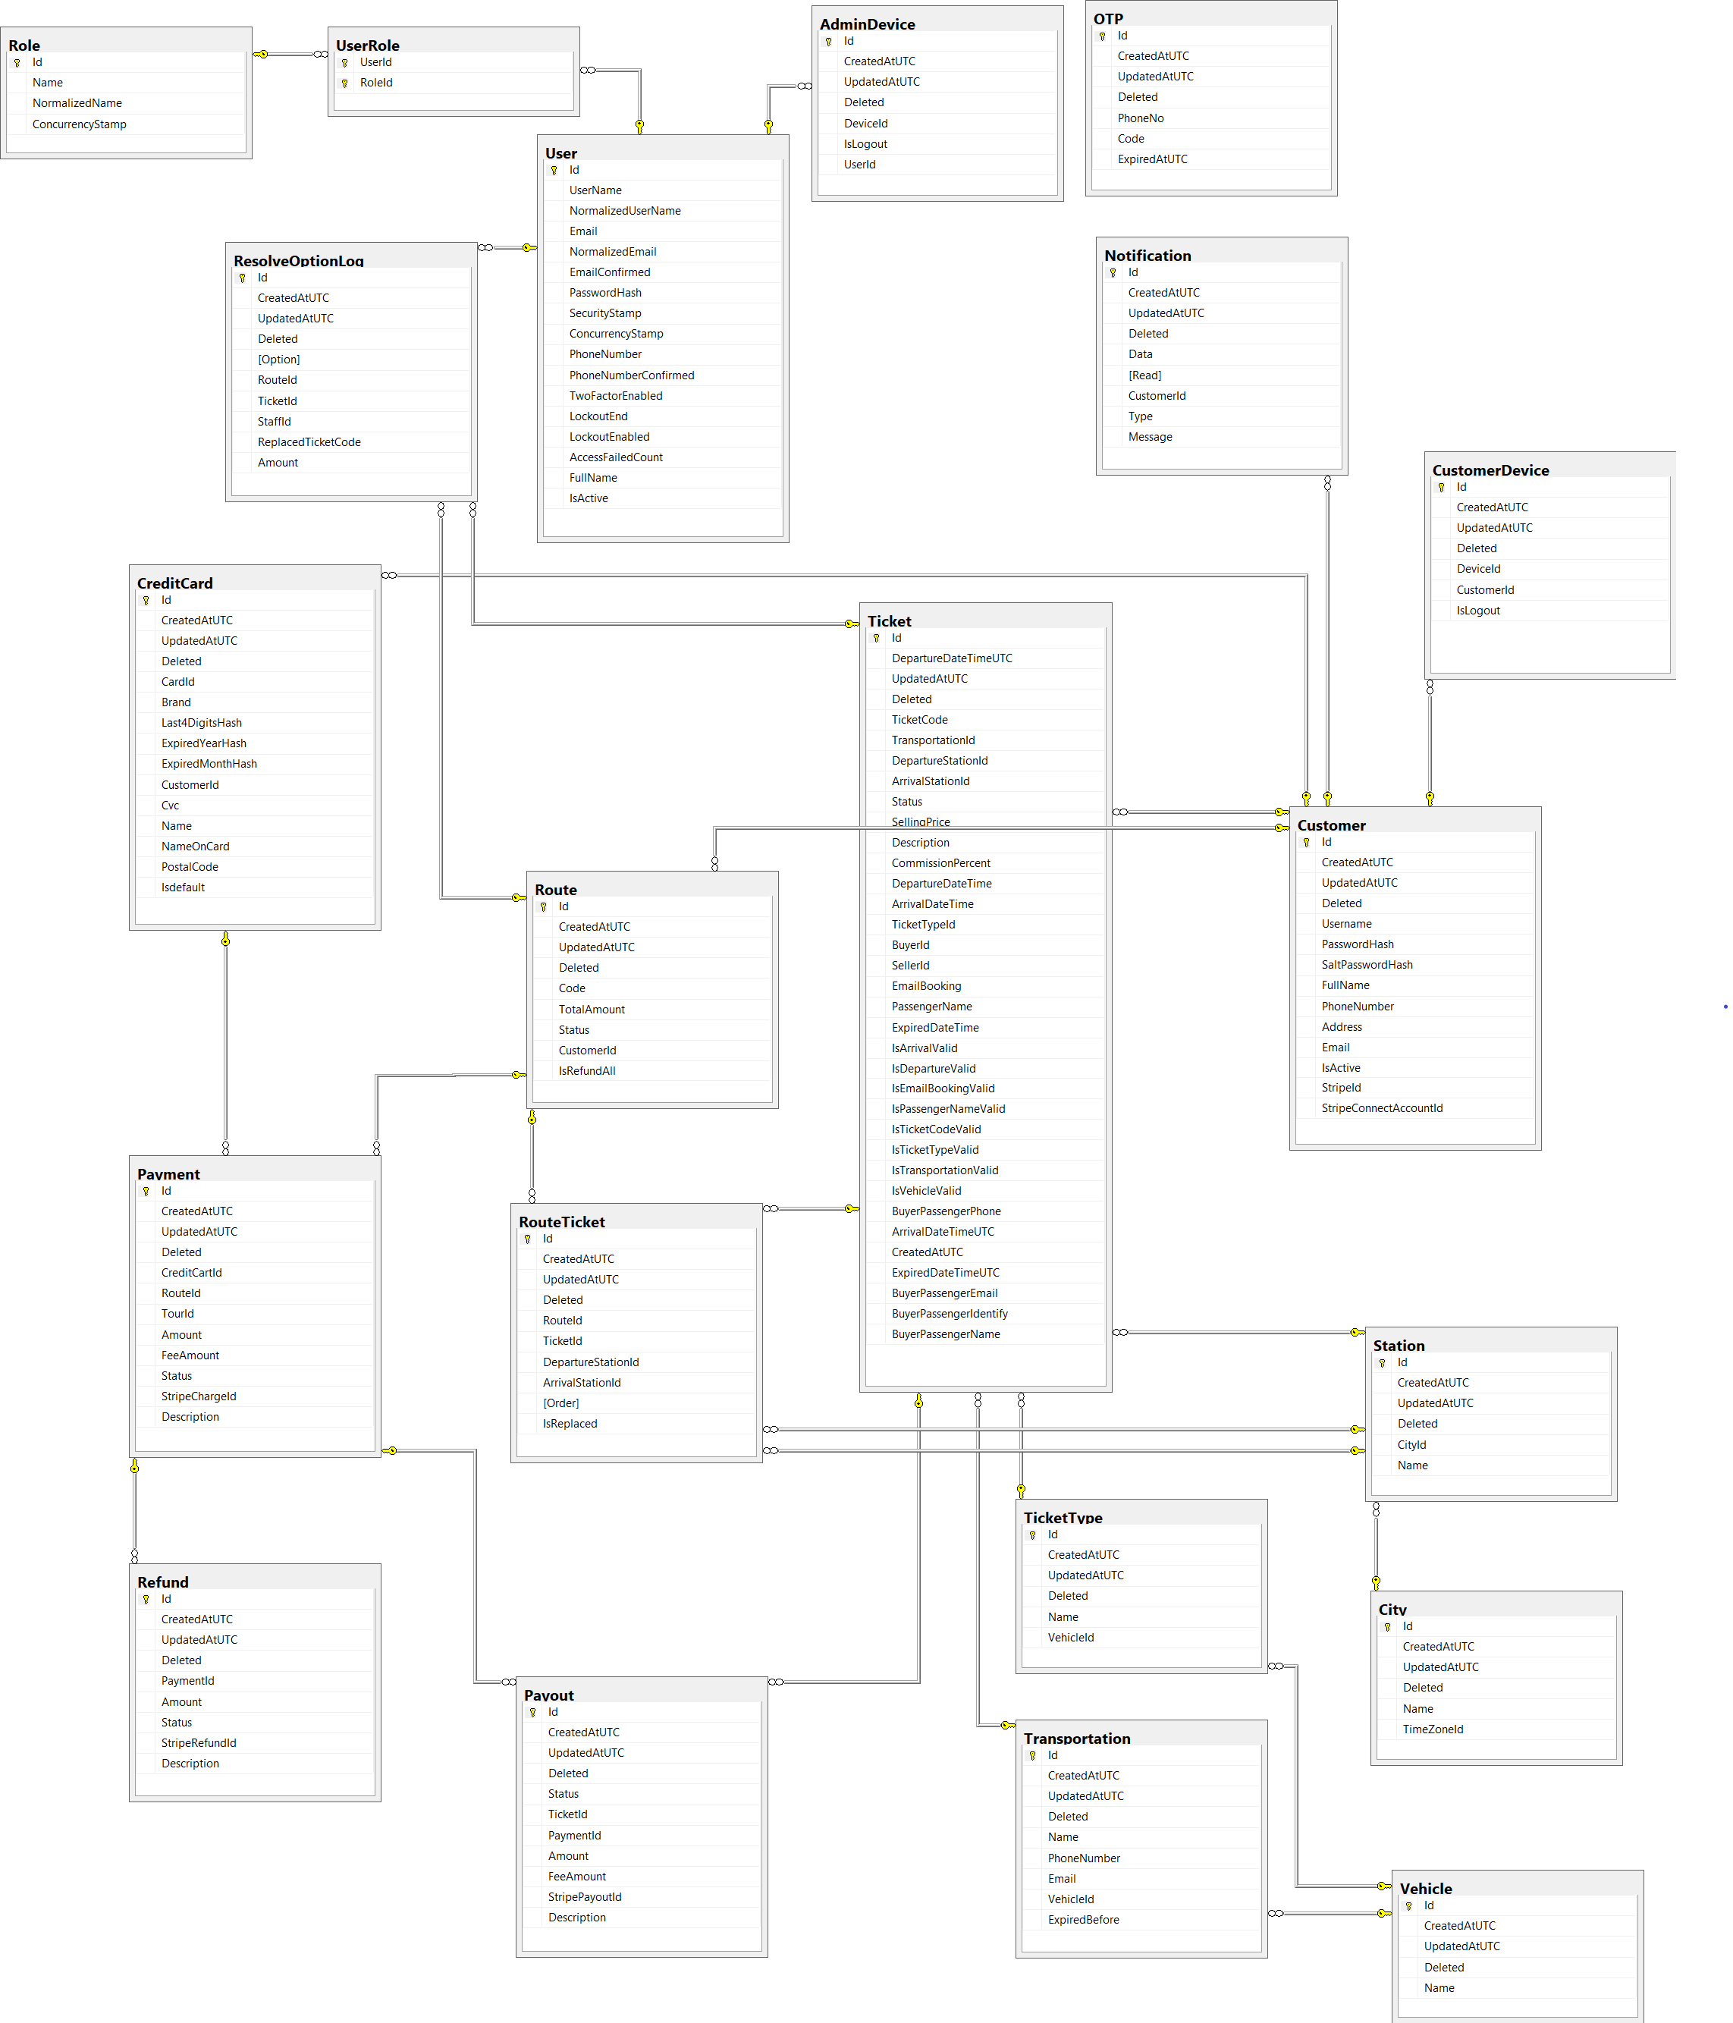

Figure 155 - Physical Diagram

### **2.2. Data Dictionary**

|  |  |  |  |  |
| --- | --- | --- | --- | --- |
| Entity Name | Column Name | Column Description | Data Type | Nullable |
| AdminDevice | CreatedAtUTC |  | datetime2 | false |
| Deleted |  | bit | false |
| DeviceId |  | nvarchar | true |
| Id |  | int | false |
| IsLogout |  | bit | false |
| UpdatedAtUTC |  | datetime2 | true |
| City | CreatedAtUTC |  | datetime2 | false |
| Deleted |  | bit | false |
| Id |  | int | false |
| Name |  | nvarchar | true |
| TimeZoneId |  | nvarchar | true |
| UpdatedAtUTC |  | datetime2 | true |
| CreditCard | Brand |  | nvarchar | true |
| CardId |  | nvarchar | true |
| CreatedAtUTC |  | datetime2 | false |
| CustomerId |  | int | false |
| Cvc |  | nvarchar | true |
| Deleted |  | bit | false |
| ExpiredMonthHash |  | nvarchar | true |
| ExpiredYearHash |  | nvarchar | true |
| Id |  | int | false |
| Isdefault |  | bit | false |
| Last4DigitsHash |  | nvarchar | true |
| Name |  | nvarchar | true |
| NameOnCard |  | nvarchar | true |
| PostalCode |  | nvarchar | true |
| UpdatedAtUTC |  | datetime2 | true |
| Customer | Address |  | nvarchar | true |
| CreatedAtUTC |  | datetime2 | false |
| Deleted |  | bit | false |
| Email |  | nvarchar | true |
| FullName |  | nvarchar | true |
| Id |  | int | false |
| IsActive |  | bit | false |
| PasswordHash |  | nvarchar | true |
| PhoneNumber |  | nvarchar | true |
| SaltPasswordHash |  | nvarchar | true |
| StripeConnectAccountId |  | nvarchar | true |
| StripeId |  | nvarchar | true |
| UpdatedAtUTC |  | datetime2 | true |
| Username |  | nvarchar | true |
| CustomerDevice | CreatedAtUTC |  | datetime2 | false |
| CustomerId |  | int | false |
| Deleted |  | bit | false |
| DeviceId |  | nvarchar | true |
| Id |  | int | false |
| IsLogout |  | bit | false |
| UpdatedAtUTC |  | datetime2 | true |
| Notification | CreatedAtUTC |  | datetime2 | false |
| CustomerId |  | int | false |
| Data |  | nvarchar | true |
| Deleted |  | bit | false |
| Id |  | int | false |
| Read |  | bit | false |
| Type |  | int | false |
| UpdatedAtUTC |  | datetime2 | true |
| OTP | Code |  | nvarchar | true |
| CreatedAtUTC |  | datetime2 | false |
| Deleted |  | bit | false |
| ExpiredAtUTC |  | datetime2 | false |
| Id |  | int | false |
| PhoneNo |  | nvarchar | true |
| UpdatedAtUTC |  | datetime2 | true |
| Payment | Amount |  | decimal | false |
| CreatedAtUTC |  | datetime2 | false |
| CreditCartId |  | int | false |
| Deleted |  | bit | false |
| Description |  | nvarchar | true |
| FeeAmount |  | decimal | false |
| Id |  | int | false |
| RouteId |  | int | true |
| Status |  | int | false |
| StripeChargeId |  | nvarchar | true |
| TourId |  | int | true |
| UpdatedAtUTC |  | datetime2 | true |
|  | Amount |  | decimal | false |
| CreatedAtUTC |  | datetime2 | false |
| Deleted |  | bit | false |
| Description |  | nvarchar | true |
| FeeAmount |  | decimal | false |
| Id |  | int | false |
| PaymentId |  | int | false |
| Status |  | int | false |
| StripePayoutId |  | nvarchar | true |
| TicketId |  | int | false |
| UpdatedAtUTC |  | datetime2 | true |
| Refund | Amount |  | decimal | false |
| CreatedAtUTC |  | datetime2 | false |
| Deleted |  | bit | false |
| Description |  | nvarchar | true |
| Id |  | int | false |
| PaymentId |  | int | false |
| Status |  | int | false |
| StripeRefundId |  | nvarchar | true |
| UpdatedAtUTC |  | datetime2 | true |
| ResolveOptionLog | Amount |  | decimal | false |
| CreatedAtUTC |  | datetime2 | false |
| Deleted |  | bit | false |
| Id |  | int | false |
| Option |  | int | false |
| ReplacedTicketCode |  | nvarchar | true |
| RouteId |  | int | false |
| StaffId |  | nvarchar | true |
| TicketId |  | int | false |
| UpdatedAtUTC |  | datetime2 | true |
| Role | ConcurrencyStamp |  | nvarchar | true |
| Id |  | nvarchar | false |
| Name |  | nvarchar | true |
| NormalizedName |  | nvarchar | true |
| Route | Code |  | nvarchar | true |
| CreatedAtUTC |  | datetime2 | false |
| CustomerId |  | int | false |
| Deleted |  | bit | false |
| Id |  | int | false |
| IsRefundAll |  | bit | false |
| Status |  | int | false |
| TotalAmount |  | decimal | false |
| UpdatedAtUTC |  | datetime2 | true |
| RouteTicket | ArrivalStationId |  | int | false |
| CreatedAtUTC |  | datetime2 | false |
| Deleted |  | bit | false |
| DepartureStationId |  | int | false |
| Id |  | int | false |
| IsReplaced |  | bit | true |
| Order |  | int | false |
| RouteId |  | int | false |
| TicketId |  | int | false |
| UpdatedAtUTC |  | datetime2 | true |
| Station | CityId |  | int | false |
| CreatedAtUTC |  | datetime2 | false |
| Deleted |  | bit | false |
| Id |  | int | false |
| Name |  | nvarchar | true |
| UpdatedAtUTC |  | datetime2 | true |
| Ticket | ArrivalDateTime |  | datetime2 | false |
| ArrivalDateTimeUTC |  | datetime2 | false |
| ArrivalStationId |  | int | false |
| BuyerId |  | int | true |
| BuyerPassengerEmail |  | nvarchar | true |
| BuyerPassengerIdentify |  | nvarchar | true |
| BuyerPassengerName |  | nvarchar | true |
| BuyerPassengerPhone |  | nvarchar | true |
| CommissionPercent |  | decimal | false |
| CreatedAtUTC |  | datetime2 | false |
| Deleted |  | bit | false |
| DepartureDateTime |  | datetime2 | false |
| DepartureDateTimeUTC |  | datetime2 | false |
| DepartureStationId |  | int | false |
| Description |  | nvarchar | true |
| EmailBooking |  | nvarchar | true |
| ExpiredDateTime |  | datetime2 | true |
| ExpiredDateTimeUTC |  | datetime2 | true |
| Id |  | int | false |
| IsArrivalValid |  | bit | true |
| IsDepartureValid |  | bit | true |
| IsEmailBookingValid |  | bit | true |
| IsPassengerNameValid |  | bit | true |
| IsTicketCodeValid |  | bit | true |
| IsTicketTypeValid |  | bit | true |
| IsTransportationValid |  | bit | true |
| IsVehicleValid |  | bit | true |
| PassengerName |  | nvarchar | true |
| SellerId |  | int | false |
| SellingPrice |  | decimal | false |
| Status |  | int | false |
| TicketCode |  | nvarchar | true |
| TicketTypeId |  | int | false |
| TransportationId |  | int | false |
| UpdatedAtUTC |  | datetime2 | true |
| TicketType | CreatedAtUTC |  | datetime2 | false |
| Deleted |  | bit | false |
| Id |  | int | false |
| Name |  | nvarchar | true |
| UpdatedAtUTC |  | datetime2 | true |
| VehicleId |  | int | false |
| Transportation | CreatedAtUTC |  | datetime2 | false |
| Deleted |  | bit | false |
| Email |  | nvarchar | true |
| ExpiredBefore |  | int | false |
| Id |  | int | false |
| Name |  | nvarchar | true |
| PhoneNumber |  | nvarchar | true |
| UpdatedAtUTC |  | datetime2 | true |
| VehicleId |  | int | false |
| User | Email |  | nvarchar | true |
| FullName |  | nvarchar | true |
| Id |  | nvarchar | false |
| IsActive |  | bit | false |
| PasswordHash |  | nvarchar | true |
| PhoneNumber |  | nvarchar | true |
| UserName |  | nvarchar | true |
| UserRole | RoleId |  | nvarchar | false |
| UserId |  | nvarchar | false |
| Vehicle | CreatedAtUTC |  | datetime2 | false |
| Deleted |  | bit | false |
| Id |  | int | false |
| Name |  | nvarchar | true |
| UpdatedAtUTC |  | datetime2 | true |

Table 173 - <Physical Diagram> Data Dictionary

## 3. Test Plan

### **3.1. Features To Be Tested**

#### 3.1.1. Guest Testcase

* Register

#### 3.1.2. Staff Testcase

* Replace ticket option
* Refund one ticket
* Refund all ticket
* Payout one ticket

#### 3.1.3. Customer Testcase

* Add payment method
* Post ticket
* Search route
* Buy route
* Create receivable account

### **3.2. Features Not To Be Tested**

* Guest: Login, reset password
* Manager:
* Manage staff
* Manage customer

## 4. System Testing Test Case

### **4.1. Guest Testcase**

#### 4.1.1. Register

|  |  |  |  |  |  |  |  |
| --- | --- | --- | --- | --- | --- | --- | --- |
| NO | Test Case Description | Test case procedure | Expected output | *Inter Dependence -test Case* | Result | Test Date | Note |
| 1 | Guest register a phone number | 1. Guest click “Register” button.  2. Guest input phone number.  3. Guest click “Send OTP” button | System renders a page to register username, password and send OTP code to guest’s phone number | N/A | Pass | 8/8/2019 |  |
| *2* | Guest register username, password with wrong OTP code | 1. Guest input username, password  2. Guest input wrong OTP code.  3. Guest click “Register” button | System show error messages  “OTP code is wrong” | N/A | Pass | 8/8/2019 |  |
| *3* | Guest register username, password with correct OTP code | 1. Guest input username, password  2. Guest input wrong OTP code.  3. Guest click “Register” button | System redirect to login page | N/A | Pass | 8/8/2019 |  |

Table 174 - <Test case> Register

### **4.2. Staff Testcase**

#### 4.2.1. Resolve Route

|  |  |  |  |  |  |  |  |
| --- | --- | --- | --- | --- | --- | --- | --- |
| NO | Test Case Description | Test case procedure | Expected output | *Inter Dependence -test Case* | Result | Test Date | Note |
| 1 | Staff payout ticket that is renamed success | 1. Staff click “Resolve” button.  2. Staff click “Payout” button.  3. Staff click “Confirm” when on confirm dialog.  3. Guest click “Send OTP” button | System renders a payout successfully message and a table that is a payout log | N/A | Pass | 8/8/2019 |  |
| *2* | Staff replace ticket that is renamed fail | 1. Staff click “Resolve” button.  2. Staff select option “Replace ticket”.  3. Staff select a ticket from replaced ticket list  4. Staff click “Replace Ticket” button. | System renders a replace ticket successfully message and a table that is a replace log | N/A | Pass | 8/8/2019 |  |
| *3* | Staff refund one ticket that is renamed fail | 1. Staff click “Resolve” button.  2. Staff select option “Refund the renamed fail ticket”.  3. Staff click “Refund” button.  4. Staff click “confirm” on confirm dialog | System renders a refund ticket successfully message and a table that is a refund log | N/A | Pass | 8/8/2019 |  |
| *4* | Staff refund the route’s total amount | 1. Staff click “Resolve” button.  2. Staff select option “Refund total amount”.  3. Staff click “Refund Total Amount” button  4. Staff click “Confirm” on confirm dialog | System renders a refund route successfully message and a table that is a refund total amount log | N/A | Pass | 8/8/2019 |  |

Table 175 - <Test case> Resolve Route

### **4.3. Customer Testcase**

#### 4.3.1. Manage payment method

|  |  |  |  |  |  |  |  |
| --- | --- | --- | --- | --- | --- | --- | --- |
| NO | Test Case Description | Test case procedure | Expected output | *Inter Dependence -test Case* | Result | Test Date | Note |
| 1 | Customer create a new payment method | 1. Customer click “Create Credit Card” button.  2. Customer input some information about the card  3. Customer send command to create card | System renders a create successfully message | N/A | Pass | 8/8/2019 |  |
| *2* | Customer set default for their credit card | 1. Customer click “Payment Method” tab.  2. Customer click “Set Default” button | System render a set default successfully message | N/A | Pass | 8/8/2019 |  |
| *3* | Customer delete their credit card | 1. Customer click “Payment Method” card.  2. Customer click “Delete” button  3. Customer click “Confirm” on confirm dialog | System renders a delete successfully message | N/A | Pass | 8/8/2019 |  |

Table 176 - <Test case> Manage Payment Method

#### 4.3.2. Manage Posted Ticket

|  |  |  |  |  |  |  |  |
| --- | --- | --- | --- | --- | --- | --- | --- |
| NO | Test Case Description | Test case procedure | Expected output | *Inter Dependence -test Case* | Result | Test Date | Note |
| 1 | Customer post new unused ticket with missing fields | 1. Customer click “+” button.  2. Customer input some fields and some field is blank.  3. Customer click “POST NOW” button | System render a message “Please input all required fields” | N/A | Pass | 8/8/2019 |  |
| *2* | Customer post new unused ticket with all fields are inputted | 1. Customer click “+” button.  2. Customer input all fields.  3. Customer click “POST NOW” button | System renders a message “Post ticket successfully”. | N/A | Pass | 8/8/2019 |  |
| *3* | Ticket with “Pending” status can be edited | 1. Customer click a “Pending” status ticket. | System navigate to a page or screen that all fields can be edited | N/A | Pass | 8/8/2019 |  |
| *4* | Customer delete a posted ticket | 1. Customer click a posted ticket  2. Customer click “Delete” button  3. Customer click “delete” on confirm dialog | System renders a delete successfully message. | N/A | Pass | 8/8/2019 |  |

Table 177 - <Test case> Manage Posted Ticket

#### 4.3.3. Search route

|  |  |  |  |  |  |  |  |
| --- | --- | --- | --- | --- | --- | --- | --- |
| NO | Test Case Description | Test case procedure | Expected output | *Inter Dependence -test Case* | Result | Test Date | Note |
| 1 | Customer search route with missing inputting fields | 1. Customer click “Search Route” button  2. Customer input some fields, but some fields are blank  3. Customer click “Search” button | System render an error message “Please input required fields” | N/A | Pass | 8/8/2019 |  |
| *2* | Customer search route with all inputting fields | 1. Customer click “Search Route” button  2. Customer input all fields  3. Customer click “Search” button | System renders a available route list or empty list | N/A | Pass | 8/8/2019 |  |

Table 178 - <Test case> Search Route

#### 4.3.4. Buy route

|  |  |  |  |  |  |  |  |
| --- | --- | --- | --- | --- | --- | --- | --- |
| NO | Test Case Description | Test case procedure | Expected output | *Inter Dependence -test Case* | Result | Test Date | Note |
| 1 | Customer buy a route that has one or more tickets are not available | 1. Customer click a route with status “Not Available”.  2. Customer click “Buy” button.  3. Customer input new passenger information  4. Customer click “Confirm” button | System renders an error message “This route is bought buy another buyer” | N/A | Pass | 8/8/2019 |  |
| 2 | Two or more customers buy same route or different route but have one or more same tickets at the same time | 1. Customer click a route  2. Customer click “Buy” button.  3. Customer input new passenger information  4. Customer click “Confirm” button | System renders a buy successfully message to one customer and error message “This route is bought buy another buyer” to another customers. | N/A | Pass | 8/8/2019 |  |

Table 179 - <Test case> Buy Route

# Software User’s Manual

## Installation Guide

### **Setting up environment at Cloud Server**

#### Hardware requirements

|  |  |  |
| --- | --- | --- |
| **Server** | **Minimum Requirements** | **Recommended** |
| **Azure App Service** | Free F1 | B1 |
| **Azure SQL Database** | Basic, 2GB | Standard, 10GB |

Table 180 - <Installation Guide> Hardware Requirements

#### Setting Cloud Service

##### Setting Azure SQL Database

###### Steps to create Azure SQL database Service.

* Connect to Azure Portal.
* Open SQL Databases.
* Add new SQL Database following below:

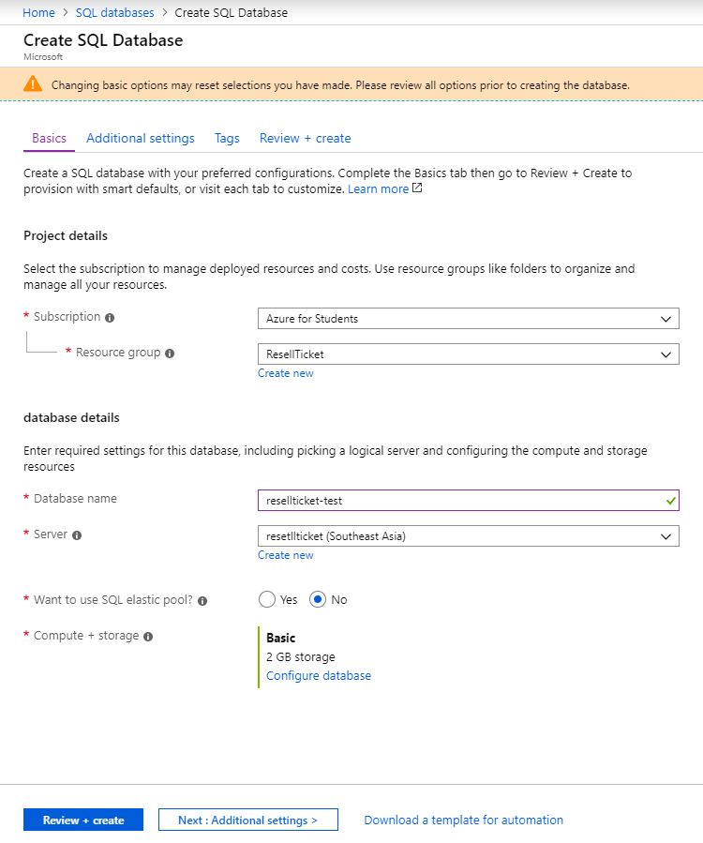

Figure 156 - <Installation Guide> Create SQL Database

* Open SQL Server Management Studio, connect to created database:

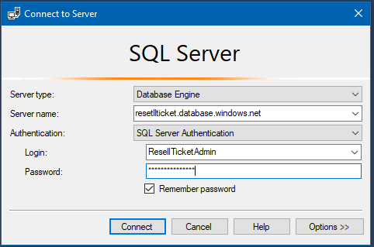

Figure 157 - <Installation Guide> Connect to SQL Database

* Result after connected:

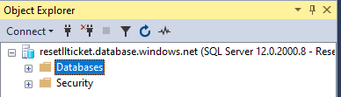

###### Steps to get Connection String

* Open SQL Database detail.
* Clicks Connection Strings.

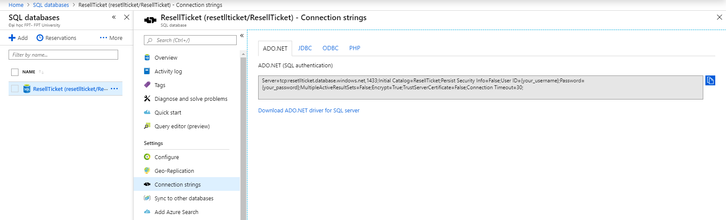

Figure 158 - <Installation Guide> Get Connection String

* Replace “{your_username}” by created username.
* Replace “{your_password}” by created password.
* Save your connection string.

##### Setting Azure App Service

We need to create 4 App Services in Azure to deploy 4 projects:

* API for admin website.
* API for customer.
* Website for admin.
* Website for customer.

Steps to create an App Service:

* Connect to Azure Portal.
* Open App Service.
* Add new App Service follow:

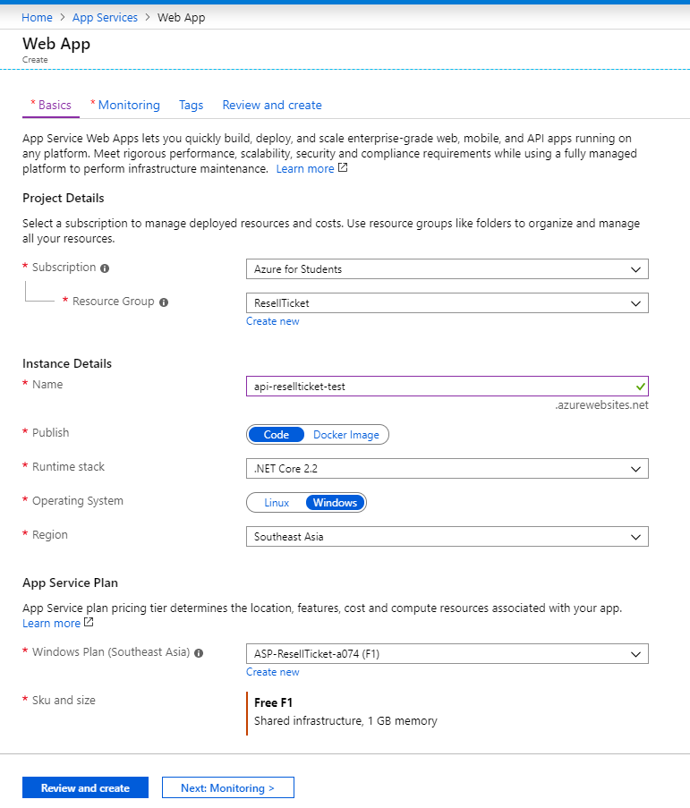

Figure 159 - <Installation Guide> Create App Service

* After created 4 App Services:

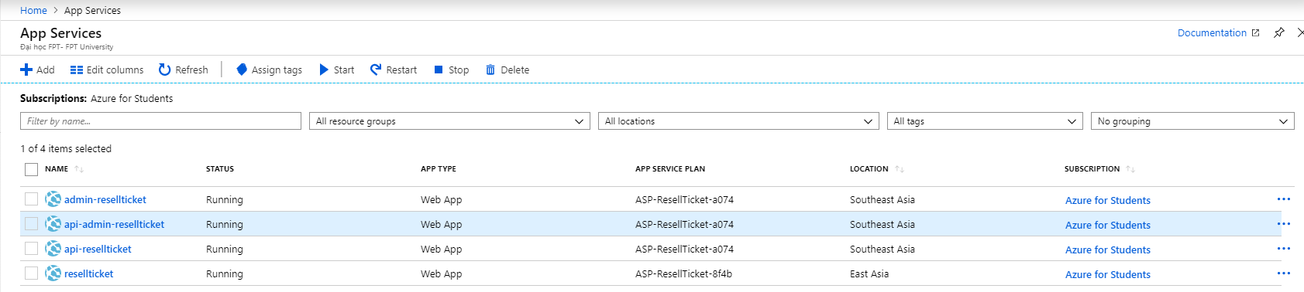

Figure 160 - <Installation Guide> Create App Services Result

### **Deployment at Server Side**

#### Prepare deployment package

##### Prepare deployment profile for Admin API and Customer API

* Connect to Azure Portal.
* Open Admin API App Service Detail.
* Click “Get Publish Profile” to download publish profile.

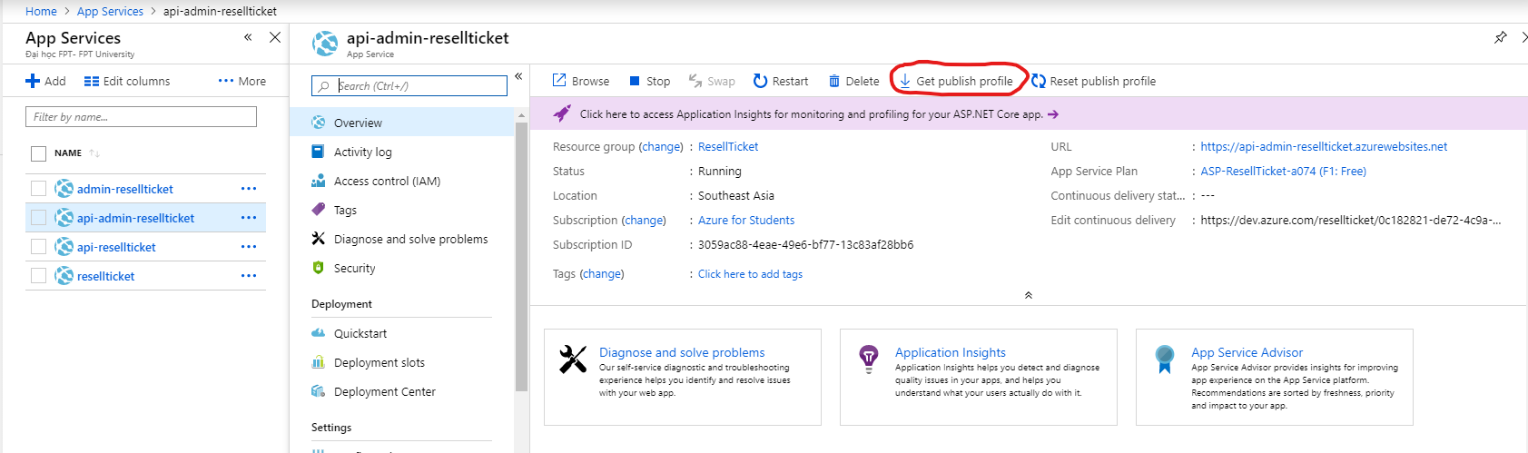

Figure 161 - <Installation Guide> Get Publish Profile

* Open Resell Ticket Solution by Visual Studio 2019.
* In Solution Explorer, Right click “WebAPI” project and choose “Publish…”

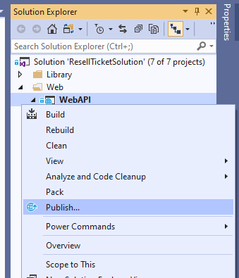

Figure 162 - <Installation Guide> Publish WebAPI

* Create new Publish Profile.
* Choose “Import Profile”, then choose downloaded publish profile.

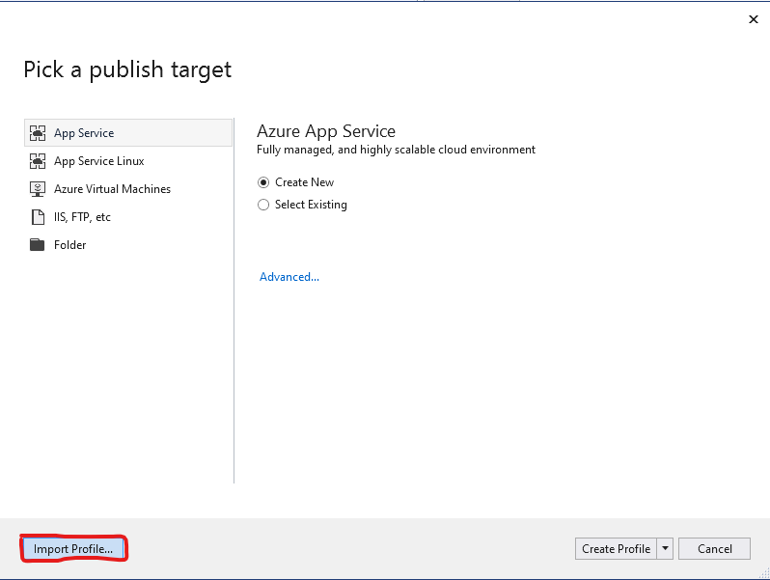

Figure 163 - <Installation Guide> Import Publish Pofile

* After successfully imported publish profile, click Edit this publish profile.
* Add Saved Connection String in above step into Settings to use SQL Database in Azure.

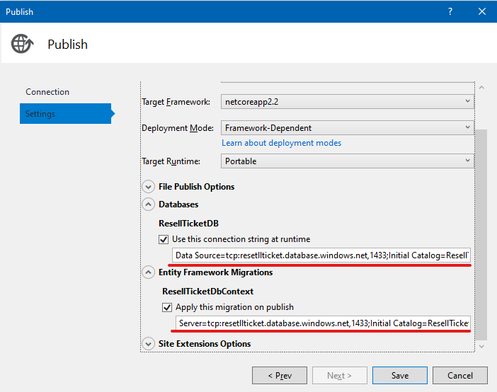

Figure 164 - <Installation Guide> Modify Publish Profile

* Do the same above steps to config for project “WebAPI.Admin”.

##### Prepare deployment package for static websites

* Open Visual Studio Code in Admin Website folder.
* Install Azure App Service Extension.
* Press “F1” and search “Azure: Sign In to Azure Cloud”.

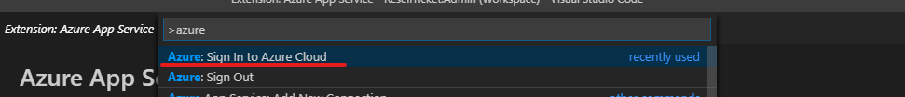

Figure 165 - <Installation Guide> Connect To Azure in Visual Studio Code

* Then input username and password to sign in.

###### Prepare deployment package for Admin Website

* Open Command Line in Web Admin folder.
* Run “npm run build” to create deployment package for ReactJs project.

#### Deploy web application on server

##### Deploy Admin API

* Open Resell Ticket Solution Visual Studio 2019.
* In Solution explorer, right click in “WebAPI.Admin” and choose “Publish…”.
* Click “Publish” button.

##### Deploy Customer API

* Open Resell Ticket Solution in Visual Studio 2019.
* In Solution explorer, right click in “WebAPI” and choose “Publish…”.
* Click “Publish” button.

##### Deploy Web Admin

* Open Visual Studio Code in “WebClient.Admin” folder.
* In Explorer, right click “Deploy to Web App…”.

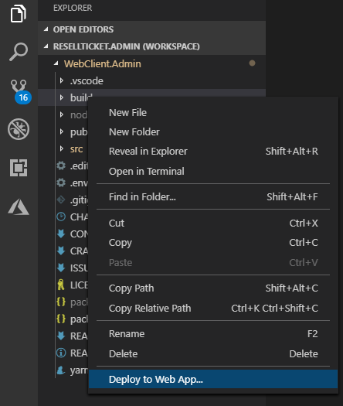

Figure 166 - <Installation Guide> Deploy to App Service in Visual Studio Code

* Choose Created App Service for web admin and press “Enter”.

##### Deploy Web Customer

* Open Visual Studio Code in “WebClient.Customer” folder.
* In Explorer, right click “Deploy to Web App…”.

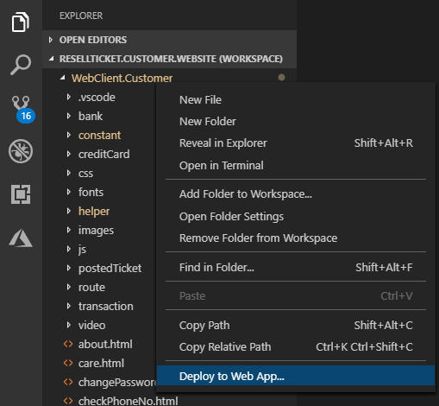

Figure 167 - <Installation Guide> Deploy into App Service in Visual Studio Code

* Choose Created App Service for web admin and press “Enter”.

### **Setting up the environment at client side.**

#### Database

* Restore database from file capstone-resell-ticket/Scripts/init.sql.

#### Admin API

* Open Resell Ticket Solution by Visual Studio 2019.
* In Solution Explorer, right clicks at “WebAPI.Admin”.
* Choose “Debug” then choose “Start new Instance”.

#### Customer API

* Open Resell Ticket Solution by Visual Studio 2019.
* In Solution Explorer, right clicks at “WebAPI.Customer”.
* Choose “Debug” then choose “Start new Instance”.

#### Admin Website

* Open Command Line at “WebClient.Admin”.
* Run command “yarn” or “npm install” to download all dependencies.
* Run command “yarn dev” or “npm start” to start client for development.

#### Customer Website

* Open Command Line at “WebClient.Customer”.
* Run command “http-server” to start client for development.

#### Customer Mobile

* Open Command Line at “ResellTicketCustomerMobile”.
* Run Command “yarn” or “npm install” to download all javascript dependencies.
* Run Command “react-native link” to download all native dependencies.
* Run Command “react-native run-android” to start development on Android or run “react-native run-ios” to start development on IOS.

## User Guide

### **Admin Web Application**

#### Verify Pending Ticket

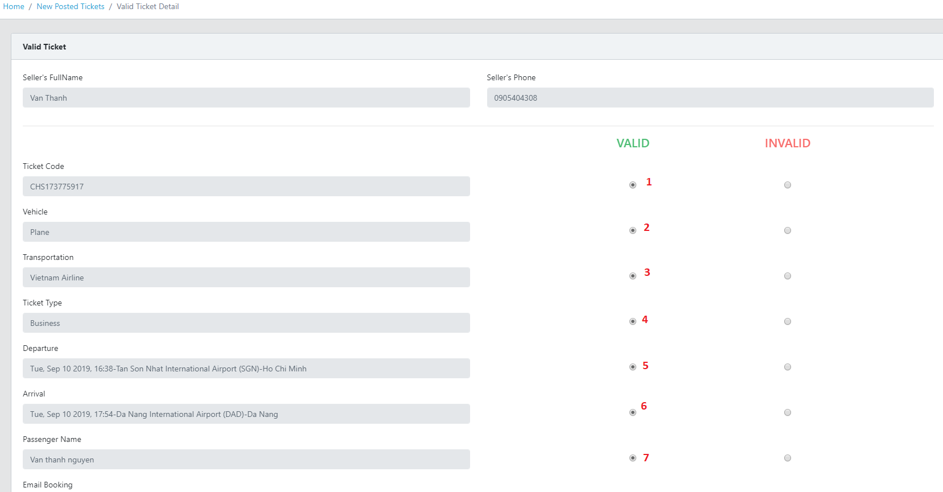

Figure 168 - <User Guide> Verify Pending Ticket

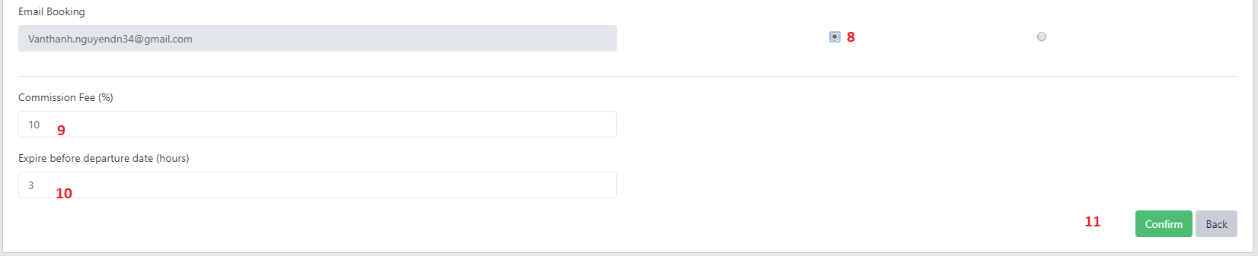

Figure 169 - <User Guide> Verify Pending Ticket

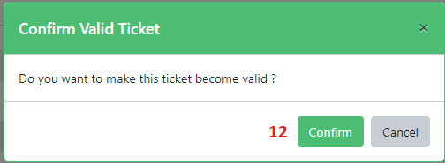

Figure 170 - <User Guide> Verify Pending Ticket

|  |  |
| --- | --- |
| **Step** | **Description** |
| 1 | Staff checks Ticket Code is valid. |
| 2 | Staff checks Vehicle is valid. |
| 3 | Staff checks Transportation is valid. |
| 4 | Staff checks Ticket Type is valid. |
| 5 | Staff checks Departure information is valid. |
| 6 | Staff checks Arrival information is valid. |
| 7 | Staff checks Passenger Name is valid. |
| 8 | Staff checks Email Booking is valid. |
| 9 | Staff inputs Commission Fee (%). |
| 10 | Staff inputs Expire Before Departure Date (Hour). |
| 11 | Staff Clicks Confirm. |
| 12 | Staff Clicks Confirm in popup confirm. |

Table 181 - <User Guide> Verify Pending Ticket

#### Verify Renamed Ticket

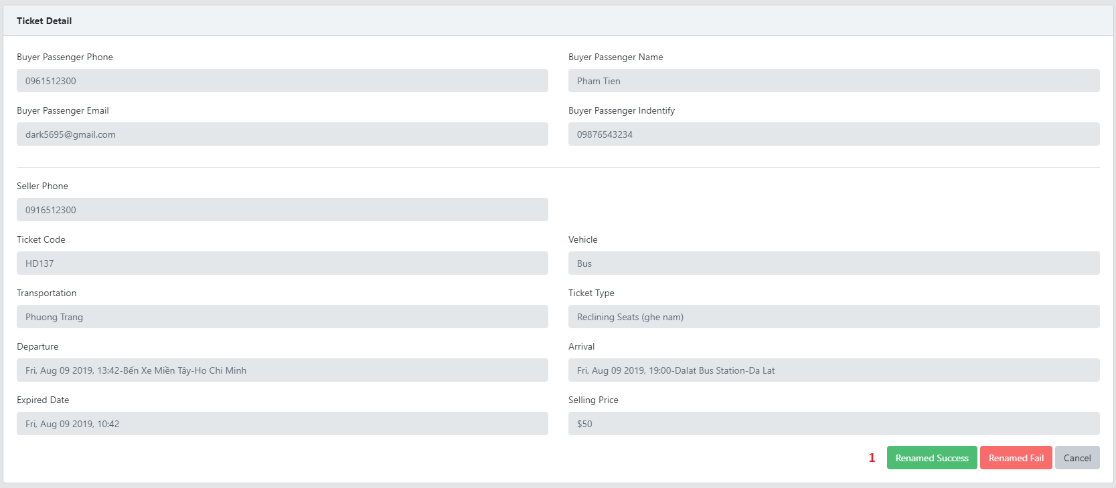

Figure 171 - <User Guide> Verify Renamed Ticket

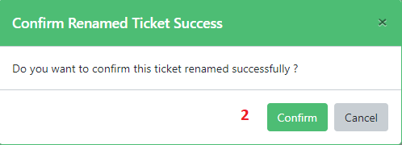

Figure 172 - <User Guide> Verify Renamed Ticket

|  |  |
| --- | --- |
| **Step** | **Description** |
| 1 | Staff clicks “Renamed Success” Button. |
| 2 | Staff clicks “Confirm” button in Confirm Popup. |

Table 182 - <User Guide> Verify Renamed Ticket

#### Transfer money to seller

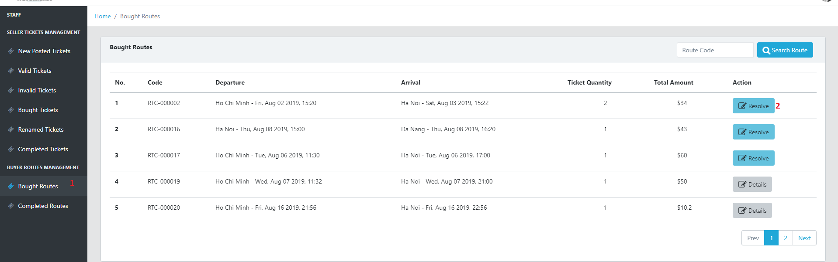

Figure 173 - <User Guide> Transfer money to seller

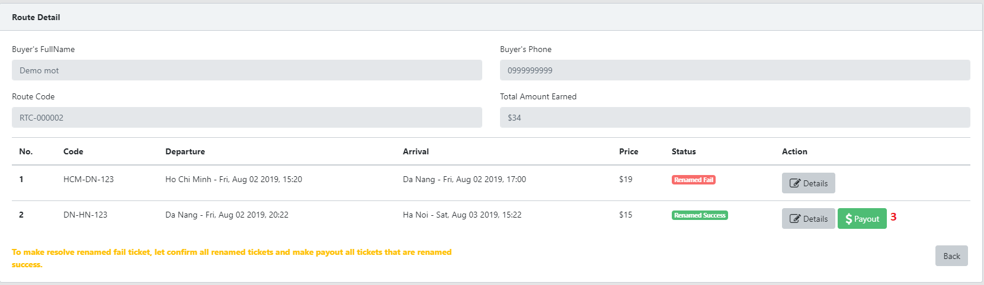

Figure 174 - <User Guide> Transfer Money to seller

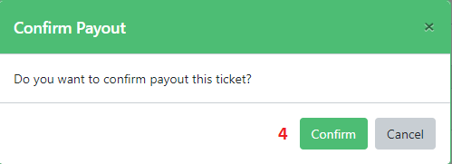

Figure 175 - <User Guide> Transfer Money to seller

|  |  |
| --- | --- |
| **Step** | **Description** |
| 1 | Staff opens “Bought Route” Screen. |
| 2 | Staff clicks “Resolve” Button Route List. |
| 3 | Staff clicks “Payout” Button in a Ticket Row. |
| 4 | Staff clicks “Confirm” Button in Confirm pop up. |

Table 183 - <User Guide> Transfer money to seller

### **Customer Web Application**

#### Add payment method

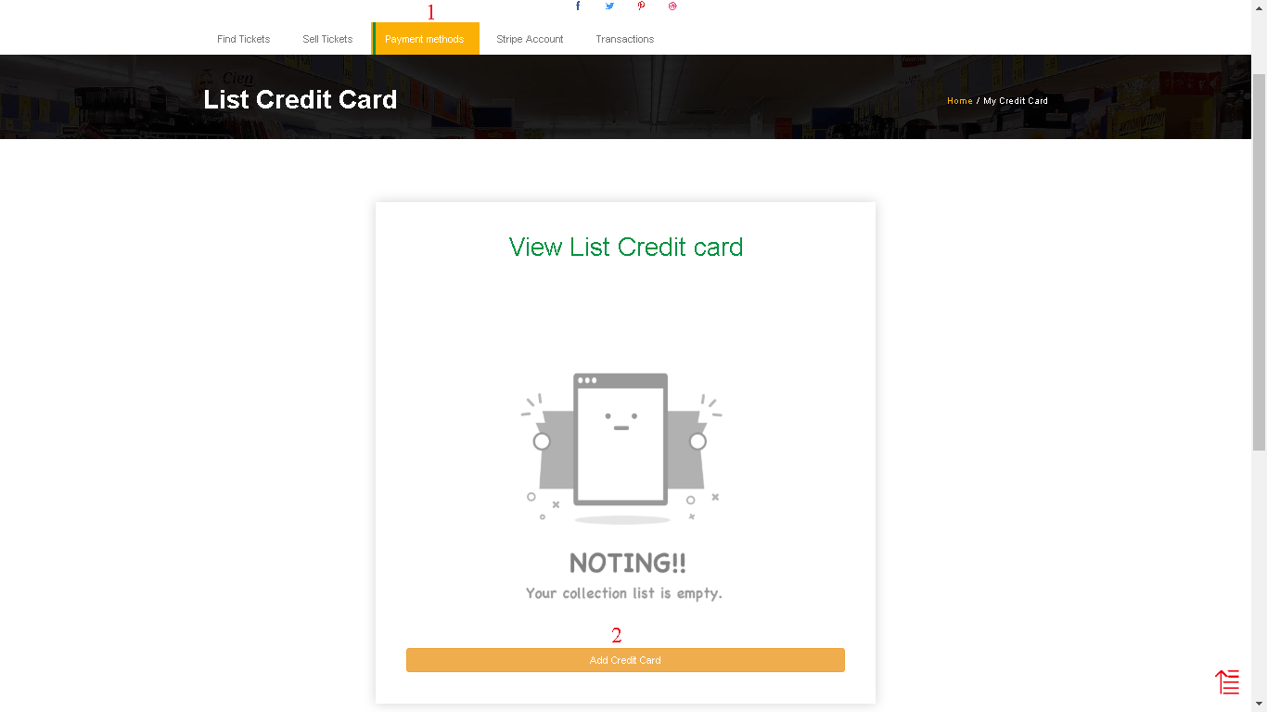

Figure 176 - <User Guide> Add Payment Method

|  |  |
| --- | --- |
| **Step** | **Description** |
| Pre-condition | User must log in |
| 1 | Click “Payment Methods” |
| 2 | Click “Add Credit Card” |

Table 184 - <User Guide> Add Payment Method

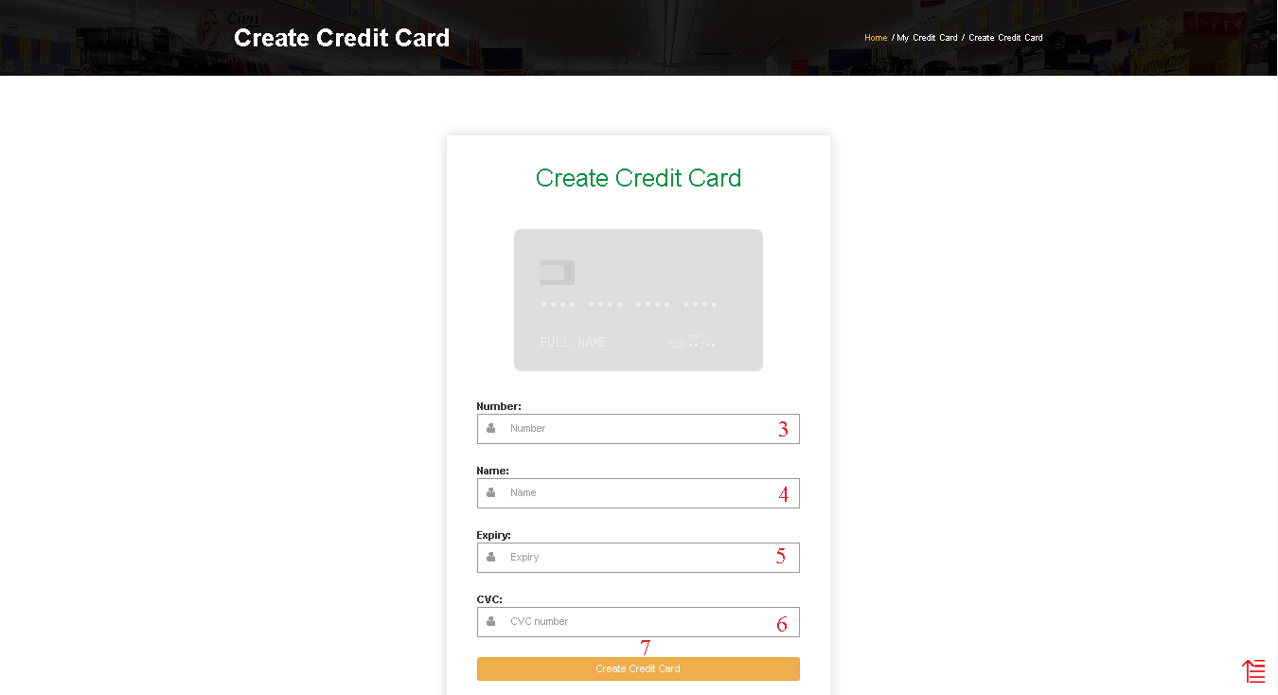

Figure 177 - <User Guide> Add Payment Method

|  |  |
| --- | --- |
| **Step** | **Description** |
| 3 | Fill the field “Number” |
| 4 | Fill the field “Name” |
| 5 | Fill the field “Expiry” |
| 6 | Fill the field “CVC” |
| 7 | Click “Create Credit Card” to finish creating credit card |

Table 185 - <User Guide> Add Payment Method

#### Add receivable account

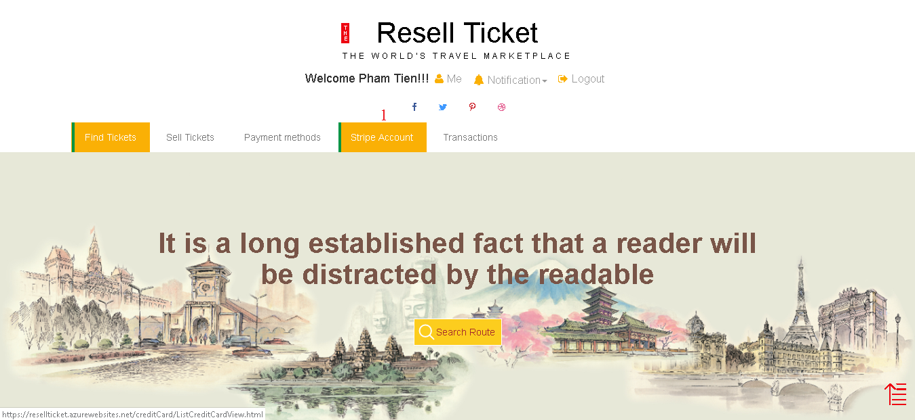

Figure 178 - <User Guide> Add Receivable Account

|  |  |
| --- | --- |
| **Step** | **Description** |
| 1 | Click “Stripe Account” |

Table 186 - <User Guide> Add Receivable Account

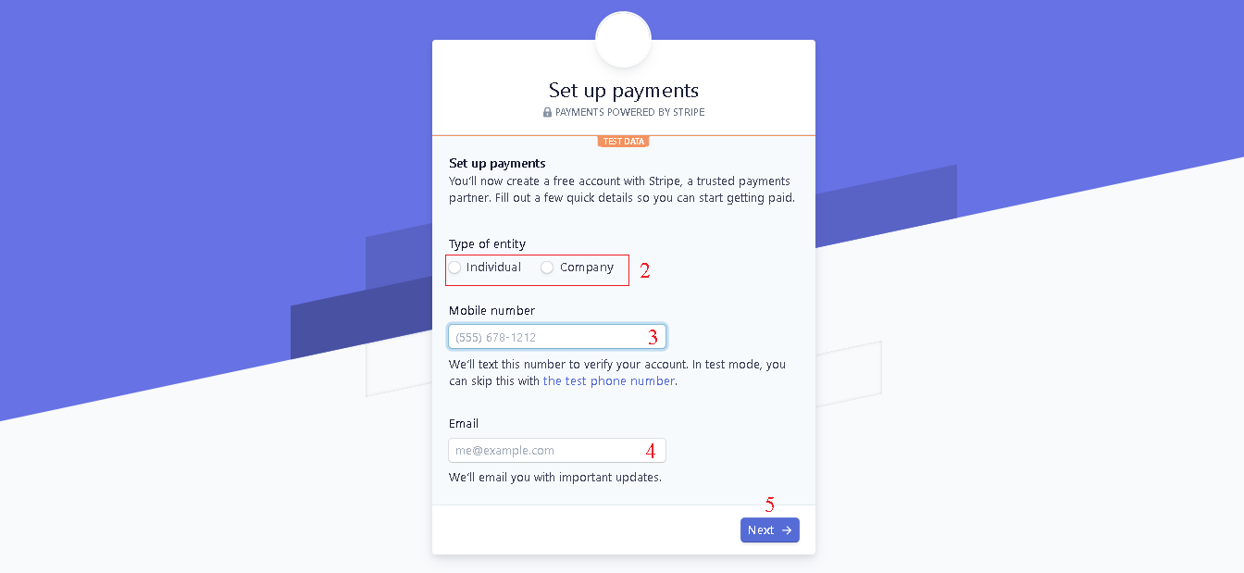

Figure 179 - <User Guide> Add Receivable Account

|  |  |
| --- | --- |
| **Step** | **Description** |
| 2 | Select type of entity |
| 3 | Fill the “Mobile Number” |
| 4 | Fill the “Email” |
| 5 | Click “Next” to move to next step |

Table 187 - <User Guide> Add Receivable Account

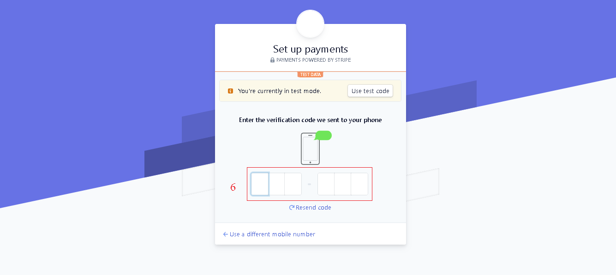

Figure 180 - <User Guide> Add Receivable Account

|  |  |
| --- | --- |
| **Step** | **Description** |
| 6 | Fill the verification code sent to your phone |

Table 188 - <User Guide> Add Receivable Account

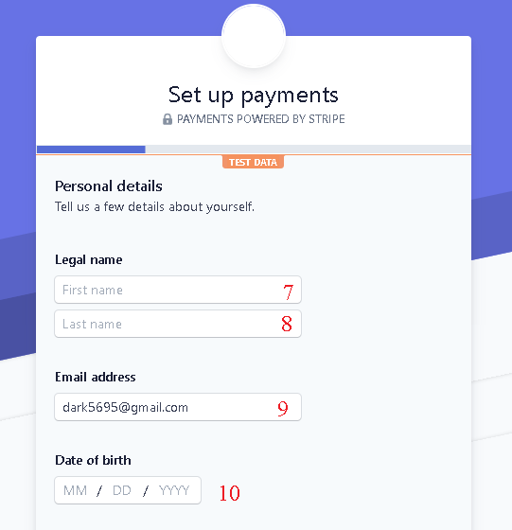

Figure 181 - <User Guide> Add Receivable Account

|  |  |
| --- | --- |
| **Step** | **Description** |
| 7 | Fill the “Legal name” |
| 8 | Fill the “Legal name” |
| 9 | Fill the “Email address” |
| 10 | Fill the “Date of birth” |

Table 189 - <User Guide> Add Receivable Account

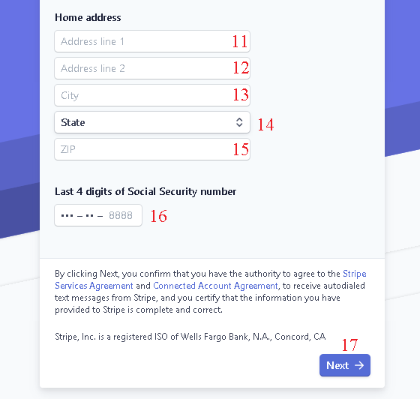

Figure 182 - <User Guide> Add Receivable Account

|  |  |
| --- | --- |
| **Step** | **Description** |
| 11 | Fill the “Home address” – “Addressline1” |
| 12 | Fill the “Home address” ­– “Addressline2” |
| 13 | Fill the “Email address” – “City” |
| 14 | Select State |
| 15 | Fill the “ZIP” |
| 16 | Fill the “Last 4 digits of Social Security number” |
| 17 | Click “Next” to move to next step |

Table 190 - <User Guide> Add Receivable Account

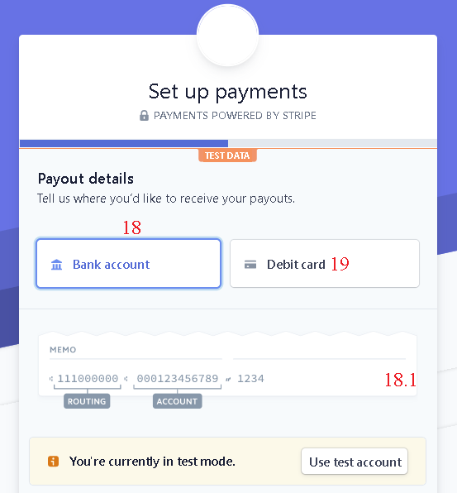

Figure 183 - <User Guide> Add Receivable Account

|  |  |
| --- | --- |
| **Step** | **Description** |
| 18 | Select payment method “Bank account” (Option bank account/ debit card) |
| 19 | Select payment method “Debit card” (Option bank account/ debit card) |
| 18.1 | Fill the “MEMO” |

Table 191 - <User Guide> Add Receivable Account

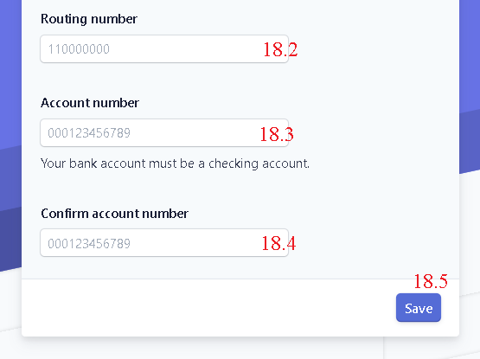

Figure 184 - <User Guide> Add Receivable Account

|  |  |
| --- | --- |
| **Step** | **Description** |
| 18.2 | Fill the “Routing number” |
| 18.3 | Fill the “Account number” |
| 18.4 | Fill the “Confirm account number” |
| 18.5 | Click “Save” to finish adding receivable account |

Table 192 - <User Guide> Add Receivable account

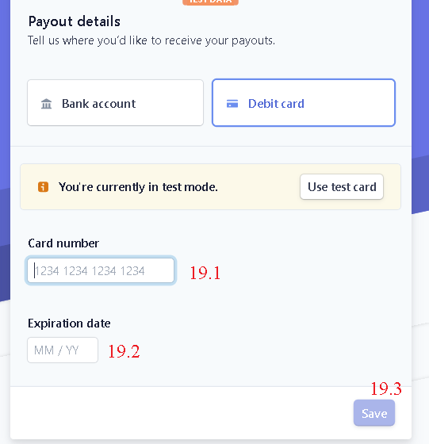

Figure 185 - <User Guide> Add Receivable Account

|  |  |
| --- | --- |
| **Step** | **Description** |
| 19.1 | Fill the “Card number” |
| 19.2 | Fill the “Expiration date” |
| 19.3 | Click “Save” to finish adding receivable account |

Table 193 - <User Guide> Add Receivable Account

#### Post ticket

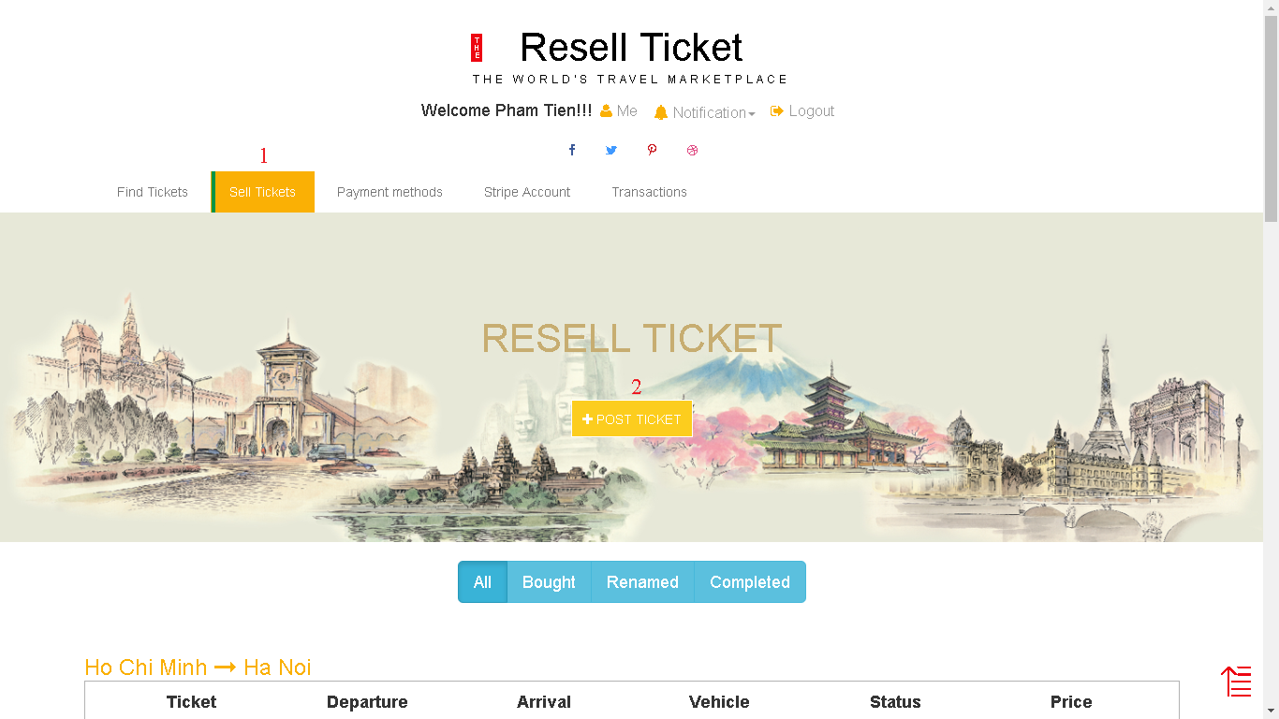

Figure 186 - <User Guide> Post Ticket

|  |  |
| --- | --- |
| **Step** | **Description** |
| Pre-condition | User must log in and registered a strike account |
| 1 | Click “Sell Tickets” |
| 2 | Click “Post Ticket” |

Table 194 - <User Guide> Post Ticket

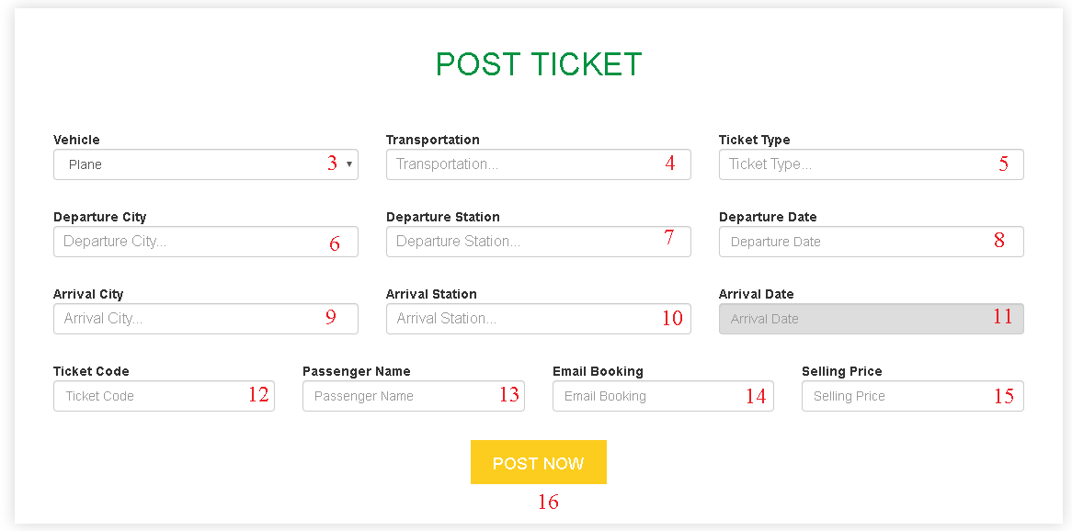

Figure 187 - <User Guide> Post Ticket

|  |  |
| --- | --- |
| **Step** | **Description** |
| 3 | Select vehicle |
| 4 | Fill the field “Transportation” |
| 5 | Fill the field “Ticket Type” |
| 6 | Fill the field “Departure City” |
| 7 | Fill the field “Departure Station” |
| 8 | Fill the field “Departure Date” |
| 9 | Fill the field “Arrival City” |
| 10 | Fill the field “Arrival Station” |
| Pre-condition of step 11 | Must do step 8 first |
| 11 | Fill the field “Arrival Date” |
| 12 | Fill the field “Ticket Code” |
| 13 | Fill the field “Passenger Name” |
| 14 | Fill the field “Email Booking” |
| 15 | Fill the field “Selling Price” |
| 16 | Click “Post now” to post ticket |

Table 195 - <User Guide> Post ticket

#### Search Route

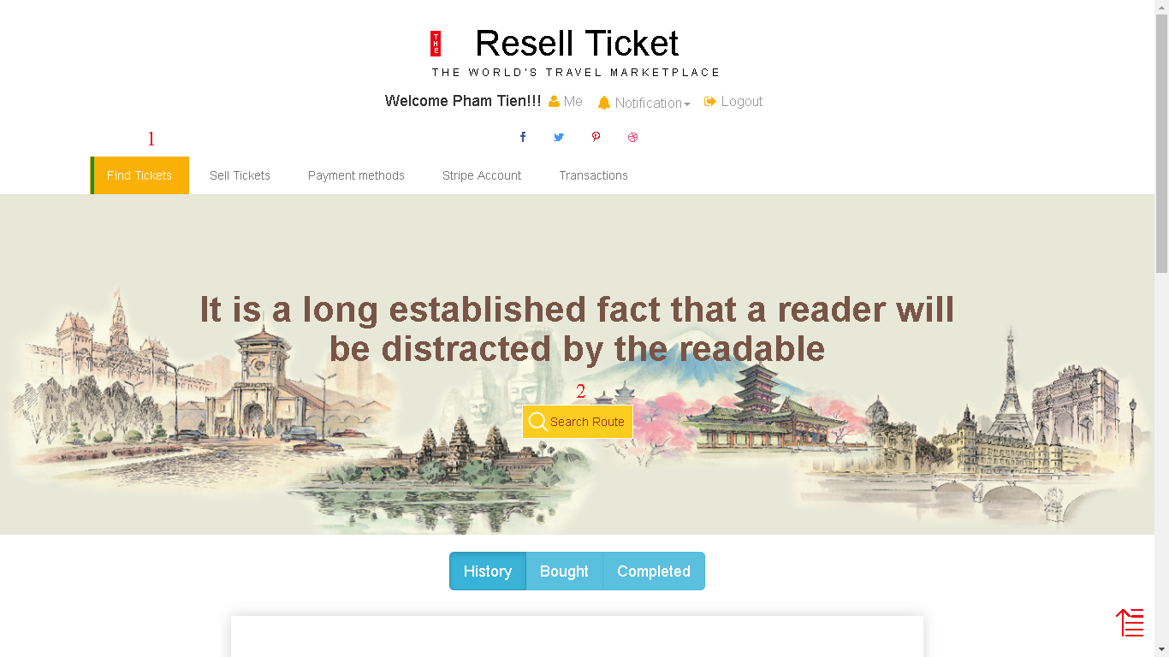

Figure 188 - <User Guide> Search Route

|  |  |
| --- | --- |
| **Step** | **Description** |
| Pre-condition | User must log in |
| 1 | Click “Find Tickets” |
| 2 | Click “Search Route” |

Table 196 - <User Guide> Search Route

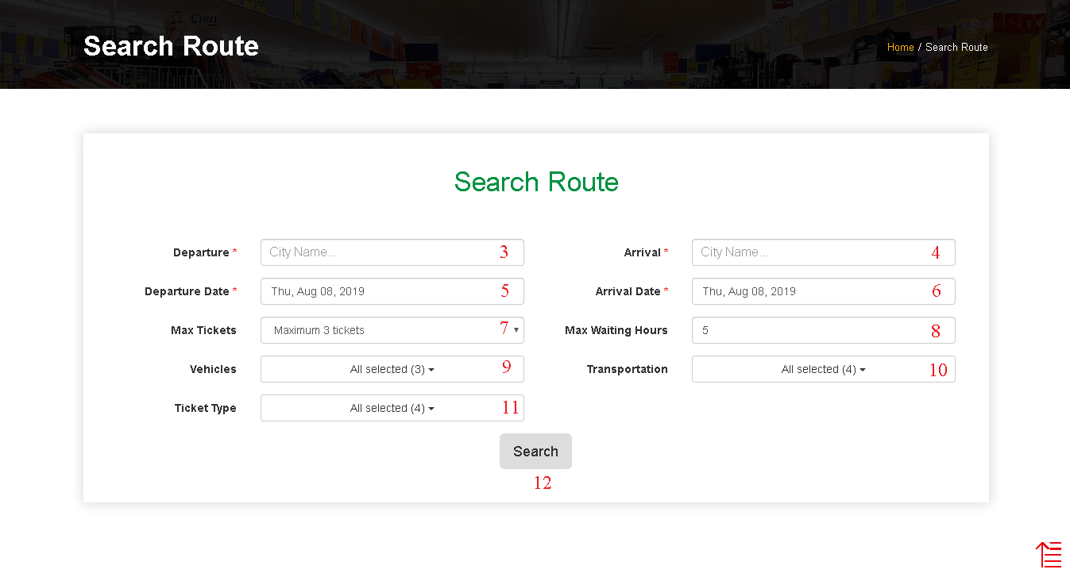

Figure 189 - <User Guide> Search Route

|  |  |
| --- | --- |
| **Step** | **Description** |
| 3 | Fill the field “Departure” |
| 4 | Fill the field “Arrival” |
| 5 | Select departure date |
| 6 | Select arrival date |
| 7 | Select max tickets |
| 8 | Fill the field “Max Waiting Hours” |
| 9 | Select vehicles |
| 10 | Select transportation |
| 11 | Select ticket type |
| 12 | Click “Search” to search tickets |

Table 197 - <User Guide> Search Route

#### Buy Route

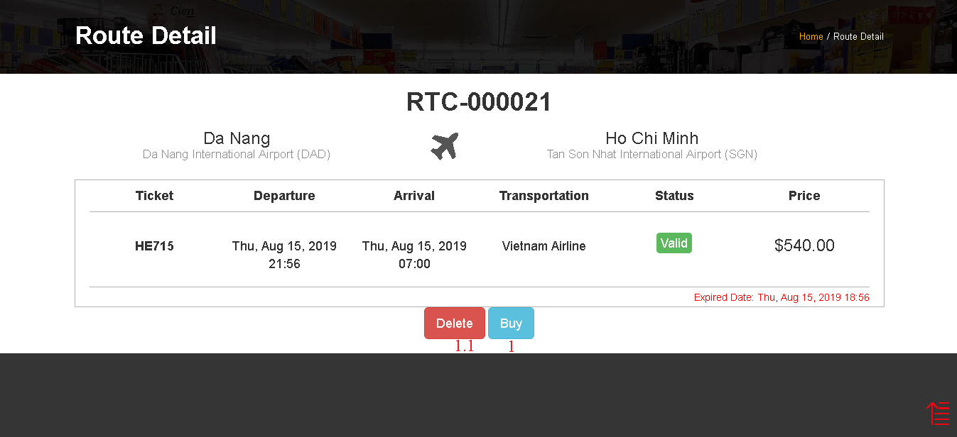

Figure 190 - <User Guide> Buy Route

|  |  |
| --- | --- |
| **Step** | **Description** |
| Pre-condition | User must log in and searching tickets first |
| 1 | Click “Buy” to move to next step |
| 1.1 | Click “Delete” to remove route from history list |

Table 198 - <User Guide> Buy Route

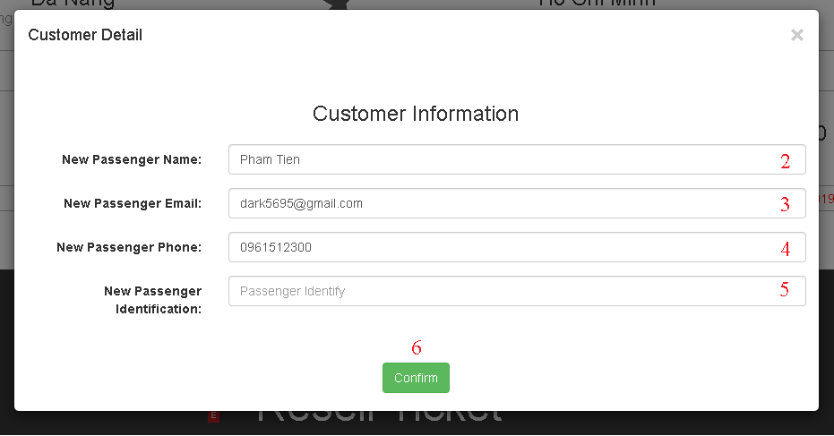

Figure 191 - <User Guide> Buy Route

|  |  |
| --- | --- |
| **Step** | **Description** |
| Pre-condition | User must add credit card in “Payment Methods” first |
| 2 | Fill the field “New Passenger Name” |
| 3 | Fill the field “New Passenger Email” |
| 4 | Fill the field “New Passenger Phone” |
| 5 | Fill the field “New Passenger Identification” |
| 6 | Click “Confirm” to buy tickets |

Table 199 - <User Guide> Buy Route

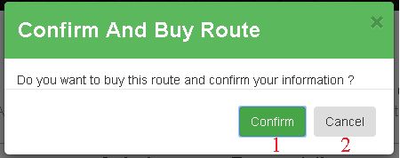

Figure 192 - <User Guide> Buy Route

|  |  |
| --- | --- |
| **Step** | **Description** |
| 1 | Click “Confirm” to finish buying tickets |
| 2 | Click “Cancel” to stop buying |

Table 200 - <User Guide> Buy Route

#### Confirm renamed ticket

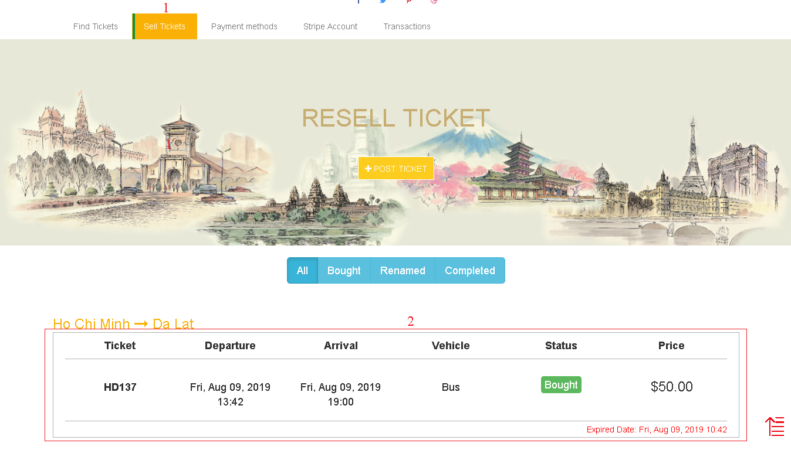

Figure 193 - <User Guide> Confirm Renamed Ticket

|  |  |
| --- | --- |
| **Step** | **Description** |
| Pre-condition | User must log in and ticket status must be “Bought” |
| 1 | Click “Sell Tickets” |
| 2 | Click on ticket with status “Bought” to confirm renamed ticket |

Table 201 - <User Guide> Confirm Renamed Ticket

### **Customer Mobile Application**

#### Add payment method



Figure 194 - <User Guide> Add Payment Method

|  |  |
| --- | --- |
| **Step** | **Description** |
| 1 | Fill the field “CARD NUMBER” |
| 2 | Fill the field “EXPIRY” |
| 3 | Fill the field “CVC/CVC” |
| 4 | Fill the field “CARDHOLDER’S NAME” |
| 5 | Click “Add Credit card” to add payment method |

Table 202 - <User Guide> Add Payment Method

#### Add receivable account

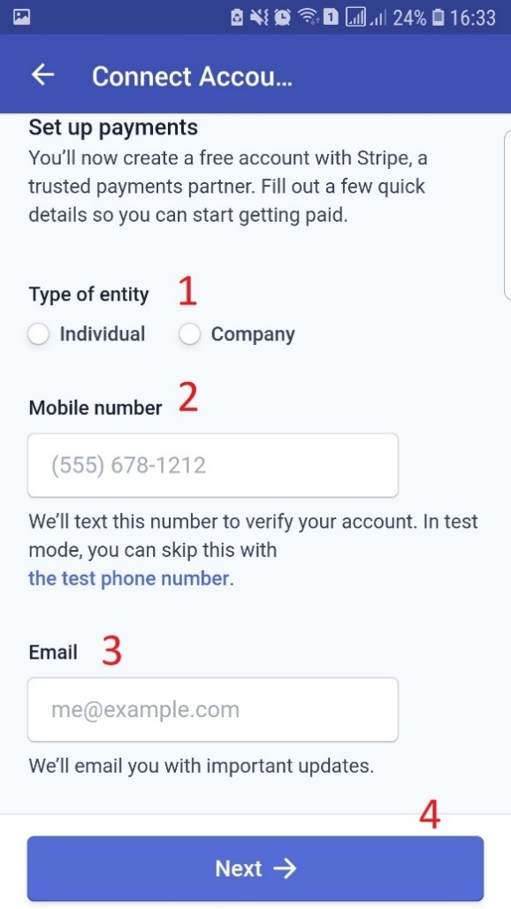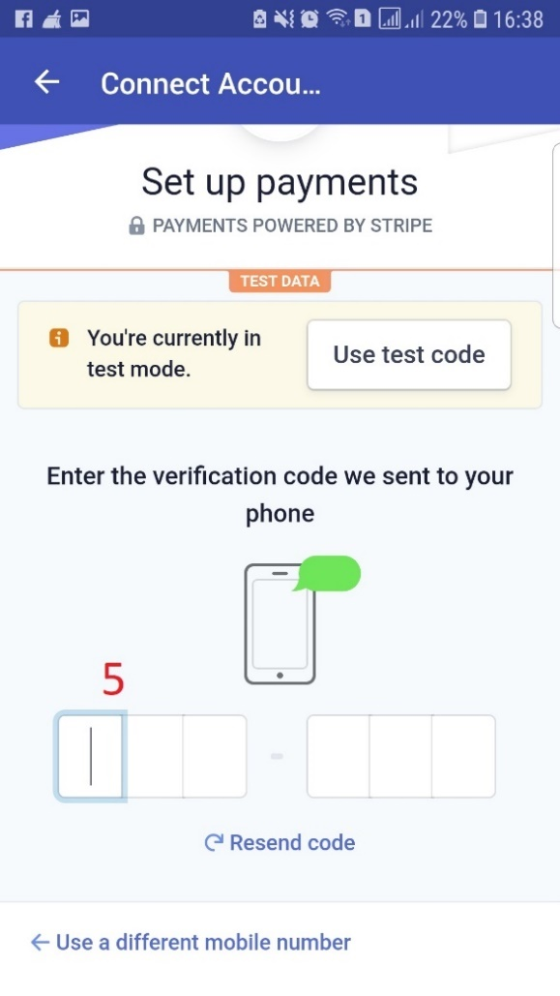

Figure 195 - <User Guide> Add Receivable Account

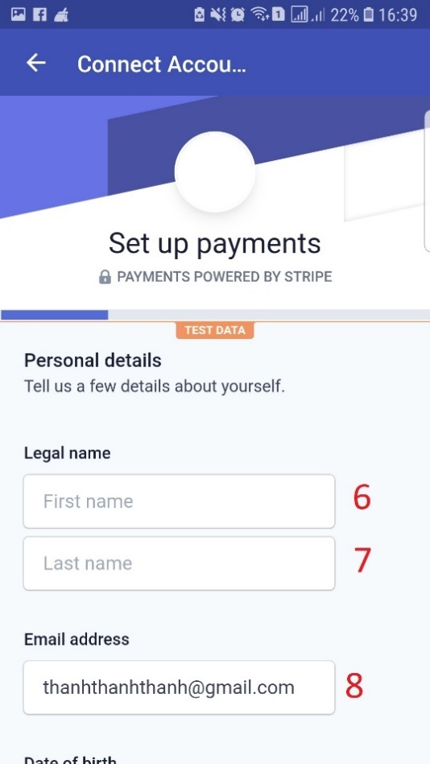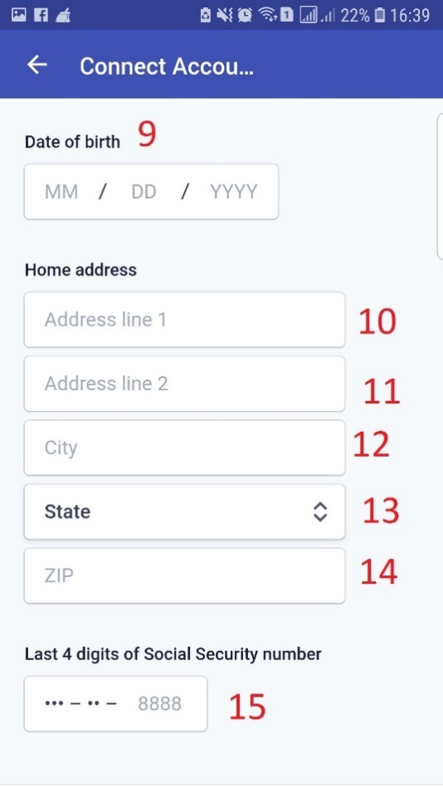

Figure 196 - <User Guide> Add Receivable Account

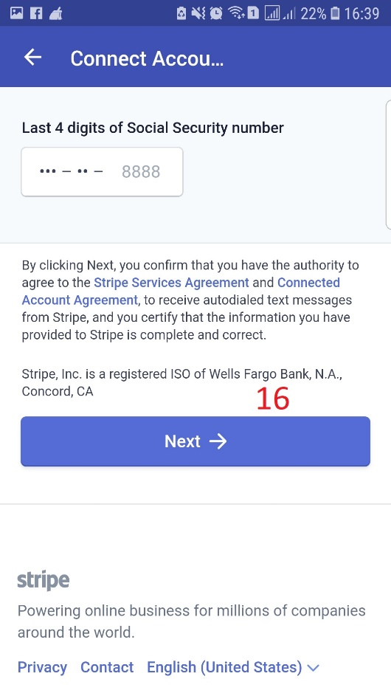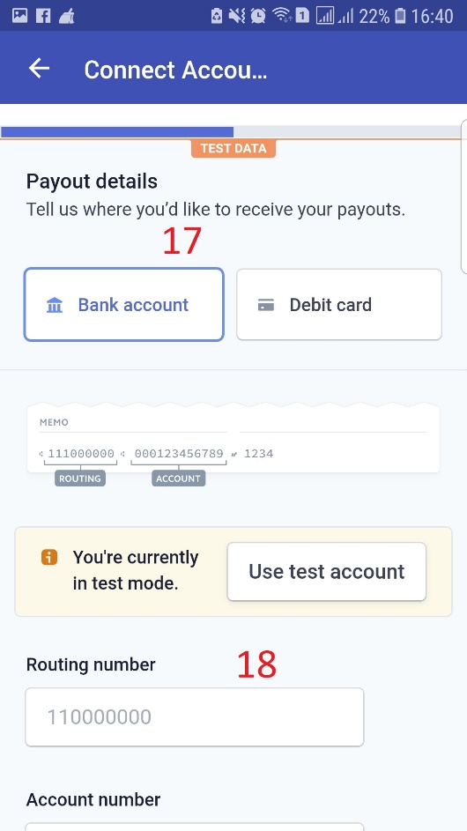

Figure 197 - <User Guide> Add Receivable Account

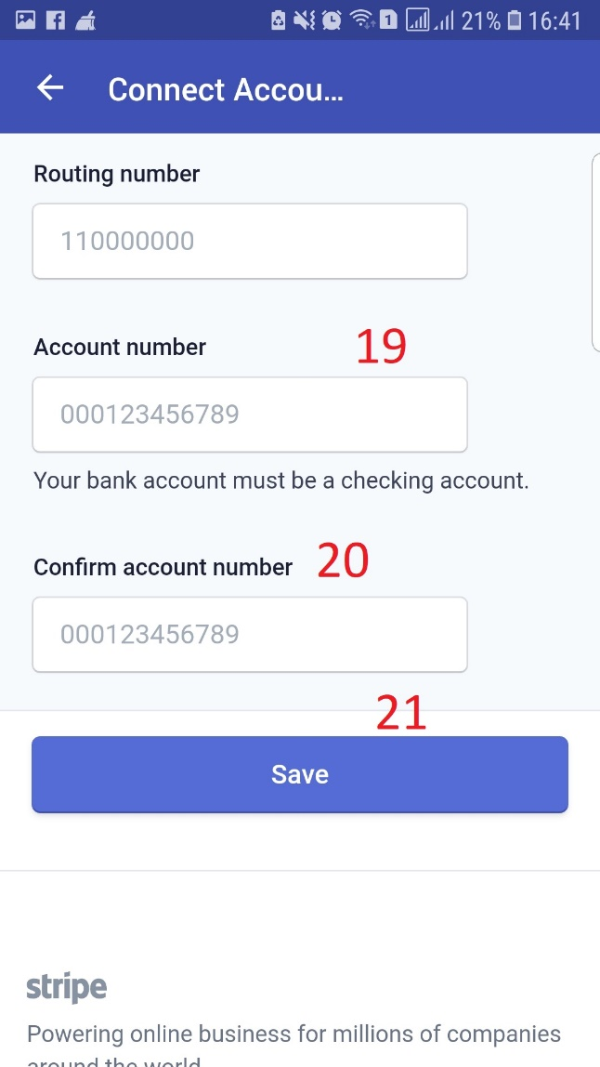

Figure 198 - <User Guide> Add Receivable Account

|  |  |
| --- | --- |
| **Step** | **Description** |
| 1 | Select Type of entity |
| 2 | Fill the field “Mobile number” |
| 3 | Fill the field “Email” |
| 4 | Click “Next” button to direct to the next page |
| 5 | Fill the field “Verification code” |
| 6 | Fill the field “First name” |
| 7 | Fill the field “Last name” |
| 8 | Fill the field “Email address” |
| 9 | Fill the field “Date of birth” |
| 10 | Fill the field “Address line 1” |
| 11 | Fill the field “Address line 2” |
| 12 | Fill the field “City” |
| 13 | Select State |
| 14 | Fill the field “ZIP” |
| 15 | Fill the field “Last 4 digits” |
| 16 | Click “Next” button to direct to the next page |
| 17 | Select Type |
| 18 | Fill the field “Routing number” |
| 19 | Fill the field “Account number” |
| 20 | Fill the field “Confirm account number” |
| 21 | Click “Save” to save receivable account |

Table 203 - <User Guide> Add Receivable Account

#### Post ticket



Figure 199 - <User Guide> Post ticket

|  |  |
| --- | --- |
| **Step** | **Description** |
| 1 | Select Vehicle |
| 2 | Fill the field “Transportation” |
| 3 | Fill the field “Ticket Type” |
| 4 | Fill the field “Departure City” |
| 5 | Fill the field “Departure Station” |
| 6 | Fill the field “Arrival City” |
| 7 | Fill the field “Arrival Station” |
| 8 | Fill the field “Departure Date” |
| 9 | Fill the field “Arrival Date” |
| 10 | Fill the field “Ticket Code” |
| 11 | Fill the field “Passenger Name” |
| 12 | Fill the field “Email Booking” |
| 13 | Fill the field “Selling price” |
| 14 | Click “POST NOW” to post a ticket |

Table 204 - <User Guide> Post Ticket

#### Search route



Figure 200 - <User Guide> Search Route

|  |  |
| --- | --- |
| **Step** | **Description** |
| 1 | Fill the field “Departure City” |
| 2 | Fill the field “Arrival City” |
| 3 | Fill the field “Departure Date” |
| 4 | Fill the field “Arrival Date” |
| 5 | Select Maximum Ticket |
| 6 | Select Maximum waiting hours between ticket |
| 7 | Select Vehicles |
| 8 | Select Transportation |
| 9 | Select Ticket Type |
| 10 | Click “SEARCH” to search route |

Table 205 - <User Guide> Search Route

#### Buy route

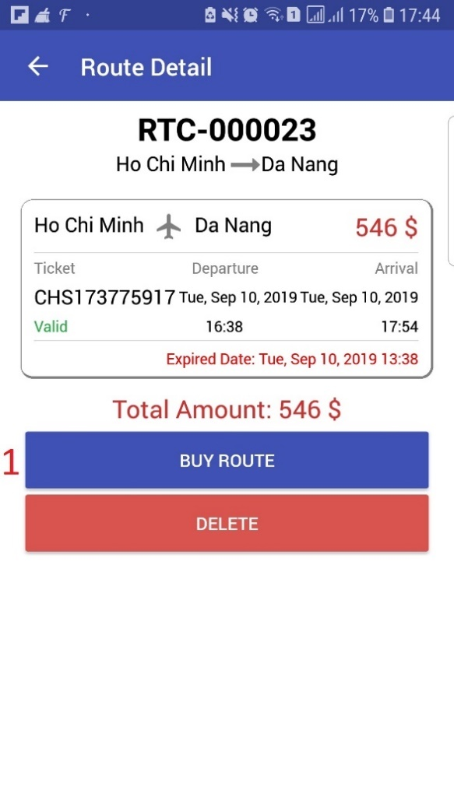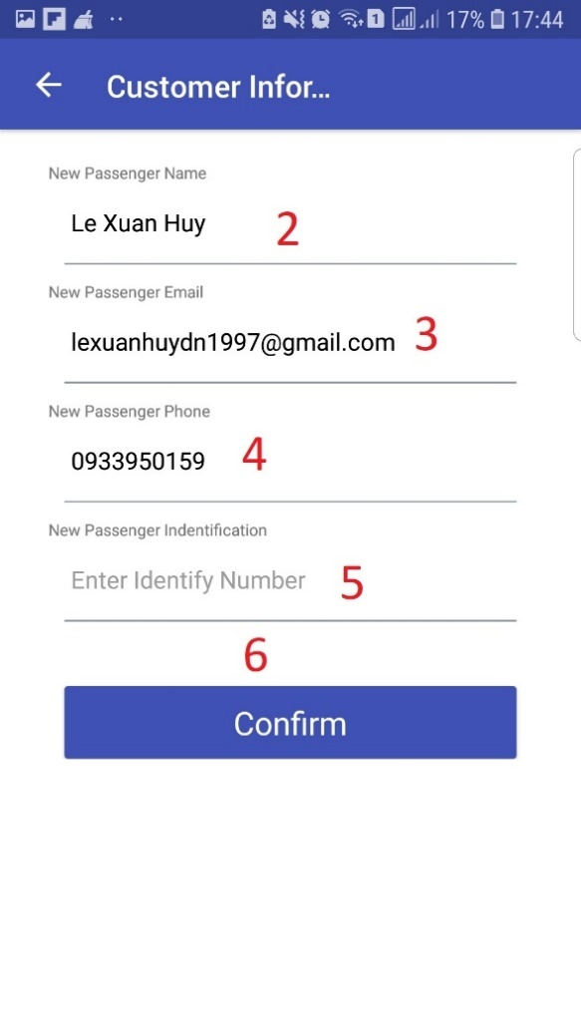

Figure 201 - <User Guide> Buy Route

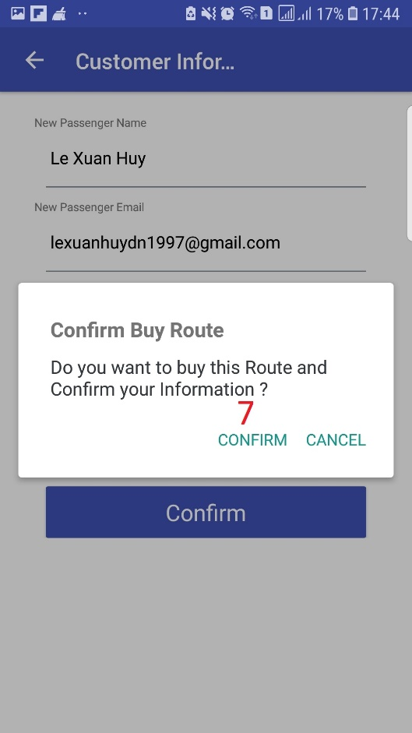

Figure 202 - <User Guide> Buy Route

|  |  |
| --- | --- |
| **Step** | **Description** |
| 1 | Click “BUY ROUTE” to direct to the next page |
| 2 | Fill the field “New Passenger Name” (optional) |
| 3 | Fill the field “New Passenger Email” (optional) |
| 4 | Fill the field “New Passenger Phone” (optional) |
| 5 | Fill the field “New Passenger Identification” |
| 6 | Click “Confirm” to show confirm dialog |
| 7 | Click “Confirm” to buy route |

Table 206 - <User Guide> Buy Route

#### Confirm renamed ticket

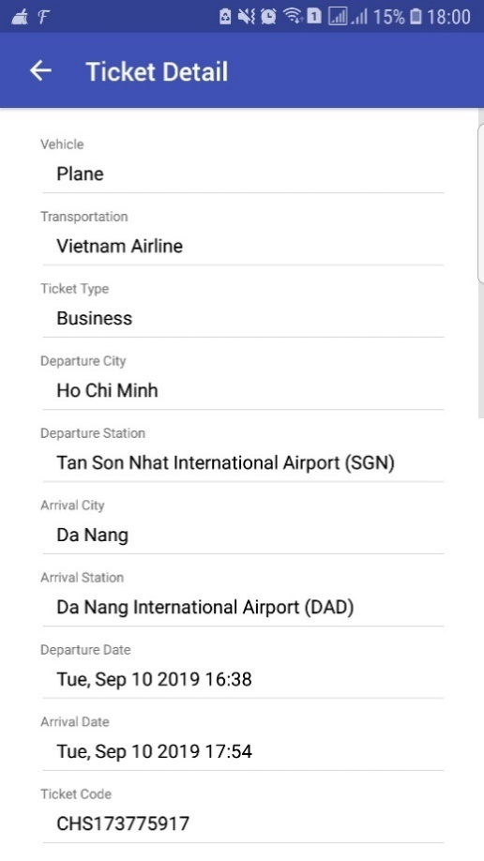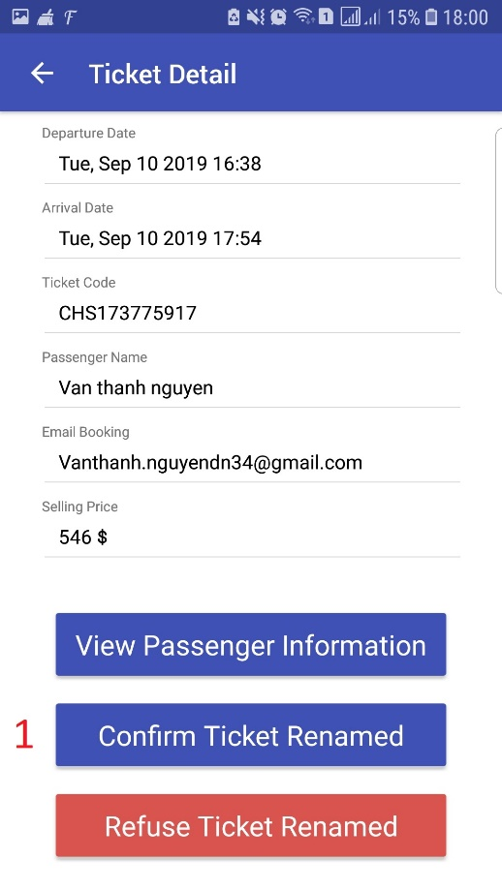

Figure 203 - <User Guide> Confirm Renamed Ticket

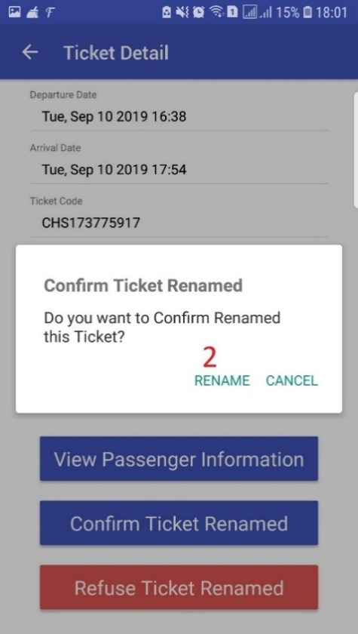

Figure 204 - <User Guide> Confirm Renamed Ticket

|  |  |
| --- | --- |
| **Step** | **Description** |
| 1 | Click “Confirm renamed ticket” to show confirm dialog |
| 2 | Click “Confirm” to confirm renamed ticket |

Table 207 - <User Guide> Confirm Renamed Ticket

# Appendix

* 1. **.NET Core 2.2** *[Online]* Available: <https://dotnet.microsoft.com/download/dotnet-core/2.2>.
  2. **SQL Server** *[Online]* Available: <https://www.microsoft.com/en-us/sql-server/sql-server-2017>.
  3. **ReactJS** *[Online]* Available: <https://reactjs.org/docs/getting-started.html>
  4. **React Native** *[Online]* Available: <https://facebook.github.io/react-native/docs/getting-started>
  5. **Visual Studio 2019** *[Online]* Available: <https://visualstudio.microsoft.com/fr/vs/?rr=https%3A%2F%2Fwww.google.com%2F>
  6. **Visual Studio Code** *[Online]* Available: <https://code.visualstudio.com/docs>
  7. **Nodejs** *[Online]* Available: <https://nodejs.org/en/docs/>
  8. **Entity Framework Core:** <https://docs.microsoft.com/en-us/ef/core/>
  9. **Identity Framework Core:** <https://docs.microsoft.com/en-us/aspnet/core/security/authentication/identity?view=aspnetcore-2.2&tabs=visual-studio>
  10. **Repository and Unit of Work Patterns in ASP.NET Core:** <https://docs.microsoft.com/en-us/aspnet/mvc/overview/older-versions/getting-started-with-ef-5-using-mvc-4/implementing-the-repository-and-unit-of-work-patterns-in-an-asp-net-mvc-application>
  11. **Dependency injection in ASP.NET Core:** <https://docs.microsoft.com/en-us/aspnet/core/fundamentals/dependency-injection?view=aspnetcore-2.2>
  12. **Eppstein’s Finding the k shortest paths:** <https://www.ics.uci.edu/~eppstein/pubs/Epp-SJC-98.pdf>
  13. **Yen’s Finding the k shortest loopless paths in a network:** <https://pdfs.semanticscholar.org/aa6a/64afc25f48ad44e510d0055405836c8cc325.pdf>